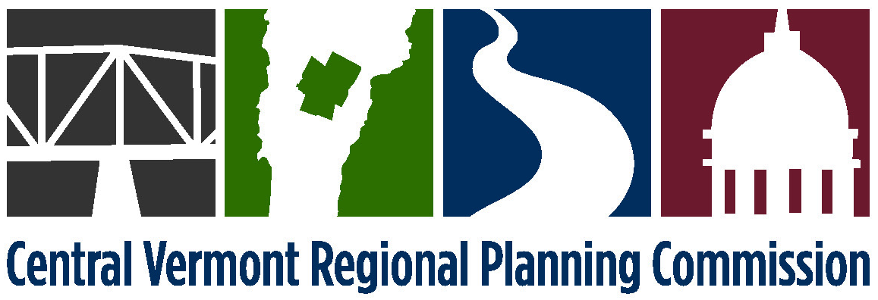

TO: Executive Committee Members
FROM: Laurie Emery
DATE: May 7, 2015

RE: Next meeting of the Executive Committee

There will be a brief meeting on Tuesday, May 12, 2015 at 6:50 p.m. at the Central Vermont Chamber of Commerce conference room to authorize signing of the revised contract with the Agency of Commerce and Community Development for the Vermont Economic Resiliency Initiative.

