Washington Town Plan
2013
Planning Commission and Adopted by the Board of Selectmen November 12, 2013

Table of Contents
Chapter one - introduction 5
1.1 Purpose 5
1.2 Background 5
1.3 Implementation 6
1.4 Basic Goals of the Washington Town Plan 7
1.5 Compatibility Statement 8

Chapter Two: A Statistical Profile of Washington 9
2.1 Washington is Small, but Growing 9
2.2 Washington is a “Bedroom” Community 12
2.3 Washington is Changing 13

Chapter Three: physical geography- the land and its resources 15
3.1 Overview 15
3.2 Setting 15
3.3 Resource Production Lands 16
3.4 Resource Protection Lands 18
3.5 Land Resource Goal and Policies 23

Chapter Four: utilities, facilities AND services 25
4.1 Overview 25
4.2 Health and Sanitation 25
4.3 Municipal Water 27
4.4 Solid Waste 28
4.5 Public Utilities 30
4.6 Education 30
4.7 Childcare 31
4.8 Emergency and Rescue Services 32
4.9 Outdoor Recreation 34
4.10 Calef Public Library 38
4.11 Religious Facilities 38
4.12 Cemeteries 41
4.13 Government 42
4.14 Utility and Facility Goals and Policies 45

Chapter Five: Energy 48
5.1 Overview 48
5.2 Heating 48
5.3 Transportation 49
5.4 Energy Goal and Policies 52

Chapter Six: Housing 53
6.1 Overview 53
6.2 Affordability 53
6.3 Housing Distribution Plan 54
6.4 Housing Goal and Policies 55

Chapter Seven: economy 57
7.1 Overview 57
7.2 Current and Future Economic Development 57
7.3 Economic Goals and Policies 57
7.4 Statistics 58

Chapter Eight: Transportation 61
8.1 Overview 61
8.2 Transportation Goals and Policies 62

Chapter Nine: Land use plan 63
9.1 Overview 63
9.2 Zoning Districts 63

Epilogue 67
Land use Guidelines 67

Summary of the washington Town plan 69

Appendix 71
Acknowledgements 71
Schedule of Town owned property and list of historic sites 73
Maps 75
CHAPTER 1: INTRODUCTION

  - Purpose
This Town Plan is intended to provide guidelines and recommendations for how Washington can best accommodate new growth and development without losing its rural character or opportunities for improvement.
This Plan recognizes the Town is, and through the planning process should remain, a small, rural, primarily residential community, characterized by a population, which are both economically and demographically diverse.
This Plan is designed to promote the health, safety, and welfare of Washington residents; to prevent overcrowding of land and foster its wise and sound use; to avoid undue concentrations of population, industry, and commercial activity; and to facilitate the adequate provision of transportation, water, waste disposal, schools, recreational opportunities and other public needs.
This Plan is specifically (but not exclusively) intended to be used in the Act 250 process. Therefore, language that is mandatory, such as "shall," "must," "should not," or "is required" is intended to be a requirement of the Plan.
This Plan will also be used as the foundation for the Washington Zoning Ordinance.

  - Background

Washington is a twice-chartered town. The original charter, granted in 1770 by the royal governor of New York, was for Kingsland in the County of Gloucester. Although there is no record of any residents during this period, Kingsland was designated as one of two county seats and a log jail was constructed close to what is now the geographical center of Washington, at the head of a stream named Jail Branch.
During the period when Vermont was an independent nation, a charter was issued naming the town as Washington. Although the exact date of this charter is not clear, most historians agree that the year was 1781. The first record of any settler in Washington is in 1785 when one Daniel Morse received title to 100 acres. By 1792, Washington was organized and the records show that in 1794 there were 32 freemen on the checklist.
For the next 45 years the population grew rapidly until it reached a peak of 1400 in 1840. The town's population was dispersed about on numerous small farms with wool production being the main cash crop. In 1840 there were 7500 sheep and 840 cows on Washington farms. Between 1820 and 1829 there were two fulling mills and one carding mill in operation; processing the wool and homespun wool cloth. Sheep raising peaked around 1830 and after 1840 there was a steady decline due to tariffs and increasing cheaper competition. After 1840 there was also a steady decline in the human population due to the westward movement. The numerous cellar holes and stone wall remnants that one can find on the hillside forests are mute testimony to the numerous farms that existed here in the 19th century.
With the arrival of railroads in Vermont in the 1850's, the dairy industry began to take over because new urban markets were now accessible. By 1895 Washington had a creamery to process its milk production. During this period the railroads were expanding with subsequent industrial development in some nearby towns. Both the railroads and industry bypassed Washington and it remained a rural community with an agriculturally based economy.
In the twentieth century the dairy business became increasingly competitive and by mid-century many small farms could not continue. By 1960 the population of Washington had declined to 565, its lowest since early in the 19th century. As these marginally productive farms were closed, land prices fell and non-residents quickly purchased much of this land. Those farmers who were able to retain some of their property were forced to seek work in nearby localities. Although Washington remains a rural community, it is no longer predominately agricultural but rather a bedroom community whose members commute for their livelihood.

  - Implementation

The Town of Washington will attempt to implement the goals, policies, and recommendations of this Plan in the following ways:
-Through the Town's participation in the Act 250 process as a "statutory party", particularly under Criterion 10 (conformance with the local plan);
-By evaluating the concept of working creatively with neighboring towns and issuing a compatibility statement.
-By reviewing the plans and activities of State agencies to ensure that they are consistent with this document (and taking appropriate action if they are not);
- By using this Plan as a guide in all relevant local government decision-making processes;
- By promoting the philosophy of this Plan, and thereby the best interests of Washington, at the regional level through continued membership and participation in the Central Vermont Regional Planning Commission;
- By using this document as the foundation for any land use regulations (i.e., zoning and/or subdivision) that the voters of the Town might amend or authorize over the life of the Plan.

  - Basic Goals of the Washington Town Plan
1) To plan development so as to maintain the historic settlement pattern of compact villages separated by rural countryside. Washington should encourage development of a village center(s), which will give the Town a central focus and foster a sense of community among residents by seeking to channel more intense residential development in the village center(s) and by discouraging strip development.
2) To plan for public investments in the construction or expansion of infrastructure such as fire and police protection, emergency medical services, schools, solid waste disposal, and others, that reinforces the desired character and planned growth patterns of the town.
3) To help meet the employment needs of the expanding Washington labor force, the Town will support new employment opportunities and programs, including home occupations and small businesses, provided they do not dramatically alter the character of the Town.
4) To maintain access to high quality educational programs so that all Washington residents have opportunities to improve academic and vocational skills.
5) To provide for safe, convenient, economic and energy efficient transportation systems that respects the integrity of the natural environment.
6) To protect and preserve important natural, historic, recreational, scenic and cultural features of the landscape including air, water, wildlife and land resources.
7) To encourage the efficient use of energy and the development of renewable energy resources.
8) To upgrade recreational opportunities, including those at Carpenter Park, so that Washington can provide for indoor and outdoor usage of leisure time by visitors and local citizenry.
9) To meet the housing requirements of the Town's expanding population through the construction of appropriately sited new housing and the rehabilitation of existing structures. Town government could seek ways to encourage this to come about.
10) To strengthen sound agricultural management and forest industries while encouraging the manufacture, marketing and use of value added products and locally grown foods.
11) To enable Washington to participate in Act 250 and other proceedings so that we may be involved in decisions that affect our community.

  - Compatibility Statement
According to Vermont Statute, a municipal plan is considered to be "compatible" with the plans of its neighboring towns and the region if it "will not significantly reduce the desired effect” of the same.
By virtue of its geography and planning goals, Washington's potential for inter-municipal land use conflicts is limited. This Plan’s basic focus (i.e., to preserve the Town’s rural· character while accommodating reasonable growth and development), and current development patterns do not appear to threaten or obstruct the planning goals of any neighboring community or the Central Vermont Regional Planning Commission.
CHAPTER 2: A STATISTICAL PROFILE OF WASHINGTON

2.1 Washington is small, but growing

Washington is one of the least populous and most rural towns in the Central Vermont Region. However, on a percentage basis, it has also been one of the Region's more rapidly growing communities over the past few decades. Given recent trends, and Washington's proximity to regional job centers, continued growth is likely. Population projections made by the Central Vermont Regional Planning Commission place the Town's population over 1,300 by the year 2020. Still, it is interesting to note that despite the current "boom", Washington's population remains considerably below its historical high of about 1400 residents, reached in 1840.

Table 1: Population Growth 1960-2010
Population: | Washington | Washington County | Orange County | Vermont
1960 | 565 | 42,860 | 16,014 | 389,881
1970 | 667 | 47,659 | 17,676 | 444,732
1980 | 855 | 52,393 | 22,739 | 511,456
1990 | 937 | 54,928 | 26,149 | 562,758
2000 | 1,061 | 58,039 | 28,226 | 604,827
2010 | 1,039 | 59,534 | 28,936 | 625,741
% Change: 1960-2000 | 88% | 35% | 76% | 55%
% Change: 1990-2010 | 11% | 8% | 11% | 11%
% Change: 2000-2010 | -2% | 3% | 3% | 3%
Source: U.S. Census

Table 1-A: Population Projections
 | Washington | Washington County
2010 Forecast | 1,156 | 61,407
2010 Census | 1,039 | 59,534
2015 Forecast | 1,226 | 63,506
2020 Forecast | 1,311 | 66,269
Source: U.S. Census; Economic & Policy
Resources, Inc.

Table 2: Population Stats 2010
 | Washington | Washington County | Orange County | Vermont
Population Density (Persons per Sq. Mi.) | 26.71 | 86 | 42 | 67.9
Number of Families | 317 | 15,410 | 7,865 | 160,360
Average Family Size | 2.68 | 2.81 | 2.83 | 2.85
Average Household Size | 2.38 | 2.28 | 2.37 | 2.34
Total Households | 437 | 25,027 | 11,887 | 256,442
Source: U.S. Census

Table 3: Age Distribution
 | Washington |  | Washington County | Orange County | Vermont
 | Number | Percent | Percent | Percent | Percent
Total Population | 1,039 | 100 | 100 | 100 | 100
Male | 533 | 51.3 | 49.4 | 49.8 | 49.3
Female | 506 | 48.7 | 50.6 | 50.2 | 50.7
Under 5 years | 49 | 4.7 | 5.2 | 5.1 | 5.1
5 to 9 years | 56 | 5.4 | 5.7 | 5.6 | 5.5
10 to 14 years | 45 | 4.3 | 5.9 | 6.2 | 6
15 to 19 years | 60 | 5.8 | 7.0 | 6.8 | 7.4
20 to 24 years | 53 | 5.1 | 6.0 | 5.4 | 7
25 to 34 years | 114 | 11 | 10.8 | 10.3 | 11.2
35 to 44 years | 132 | 12.7 | 13.3 | 12.4 | 12.5
45 to 54 years | 221 | 21.2 | 16.6 | 17.6 | 16.4
55 to 59 years | 99 | 9.5 | 8.1 | 8.4 | 7.8
60 to 64 years | 84 | 8.1 | 7.0 | 7.4 | 6.6
65 to 74 years | 84 | 8.1 | 7.8 | 8.4 | 7.9
75 to 84 years | 34 | 3.3 | 4.5 | 4.6 | 4.6
85 years and over | 8 | 0.8 | 2.2 | 1.8 | 2
Median Age | 45.5 |  | 42.3 | 43.8 | 41.5
Source: U.S. Census

Table 3 – A
Vital Statistics
Year | Births | Deaths
2010 | 16 | 12
2009 | 9 | 3
2008 | 12 | 11
2007 | 9 | 6
2006 | 11 | 9
2005 | 14 | 12
2004 | 10 | 11
2003 | 4 | 9
2002 | 21 | 8
2001 | 3 | 4
2000 | 6 | 8
Source: Vermont Department of Health

Sales of Primary Residences
 |  | Median Sales Price (in 2012 dollars)
 | Washington # of Sales | Washington | Washington County | Orange County | Vermont
2012 | 3 | $144,625 | $185,000 | $156,000 | $199,000
2011 | 0 | - | $189,300 | $159,900 | $199,000
2010 | 3 | $191,600 | $184,300 | $172,400 | $204,300
2009 | 3 | $96,300 | $181,900 | $181,400 | $203,300
2008 | 3 | $98,100 | $197,300 | $176,000 | $213,300
2007 | 7 | $171,600 | $199,300 | $189,400 | $221,500
2006 | 6 | $186,200 | $201,900 | $187,900 | $222,100
2005 | 9 | $188,100 | $191,100 | $182,200 | $217,400
2004 | 14 | $157,900 | $179,300 | $158,000 | $199,900
2003 | 6 | $90,500 | $164,100 | $149,100 | $187,000
2002 | 9 | $127,600 | $151,200 | $146,600 | $172,200
2001 | 7 | $118,000 | $142,600 | $125,800 | $164,500
2000 | 14 | $120,000 | $126,700 | $126,700 | $158,700
1999 | 4 | $88,300 | $136,300 | $123,500 | $151,600
1998 | 3 | $70,400 | $133,800 | $122,500 | $155,000
1997 | 6 | $93,300 | $131,600 | $125,200 | $151,600
1996 | 7 | $81,900 | $130,200 | $122,000 | $146,300
1995 | 8 | $121,300 | $136,700 | $120,500 | $149,100
1994 | 10 | $126,000 | $135,600 | $124,700 | $150,300
1993 | 3 | $103,300 | $141,400 | $135,000 | $152,500
Source: Vermont Department of Taxes

Continued population and housing growth in Washington will present some interesting challenges. Demands for municipal services are certain to increase, as are impacts on the Town's natural resources. It will take wise and careful planning for Washington to continue to accommodate the future while retaining its rural character and identity.

2.2 Washington is a “Bedroom Community”
In earlier times, Washington's economy placed greater emphases on the use of its natural resources. Until the second half of this Century, agriculture, mill-powered manufacturing, mining, and forestry, were the town's employment mainstays and most residents made their living in town. Several retail establishments catered to the population drawn by such industry. Now, with only 15% of the Washington's employed residents, working in town, only a few retail establishments, and no large employers, Washington has clearly evolved into a bedroom community."
Table 6: Employment by Industry
 | Washington |  | Washington County |  | Orange County |  | State
Industry | Estimate | Percent | Estimate | Percent | Estimate | Percent | Estimate | Percent
Civilian employed pop. 16 years and over | 585 |  | 31,918 |  | 15,344 |  | 328,365
Agriculture, forestry, fishing and hunting, and mining | 21 | 3.6 |  | 1.5 |  | 4.6 |  | 2.6
Construction | 63 | 10.8 |  | 7.7 |  | 9.7 |  | 7.7
Manufacturing | 40 | 6.8 |  | 8.3 |  | 9.4 |  | 10.6
Wholesale trade | 33 | 5.6 |  | 2.9 |  | 2.4 |  | 2.5
Retail trade | 64 | 10.9 |  | 10.1 |  | 12.4 |  | 11.6
Transportation and warehousing, and utilities | 18 | 3.1 |  | 2.8 |  | 3.2 |  | 3.7
Information | 0 | 0.0 |  | 3.1 |  | 1.3 |  | 2.0
Finance and insurance, and real estate and rental and leasing | 47 | 8.0 |  | 6.1 |  | 4.4 |  | 4.8
Prof., scientific, and mgmt, and admin. And waste mgmt services | 48 | 8.2 |  | 8.8 |  | 8.4 |  | 8.6
Educ. services, and health care and social assistance | 116 | 19.8 |  | 26.2 |  | 28.7 |  | 27.3
Arts, entertainment, and recreation, and accommodation and food services | 44 | 7.5 |  | 7.5 |  | 5.7 |  | 9.1
Other services, except public administration | 34 | 5.8 |  | 5.4 |  | 4.2 |  | 4.7
Public administration | 57 | 9.7 |  | 9.7 |  | 5.6 |  | 4.9
Source: 2007-2011 American Community Survey 5-year Estimates

2.3 Washington is Changing

Washington is becoming more socially diverse, better educate and less economically disadvantaged. Some of these changes can probably be traced to the influx of "commuter residents" in professional or skilled labor occupations.
For decades Washington displayed several statistics that reflected a high degree of economic distress, this situation is improving. Income levels are now above average for our area. Orange County had a median household income of$39,855 and Washington County was $40,972 per household in 1999.
In addition, the poverty level for Washington has been steadily declining for decades. Washington is well above average in the percentage of population above the Poverty Level as compared to the State and County. The latest census shows that the town has only 9 families (65 persons) under the Poverty Level.
Table 7: Household Income
 |  | Washington |  | Washington County |  | Orange County |  | State
Income and Benefits |  | Number | Percent | Number | Percent | Number | Percent | Number | Percent
Total Households |  | 419 |  | 24,728 |  | 11,805 |  | 256,711
Less than $10,000 |  | 4 | 1.0 |  | 5.1 |  | 4.9 |  | 5.9
$10,000 to $14,999 |  | 8 | 1.9 |  | 5.3 |  | 4.2 |  | 5.5
$15,000 to $24,999 |  | 28 | 6.7 |  | 9.4 |  | 11.0 |  | 10.5
$25,000 to $34,999 |  | 47 | 11.2 |  | 10.4 |  | 11.2 |  | 10.1
$35,000 to $49,999 |  | 81 | 19.3 |  | 13.9 |  | 16.3 |  | 14.7
$50,000 to $74,999 |  | 132 | 31.5 |  | 20.7 |  | 21.7 |  | 20.5
$75,000 to $99,999 |  | 67 | 16.0 |  | 15.4 |  | 13.3 |  | 13.6
$100,000 to $149,999 |  | 43 | 10.3 |  | 13.0 |  | 12.8 |  | 12.2
$150,000 to $199,999 |  | 0 | 0.0 |  | 3.9 |  | 2.5 |  | 3.9
$200,000 or more |  | 9 | 2.1 |  | 3.0 |  | 1.9 |  | 3.1
Median household Median income |  | $57,798 |  | $57,163 |  |  |  | $53,422
Source: 2007-2011 American Community Survey 5-year Estimates

Table 8: Persons Below Poverty Level (Percent Total Population)
 | Number | Percent
Washington | 126 | 12.6
Washington County |  | 9.3
Orange County |  | 10.6
Vermont |  | 11.5
Source: 2007-2011 American Community Survey 5-Year Estimates

Evidence of the Town's changing social fabric can also be seen in the dramatic changes in education level over the past decade. In 1980, only 59% of Town residents over 25 years old had a high school degree. By 2000 this figure rose to 82.4%, and by 2011 to 86.5%.

Table 9: Highest Grade Achieved for Persons 25+ years of age (% of total)
 | Washington | Washington County | Orange County | Vermont
K-8 | 6.7 | 2.5 | 3.1 | 3.1
9-11 | 6.7 | 4.5 | 6.6 | 5.9
12th Grade | 50.1 | 29.4 | 36.4 | 31.7
1-3 Yrs of College | 20.1 | 25.4 | 26.1 | 25.5
4+ Yrs of College | 10.3 | 22.2 | 15.6 | 20.5
Grad or Prof. Degree | 6.0 | 16 | 12.1 | 13.3
Source: 2007-2011 American Community Survey 5-year Estimates

CHAPTER THREE: PHYSICAL GEOGRAPHY; THE LAND AND ITS RESOURCES

3.1 Overview

The landscape is the stage and source for all human activity. However, as recent decades have demonstrated, the resources and frontiers that the land can provide are finite and vulnerable to abuse. This is particularly true during periods of rapid growth and development. It will be in our long-term best interest therefore, to use land resources efficiently and wisely so that they may continue to provide opportunities for human endeavor and growth in the future.
This chapter first examines Washington's physical landscape and then considers the resources contained therein, exploring their relationship to various human activities. Finally, it offers some recommendations designed to help maintain a harmonious and mutually beneficial balance between people and the land.

3.2 Setting

The Town of Washington is located in Orange County near the geographical center of Vermont. It is bounded by the Towns of Barre, Orange, Williamstown, Chelsea, Corinth, and Vershire, and contains 25,216 acres of land. It is about 84% forested, with only about 3% of its land area developed. Approximately 13% of Washington’s land area is cropland, pasture, or open land. Wetlands and surface waters comprise less than one percent of the Town's total area.
With just over 1,400 feet of topographic relief inside its boundaries, Washington is rugged and picturesque. Hilly, but not mountainous, it is part of physiographic region known as the Vermont Piedmont- a plateau that has been dissected by streams and subdued by glaciations. Generally, slopes are moderately steep. From a minimum elevation of just under 1,000 feet along the First Branch of the White River the terrain climbs to over 2000 feet in many places. Michigan Hill, at 2402 feet, is the highest point in Town.
The Town's stony, often steep, and occasionally wet glaciated soils present some widespread and significant limitations for development. A generalized soils analysis of Washington reveals that five major soil associations occur here. None are considered to be particularly favorable for buildings with on-site sewage disposal; however, each may contain sites that are suitable for development.
In spite of difficult geography and soils, development obviously has, and is, occurring in Washington. As topography and current population distribution might indicate, the valley of the Jail Branch has historically been the site of the most human activity in Washington (Although the original Town Center was on Boyce Hill). However, growth in Washington has more dispersed in recent decades. Settlement patterns are now following the valleys of some smaller streams expanding into upland areas. Much of the Town's new residential growth has been on somewhat remote, scattered parcels. Such growth is also the forecast for the foreseeable future.
Despite recent growth and development trends, the Town's landscape is still largely defined by a harmonious blend of hills, meadows, forest and streams. It is this natural setting that is in large part responsible for the character of this community. Furthermore, such a landscape offers recreation, solitude, scenic enjoyment, and (as we saw in the previous chapter) economic opportunity to its inhabitants and visitors alike. Accordingly, good town planning and wise resource management would suggest judicious and sound use of natural areas, surface and groundwater, flood plains, prime forest and agricultural lands important wildlife habitats and other vulnerable resources.
To accomplish this, the Town will need to plan for and implement efficient and thoughtful growth and settlement patterns over the long run, taking advantage of those lands capable of supporting development without detriment to the environment or fiscal well being of the community.

3.3 Resource Production Lands

Agriculture and forestlands benefit society on many levels -economic, aesthetic, recreational, and environmental. Both land uses provide habitat for game and non-game wildlife, undeveloped sites for flood storage and watershed protection, scenic vistas, open spaces for a variety of outdoor pursuits, and increased self-sufficiency as local sources of food and wood products. In addition, these lands play an important part in Washington's economy, providing a relatively large number of jobs on a percentage basis compared with other towns in the region.
Few would argue against the need to protect and maintain these important and traditional uses of our land. Development pressures, poor practices and a variety of economic forces are threatening still, both agricultural and forestlands. Agricultural lands are particularly vulnerable to encroachment and conversion as they are generally level, cleared and on good building soils. Although Washington, with its rugged landscape and narrow valleys, may not fit the image of an agricultural community, it does contain some good farmland soils, pa1ticularly in the Northwest corner of Town. Several parcels in Town are actively used for agricultural purposes. These include hay and pasturelands, livestock operations, dairy farms
and some tilled acreage. Some of this agricultural land is enrolled in Vermont's Use Value program. Through this program landowner's property taxes are assessed on the basis of the land's current use (as opposed to its development potential). In return, the landowner pledges to abide by a management plan for the parcel. Some of Washington's agricultural landowners are not full time farmers. Still, the open spaces they provide play an important role in defining the character of this rural community.
Perhaps even more important to Washington's identity are the vast forestlands within its borders. In addition to providing intangible benefits, many of Washington's large, managed parcels are important sources of lumber and cordwood. The bounty of Washington's forestland and the extent to which its resources are harvested probably accounts, in part, for the fact that Washington residents heat their homes with wood at more than twice the rate of the rest of the region (43% vs. 18%).
About 430 acres of the Town's forestlands are protected and managed within the boundaries of Washington State Forest. The State Forest is managed for multiple uses. Consequently, timber harvesting is allowed and occurs in most locations. Another 260 acres of public forestland exists within the boundaries of the Washington Wildlife Management Area, under the auspices of the Vermont Department of Fish and Wildlife. In addition a 318-acre parcel off Pepper Road is protected by permanent conservation easement through the Vermont Land Trust.
The vast majority of Washington's forests are privately owned. There are 73 parcels totaling 9,136 acres of privately and corporately owned land is enrolled in Vermont's Use Value Program for timber management. With the recent initiation of the U.S. Forestry Service's ''Forest Legacy" program, these forest landowners may have another option and incentive for the voluntary conservation of their land (provided funding is continued). Under this program, federal funding is available for the purchase of conservation easement on eligible, privately owned forestlands.
Another type of resource-based production which should not be overlooked is that of earth materials extraction; in Washington this refers primarily to gravel. Gravel deposits in Washington are glacial in origin and like human residences, agricultural operations, and groundwater supplies, generally follow the courses of streams and rivers. While these deposits may yield important and needed materials for road and- building construction, Washington's coincidental development patterns render their extraction a matter of some sensitivity. It is vital that care be taken in situating and operating future gravel pits in order to avoid land use conflicts and environmental damage.

3.4 Resource Protection Lands

3.4 (1) Natural Areas

A natural area is defined by the State as "an area of land or water that, in contrast to the normally encountered landscape of a region, retains or has re-established its natural character and retains unusual or significant flora, fauna, geological features or similar features of scientific interest. Such places, often remote, quiet and beautiful, are of great, but unquantifiable value to local residents and visitors alike. Generally included under this definition are areas above 2500 feet in elevation, "Fragile Areas” as identified by the Vermont Agency of Natural Resources, and ANR Natural Heritage Program sites (which locate rare or threatened species)? At the moment, Washington contains no such natural areas although it is certainly possible that sites fitting the latter two categories exist, but have not yet been identified.

3.4 (2) Critical Wildlife Habitat

Washington boasts considerable wildlife habitat for a variety of wildlife species, including many associated with wilderness or near-wilderness settings (e.g. moose, bear, fisher, bobcat, coyote, etc). Residents value native wildlife for a variety of reasons - hunting, wildlife viewing, and indirect income among them.
Our most critical wildlife species are generally thought of as those, which yield significant economic returns provide for sport and subsistence hunting, are symbolic of wilderness values, or face the threat of extirpation or extinction. We know that viable habitat is the single most important survival need for most of these species, yet for many, habitat loss or fragmentation is a real and present threat.
Critical habitats are defined as: those habitats that provide a critical source of food, water, shelter, space, or travel that is decisive to the survival of a species including, but not limited to, deer wintering areas, wetlands, seasonal bear feeding areas, bear travel corridors, habitats of threatened and endangered species, and rare and irreplaceable natural areas.
Winter deer ranges are generally located in coniferous stands in valleys offering food and relief from icy winds and deep snows, such areas are often desirable sites for human activities as well. Washington possesses a few significant winter deer ranges. The largest of these occurs on the eastern side of Route 110, south of the former Sky Acres Girl Scout Camp (see map #1).
While nearly the entire eastern half of Town is considered to be seasonal habitat for black bear, only a small area on the north-central border is mapped as "production habitat". Such areas support relatively high densities of cub-producing females and as such are important to the survival of the species. The beech stands on Michigan Hill and the plants of Duplissey Swamp are particularly important fall and spring feeding areas respectively. According to some, a bear travel corridor may extend from Spruce Mountain in Plainfield through Orange Heights, Lyme Emery and Washington.

3.4 (3) Surface Waters

Watershed Planning Initiative:
The Vermont Department of Environmental Conservation (DEC) has recently begun its' Watershed Planning Initiative throughout the state's 17 sub-watersheds as required by the Vermont General Assembly. A watershed is the entire area that drains into a particular water body either through channelized flow or surface runoff. Top water quality issues within each watershed will be identified.
Through extensive public involvement a watershed plan for each basin will be developed and water quality improvement projects implemented as the result of the plans. The Vermont Water Quality Standards requires changes in the current classification system of the management of all surface waters and will take place as part of the watershed planning initiative

Watersheds located within the Town of Washington:
The Town of Washington serves as the headwater area to 3 major watersheds: the Waits River, White River, and the Winooski River watersheds. Washington Heights is the watershed divide separating the Winooski and White River watersheds. The First Branch of the White River flows south parallel to Route 110 into Chelsea, Tunbridge, and South Royalton before entering the White River. The Jail Branch flows north along Route 110 to East Barre, then north west along Route 302 to Barre joining the Stevens Branch before entering the Winooski River. Cookville Brook flows southeast from Michigan Hill to the South Branch of the Waits River and joins the Waits River in Corinth. The East Orange Branch flows east to the Waits River in Topsham. The Waits River and White River eventually join the Connecticut River while the Winooski River enters Lake Champlain. A DEC watershed plan was recently completed for the White River basin. A new surface water management typing and classification map for the White River basis was submitted to the Vermont Water Resources Board for their approval. Watershed planning efforts began in the Waits River basin in 2003.

Classifications System:
Since the 1960s, Vermont has had a classification system for waters that establishes management goals. These goats describe the values and uses of surface waters that are to be protected or restored through appropriate management. According to the 2000 Vermont Water Quality Standards, Class C surface water management designation was eliminated. Until recently, the system included two classes: A and B. Class A waters were divided into two subclasses: A (1) and A (2).
Presently in all basins, waters above 2,500 feet in elevation are classified A (1) by Vermont statute. The management objective for A (1) waters is to maintain their natural condition. Waters used as public water supplies are classified A{2). All the remaining waters are Class B waters. As part of the Water Quality Standards revisions in 2000, the system was changed to divide Class B waters into three management types: 1, B2 and B3. The revised Water Quality Standards require that all basin plans place Class B waters into one of the three management types.
A simplification of the B1, B2 and B3 designations would be to say that the spectrum from B3 to B2 to B1 is described as representing "good", "better" and "best" aquatic conditions. All Class B waters must still support the designated uses described in the Vermont Water Quality Standards for Class B Waters, which includes suitability for boating, swimming, and drinking with treatment.
For all water quality management goals, it is assumed that agricultural and silvicultural activities that followed Accepted Agricultural Practices and Acceptable Management Practices respectively would comply with the Water Quality Standards. Once the Vermont Water Resources Board adopts the goals, the Agency of Natural Resources will work to achieve or maintain the level of water quality specified by the established goals.

3.4 (4) Wetlands

Wetlands are swampy or marshy areas, which are not quite water and not quite earth, but some mix of both. They are inhabited by a unique variety of plants and animals and help make our environment more livable by purifying surface and underground water supplies, storing floodwaters during wet periods and replenishing water supplies in dry weather, and providing for productive and diverse biological communities. Wetlands may be threatened or destroyed by building and other human activity.
Washington contains numerous small wetlands that are listed on the National Wetlands Inventory totaling approximately 150 acres. Duplissey Swamp is probably the most significant of these. There are also two fens (unique wetlands having special characteristics) in Washington that are on the State list of Heritage Sites.

3.4 (5) Floodplain

The one hundred- year flood (i.e. a flood of a magnitude that has a statistical recurrence interval of once every 100 years) has been adopted by the Federal Insurance Administration as the base flood for floodplain management. Washington's principal flood hazard zones occur along the Jail Branch and First Branch of the White River. However, some of the smaller tributary streams are subject to flash flooding and are capable of causing property damage as well. The most frequent flooding occurs in early spring as a result of snow melts and heavy rains, but flooding has historically occurred in every season. Flooding has also occurred as a result of ice jams and debris collection.
Encroachment by development on floodplains reduces their water storage potential, increasing flood heights and thus damage to downstream areas. In addition, development of these areas and the resulting effect on floodplain mechanics is disruptive of river ecology. Finally, the economic benefit of locating a structure in a flood hazard zone seldom outweighs the economic risks of damage to or destruction of that building.

3.4 (6) Groundwater

The importance of groundwater to the residents of Washington cannot be overstated. So dependent is the community on underground sources for domestic water supply, that pollution or significant depletion of its aquifers would spell hardship for many years to come. The fact that the Town has already had some experience with the cost and inconvenience associated with inadequately protected groundwater supplies testifies to this fact. Washington therefore, must consider the protection of groundwater resources in planning for its future.
Vital to the protection of groundwater sources is an awareness of their "recharge" areas. Aquifer recharge areas are zones that contribute to subsurface supplies. A recharge area consists not only of the land area directly above the aquifer through which precipitation percolates, but also of upland areas from which runoff drains towards the aquifer. Uses of these lands, which may have the potential for spills of toxic or dangerous substances, also have the potential to pollute the aquifer. Uses that render the land impermeable (e.g. parking lots, buildings, etc) will deplete the groundwater supply. Also, as there is exchange between surface and ground waters, land uses that pollute up stream waters may in time damage downstream aquifers. Obviously, the regulation of potentially hazardous land uses is a vital part of aquifer protection.
Recognizing this fact, the Agency of Natural Resources (ANR) has designated three well head protection areas (WHPA's) for public water supplies within the town of Washington (see map #1). The most significant of these is a 2,890-acre zone, south of the village and east of Route 110, which serves as the primary recharge area for the municipal water supply system. A 36-acre WHPA around the Washington North Trailer Park and a small portion (less than 20 acres) of the Graniteville Fire Districts WHPA also can be found within Town boundaries. Vermont's groundwater protection law (10 VSA, Chapter 48) sets forth general policies for WHPA's and ANR's Water Quality Division has published recommended land use guidelines for WHPA's.

3.4 (7) Historic Resources

Over 75 of Washington's historic buildings and other features are listed in the Vermont Division for Historic Preservation's "Inventory of Historic Sites and Structures" (see appendix for listing). In addition, the Division categorizes the entire village area as an historic district. Most of the structures listed in the inventory are private residences, although a few public and semi-public buildings are listed as well. A listing in the inventory affords no specific protection for a structure or benefits for its owner. It is merely intended to catalogue historic resources to facilitate individual or local protection efforts.

3.4 (8) “Special Places”

Washington is blessed with many "special places" that provide unusual scenic, historic, natural or cultural interest. A partial listing of these places would include the old cemeteries that contain the gravestones of the first settlers of Washington, and our historic buildings like the churches and some of the old farms and homes. Each of us probably knows some of these places, but probably very few of us are familiar with all of them (see appendix for partial listing.)
It is the intent of this Plan to work with the landowners of these areas to protect the values that are available here. The timber, wildlife, aesthetic and recreational values are worthy of our highest consideration. The landowners should be supported in retaining these values through purchase of conservation easements, the current use tax program, grants, and whatever other means are available.

3.5 Land Resource Goal and Polices:
Goal: To promote sound management of the town’s natural resources.

Policies:
- The fragmentation and use conversion of agricultural and timberland should be discouraged. Development that does occur on such lands should be situated so as to leave the most productive portions of the site available for continued use.
- Clustering of lots and structures with protected open space is recommended as a means of achieving this objective.
- Washington recognizes the right of pre-existing resource production landowners to continue current operations and management practices (provided they are environmentally sound and legal) and therefore encourages the siting of new surrounding development so as to avoid the potential for nuisance complaints against such operations.
- Washington encourages the siting of non-polluting businesses and industries which might use or sell locally produced farm or wood products in Washington, provided such siting and activity is otherwise consistent with this Plan.
- The community should encourage regulatory and non- regulatory methods for preserving important farm and forest lands, including but not limited to, agricultural zoning, the formation of a local land trust or participation in a regional one, tax abatement programs, off-site mitigation, transferable development rights, and the voluntary sale of development rights.
- Gravel extraction, like other commercial/industrial uses, should be compatible with their surroundings and with surrounding land uses. Traffic types and volume and noise levels will be factors in making this determination. In addition, active sites should be well screened and mined areas quickly reclaimed.
- The protection of important wetlands, natural areas, and critical wildlife habitats through creative development techniques (including clustering), off-site mitigation, voluntary easements, acquisition in fee simple or less than fee simple, and landowner education is encouraged.
- Potentially polluting land uses should be restricted from Washington's Well Head Protection Areas, in accordance with State policies and guidelines.
- This Plan opposes the downgrading of current surface water classifications unless such downgrading would serve an overriding public need.
- Trees and other vegetation along streams, rivers, and lake shores serve to: protect property from flood flow and ice jams, prevent bank erosion, enhance aesthetic appeal, and maintain the oxygen level of the water for fish habitat and effluent assimilation capacity. For these reasons, undisturbed areas of vegetation should be retained and encouraged along the banks of surface waters.

Goal: Washington should appoint a task force or Conservation Commission (under VSA 24, Chapter 118) to assist in the identification, study, maintenance and protection of important natural resources and "special places."

Policies:

- Development that threatens to diminish the scenic value or unique nature of Washington's special areas should be discouraged.
- Development near historic structures or sites identified in this Chapter should not compromise their aesthetic integrity nor interfere with their function.
CHAPTER 4: UTILITIES, FACILITIES, AND SERVICES

4.1 Overview

Public and private utilities, facilities and services play a critical role in providing for the health, safety and welfare of Washington residents. The location, timing and capacity of such infrastructure can also have a profound influence on growth and development within a community. Through thoughtful infrastructure planning and maintenance Washington may encourage growth where it is most suitable and least expensive to the community.

4.2 Health and Sanitation

Washington has no public sewage disposal system. Therefore, all wastewater must be disposed of and treated where it is generated. On-site septic systems require specific soil and site characteristics to enable the effective treatment of wastes. Where soils are impermeable, too permeable, shallow, or wet, or where slopes are steep, conventional septic systems are problematic and potentially hazardous. Accordingly, areas displaying such site limitations are generally not suitable for development. Restricting such areas however, intensifies development pressures on soils that can accommodate septic systems, including most prime agricultural soils.
The proper treatment of septic waste is essential to a clean, healthy environment. Faulty on-site septic systems can pollute soils, surface waters and groundwater and endanger public health. As Washington's population grows, sanitary disposal will become even more critical. It is important then, that the Town require the safe and efficient treatment of sewage, for current and future residents alike.
The Board of Selectmen adopted a Sewage Ordinance in August 1983 for the following purposes:
1) to prevent the creation of health hazards;
2) to prevent surfacing sewage, the contamination of drinking water, ground water and surface water;
3) to insure adequate drainage related to the proper functioning of sewerage disposal; and to insure that facilities are designed, constructed, operated and maintained in a manner that will promote sanitary and healthful conditions.
The ordinance requires that all sewage disposal systems be built, altered and used in accordance with design specifications of the Vermont Health Regulations (Chapter 5, Subchapter 10- Wastewater Treatment and Disposal-- Individual On-site Systems). A permit for construction and use of said systems must be obtained from the Town Health Officer.
In the long term, Washington should add a sewage treatment plant to its infrastructure as a better alternative for handling sewage disposal.
New rules for the design and installation of septic systems took effect on June 14, 2002.
The new rules are somewhat less restrictive as to the design specifications for septic systems, but all new subdivision of property must now obtain a permit from the State, even those over 10 acres. Land that was subdivided prior to the new rules may be developed under specific conditions. Below are the high points of the new rules.

Existing Single Family Residences:
If a single family residence on its own lot that was exempt from the state permit requirement and in existence prior to 6/14/02, or substantially completed by 11/1/02, then modifications to the water supply or septic systems or the addition of bedrooms do not require a state permit if they are done before 7/1/07. On or after July 1, 2007, a permit is required if any of these actions are taken. Subdivision of the lot at any time will require a state permit.
The change that may affect the largest number of home owners-- when you subdivide the property that a single family home sits on, then you need to do a perk test and have a system designed for the new lot and have a perk test and a replacement septic system designed for the existing home.

Undeveloped Lots:
The construction of one single family residence on an undeveloped pre-existing or existing exempt lot in existence before 6/14/02 is allowed with no state permits until 7/1/07, provided that the water supply and septic system are certified by a licensed designer to meet the updated technical standards in the proposed rules, and is certified by an installer or licensed designer that the system was installed in accordance with the ce1tified design, and both certifications are recorded in the land records.
The exemption terminates if the lot is subdivided at any point. If the lot remains unimproved on or after 7/1/07, a permit is required prior to construction and must meet all requirements of the rules.

New Subdivided Lots:
All new lots need a state permit. 10-Acre lots are no longer exempt. 10-acre lots created between 6/14/02 and 11/01/02 may use the updated minimum site conditions through 7/11/07.
The entire rule changes are much more extensive and very complex. Anyone wishing to subdivide or develop their property should contact the Wastewater Management Division of the Agency of Natural Resources (the Regional Office is in Barre at 476-0190) for more specific information.
Washington should add a sewage treatment plant to its infrastructure as a better alternative for handling sewage disposal. In March of 1996, the town conducted a Sewage Disposal Survey. Of the 46 households responding that are located in the Village/Water District, 30 answered that they would be interested in connecting to a municipal disposal system. In 1999 the Town contracted with DuBois & King, Inc. for a Wastewater Feasibility Study. The Desktop Survey dated December 3, 1999 reviewed five potential sites for the location of a Subsurface Disposal Facility. The only site found to be feasible was located at Carpenter Park. A committee needs to be appointed to continue working on the planning and construction of a municipal wastewater disposal system.

4.3 Municipal Water System

The water source is a 499-foot deep bedrock, artesian well that was drilled in 1988. This source was approved by the Vermont Department of Health in March, 1990 following evaluation for well siting, water quality, water quantity, well installation, interference and Wellhead Protection Area delineation.
Water from the well is pumped up the Corinth Road to a 70,000-gallon concrete reservoir where it is gravity feed back to the distribution system. Water mains pump house, and storage facility specifications and as-built drawings are filed at the Town Clerk's office.
The system has the capability of providing 500 gpm for two hours of fire protection and a one-day daily demand reserve storage. Presently, there are 64 users.
The Vermont Wellhead Protection Program requires that a Wellhead Protection Area (WHPA) be established for all public water sources to be used in the management of groundwater quality and quantity. The Washington Fire District #1 has prepared this WHPA delineation, as well as a source protection plan. Potential sources of contamination within the WHPA have been identified and ranked. The WHPA is divided into three zones that require incremental and increasing levels of source protection moving towards the well. The zones are identified as follows:
Zone 1 is the isolation zone, or a 200-foot radius, where impacts are likely to be immediate and certain.
Zone 2 is the primary recharge area, or a 2,000-foot radius delineated using the Vermont Water Supply Rule, which sets the radius on the permitted maximum daily demand for the Source.
Zone 3 is the remaining wellhead protection area.

Some of the methods to regulate and minimize risk to this public water source include (but are not limited to):
1) A copy of the Wellhead Protection Area map and identification of the zones should be included in the Town Plan. See Map #1.
2) The Vermont Agency of Natural Resources, Water Supply Division has been provided with a map of the WHPA, as well as locations and types of land use activities. The Water Supply Division has been requested to notify the water system owner when a permit related to land use activities within the WHPA is received and an inspection is scheduled.
3) The water system owner requests that the Planning/Zoning Board notify the water system owner of any proposed permits within the WHPA and allow the water system owner to be a party to discussions and hearings.
A contingency plan has been prepared in the event of contamination of the groundwater source for this public water system.

4.4 Solid Waste

Washington is a member of the Central Vermont Solid Waste Management District and is included in the CVSWMD’s solid waste implementation plan. The District was formed in 1984 and given the mission of addressing the long-term solid waste needs of Central Vermont communities. The Washington Town Selectmen appoint a citizen of Washington to the District Board to represent the Town.
The District has adopted a Zero Waste approach to managing discarded and unwanted resources that are typically referred to as waste materials. They are embarked upon a ten-year effort of restructuring their programs and practices to offer communities opportunities to move closer to and finally achieve a no-waste region. The District devotes significant resources to developing organics diversion programs for residents, businesses, schools and other institutions. Organic material represents between 20 and 40% of the waste stream, depending upon the generator. In a landfill, organic material contributes significantly to Green House Gas emissions, even when recaptured for energy during post-closure. By diverting the material, the embodied energy of this resource is captured and turned into a viable product used by farmers, gardeners, nurseries and landscapers. As of October of 2011, all of the public schools in the CVSWMD are diverting food waste to composting facilities. Business and residential organic collection expansion efforts will take place through 2012 and 2013. The organics programming being developed by the CVSWMD will allow all District residents and businesses, to diminish regional contributions to global warming, divert material to local composters thereby strengthening local economic development and creating sustainable, environmentally friendly waste-based programming. This is a goal for all Zero Waste endeavors.
During the 2012 legislative session Act 148, An Act Relating to Universal Recycling of Solid Waste was ratified by the Vermont legislature. This legislation contains phased bans of recyclables and organic materials from the landfill using a phased in approach that concludes in 2020. Other similar endeavors may be pursued including: seeking extended producer responsibility on specific products, and establishing advance disposal fees on other items that are typically dumped in roadside rural areas. Washington will continue to actively participate in these efforts, carefully considering which may be appropriate for implementation on a local level.
While developing new programming, the District continues to provide recycling and household hazardous waste collection services to Washington residents and small business owners, collecting hazardous items including mercury thermometers, fluorescent light bulbs, heavy metal batteries, pesticides and herbicides. The District also provides additional recycling and reuse programs including the Lawrence Walbridge Reuse, School, Municipal and Disaster Relief Grants, computer collections and more.
As a member, Washington’s benefits include the development of a Solid Waster Implementation Plan, which is critical for the Town of Washington in order to fulfill State solid waste planning requirements. The State requires that the plan be based upon the following priorities, in descending order: a) the greatest feasible reduction in the amount of waste generated; b) reuse and recycling of waste to reduce to the greatest extent feasible the volume remaining for processing and disposal; c) waste processing to reduce the volume necessary for disposal; d) land disposal of residuals.
Many residents contract with private haulers to dispose of their waste and to pick up materials for recycling. Others haul their waste and materials for recycling to transfer stations in nearby towns or use Saturday “fast trash” services in Washington village or elsewhere. Waste is transported and disposed at the Waste USA landfill in Coventry, Vermont. Haulers may choose to dispose the waste in landfills or incinerators in other states if cost-competitive to Vermont landfills of if the Vermont landfills have reached, their tonnage limits for the year. Many residents compost food and yard waste on site. Some residents burn waste on-site in “burn barrels” and some waste is dumped, though both are illegal.
Fifty-six licensed haulers service the Central Vermont Solid Waste Management District providing trash and recycling services through bag drops, curbside collections, and transfer stations. 3 D Trash and Recycling Services on Woodchuck Hollow Road , with Saturday drop off from 9:00 A.M. to 2:00 P.M. located on Route110, for Washington residents. Individuals and businesses may also take the trash and recycling to bag drops or transfer stations in Montpelier or Barre.
Prior to 1992, Washington residents took their trash to the town's sanitary landfill located on the West Corinth Road. In June of that year, the "dump" was closed in accordance with the State's mandate for landfill closure. This seven-acre site is managed in accordance with post-closure care. The area is fenced and brush hogged each year.

4.5 Public Utilities

A. Electric Power
Electric power service is provided by Green Mountain Power Company and Washington Electric Cooperative, Inc.
B. Telephone
Telephone service is provided by Fairpoint and the Topsham Telephone Company through three separate exchanges (883, 685, and 439).
C. Communication Towers
There is presently only one communication tower located in Washington. This is located above Washington Heights off Route 110 and is owned by the federal government for airplane communication.

4.6 Education

The town of Washington operates a school serving grades Pre-Kindergarten - Eighth grade in a single story concrete block and brick building. The capacity of the school is 185 students, with current enrollment at about 91 (as of 2012). The classes at Washington Village School are multi-age. (1 & 2, 3 & 4 etc.) In 1998, the school was wired for technology throughout the building.
The existing educational classroom facilities are adequate for the programs being provided. Although the electrical system for the older part of the building will need some improvement with the arrival of technology, there are no plans for expansion at the current time.
The gymnasium serves as a cafeteria, town meeting place, as well as a gym and is a source of concern to some people. It is not adequate for athletic events, causing the school basketball teams to rent Chelsea's gym for their games. There has been some sentiment in town to renovate the gym. However, a proposal to come before voters is not foreseen at this time.
Onward Afterschool Program is a project utilized by Washington Village Students in grades K-8. At the end of the school day students receive a nutritious snack, participate in hour-long enrichment or recreational activities and have thirty minutes of homework and tutoring time. These activities help promote learning Skills, and nurture the healthy social, emotional, and physical development of school-age children.
The Washington Board of School Directors is committed to fulfilling the goal of improving the quality, equity, and efficiency in education for the students of the Town of Washington. In an effort to provide greater financial stability, and achievement, the Board could re-consider a Joint Contract School District between the Washington and Orange. The Joint Contract was first considered in 2007 but was not implemented at that time. Application for a grant to assist in the education analysis of both governances has been initiated by the Board.
There are multiple choices for adult education in Central Vermont such as Spaulding High School Vocational Education Center , Randolph Vocational Education Center and River Bend Career and Technical Center in Bradford .

4.7 Child Care

There are no State registered Daycare providers available in the Town of Washington. Parents depend on relatives, neighbors, and friends as caregivers for children. These providers may be located in Washington or in route to their places of employment. Childcare is difficult to find, especially for infant and school-age care. Washington Elementary Preschool Program provides limited childcare services Monday through Friday.
As a member of the Orange North Supervisory Union, the school operates a before and after school program for students attending Washington Village School. The ONWARD Afterschool Program is attended by 65 Washington Students (as of 1/24/13). 100% of the student population at WVS have participated in the program at one time or another over the past five years.
Quality afterschool programs give young people the opportunity to explore new ways of learning, to acquire new skills, and to form positive relationships with adults in their community.

4.8 Emergency and Rescue Services

4.8 (1) Fire Department
The Town of Washington is served by a 22 member volunteer fire department. They presently have six vehicles: 2 pumpers, 1 pumper/tanker, 1 tanker, 1 tank and pump equipped brush truck and 1 utility/rescue vehicle. Other equipment includes various sized ladders, 2 portable pumps, generators and lights, 2000 feet of 4-inch hose, 1200 feet of 2 ½-inch hose, thermal imager, multigas meter and protective gear for heat firefighter. They have 16 SCBA’s (self contained breathing apparatus) for interior firefighters.
The vehicles and equipment are housed in a concrete block building located in the center of Washington Village. The Department is a member of the Capital Fire Mutual Aid system and reciprocates in responding to area fire emergencies.
The Department is considered to be adequately equipped and trained to serve the town as it presently exists. The Department does have long-term goals and needs for the next five-year period as follows:
Goals:
- Replace 19W1 – water supply truck.
- Replace 19E31 – brush truck.
- Purchase a portable deck gun.
- Improvement of radio coverage throughout the Town with either repeaters or radio towers.
- The following improvements to the firehouse should be made in the next five years:
  - Heavy-duty washer for cleaning protective gear.
  - Seal or side the exterior of the building to improve heating efficiency.

4.8 (2) FAST Squad

The Town of Washington is served by a eight member volunteer FAST squad, all of who are EMT or higher level of training and certified by the Vermont Department of Health. The FAST squad members are all co-members of the Fire Department.
The first response vehicle is a 2005 utility rescue vehicle purchased in 2012 by the Fire Department. Other equipment consists of individual jump kits, oxygen and suction units that are carried in personal vehicles. Back boards, air and vacuum splints, traction splint, defibrillator, and bandage materials are contained in the first response vehicle which is housed at the Fire Station.
The FAST squad is dispatched by Barre City Dispatch in conjunction with our responding ambulance service, which is the Barre Town EMS.
Goals:
1. Increase membership while continuing to maintain a diversely trained squad;
2. Promote public education by conducting CPR and First Aid Classes.

4.8 (3) Ambulance Service
The Town contracts annually with the Barre Town Ambulance Service at a per capita cost. The cost to the Town in 2002 was $20,416. In 2002 the service responded to 34 calls to Washington. In addition to Barre Town and Washington, the ambulance service currently serves the towns of Berlin, Calais, East Montpelier, Orange, Plainfield and Topsham.

4.8 (4) Law Enforcement
Washington does not have a police department or town constable. The town does have one appointed animal control officer and one appointed health officer. Washington has contracted with the Orange County Sheriff's Department located in Chelsea since 1996 for limited police protection. For the past seven years, the Selectmen's budget has included $2,000 for this service. Residents can also call 911 in an emergency and the nearest State Police unit, K Troop Headquarters, located in Middlesex will respond.

4.8 (5) VT Rapid Response Plan
Washington prepared a Rapid Response Plan early in 1999. This was updated April 14th of 2013. This plan identifies our Emergency Management team, emergency operation centers and shelters. Harry Roush is Washington's E.M. Coordinator. A completed RRP brings the town into full compliance for having a current emergency plan and assures eligibility for all forms to state and federal assistance in the event of disaster. The Plan is housed at the Town Clerk’s Office. Copies are available.

4.9 Outdoor Recreation

Washington's greatest recreational resource is its abundant wild lands and natural diversity. For those who seek it, the Washington landscape offers excellent opportunities for hiking, cross-country skiing, snowmobiling, hunting, horseback riding, fishing, bicycling, and more.

4.9 (1) Public Lands

1. Carpenter Park
In 1993, Washington purchased 77.4 acres of the land owned by former Town Clerk Thelma Carpenter for use as a community recreation area and park. The purchase was made possible by an appropriation from the Town and grants from the VT Housing and Conservation Trust Fund and the Land and Water Conservation Fund. Located at the intersection of Route 110 and the Lowery Road, it is less than one-third of a mile from the village center.
The open fields, forests, and wetlands make the site an outstanding resource for recreation and education. This property is now known as Carpenter Park. The five members of the Recreation Dept. whom are elected at the annual Town Meeting oversee the use and development of the park. Carpenter Park is divided into a municipal area, a conservation area, and a recreation area.
The 7-acre municipal area of Carpenter Park is now the site of the Washington Snow Flyers building where they hold their monthly meetings. They store their trail grooming equipment in the building. There are no other immediate plans for the development of this area, although it would be a suitable location for additional Town facilities, as they become necessary.
The 57.8-acre conservation area of Carpenter Park is primarily forested, but has a large open wetlands area near the trail system here. Approximately 3,000 feet of multi-use trail exists. Some of this trail is part of the VAST network of snowmobile trails. A loop around the wetlands could be made that would involve the construction of approximately 2,800 additional feet, with the protection of the wetlands. Cross-country skiers, hikers, horseback riders, bird watchers, snowmobilers, and others could use such trails. Classes from the Washington Village School have worked on a nature trail project in this area.
The 12.6-acre recreation area of Carpenter Park was the site of a construction project in 1996. This project added a driveway, parking area, and playing fields. This was done with the help of the 151 Engineer Company of the Vermont Army National Guard, another grant from the Land and Water Conservation Fund, an appropriation at Town Meeting, and many hours of volunteer labor.
Additional projects at the park have added fencing and backstops for the playing fields, dugouts at the Little League field, a basketball hoop, horseshoe pits, a picnic shelter, and some landscaping. The Dog River Horse Club has also sponsored a riding arena.
Teams that have used the fields at Carpenter Park include Babe Ruth baseball, T-ball, Little League, and soccer. Events that have taken place at Carpenter Park include Field Days, ice-skating, family picnics, and a summer soccer program. If funding were available, an expanded summer recreation program would provide additional opportunities for the community.
Future projects that have been discussed for the recreation area include dugouts for the Babe-Ruth field, safety fencing along Route 110, a playground area, and additional picnic facilities. In the conservation area an expansion of the nature/recreation trail is planned.
An ongoing concern is the safety of children and families traveling by foot or bicycle from the village center to the park. There is only a narrow shoulder area along Route 110, and the traffic may be traveling faster than the posted speed limit.

2. Washington State Forest:
This 430 acre site is located in the southeast section of town between the Corinth Road and Scales Hill Road and owned by the Department of Forests, Parks and Recreation. The Forest is managed for multiple use including timber, wildlife and recreation. As Washington grows, its value as a resource to the town will increase.

3. Washington Wildlife Management Area:
This 260-acre site is located in the southeast corner of town and managed by the Fish and Wildlife Department. It is managed by the Fish and Wildlife Department for the purpose of wildlife production.

4. Washington Village School:
The school is the focus of much recreation in the community. The 2.57-acre school grounds contain a playground, basketball court, and a playing field. The school gym is used for basketball and various community activities.

4.9 (2) Public Recreation Programs

Washington's organized recreation programs include the following:

After school sports teams including basketball and soccer
Adult softball teams for both women
Little League and Babe Ruth teams and men
4-H and Girl Scout programs depending on the availability of volunteer leaders
Summer church camp programs by the Baptist church depending on the pastor
Washington Snow Flyer's Club with related rides and social gatherings
Adult discussion groups offered by the Calef Library
Open basketball times for youth and adults
Friendly Circle Home Demonstration Club
Washington Field Days, depending on interest and volunteers to organize
Annual Big Washington Slide
Dog River Horse Club
VASA Central Vermont Club
Central VT ATV Club

4.9 (3) Recreation Trails and Transportation Paths

Trail recreation of all types is growing in popularity as more people take to the out of doors for personal recreation and fitness. Many Washington residents are snowmobiling, cross country skiing, horseback riding, mountain biking, running, and walking.
Currently, there are about thirty-seven (37) miles of trails located on class 4 roads and private lands which are used for snowmobile riding, cross country skiing, horseback riding, mountain bicycling, walking, and ATV's. However, as the Town continues to grow, more land is subdivided and developed, more land is posted, the old unmaintained class 4 roads are upgraded to class 3 highways, and the opportunities for trail recreation becomes more limited.
4.9 (3)a
The Central VT ATV Club was formed when a few townspeople, who had ATVs, realized that this machine could be useful recreationally as well as the workhorse that it is. Thus, a social club emerged, meeting new friends and neighbors and spending time in the Great Outdoors. Did you know that the average age of ATV enthusiasts is 45?
Our goal is to expand on our 13 miles of trail, working toward establishing a state wide connection, as the VAST snowmobile clubs have done over the years. We appreciate the understanding and generosity of the landowners who allow us to travel across their property. We couldn’t do it without them.
We have joined an organization called “Tread Lightly” to help us be environmentally friendly and to educate our members to take on a role of stewardship for the places we all enjoy, whether it be biking, hiking camping, or horseback riding.
We derive great satisfaction in giving back to our community; cleaning the roadways and trails, sending local children to camp, giving $$$s to the library, fire station, and school. People who know how to balance work, recreation, and compassion for our neighbors in need.
4.9 (3)b
Dog River Horse Club is a family oriented riding club. The Club hosts several events such as trail rides and several gymkhana’s throughout the season for its members enjoyment of Vermont’s beauty and charm on horseback. The Club’s website provides membership information, riding and competitive events schedules.

In addition to trails for recreation, there is growing interest in being able to use "transportation paths" to get to work or school, go to recreational areas, or even shopping. All of the communities from Barre Town to Montpelier have combined their efforts to plan an interconnected bicycle/pedestrian path system. Legs of this system will extend to East Barre and Websterville. Washington would like to connect the Village to Carpenter Park with such a path to provide a safer and more enjoyable access. It is the intent of the Town to eventually connect this link to a regional path network.

4.10 Calef Memorial Library

The Calef Memorial Library came into being by the generous bequest of Ira C. Calef. The Library doors were opened to the public July 19, 1920. The construction of the building was by A. B. Lane. The interior was completed by Charles Russell of Barre, VT.
Over the past 90 years, Calef Library has played an active role in the community, providing valuable educational, and recreational materials to everyone in the community. As with most public libraries, the range of materials and services provided has shifted and expanded dramatically in recent years. In response to changing community demands, the library now offers movies, magazines, internet access, databases, online continuing education courses, downloadable ebooks, and much more. The library also offers community programs for all ages, including an adult book discussion group and children’s story time. Services and materials are provided at no cost to patrons.
The Library has established a long-term goal of making the building ADA accessible so that all patrons may access its programs and services on site. Each year the town has supported this goal by contributing to the accessibility fund. In a November 2012 ballot the town voted to allow the selectmen to borrow the rest of the money necessary to fully fund the project. The architectural plans involve a small addition on the back of the current building with an interior three stage lift. The additional space will allow for a wheelchair accessible restroom and adequate passageways between bookcases and other furniture. Until work is completed, the library continues to offer home delivery services to anyone who is physically unable to access the library.

4.11 Religious Facilities

1. Washington Baptist Church
The Washington Baptist Church was built on Main Street in Washington in 1848 during a time of spiritual revival in the surrounding area. It was dedicated on May 9, 1849 as a Union Church.
After affiliation with Free Will Baptists and the Northern Baptist Convention, the church became a member of the Southern Baptist Convention in 1975. On October 16, 1982, Washington Baptist
Church became a charter member of the Green Mountain Baptist Association and continues to be affiliated with the Baptist Convention of New England and the Southern Baptist Convention.
Washington Baptist functions as an autonomous body of believers in Jesus Christ. The church ministers and shares the gospel in cooperation with other churches in our community and around the world. The purposes of Washington Baptist Church are:
1)Worship, 2) Ministry, 3) Evangelism and Missions, 4) Discipleship, 5) Fellowship.

The events and ministries that fulfill these purposes include:
1. Sunday services: Sunday School for all ages - 9:00 a.m.
Worship -10:00 a.m.
2. Wednesday services: Adult worship team practice - 7:45 p.m.
Fellowship meal 5:30 p.m.
Adult Bible study - 6: 30 p.m.
Children in Action - 6: 15 p.m.
Youth Group - 6:15 p.m.
Adult prayer meeting - 7:00 p.m.

3. Men's Ministries
4. Women's Ministries
5. Discipleship groups

For more information or spiritual assistance, call the pastor at 883-5509. In June of 1999, Washington Baptist Church purchased the Calef House on Main Street to be used a church pastorium, mission apartment and retreat center. This beautiful home, built by Ira Calef in 1850, has been renovated to house the pastor's family as well as volunteers that come to minister to the people of Vermont. Resident managers also live in the facility to coordinate scheduling and maintenance.
For more information call 883-5443.

2. Washington Unitarian Universalist Church
The North Washington Universalist Society was established in 1836 by a group of citizens who broke away from the established Congregational Organization.
The present building was erected in 1848, and renovated in 1898 by the congregation at the time, adding the stained glass windows and interior fir paneling. Many improvements have since been made, the latest being a new metal standing seam roof and new wiring throughout the building.
A local Board of Trustees, elected by the congregation, governs the Society. The church is affiliated with the Vermont-Quebec Convention of Universalists, the Northern New England District of the Unitarian Universalist Association and the Unitarian Universalist Association.
The Universalist Church of America elected to merge with the American Unitarian Association in 1961, thus becoming the Unitarian Universalist Association and in 1993, the Washington Church voted at an annual meeting to change its name to the Washington Unitarian Universalist Church.
At present it holds summer services at 10:00am with a variety of speakers. It is closely affiliated with the Universalist Church in Barre and the Unitarian Church of Montpelier, though receives no financial support from either church. At its meeting in June 2007 the Board of Trustees hired the Rev. Dr. M'ellen Kennedy to be its minister. She can be reached at: 802-453-5469 for weddings, funerals and child dedications. The church also has a website at: www.washingtonvtuu.org
The congregation welcomes visitors to its Sunday services. Unitarian Universalism is a liberal faith which affirms the inherent worth and dignity of every person. Those who attend are from a wide variety of religious backgrounds, often on a path toward spiritual grown and friendship. The church holds a film series each summer which is open to all. Church members welcome visitors. They also encourage the community to use the church for community and social events, and hope to see the front yard picnic table become a summer gathering place for all. For more information please contact the minister, Rev. Dr. M'ellen Kennedy at the number listed above, or Church Board Member, George Plumb, at 802-883-2313.

3. St. Cecilia Catholic Church
The Roman Catholic parish of St. Cecilia was established as first pastor. It served fifty families who were engaged in farming and granite work. The last pastor was Rev. William P. Morgan who received his pastoral appointment here in June of 1994. Upon the retirement of Fr. Morgan in 1999, the church closed with the last Mass being celebrated on June 27. Today, the parish and mission church, St. Frances Cabrini, East Barre serve approximately 200 families many of whom work in the local areas- Barre, Montpelier. The parish draws from area towns of Washington, Chelsea, Vershire, Orange, West Topsham, East Barre, Graniteville and Bane.
In July of 1999, the Town of Washington purchased the property known as St. Cecilia Church from the Roman Catholic Diocese of Burlington for the location of a municipal building/town clerk’s office.

4.12 Cemeteries

There are seven cemeteries in Washington. The maintenance and operation of these cemeteries is overseen by the Cemetery Commissioners, which are elected for 3-year terms at Town Meeting. There is a brief listing of rules regarding the cemeteries on file at the Town Clerk's office. The cemeteries are open: from dawn to dusk from May through Oct.
The Maple Hill Cemetery, located on the Carrier Road (TRI4), is the largest cemetery in Washington. The land was deeded to the town from Bether Willard Bartholomew. It is endowed with a perpetual care fund. This fund is used to pay for the maintenance of the cemeteries. In 1990 a new section of the cemetery was developed. This is adequate space for the immediate future, but additional land will need to be acquired at some point for future expansion. This cemetery has a maintenance shed for the storage of the cemetery equipment. It also has a granite water bowl that was donated by the Carrier family in 1994. This water bowl, which stood near the Carrier Road for many years, was hand carved around the turn of the century and was originally from the Johnson farm. Some of the older burials in the Maple Hill Cemetery are Emery (1819), Peaslee (1822) and Bartholomew (1822).
There are six smaller cemeteries in Town. The cost of their maintenance is supported by an annual appropriation voted on at Town Meeting.
- The Fish Cemetery is on the Poor Farm Road (TR28). The monuments in this cemetery were cleaned and repaired in 1996, with the help of a donation from the Fish family. A new fence was installed in 2013. Some of the older burials are Ramsdell (1824), Palmer (1825), Allen (1827). The Folsom family monuments in this cemetery indicate that they lost several children in February 1866. This cemetery is now in good condition, mowed regularly and has space available for additional family burials.
- The South Washington Cemetery is near Scales Hill (TR4). The monuments in this cemetery were cleaned and repaired in 1997. A new granite fence was installed in 2010. Some of the older burials are Tracy (1823), Austin (1825) and Bacon (1825). This cemetery is in good condition, mowed regularly and also has space.
- The Cheney Cemetery is at the corner of the Turnpike and the Cheney roads (TR30 and TR.29). The monuments in this cemetery were cleaned in 1998 and repaired in 2000. A new fence was constructed in 2003. Four marble stones were repaired in 2012. The commissioners would like to repair a few each year until all 25 stones are repaired. Some of the older burials here are Cheney (1815), Ring (1819) and Farwell (1819). In addition, it is the resting place of Jacob Burton the first town clerk of Washington. This cemetery is mowed regularly and has space available for additional family burials.
- The Bohonon or Weedon Cemetery is near the site of the old jailhouse on TR33. The first burials in town were in this cemetery, and include Sarah Bliss in April 1789. Also buried here in Robert Ingram (1803) who was one of the first selectmen in Washington, elected in March of 1793. Bashaba White wife of Thaddeus White, one of Washington's first settlers, was also buried here in 1809. Six members of the Weeden family were buried in 1815. Many of the monuments in this cemetery are now missing or in need of repairs. This cemetery is generally mowed once each summer and is not available for new burials. This cemetery needs a right of way to the property.
- The Clough Cemetery is on the Hart Hollow Road (TRI8). Many members of the Clough family are buried here including Levi Clough (1894) and his wives Mary (1854), Philura (1860) and Elizabeth (1874). This cemetery is mowed regularly but is not available for new burials.
- The Caswell Cemetery is on the Sky Acres Road (TR50). Burials in this cemetery include Hull (1843) and Caswell (1849). This cemetery is generally mowed just once each summer and is not available for new burials.
In the future, more land will be needed for additional burial sites. Also, additional funding will be needed to continue the maintenance and repair of the smaller cemeteries, as well as to continue the work on improving the cemetery records. The cemeteries are an important resource of the Town. The old monuments are a source of important information on the history of the area as well as the resting place of the early settlers, veterans and family members and they deserve to be treated with care and respect.

4.13 Government

4.13 (1) Elected Officials
The town of Washington is governed by a Board of Selectman. The Board is a part-time body comprised of three citizens, each elected to three year terms. The board manages town roads and facilities and oversees the work of all Town committees and commissions.
The current Selectboard members are Donald Milne, Robert Blanchard, and Scott Blanchard.
The Washington Planning Commission is an eight-member elected board. The Washington Town Plan and Zoning Regulations are all products of this commission. The Planning Commission's future work will be aimed at implementing the goals of the Washington Town Plan. It will support local and regional planning initiatives and represent the Town in Act 250 hearings.
The office of Zoning Administrator is a paid appointed position. He oversees the issuing of all permits in town. He is also a member of the Planning Commission.

The seven-member Zoning Board of Adjustment is elected and oversee the issuance of all needed variances and conditional use permits.

The three-member Board of Listers is elected. The Listers sign the grand list book and hear tax appeals. Since 1995, a professional assessor has performed the actual listing/appraisal of town properties. The annual cost to the town has been $4,000.

The School Board is a five-member board elected to govern the educational system within Washington School, as well as the education of Washington high school students attending various high schools across the state.

The Washington Town Clerk maintains Town records, handles local licensing programs, responds to record searches, and collects and bills town taxes. Questions concerning all town problems should be directed to the Town Clerks· office. Notary and copy services are available.

The Washington Recreation Department has an elected board of five members and has been focusing on developing Carpenter Park.

4.13 (2) Buildings
The Municipal Building is located at 2895 VT Route110. This property was formerly the location of St. Cecilia Church and was purchased by the town in 1999. A portion of the building was renovated and the town clerk's office was moved to this site in November 2001. Much of the building remains vacant but would be available for rental for office space after appropriate renovation. The town's sand is stockpiled on a section of the 1.7- acre parcel.
The Old Town Clerk's Office, located at 2974 VT Route 110, served as the clerk's office from 1903 to 2001. Presently the building is vacant. The value of the property is impacted by the fact that the septic system is shared with the Calef Library and limits the town's ability to sell. Perhaps the space could be rented to a small 'business with a minimal number of employees. A municipal wastewater system would greatly increase the value and options for this property.
The Town Garage located at 44 Firehouse Road, is directly across from the Fire Station on .6 of an acre of land. The original structure was built in 1967 with an addition built in 1987. This single story concrete block building has private water and sewer with a total of 3,340 sq. ft. It has three 10'x12'overhead doors. The furnace is a hot-air wood/oil combination unit. The road crew conserves energy by burning the wood from fallen/dead trees that they occasionally need to remove from roadsides.
In 1996 the underground fuel tanks at the garage were replaced in accordance with the State mandate. For $8,000, the old tanks were removed and replaced by above ground tanks: 1,000- gallon diesel tank and a 500-gallon gas tank.
The building houses the town's road equipment: loader, rock rake, and 4 trucks with snow plows and sanders as well as other miscellaneous equipment, supplies and tools. As much as possible, the road crew repairs highway equipment at the town garage.
There's not room in the garage for the grader so it is parked outside. There is not enough available space on the lot to build another addition. Perhaps a lean-to could be added on the side closest to the Flint Brook to park the grader in. The project would probably require a variance from the Zoning Board.
The following improvements to the town garage should be made in the next five years:
1. Insulate the ceiling in the original section;
2. Replace the single pane windows in the original section;
3. Seal the exterior of the building.
(See Schedule of Town Owned Property in Appendix for complete listing.)
(An U.S. Post Office located at 3029 VT Route 110 in the Village services the Town.)

4.14 Utility and Facility Goals and Policies

Goal: To provide and maintain the services necessary for the health and welfare of the Town. Policies:
Sewage Disposal:
1) Washington endorses the concept of clustered subdivisions with community septic systems, and alternative on site systems (composting, chemical and biological toilets) which are recognized for their potential to overcome site limitations while simultaneously protecting resource lands.
Water Supply:
1) Groundwater sources serve the domestic needs of the majority of Town residents and must be protected from potentially polluting land uses and activities.
Electric Power:
1) Transmission and distribution line routes should be designed to minimize aesthetic impacts. To the extent possible, existing public rights of way should be used in service expansions.
2) Extension of distribution lines should reinforce existing settlement patterns.
Transportation:
1) Development patterns that reflect the capacity of the existing functional classification of roadways are encouraged.

2) The Town should not assume the responsibility for maintaining any new roads unless those roads are brought to Class 3 standards (Agency of Transportation Standard A 76) before the Town takes them over.
3) The Town would like to see the development of a Bicycle/Pedestrian path connecting the Village to Carpenter Park and eventually to East Bane. .
4) Multi-modal travel options are encouraged to stabilize increasing traffic volumes and achieve environmental objectives.

Education:
1) Washington encourages broader access to educational and vocational opportunities for its citizens.
2) New development that will place significant burdens on the local school system should address and mitigate those impacts.
Wireless Telecommunications Facilities:
The demand for communication towers is growing, particularly with respect to cellular phones, but also for other communication purposes. Under present technological standards, transmission towers are the dominant telecommunication facility. These towers have emerged as a planning concern. To ensure adequate transmission of signals in mountainous areas, towers and related facilities need to be sited on hilltops or high elevation points. Due to their higher visibility from multiple vantage points, they conflict with scenic landscapes. Bill Doyle’s annual 2013 Town Meeting Survey showed that a substantial majority of respondents believe that “cell service and broadband [is] important to the future of Vermont’s economy”. Therefore this Plan supports the development of communication towers. However, municipalities have little to say about the matter. In accordance with, 24 V.S.A. § 4412, Required provisions and prohibited effects: “The regulation of a telecommunications facility, as defined in 30 V.S.A. § 248a, shall be exempt from municipal approval under this chapter when and to the extent jurisdiction is assumed by the public service board according to the provisions of that section”.
Solid Waste:
1) The Town encourages recycling, source reduction, and composting as ways to reduce the volume and toxicity of solid waste.
Emergency Services:
1) Future planning for emergency services should take settlement patterns and population distribution into account.
Recreation:
1) Where possible, the town should upgrade and continue to improve recreational opportunities so that Washington can continue to provide for indoor and outdoor use of leisure time for Washington residents and their guests.
2) Washington should continue to support a study of the feasibility of connecting its planned transportation/recreation paths to those of other communities in the region.
3) The Recreation Department should do a survey of the community to find out what other recreational interests there are for organized recreation. As an example, with the development of Carpenter Park there will be an opportunity to operate a community summer recreation program for children and youth. Perhaps there is an interest in a greater variety of adult evening programs that could be held at the school. These programs could be operated on a fee basis with no expense to the taxpayers.
4) The Town should encourage, where appropriate, the dedication of recreational easements and public access before new development is approved.
5) The Town should continue to hold rights of way for class 4 roads and public trails, which receive or could provide recreational use.
6) Hunting and fishing are encouraged with permission of landowners. Landowners are encouraged to keep their land and not post it except for certain activities if there are problems.
Government Services:
1) Washington should continue to provide reliable government services to its residents at reasonable costs.
2) Washington should pursue the establishment of a municipal Conservation Commission (under VSA 24, Chapter 118) to assist in the identification, study, maintenance and protection of important natural areas.
3) Washington should continue working to plan for the construction of a municipal wastewater system to serve the village.
CHAPTER FIVE: ENERGY

5.1 Overview

Energy is a pervasive influence in our lives. We use energy to heat homes and offices, power industry, and to transport people, goods and services from place to place. Energy costs are a major line item in government, business, and personal budgets. Still, too often, we take the availability and current cost of our energy supplies for granted and ignores the impacts of our energy conception entirely.
In Vermont, fossil fuels are the primary source of our energy, accounting for 75% of all energy use. Our reliance on fossil fuels contributes to our dependency on foreign countries, the accumulation of "greenhouse gases" in the atmosphere, acid precipitation, and human health hazards resulting from declining air quality. Continued dependency on fossil fuels over the long term will ultimately create severe environmental problems and the potential for economic hardship when supplies dwindle or are cut off.
Common sense dictates that we attempt to decrease our overall energy demands, use our current supplies more efficiently, and begin to shift some of what demand remains to renewable sources such as hydropower, wind, solar, and biomass. While these alternatives are not completely benign in their impacts, they are generally less harmful than fossil fuels and are available in perpetuity at more stable costs.
Although the energy picture often appears abstract and beyond the influence of individual communities, local planning can play a positive and effective role in guiding energy decisions. In fact, by promoting efficient land use patterns, participating in energy development decisions, facilitating alternative transportation options, and encouraging energy conservation strategies, even small towns like Washington can do much to bring about a sustainable energy future.
The three main sources of energy consumption in Washington are household heating, private vehicles, and electricity. As the latter is addressed in the previous chapter, only the first two uses are considered here.

5.2 Heating
Washington residents have already begun the shift towards locally available and renewable energy for home heating. In fact, wood is the second most popular heating fuel in Town, with almost 28% of households burning it as their primary source of heat. While the entire region witnessed a return to wood heat during the "energy crises” of the 70's, Washington's residents employed wood at a rate well above the State average and more than twice the· county average (14%).
The popularity of wood as a heating fuel keeps money in the local economy and argues for the long-term maintenance of Washington's productive forestlands (as does growing interest in its use in the generation of electricity). Heating with wood is encouraged in Washington.
While solar energy as a primary heating source may not always be practical in a climate as unreliable as ours, home heating costs and energy use can be dramatically reduced through auxiliary solar systems, passive solar design, and even building orientation. In addition, proper insulation/weatherization of both new and existing structures yields returns far greater than the investment required over the life of most buildings.

House Heating Fuel
 | Washington |  | Washington County |  | Orange County |  | Vermont
 | Number | Percent | Number | Percent | Number | Percent | Number | Percent
Occupied housing units | 419 |  | 24,728 |  | 11,805 |  | 256,711
Utility gas | 14 | 3.3 |  | 2.4 |  | 1.0 |  | 15.1
Bottled, tank or LP gas | 36 | 8.6 |  | 19.6 |  | 20.4 |  | 14.7
Electricity | 0 | 0.0 |  | 4.7 |  | 1.6 |  | 4.4
Fuel oil, kerosene, etc. | 248 | 59.2 |  | 57.4 |  | 49.9 |  | 50.1
Coal or coke | 4 | 1.0 |  | 0.2 |  | 0.1 |  | 0.2
Wood | 117 | 27.9 |  | 14.3 |  | 25.9 |  | 14.2
Solar energy | 0 | 0.0 |  | 0.1 |  | 0.0 |  | 0.0
Other fuel | 0 | 0.0 |  | 1.3 |  | 1.0 |  | 1.0
No fuel used | 0 | 0.0 |  | 0.1 |  | 0.1 |  | 0.2
Source: 2007-2011 American Community Survey 5-year Estimates

5.3 Transportation

Transportation accounts for about 45% of Vermont's total energy demand and 60% of the State's fossil fuel use. Washington's status as a "bedroom" community, its rural nature, and its previously discussed affinity for wood heat would suggest that even loftier percentages apply here.
GMTA, the public transportation provider for northwest and central Vermont, provides a variety of services to the communities within the Washington County area. GMTA operates commuter, deviated fixed route, demand response, shopping and health care shuttles, along with individual transportation services through the Medicaid and Elderly and Disabled programs. The following information is a summary of the specific services provided to the Town of Washington and the numbers served.

Elderly and Disabled Transportation
GMTA provides medical and daily needs transportation service to those who qualify for either Medicaid or Elderly and Disabled funds or both. We offer that in need the scheduling and payment of rides and provide service through volunteer drivers, special shuttles or bus service. GMTA collaborates with area organizations such as the Vermont Center for Independent Living and Central Vermont Council on Aging, to offer rides for medical treatment, meal site programs, senior centers, prescription and shopping trips. Many individuals who qualify for these funds rely on GMTA as their only means of transportation for daily needs. GMTA not only provides the transportation, but also the administration and operational skills required to coordinate such a service.
For FY12, GMTA provided ongoing individual transportation services to a total of 9 Washington residents who qualified for Medicaid and/or Elderly and Disabled transportation totaling 279 trips and 2,378 miles traveled.

Health Care
GMTA offers Washington residents medical transportation service to local health care practices for services or in some cases, vital acute care transportation for radiation and dialysis treatments. GMTA travels to local medical practices within the area, as well as to places like Central Vermont Medical Center, Dartmouth Hitchcock, Gifford Medical Center, Fletcher Allen, and numerous Boston medical centers. We also provide weekly free shuttle service to the Health Center in Plainfield allowing residents direct access to an affordable and multi-service federally qualified health care center provider.
Social Service
Along with our elderly and disabled services, GMTA collaborates with the VT Agency of Human Services and area providers to support the needs of those seeking access to human services. Trips can include rides to Reach Up job training and childcare sites, Central Vermont Substance Abuse, Washington Family Center, Washington County Mental Health, Vocational Rehabilitation and Vermont Association for the Blind.

Senior Center and Adult Day Service
GMTA provides transportation service for residents seeking access to senior and adult day centers like Project Independence and area senior centers. Organizations such as these are vital community resources which support the well being of our most vulnerable community members.

Volunteer Driver Program
In addition to our shuttle vehicles, GMTA uses an extensive network of Volunteer Drivers to provide coordinated rides to those residing in rural locations outside our route service area. Volunteer Drivers are generous residents within our service area who provide cost effective and community oriented individual transportation services under the management of GMTA. Drivers are reimbursed for the miles they drive, design their own schedule and are the foundation of our rural services. If you are interested in becoming a Volunteer Driver within your community, please contact us at 802.223.7287 or info@gmtaride.org.

Washington’s Commitment to GMTA
Thank you to the residents of Washington for your continued support and use of GMTA’s public transportation service. We thank you for your commitment to public transportation and consider it an honor to serve your community.
Information: Please feel free to contact us with questions or to request additional information on GMTA

Ticket to Ride (TTR)
TTR is a collaborative between Vermont’s disability community, CVCOA and GMTA. TTR pays for the cost of rides for senior citizens (60+) and persons with disabilities to medical services, shopping and daily needs. GMTA provides TTR to Washington County and the towns of Orange, Williamstown and Washington. Enrollment is limited. Call 223-7287 to reserve space.
GMTA provides TTR service to 20 municipalities within Washington County, with service also to Orange, Williamstown and Washington in Orange County.
Those interested in becoming a participant in the TTR program and those inquiring about the current voucher amount for the fiscal year, should call GMTA directly at 802-223-7287. Space is limited and will be provided on a first come first served basis. http://www.gmtaride.org/programs/elderly-disabled.html

5.4 Energy Goal and Policies
Goal: To promote the efficient use of energy in the Town.
Policies:
1) Washington supports demand-side conservation programs which are designed to reduce demand for electricity through enhanced energy efficiency and conservation.
2) The Town of Washington through its zoning bylaws could enhance energy efficiency by maintaining high building standards during building construction. The Act 250 process has been cited as successful in reducing statewide electrical demand.
3) Washington endorses the concept of energy saving transportation alternatives and public transit. As Washington's commuting population grows, the Town may choose to encourage ride sharing through the provision of commuting parking areas with ride sharing, van pooling, and special transportation needs. Currently there are two informal park and rides in Town, the parking lot of the Town Offices and Carpenter Park.
4) The Town should promote renewable energy use such as wood, hydroelectric, wind, and solar power.
5) It is recommended that practical energy conservation measures be employed in the siting of new development and in the orientation, design, construction, function, and maintenance of new or renovated buildings.
6) Washington supports home weatherization programs.
CHAPTER SIX: HOUSING

6.1 Overview

Shelter is among the most basic of human needs. The availability, cost, and location of housing within a community can have far-reaching implications. These factors can affect land use, employment, and transportation patterns, and the social and economic mix in any given town.
One of the most difficult challenges facing communities in Vermont is how to provide an adequate supply of decent and affordable housing for all residents without compromising community character or overburdening physical infrastructure.
Washington has long recognized that a full range of housing alternatives must be available to Town residents to ensure a socially diverse and economically viable community in the future.

6.2 Affordability

Housing Statistics
 | Washington |  | Washington County | Orange County | Vermont
 | Number | Percent | Percent | Percent | Percent
Total Housing Units | 570 | 100.0 | 100.0 | 100.0 | 100.0
Occupied Housing Units | 437 | 76.7 | 83.6 | 80.1 | 79.5
Owner Occupied Housing Units | 380 | 87.0 | 70.1 | 78.6 | 70.7
Renter Occupied Housing Units | 57 | 13.0 | 29.9 | 21.4 | 29.3
Vacant Housing Units | 133 | 23.3 | 16.4 | 19.9 | 20.5
Vacant Housing Units, For Rent | 4 | 0.7 | 2.0 | 1.4 | 1.7
Vacant Housing Units, For Sale Only | 1 | 0.2 | 0.9 | 1.2 | 1.1
Vacant Housing Units, Rented or Sold, not occupied | 2 | 0.4 | 0.2 | 0.2 | 0.2
Vacant Housing Units, For seasonal, rec., or occasional use | 113 | 19.8 | 11.5 | 14.5 | 15.6
Median Housing Unit Value | $172,600 |  | $203,100 | $182,600 | $213,000
Median Contract Rent | $633 |  | $701 | $673 | $725
Median Gross Rent | $697 |  | $802 | $778 | $843
Median Gross Rent as a % of a Household Income
Occupied units paying rent (excluding not computed) | 46
Less than 15.0% | 3 | 6.5 | 12.4 | 9.0 | 9.2
15.0 to 19.9% | 8 | 17.4 | 14.2 | 11.8 | 12.6
20.0 to 24.9% | 7 | 15.2 | 14.9 | 13.3 | 13.1
25.0 to 29.9% | 3 | 6.5 | 15.5 | 12.4 | 13.3
30.0 to 34.9 % | 18 | 39.1 | 11.9 | 12.4 | 10.6
35.0 % or more | 7 | 15.2 | 31.1 | 41.1 | 41.3
Source: U.S. Census, 2007-2011 American Community Survey 5-year Estimates

6.3 Housing Distribution Plan

In 2008, the Central Vermont Regional Plan adopted a Housing Distribution Plan as part of its Regional Plan. CVRPC’s Housing Committee developed the Plan to encourage the development of more meaningful and practical local housing plans and to promote the sustainable and efficient distribution of housing region-wide. It was formulated with the aim of ensuring that all towns continue to contribute similar percentages of the Regions total housing in the future as they did in the year 2000. By doing so, it is hoped that the burdens and benefits of providing housing can be balanced among Central Vermont communities and sprawling, inefficient patterns of growth can be curtailed.
This document asks municipalities to plan for a future estimated housing need through the year 2020. Specifically, it asks municipalities to provide:
- A detailed map or maps of the town showing the town’s preferred locations for future housing units – consistent with current or proposed zoning – for 80 percent of the anticipated 10 to 15 year housing allocation.
- Mapping updates that identify the locations and number of housing units created in the town since the previous town plan adoption. See Map #8.

While municipalities are under no obligation to comply with the guidelines of Distribution Plan, inclusion of the above items will be necessary in order for any plan adopted after January 1, 2009 to receive regional “approval” (per Chapter 117, Section 4350).
Washington Housing Distribution (p. 6-17 in CVRPC Regional Plan)
2000-04 | 2005-09 | 2010-14 | 2015-20 | Total
24 | 37 | 38 | 51 | 150

The Distribution Plan allocates 89 new housing units to Washington over the next ten years (2010-2020). This exercise is required in order for Washington’s Town Plan to receive regional “approval” by CVRPC. The assignation of housing units to locations in Town is not to be considered a mandate but is a planning exercise that will allow Washington to be better prepared for future development.

Calculation for units for which to plan:

Units added 2000 to 2010 = 42
Forecasted units between 2000-2009 = 24+37= 61
Difference between forecasted and actual = 61-42 =19
Units to plan for between 2010 and 2020 = (89 (forecasted) + 19 (deficit)) x 80%
= 86 units

6.4 Housing Goal and Policies

Goal: The Town of Washington encourages safe and affordable housing for future generations and for all segments of its population, including the elderly, disabled and lower income groups.

Policies:
1) Any permitting process that is established should avoid creating barriers to the affordability of housing options. Currently our Zoning Ordinance allows affordable and elderly housing in both of our Zoning Districts.
2) Washington encourages housing development that reinforces and compliments existing neighborhoods. Ideally development of multi-family housing should be encouraged in the Village District to reduce over development of our rural areas, however due to the District’s lack of a sewer system and location near several brooks, housing sites in the Village District are severely limited.
3) The Town encourages creative site designs, including clustering, as a means to reduce infrastructure and land costs, and thereby promote affordability.
4) Partnerships with non-profit agencies, including community land trusts and the Vermont Housing and Conservation Trust Fund, are encouraged to provide assistance in financing affordable housing projects.
5) Large-scale residential developments or subdivisions are inappropriate for Washington and should be discouraged. Simply put, the town's present infrastructure will not facilitate large-scale development.

CHAPTER SEVEN: ECONOMIC DEVELOPMENT

7.1 Overview

A healthy economy is essential to maintaining Washington's quality of life. A diversified and dynamic economy provides employment, stimulates social and cultural interaction, and provides the resources for the provision of community services, education and infrastructure. On the individual level, a diversified economy offers greater opportunity for people to engage in satisfying and meaningful pursuits. Economic vitality is a balance between human, natural and capital resources and it is the interaction of these factors which determines the scale and intensity of growth and development.

7.2 Current and Future Economic Development

Washington’s current unemployment rate is 0.1% below the State rate and 0.5% below the Orange County rate at 4.6%.
Washington’s economy consists of a village store/gas station, an auto repair shop, a construction company, several small farms and logging operations and numerous homes occupied small businesses. Due to the Village Districts limited infrastructure this is the most suitable type of development for Washington.

7.3 Economic Goals and Policies

Goal 1. Washington encourages the maintenance, growth and development of a diversified and sustainable local economy in order to reduce the Town's unemployment rate, provide jobs to the Town's future labor force, prevent energy expenditures associated with long distance commuting, and alleviate the property tax burdens of its residents provided associated development does not:
--degrade surface or subsurface water;
--cause air pollution;
-- raise average noise levels at adjacent, occupied structures by more than 10 decibels over ambient levels during operational hours;
-- generate vehicular traffic at volumes or types inappropriate for the neighborhood or time of day;
--differ substantially in scale or character with the surrounding countryside or surrounding structures.
Policies:
1. Washington will continue to foster an environment which is favorable to home occupations provided that they remain compatible with residential living.
2. Washington will foster, through the zoning ordinance, small economic development within the Village to include: affordable housing, a medical clinic, law offices, retail shops and other commercial entities that will serve the community.
3. A capital improvement plan and budget is maintained by the School, Fire Department, Cemetery Commission and by the Town for road maintenance and improvement.

7.4 Statistics
Business Receipts
 | FY2012 | FY2011 | % Change
Gross
Washington | 1,986,983 | 1,959,188 | 1.4%
Orange County | 408,300,380 | 386,895,189 | 5.5%
Washington County | 2,619,561,903 | 2,628,106,315 | -0.3%
Vermont | 31,957,921,658 | 31,415,753,879 | 1.7%
Retail
Washington | 699,715 | 569,008 | 23.0%
Orange County | 71,998,139 | 69,265,384 | 3.9%
Washington County | 435,240,400 | 428,624,620 | 1.5%
Vermont | 5,318,483,474 | 5,221,741,049 | 1.9%
Source: VT Dept. of Taxes

Establishments, Employees and Avg Wages
 | No. of Establishments | No. of Employees | Average Wage (in 2011 dollars)
Year | Washington | Washington | Washington | Barre-Montpelier LMA | State
1978 | 10 | 46 | $30,300 | $34,400 | $34,800
1979 | 10 | 39 | $27,400 | $32,500 | $33,800
1980 | 10 | 40 | $22,300 | $30,900 | $32,300
1981 | 11 | 46 | $23,800 | $30,500 | $31,800
1982 | 12 | 47 | $21,800 | $31,000 | $31,900
1983 | 11 | 49 | $23,200 | $32,000 | $33,000
1984 | 11 | 58 | $24,600 | $32,700 | $33,200
1985 | 12 | 56 | $24,600 | $32,600 | $33,400
1986 | 13 | 69 | $22,400 | $33,400 | $34,600
1987 | 16 | 67 | $22,000 | $34,400 | $35,000
1988 | 14 | 71 | $23,600 | $34,700 | $35,400
1989 | 14 | 83 | $25,600 | $36,200 | $35,300
1990 | 14 | 80 | $24,400 | $34,700 | $35,300
1991 | 13 | 79 | $27,500 | $34,100 | $35,300
1992 | 13 | 73 | $35,500 | $35,000 | $35,900
1993 | 13 | 80 | $31,200 | $34,600 | $35,300
1994 | 11 | 75 | $27,200 | $35,500 | $34,900
1995 | 13 | 75 | $25,600 | $34,600 | $34,800
1996 | 15 | 78 | $27,400 | $34,300 | $35,100
1997 | 16 | 78 | $25,500 | $34,900 | $35,700
1998 | 13 | 71 | $24,900 | $35,500 | $36,700
1999 | 13 | 71 | $25,800 | $36,200 | $37,200
2000 | 17 | 80 | $26,852 | $36,600 | $37,800
2001 | 16 | 98 | $28,800 | $37,600 | $38,500
2002 | 17 | 95 | $29,300 | $25,700 | $38,800
2003 | 17 | 88 | $27,200 | $39,000 | $39,200
2004 | 20 | 98 | $28,500 | $39,600 | $39,600
2005 | 21 | 111 | $28,600 | $39,500 | $39,400
2006 | 22 | 121 | $27,900 | $39,500 | $39,700
2007 | 21 | 113 | $27,900 | $40,300 | $40,100
2008 | 21 | 107 | $26,600 | $41,200 | $40,000
2009 | 19 | 89 | $29,500 | $41,700 | $40,600
2010 | 20 | 85 | $31,800 | $42,200 | $40,700
2011 | 20 | 84 | $30,578 | $41,871 | $40,284
Source: Vermont Department of Labor

Unemployment Rate (Annual Avg, not seasonally adjusted)
 | Washington |  | Barre-Montpelier LMA | Vermont
Year | Labor Force | Unemployment Rate | Unemployment Rate | Unemployment Rate
2012 | 640 | 6.1 | 5.1 | 5.0
2011 | 640 | 5.8 | 5.8 | 5.6
2010 | 640 | 7.0 | 6.6 | 6.4
2009 | 690 | 7.3 | 6.9 | 6.9
2008 | 680 | 4.5 | 4.9 | 4.5
2007 | 680 | 4.6 | 4.4 | 3.9
2006 | 670 | 3.7 | 4.2 | 3.7
2005 | 670 | 4.8 | 3.9 | 3.5
2004 | 660 | 4.7 | 4.1 | 3.7
2003 | 670 | 5.4 | 4.9 | 4.5
2002 | 660 | 5.6 | 4.6 | 4.0
2001 | 640 | 3.7 | 3.5 | 3.3
2000 | 640 | 3.0 | 2.7 | 2.7
Source: Vermont Department of Labor

Type of Income
 | Washington |  | Washington County |  | Orange County |  | Vermont
 | Number | Percent | Number | Percent | Number | Percent | Number | Percent
Civilian employed pop. 16 yrs and over | 585 |  | 31,918 |  | 15,344 |  | 328,365
Private wage and salary workers | 418 | 71.5 |  | 69.2 |  | 79.1 |  | 74.8
Government workers | 98 | 16.8 |  | 20.0 |  | 16.1 |  | 14.8
Self-employed in own not incorporated business workers | 69 | 11.8 |  | 10.5 |  | 13.5 |  | 10.1
Unpaid family workers | 0 | 0.0 |  | 0.3 |  | 0.3 |  | 0.3
Source: 2007-2011 American Community Survey 5-year Estimates
CHAPTER EIGHT: TRANSPORTATION

8.1 Overview:

The highway and transportation network of the Town is of primary consideration in the planning process since the system ties all of the town assets and activities together. A network of roads that is sufficient for the limited density of a rural population presently serves Washington.
The State of Vermont Certificate of Highway Mileage for the year ended February 20, 2003 showed a total of 58.015 miles of traveled highways, consisting of 7.25 miles of State Highway Route 110, 13.84 miles of class 2 town highway and 37.15 miles of class 3 town highway. There are also 32.78 miles of class 4 roads and trails. The Town is responsible for maintaining these roads only to the extent required by the necessity of the town, the public good, and the convenience of the inhabitants on a seasonal basis.
Washington Road Classifications
 | Mileage
State Highways (Rt. 110) | 7.025
Class 2 Town Highways | 13.84
Class 3 Town Highways | 37.15
Class 4 Town Highways & Trails | 32.78
Source: VTrans

Average Annual Daily Traffic
VT Route 110 | 2006 | 2008 | 2010
Chelsea town line to Williamstown Rd | 1200 (E) | 1100 (E) | 1100 (E)
Williamstown Rd to Corinth Rd | 860 (E) | 850 (A) | 840 (A)
Corinth Rd to Orange town line | 2300 (E) | 2100 (E) | 2100 (E)
Source: VTrans (E = Estimates; A = Actual)

During 2002 the road crew completed an inventory of the town's 506 bridges and culverts. This inventory included the following: exact location, description, and condition of each roadway culvert pipe including length, and width. The road, bridge, and culvert inventory is currently being updated. As of November of 2004 every town was required to have in place a Pre-disaster Mitigation Plan in order to qualify for assistance from FEMA should the town sustain flood damage resulting from the malfunction of a bridge or culvert. Washington completed a Pre-disaster Mitigation Plan in August of 2013.
The upgrading of trails to class 4 roads or class 4 roads to class 3 roads involves a significant expense and is counter to the objective of keeping some sections of Town undeveloped for recreation and conservation purposes.

8.2 Transportation Goals and Policies

Goal l: To provide for safe, convenient, economic and energy efficient transportation systems that respect the integrity of the natural environment.
1) The Town would like to see the development of a Bicycle/Pedestrian path connecting the Village to Carpenter Park and eventually to East Barre.
2) The Town should not assume the responsibility for maintaining any new roads unless those roads are brought to Class 3 standards (Agency of Transportation Standard A 76) before the Town takes them over.
3) Development patterns that reflect the capacity of the existing functional classification of roadways are encouraged.
4) Multi-modal travel options are encouraged to stabilize increasing traffic volumes and achieve environmental objectives.

CHAPTER NINE: LAND USE PLAN

9.1 Overview

The Land Use Plan for the Town of Washington is based on the establishment of land use districts. The approximate dimensions of each of these districts are shown on the proposed Land Use Plan District map #7 at the end of this Town Plan. However, whenever greater accuracy is needed or a specific project is contemplated, citizens are advised to consult the Land Use Map in the Town Clerk1s Office; it is the only official map and therefore the only reliable way to determine the boundaries of the land use districts.

The two identifiable land use districts are described below. These districts generally represent present land use patterns. Future development should be limited to densities and types that preserve the identity of these districts, and limited to a scale which is in keeping with the nature of the districts.

9.2 Zoning Districts (See Map #7)

A. Village District

This district comprises all the land within the Village Water District. The Village District is primarily a residential district that also serves as the hub of the Town’s official activity.
Soils and slopes that are generally suitable for development characterize this district. A public water system also serves this area which makes development easier. The school, churches, library, recreation area, town offices and garage, fire station, post office, and general store also serve this area.
The village is located on Route 110, the only paved highway in Town. Surrounding topography slopes into the Village with major roads converging here. Most people in Town pass through the Village on their way to work, shopping or other activities.
Housing density tends to be more compressed than that in other areas of Town. Consequently, a mixture of village-type uses is encouraged and should be permitted.

Goals and Policies:
Goal 1. Future development of residential and appropriate commercial projects should be encouraged in the Village District.
Policy:
1. New development should be consistent with the present population and housing densities and the traditional New England village character, characterized by compact, pedestrian-oriented developments that provide a variety of uses, diverse housing types, and are anchored by a central public space and civic activity.
Goal 2. It is the intent of this plan that the Village District has the highest density of development.
Policies:
1. The spacing pattern of new development should be consistent with existing development.
2. Development, of whatever nature, should not place unreasonable burdens on the municipal water system.
Goal 3. The existing physical profile should be maintained.
Policies:
1. The pastures, woodland and hillside that serve as a backdrop to the Village should be preserved.

B. Rural Residential District

This district comprises all the land outside the Village District. Beyond the Village District lies a rural area that is almost entirely low density residential in nature. Steeper slopes and more severe soil limitations for subsurface sewage disposal characterize the district. The roads that serve this district are unpaved and, in place, narrow and/or steep, making them more vulnerable to erosion.
Despite the limitations noted above, there are areas in the District which are well suited for residential development, particularly along the roadways. It also has the land that is closest to the rapidly expanding Barre area. For this reason it is this district which has seen the most dramatic increase in housing starts over the past several years and where growth pressures will be most pronounced in coming years.
This district also contains some of the Town's most scenic countryside with excellent views of mountain ranges in different directions. It is also the area that contains most of the Town's few remaining farms.

Goals and Policies:
Goal 1. Development should not place undue burdens on the roads in the district.
Policies:
1. Residential development should be sited and spaced so that the rural flavor of the district is maintained.
2. The scenic views that characterize the District should be preserved. Particularly, the scenic corridors, which make up the entrances to Town from the North and South, should be preserved.
Goal 2. The remaining farms should be supported in staying in operation. Policies:
1) Distribute information on the Current Use Program and other State programs that assist agriculture and barn preservation. ·
Agricultural Statistics
 | 2007
Number of Farms | 27
Farms (1 to 49 acres) | 6
Farms (50 to 999 acres) | 21
Farms (1000+ acres) | 0
Full Owner | 22
Part Owner | 4
Tenant | 1
Farming as Principle Occupation | 9
Operator Living on Farm | 27
Farms with Cropland Harvested | 20
Cropland Harvested (1 to 49 acres) | 10
Cropland Harvested (50+ acres) | 10
Farms with Woodlands | 27
Cattle & Calf Inventory | 7
Beef Cow Inventory | 4
Milk Cow Inventory | 7
Horses & Ponies Inventory | 7
Berries | 3
Maple Trees Tapped | 8
Source: USDA Census of Agriculture

Goal 3. The protection of the town's natural resources within the Rural Residential District.
Policies:
1) The wellhead area for the Village Water System must be protected according to state law.
2) Timber and wildlife management will be encouraged.
Goal 4. It is the intent of this plan that the Residential District has a density of development somewhat less than the Village District.
Policy:
1) Density is supplied by the Zoning Ordinance.

EPILOGUE

Washington residents have shown over the years through the Town planning surveys that they strongly want to preserve the rural character of the community. In the 1994 survey, 70% of the respondents indicated that this is a high priority. Many people have moved to Washington or continue to live here because they like the sense of living in a rural community. They like being able to easily snowmobile, hunt, fish, go horseback riding, walk in the woods, or cross-country ski. They also just like to look out their car or house window and see woods, meadows, and hills.
However, Washington is changing. There are only a few remaining dairy farms. Town roads that just a few years ago had no houses on them now have many houses. Land where we could freely go now may have a house on it or be posted against trespassing. The beautiful hillside view may now have one or more houses on it. More and more, Washington is looking and feeling like so many other suburban communities and not the once rural community many of us knew.
Change appears inevitable. The causes are many and complex. Population growth is one. Rising property taxes which force people to sell their land is another. People moving here to escape the poor quality of life in other communities and states are a contributor. All of these are factors over which we have no control.
What we do have control over is how we choose to use the land. As a community and as individual citizens, we can make decisions about where and how development takes place so that as much as possible we maintain the rural character and natural beauty of Washington.
The Town Plan and Town Zoning Ordinance are two legal documents that attempt to see that the most important natural resources and rural character are protected. Some people see these documents as too weak and not going far enough while others may feel they are too strong and infringe on individual rights to do what they want with their land. By themselves they will clearly do little over the long term to protect the rural character and natural beauty of Washington.
If we are really going to keep the rural character and natural beauty of Washington then that will only be done by the individual decisions that we make as landowners and land developers. We can never write a town plan or a zoning ordinance that will do it for us.

Land Use Guidelines:
The following are some guidelines for you to consider that will help to protect the rural character and natural beauty of Washington:
* Instead of building a new home in the middle of a meadow or field, build it in the adjacent woods or at least on the edge of the field so that the view remains open.
* Instead of building a home on ridge line or hill top that detracts from others' enjoyment of the view, build the home off of the ridge line or hill top where the view for the homeowner might be somewhat less, but the view for thousands of others is preserved. You can always walk to the ridgeline or hilltop to enjoy the view and it will then be even more special.
* Refrain from putting in a long driveway which fragments the land and is expensive to build and maintain. Instead of putting in a long, straight driveway, put in a curved driveway so that the view from the road is made more enjoyable.
*Instead of building close to a stream or river, leave a good distance of natural buffer so that people and wildlife still have access to the water and pollution of the water is avoided.
* Avoid building on steep slopes which results in steep driveways and resulting erosion.
*Keep forested land forested as much as possible to screen buildings and provide habitat for wildlife. Avoid building large lawns that reduce wildlife habitat and are time consuming to maintain.
* Consider donating the development rights to your land to the Vermont Land Trust so that the land remains in private ownership, but will not be developed.
*For further ideas on how you can develop land and help to protect the rural character and natural beauty of Washington, consult the booklet "Designing Your Corner of Vermont" which is available at the Town Clerk's office.
These are simple, voluntary guidelines, but this is the only way that we have any hope of keeping Washington the kind of community most people seem to want. Either we become just another suburban community like so many others in Vermont, or we work together to voluntarily keep Washington's rural character and natural beauty. It is entirely up to each one of us. The decisions about what you do with your land will make a difference.

SUMMARY OF THE WASHINGTON TOWN PLAN

The proposed Town Plan is intended to provide guidelines and recommendations for how Washington can best accommodate new growth and development without losing its rural character or opportunities for improvement. It recognizes Washington is, and through the planning process should remain, a small, rural, primarily residential community, characterized by a population which is both economically and demographically diverse.
The Plan contains a statistical profile of the Town, as well as chapters which highlight current conditions and proposed policies regarding natural and historic resources; public utilities, facilities and services; energy conservation; housing; the economy; and land use patterns. These elements are designed to promote the health, safety, and welfare of Washington; to prevent overcrowding of land and foster its wise and sound use; to avoid undue concentrations of population, industry, and commercial activity; and to facilitate the adequate provision of transportation, water, waste disposal, schools, recreational opportunities and other public needs.

More specifically, the basic goals of the proposed Washington Town Plan are as follows:

Goals:
1) To plan development so as to maintain the historic settlement pattern of compact villages separated by rural countryside. Washington should encourage development of a village center(s) which will give the Town a central focus and foster a sense of community among residents by seeking to channel more mixed-use development in the village center(s) and by discouraging strip development.
2) To plan for public investments in the construction or expansion of infrastructure such as fire and police protection, emergency medical services, schools, solid waste disposal, and others, to meet future needs should reinforce the general character and planned growth patterns of the town.
3) To meet the employment needs of the expanding Washington labor force, the Town should encourage new employment through an active development program with appropriate support and incentives which focus on areas designated as village centers.
4) To maintain sufficient access to educational programs so that all Washington residents have opportunities to improve academic and vocational skills.
5) To provide for safe, convenient, economic and energy efficient transportation systems that respect the integrity of the natural environment.
6) To protect and preserve important natural and historic, recreational, scenic and cultural features of the landscape including air, water, wildlife and land resources.
7) To encourage the efficient use of energy and the development of renewable energy resources.
8) To upgrade recreational opportunities at Carpenter Park, so that Washington can provide for indoor and outdoor usage of leisure time by visitors and local citizenry.
9) To meet the housing requirements of the Town's expanding population through the construction of new housing and the rehabilitation of existing structures. Town government could seek ways to encourage this to come about.
10) To strengthen sound agricultural management and forest industries while encouraging the manufacture, marketing and use of value added products and locally grown foods.
11) To provide that Washington rather than Act 250 or the Regional Plan should have jurisdiction over development in the Town when the impact of such development is primarily local, and Washington should seek to identify regulations, rules and mandates of Act 250 or the Regional Plan which may affect the Town.

Although the Plan itself has no regulatory authority, it should be used as a guide in all relevant local decision-making processes. By law, it serves as the legal foundation for any land use regulations (i.e., zoning and/or subdivision) that the voters of the Town might amend or authorize over the life of the Plan. Furthermore, it is the basis for the Town's participation in the Act 250 process where conformance with the local plan is required for project approval.
APPENDIX

ACKNOWLEDGEMENTS
Members of the Washington Planning Commission who devoted many meetings and countless hours to developing the 2013 Town Plan:

Joe Bresette, Chair
Joyce Waters, Vice Chair
Gary Winders, Secretary
Gabriel Costa
Robert Farnham
Harry Roush
Vince Vermette

Washington Board of Selectmen who supported this endeavor:

Robert Blanchard, Chair
Scott Blanchard
Donald Milne

Maxine Durbrow (Fire Dept., Fast Squad, Water System)
Sarah Costa (Calef Memorial Library)
Robert Blanchard (Cemeteries, Carpenter Park, Public Rec Programs, Public Lands, Paths)
Alice Poulin (Central VT. ATV Club)
James Deberville ( Dog River Horse Club)
Rev. Dr. M'ellen Kennedy, George Plumb, Board Member ( Unitarian Universalists Church)
Washington Baptist Church
Kathie Ball (Principal Washington Village School)
Joe Bresette, Board Chairman (Washington Village School)
Onward Afterschool Program (Child Care)
Green Mountain Transit Agency (FY12 Town Annual Report)
Central VT Solid Waste Management District

The Staff of the Central Vermont Regional Planning Commission for technical assistance.

To everyone who gave their input, those who attended the Planning Commission’s Public Hearing, and special thanks for the support and valuable assistance of Carol Davis, Town Clerk.
SCHEDULE OF TOWN OWNED PROPERTY

Parcel No. Description Location Value

7102.000 Calef Memorial Library .3 Acres - 2964 VT Rte. 110 $ 87,500

7103.000 Washington Village School 4.3 Acres - 72 School Lane 1,690,700

7106.000 Town Garage .6 Acres - 44 Firehouse Road 118,500

7107.000 Fire Station .5 Acres - 51 Firehouse Road 131 ,900

7112.000 Town Dump Site 7.0 Acres - West Corinth Road 4,500

7115.000 Old Town Clerk's Office .1 Acre -2974 VT Rte. 110 53,900

7120.000 Municipal Building 1.7 Acres - 2895 Vt Rte. 110 183,200

7028.000 Perriello Land 20.7 Acres - Williamstown Road 27,500

7108.000 Carpenter Park 77.4 Acres - Lowery Road 85,300

7105.000 Mill Pond 3.5 Acres - W. Corinth Road 11,100

$2,394,100
HISTORICAL SITES
(Partial listing)

Name of Site Site No. Negative File No.
Davis House 0915-2 79-A-107-7,8
Calef-Carrier House 1915-3 79-A-162-4
Calef- Hunt House 0915-5 79-A-108-18
Emery - Grassette House 0915-6 79-A-108-20
McDonald-Buzzell-Trag 0915-9 79-A-162-3
Pepper-Merriii/Solbert House 0915-11 79-A-107-3
Nolan Farm - Crowther & Frana 0915-14 79-A-163
Calef House - Baptist Parsonage 0915-15 79-A-107-10
Taylor- Calef- Busconi House 0915-17 79-A-107-11
Roberts - Carpenter - Ronson House 0915-19 79-A-162-20
Tucker- Lorden - Gavin House 0915-21 79-A-107-15
Eastman - Mason - Babic 0915-22 79-A-107-16
Webster House 0915-23 79-A-162-16
Richardson- Lemieux House 0915-25 79-A-107-20
Clough- Cheney- Vermette House 0915-26 79-A-108-1
General Thomas - Plumb House 0915-27 79-A-108-9
Jesse Beede Farm 0915-28 79-A-108-2,3
Putter- Brynn House 0915-29 79-A-108-8
S. Washington School-Hayden 0915-30 79-A-108-7
Stevens - Riggs House 0915-31 79-A-108-4
MAPS

Map 1: Natural Resources 76
Map 2: Land use / Land cover 77
Map 3: General Soil Categories 78
Map 4: Soils by Slope Category 79
Map 5: Soils by Septic System Suitability 80
Map 6: Utility, Facility, Transportation, and Education 81
Map 7: Zoning Map 82
Map 8: Housing Resources 83
Map 9: Highway Map 84

Map 1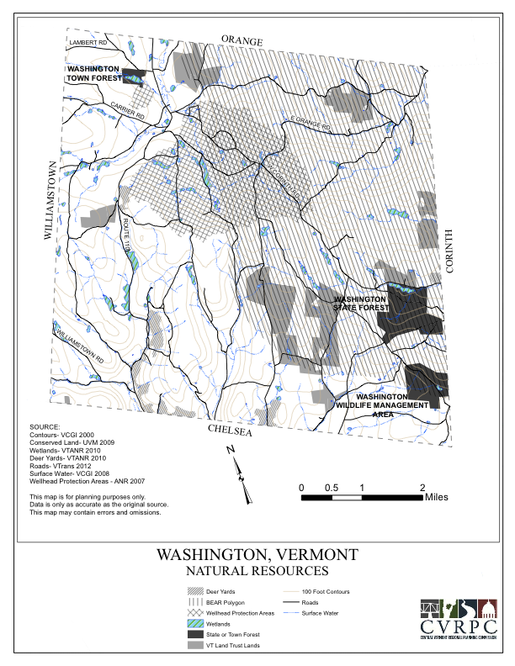

Map 2
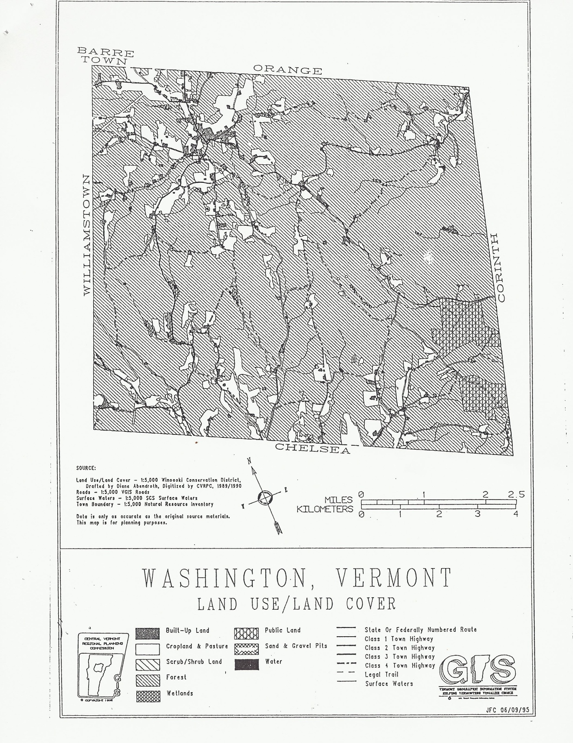

Map 3
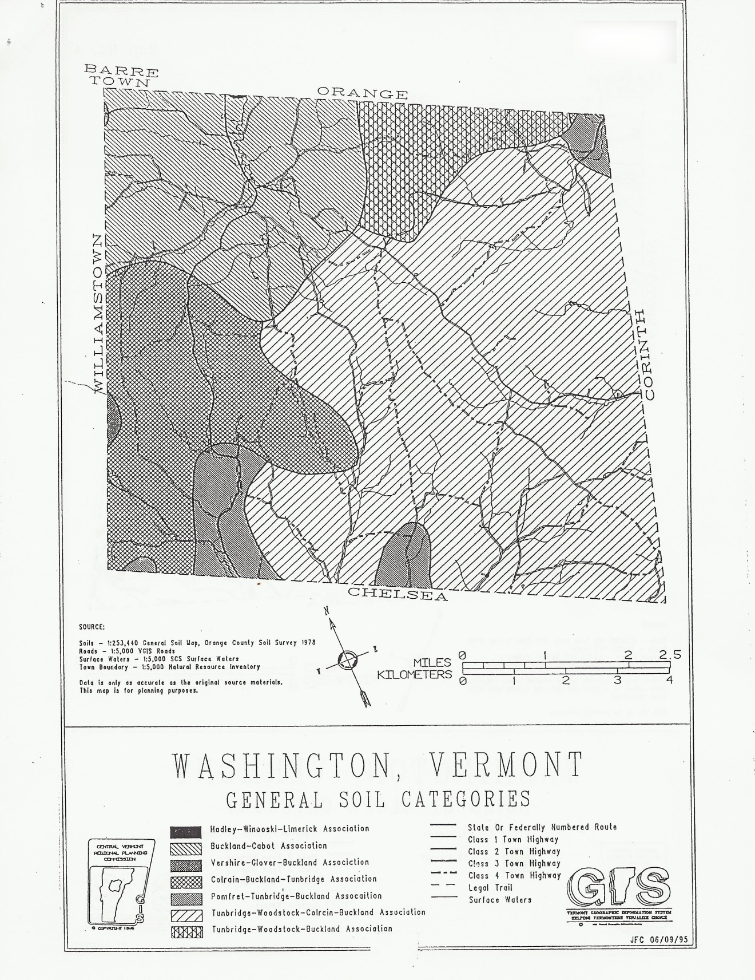
Map 4
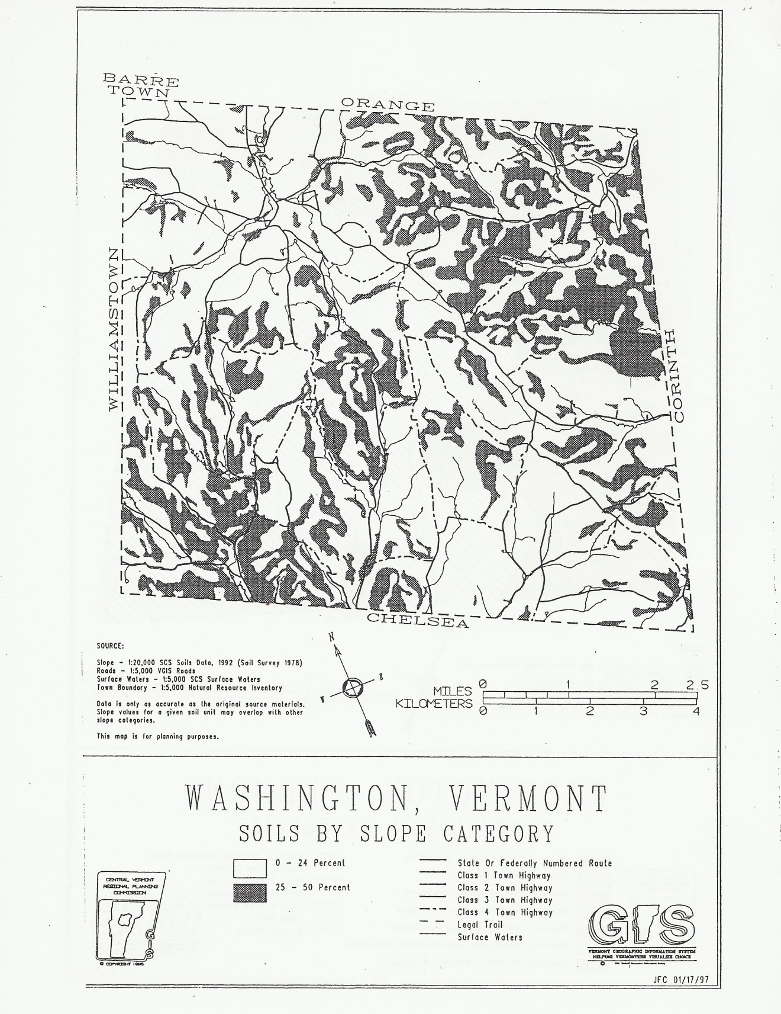
Map 5
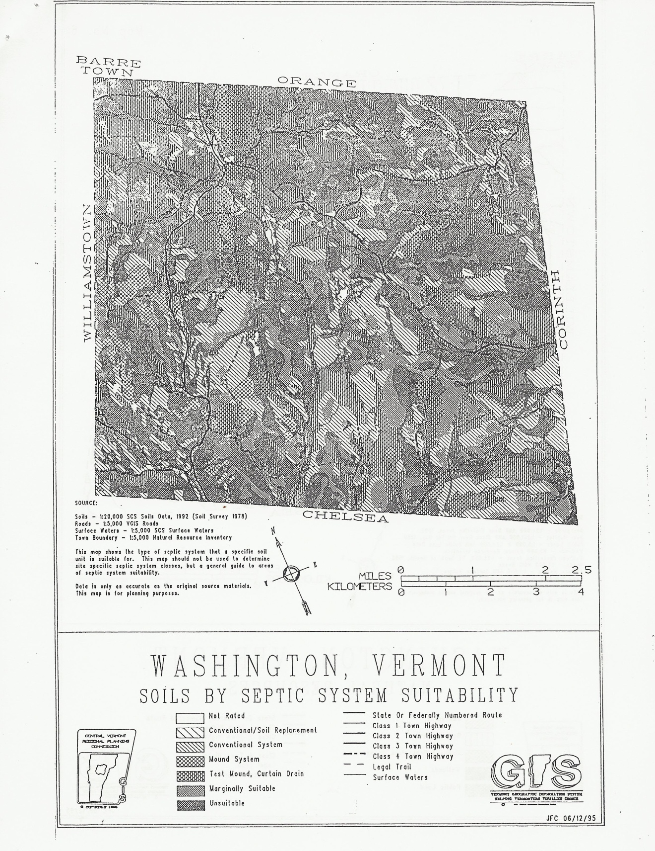

Map 6
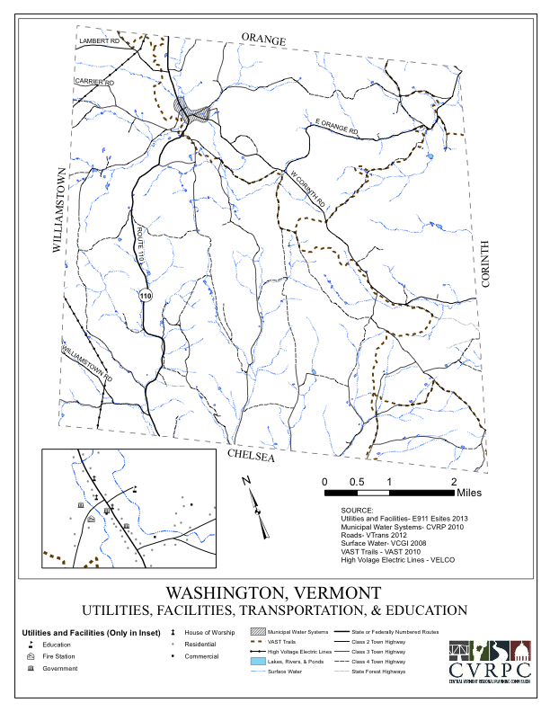

Map 7
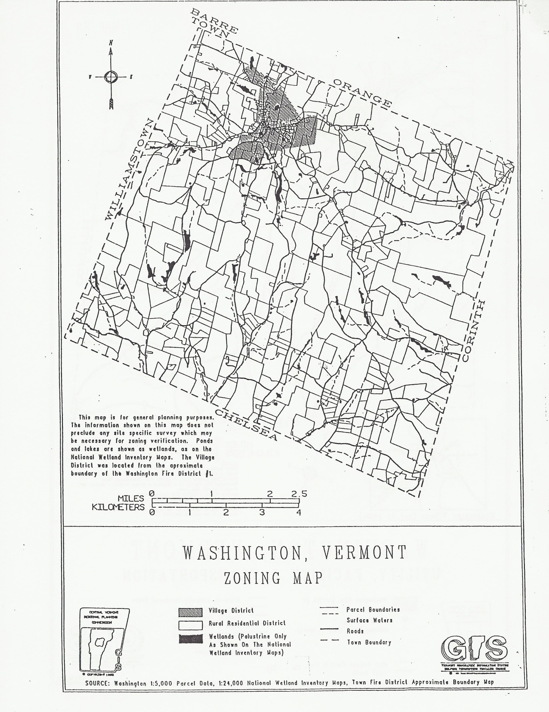
Map 8
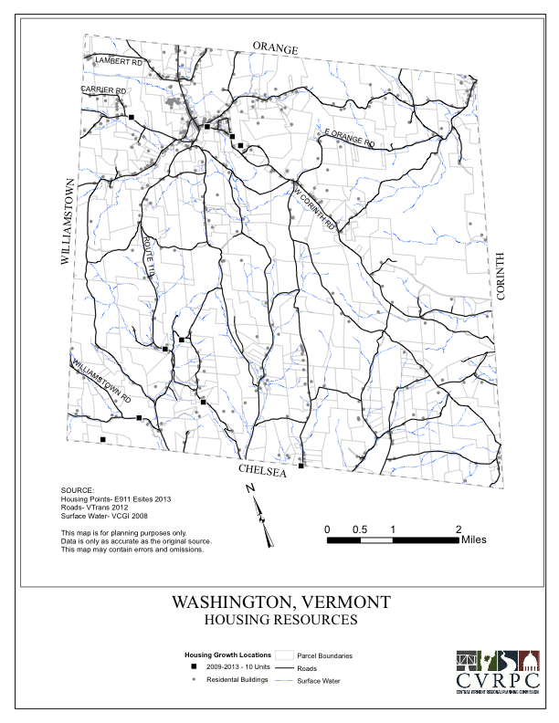
Map 9


