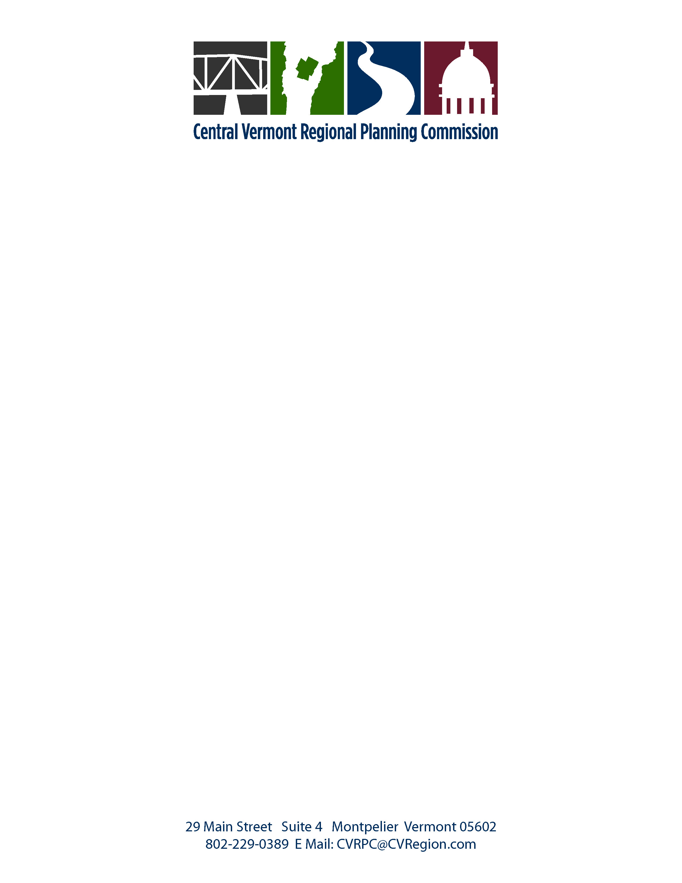

PROJECT REVIEW COMMITTEE
PROCEDURES
Adopted October 9, 1990,
Amended May 12, 1992, March 12, 1996, July 9, 1996, July 8, 1997,
June 11, 2002, June 1, 2010

1. The stated policies within the adopted Regional Plan shall serve as guidance for participation by CVRPC as a statutory party in Act 250/Section 248, or other relevant review processes. Staff shall represent the Commission at review proceedings. The CVRPC Project Review Committee will make a determination on behalf of the full Commission regarding conformance or non-conformance with the Regional Plan based on information provided. The conclusions reached will so state that they are made on available information.

2. CVRPC will actively participate in the Act 250/Section 248 hearing processes and other relevant review processes on projects of substantial regional impact for the purpose of advancing the goals and objectives of the Regional Plan.

3. If a request is made on behalf of a member municipality for CVRPC's involvement in the review of a project, both the municipal planning commission and board of selectmen shall concur with the request. If CVRPC is requested by one of the above bodies, concurrence of the other body shall be requested. Should joint concurrence not be agreed to, CVRPC staff will provide technical assistance to the requesting body, but CVRPC's involvement in any hearings will only be on regional issues.

4. The Project Review Committee will consist of a standing body of five municipal commissioners and one alternate, appointed annually for three year, staggered terms, and to include at least one member of the Executive Committee. The alternate will only vote on a project when filling in for one of the five standing members or if otherwise designated. If none of the standing members are from the municipality hosting the project under review, the host municipality's commissioner will be asked to serve on the Project Review Committee for the duration of the review of the project in his or her municipality. The Review Committee may be expanded on a case by case basis to afford other commissioners the opportunity to participate. Additional members shall be appointed by vote of the Commission or the Executive Committee. The majority of the members appointed will be the quorum. A majority vote of those present is required to decide an issue.

5. In the event that the number of projects to be reviewed at any one time outstrips the Commission's ability to staff, coordinate, and undertake project review through the review committee process described herein, the staff may be authorized by the Executive Committee to conduct an independent review of the projects and present positions on behalf of CVRPC, subject to the final approval by majority vote of the Executive Committee and interested Commissioners. All Commissioners will be notified, by mail, with specific consultation with the host town Commissioner of any project to be reviewed under this clause, and be invited to consult with the staff regarding same. When this clause is exercised, Commissioners will receive copies of the draft position prior to its submission to the Executive Committee.

6. CVRPC appeals of a hearing board’s decision on a project shall be approved by the Executive Committee or the full Commission.

7. CVRPC will offer to mediate disputes regarding a project if the effects of a project advance the purposes of the Regional Plan, or a local plan where there is no substantial regional impact, and staff resources are available.

Operating Guidelines for the Review of Projects
Adopted October 9, 1990 and amended March 12, 1996, June 12, 2007, June 1, 2010

1. Development projects of substantial regional impact are those that will have substantial and ongoing impact on two or more municipalities, including the host municipality.

Because CVRPC has defined housing as a critical need in the Region, CVRPC will participate in the Act 250 review for any project which proposes to: increase the total number of year round housing units (according to the most recent U.S. Census) in its host municipality by more than 2%; or create more than 30 housing units of any type; or create more than 5 “affordable” housing units, as defined by VSA 24 Chapter 117 Section 4303. _{(added June 12, 2007)}

2. Among the development projects of substantial regional impact are those that will likely impact on a resource within the Region which is widely used or appreciated by people outside of the locality in which it is located.

3. Development projects of substantial regional impact are those which may affect settlement patterns to the extent that the character or identity of the Region (or its sub-regions) is significantly impacted.

4. Development projects of substantial regional impact are those that are likely to alter the cost of living, availability of choices, access to traditional way of life or resources widely used or appreciated by regional residents.

5. CVRPC will take a position with respect to conformance with the Regional Plan only on projects of substantial regional impact or when requested by the planning commission and legislative body of the host municipality, the District Commission, Public Service Board, or the Environmental Court or other relevant board or panel. Where a project has no substantial regional impact, a statement will be made that conformance with the Regional Plan is not germane.

6. The Commission will focus its testimony on a project to those aspects of the project that have been determined to be of substantial regional impact.

7. The Commission will limit its determination of conformance with the Regional Plan to those aspects of the project that have been determined to be of substantial regional impact.

8. The Commission’s testimony will reflect its commitment to maximize the region’s environmental quality and the social and economic good of its citizens.

9. CVRPC’s “position” must state that the project is either “in conformance” with the Regional Plan or “not in conformance” with the Regional Plan. Position statements such as “generally in conformance” or “not in conflict” will not be given.

