Town of Moretown, VT

Local Hazard Mitigation Plan Update

Prepared by the Town of Moretown &
Central Vermont Regional Planning Commission

Date of Town Adoption:
Date of Final FEMA Approval:
Table of Contents
1. Introduction 2
2. Purpose 2
3. Community Profile 3
3.1 Public Safety 4
3.2 Municipal Plan 5
3.3 Emergency Relief & Assistance Funds (ERAF) 5
3.4 National Flood Insurance Program (NFIP) 5
4. Planning Process and Maintenance 6
4.1 Planning Process 6
4.2 Plan Update Process 8
4.3 Plan Maintenance Process 14
5. Risk Assessment 15
5.1 Hazard Identification and Analysis 15
5.2 Fluvial Erosion and Inundation Flooding 17
5.3 Wind 23
5.4 Winter Storms: Ice and Snow 32
6. Mitigation 40
6.1 Town Plan Goals and Objectives that Support Local Hazard Mitigation 40
6.2 Proposed Hazard Mitigation Programs, Projects & Activities 42
7. Attachments 45
7.1 Moretown Areas of Local Concern Map 46
7.2 Moretown Areas of Local Concern Map – Village Inset 47
7.3 5-Year Plan Maintenance and Review Process 48
7.4 Public Engagement Survey 49

In accordance with the Stafford Act, municipalities may perform mitigation planning and be eligible to receive increased federal funding for hazard mitigation measures. (42 U.S.C. 5165).

1. Introduction

The impact of anticipated, but unpredictable natural and human-caused events can be reduced through community planning. The goal of this updated plan is to provide an all-hazards local mitigation strategy that makes Moretown more disaster resistant.

Hazard mitigation is any sustained action that reduces or eliminates long-term risk to people and property from natural and human-caused hazards and their effects. Based on the results of previous project impact efforts, FEMA, State agencies, and Towns have come to recognize that it is less expensive to prevent disasters than to repeatedly repair damage after a disaster has struck. This plan recognizes that communities may identify mitigation strategies and measures during all of the other phases of emergency management – preparedness, response, and recovery. Hazards cannot be eliminated, but it is possible to determine what the hazards are, where the hazards are most severe and identify local actions that can be taken to reduce the severity of the hazard.

Hazard mitigation strategies and measures alter the impact of a hazard by eliminating or reducing the frequency of occurrence, averting the hazard by implementing a structure or land treatment, adapting to the likelihood of a hazard by modifying structures or standards, or avoiding the hazard by preventing or limiting new development in hazard areas.

2. Purpose

The 2019 Moretown Local Hazard Mitigation Plan is an update of the town’s adopted 2013 Local Hazard Mitigation Plan approved by FEMA on March 4, 2013. This Local Hazard Mitigation Plan catalogues hazards facing the region and town, and identifies strategies to reduce risks from acknowledged hazards based on current information. The town reviewed, evaluated, and revised the 2013 plan to reflect changes in development, progress in local mitigation efforts, and changes in priorities. New information has been incorporated in the updated plan resulting in a plan that is stronger and more useful to the Town of Moretown officials and residents who will implement its actions and recommendations going forward. Implementation of this plan will make Moretown more resistant to harm, resilient in the face of damage in the future, and help to reduce public costs over time.

Moretown expects to address the strategies, goals and objectives of the 2018 State Hazard Mitigation Plan, including an emphasis on proactive pre-disaster flood mitigation for public infrastructure, appropriate floodplain and river management practices, and fluvial erosion risk assessment initiatives.
The 2019 Moretown Local Hazard Mitigation Plan is an update of the 2013 adopted plan. The plan consists of the following sections which have been reorganized, and new sections added regarding:

- Current information since the last plan update completed in 2013;
- Updated the list of potential hazards reflecting the community’s priorities;
- Plan Update Process section;
- Plan Maintenance section;
- Updates to Local Areas of Concern Map to reflect current information;
- Status of 2013 mitigation strategies;
- Identification of new mitigation strategies that reflect the current priorities and intended actions of the Town over the next five years.

3. Community Profile

The Town of Moretown is a small, rural, and residential, community located in west-central Washington County. It is bounded to the east by Berlin, to the south by Waitsfield and Northfield, to the west by Duxbury, and to the north by Waterbury and Middlesex. According to the 2017 American Community Survey, Moretown has an estimated total population of 1,739 people living in 879 housing units. According to the Moretown Town Plan, Moretown has a relatively dispersed population and is a rural community comprised of approximately 797 homes, nearly 90% of which are occupied on a year round basis. The Town’s population has increased by less than 1% from the 2000 Census. The number of housing units has increased by 9.1% since 2000.

Moretown’s 40.2 square miles are situated within the Winooski River watershed and due to the defining mountains and river valleys, stream tributaries drain into both the Dog River sub basin and the Mad River sub basin. To the east of the village rises Chase Mountain to an elevation of 2,080 feet, and to the northwest Mt Cobb, elevation 1,592 feet. As stated in the Moretown Town Plan “historically, the town’s settlement patterns have been influenced by natural land forms and the distribution of natural features. Moretown is bisected by Route 100B which traverses a valley formed by the Mad River, running northeast to southwest. It is within this valley, in the southwestern region of the town, that the Village of Moretown was settled in the late 1700’s. The town garage, the town hall, the general store, the town offices, and the local elementary school are all located within the village, amongst a cluster of historic and contemporary homes. However, most of private residences are widely dispersed throughout the Town’s rural lands. Commercial development is occurring largely along Route 2.

In Moretown, electricity is primarily provided by Washington Electric with Green Mountain Power servicing clients along the northern, eastern and western town boundaries. The majority of Moretown is dependent upon groundwater for its domestic water supply and individual on-site septic systems for wastewater treatment. Broadband service is provided at high speeds to part of the Town by Champlain Valley Telecom and at lower speeds by Consolidated Communications in the remaining parts of town. Cell telephone service is lacking in multiple locations in town.

Public Safety

The Town’s principal fire coverage is provided by the Moretown Volunteer Fire Department (MVFD), which also provides support to portions of the Town of Duxbury. Moretown has also entered into agreements with the Waterbury Fire Department to assist with emergencies that are in proximity to Waterbury and trains with the Waitsfield and Warren Fire Departments. The MVFD participates in Mutual Aid with Waitsfield, Warren Waterbury ad Middlesex. According to Moretown’s 2018 Town Report, the MVFD responded to 36 calls for emergency assistance. The Waterbury Fire Department responded to five calls in Moretown in 2018 and 22 mutual aid calls. Montpelier Ambulance Service and the Mad River Valley Ambulance Service provide ambulance service to Moretown. The ambulance services responded to ___ calls for assistance within the Town of Moretown in 2018. The Washington County Sheriff’s Department and the Vermont State Police provide law enforcement for the Town of Moretown. The Moretown Elementary School has an emergency evacuation plan which is in the process of being updated.

The Town of Moretown has an approved Local Emergency Management Plan (LEMP) that is updated and adopted annually, after Town Meeting Day and before May 1st. The current LEMP was adopted on March 19, 2018 and is due for renewal by May 1, 2019. The town coordinates with the Central Vermont Regional Planning Commission who provides technical support and guidance with the LEMP plan update. The town requires the certifying officer to be trained in ICS 402 or ICS 100 at a minimum. All Selectboard members as of 2016 were trained in ICS 100. In conjunction with the LEMP, on April 10, 2012, the town adopted the use of the National Incident Management System (NIMS) as the standard for management and systematic approach involving all threats and hazards, regardless of cause, size, location, or complexity, in order to reduce loss of life, property, and harm to the environment.

Municipal Plan

The Town Plan includes descriptions, goals, policies, tasks and strategies in regards to flooding, groundwater protection, steep slope development, and transportation and emergency services. Moretown Zoning Regulations, last amended in August 2016, include a Flood Hazard Area Overlay District (last amended in March 2008), the purpose of which is to promote public health, safety and welfare by preventing or minimizing hazards to life or property due to flooding and provisions for stream, stream bank and wetland protection and to comply with the National Flood Insurance Program requirements.

Emergency Relief & Assistance Funds (ERAF)

Moretown is eligible under the Vermont Emergency Relief and Assistance Fund (ERAF) to receive state funding to match Federal Public Assistance funds after a federally declared disaster. Communities that take specific steps to reduce flood damage can increase the percentage of state funding they receive from 7.5% up to a maximum of 17.5%. At the time of this Plan development, Moretown has an ERAF rating of 7.5%. Moretown has taken the specific steps to reduce flood damage by 1) participating in the National Flood Insurance Program, 2) adopting standards that meet or exceed the current Vermont Roads and Bridge Standards 2016, 3) adopting a Local Emergency Management Plan which is renewed and adopted annually, 4) adopting a Local Hazard Mitigation Plan approved by FEMA. The town has not yet adopted Interim River Corridor protection standards (River Corridor Plan criteria) which, if it did, would bring the rate to 17.5%.

Moretown can qualify for the maximum 17.5% rate if it adopts river corridor standards that meet the Agency of Natural Resources (ANR) criteria within two years of ANR publishing a statewide river corridor map updated to include existing Phase 2 Stream Geomorphic Assessment (SGA) data. The data release, expected to occur at the end of 2016, has been delayed and the agency has not announced a new release date. The other option to qualify for the maximum ERAF rate is for Moretown to enroll in the NFIP Community Rating System (CRS) and adopt a bylaw that prohibits new structures in the Flood Hazard Area. The CVRPC is poised to assist the community in drafting a river corridor plan with the release of the Phase II data or to assist in enrolling in the CRS Program.

National Flood Insurance Program (NFIP)

Since 1982, Moretown has participated in the National Flood Insurance Program. In 2013, official Digital Flood Insurance Rate Maps (FIRMS) became available. The Moretown FIRMS were last updated effective 3/19/2013, Community panel #50023C0209E, and can be found online at tinyurl.com/floodreadyatlas and www.msc.fema.gov. Many of the panels are not printed due to large areas being in Zone X, areas of minimal flood hazard. Using 2019 data, there are 55 structures in the FEMA Special Flood Hazard Area, of which are 2 critical or public buildings. There are 85 parcels that touch the flood plain. Within the SFHA, there are 28 active NFIP policies. There are no repetitive loss properties in Moretown, and they may be eligible for participation in the Community Rating System (CRS) if they choose. The administrative resources necessary for enrollment and ongoing program maintenance are likely to be a significant challenge for Moretown and a deterrent for participation.

4. Planning Process and Maintenance

4.1 Planning Process

The Moretown Planning Commission, pursuant to a consulting contract with Central Vermont Regional Planning Commission (CVRPC), coordinated the Local Hazard Mitigation Plan process. CVRPC and Planning Commission members started updated the 2013 LHMP beginning in February 2019 during regularly scheduled monthly warned meetings and through email correspondence. The LHMP was also on the agenda at multiple Selectboard meetings. A draft of the LHMP was reviewed at the December 2017 Selectboard meetings. The March and April 2019 meetings reviewed and identified future hazard mitigation programs, projects and activities based off of an assessment of past projects and a predictive analysis of future weather events. Town residents were present at the Selectboard meetings but made no comment on the LHMP. The Moretown Planning Commission discussed the LMHP and work items at the Planning Commission meetings on February 19, March 19, April 16, May 7, and May 21. On May 20, the selectboard and planning commission heard presentations on floodplain management from Ned Swanberg, Regional Floodplain Manager at the Department of Environmental Conservation and Milly Archer, Water Quality Coordinator at the Vermont League of Cities and Towns.

UPDATE PARTICIPATION

The following town residents participated in the planning process:

Moretown Planning Commission Members

Jonathan Siegel, Chair | jsiegel@gmavt.net
Karen Horn, Vice-Chair | kebhorn@gmail.com
John Schmeltzer | metsch@comcast.net
Deborah Carroll |deborahcarroll59@gmail.com
Rube Scharges | rscharges@gmavt.net

The meetings indicated that the Town is most vulnerable to fluvial erosion and inundation flooding. Other threats include ice, wind, snow and other extreme weather events. Previously identified hazards include flooding, dam failure, transportation accidents, and hazardous materials incidents. Dam failure is not considered a significant hazard due to ongoing communications with Green Mountain Power. The Local Emergency Management Plan addresses issues with hazardous materials and transportation accidents. The Town is now focusing on flooding hazards as these events are the most common.

Additional opportunities for the public to weigh in on the planning process have been made available at Planning Commission meetings and Selectboard meetings. Each meeting is conducted pursuant to the Vermont Open Meeting Law and provides opportunity for comment from the public. The planning meetings focused on 1) assessing past mitigation projects and compiling information on its current and future hazard mitigation programs, projects and activities, 2) identifying and ranking the hazards significant to Moretown, 3) discussion of vulnerabilities, 4) plan maintenance, and 5) public engagement. No public comments were received at any of these meetings. After public comments that had been provided in survey responses were considered, the draft plan was updated and made available May 21st, 2019. It will also be made available during local meetings with State and local officials to allow for more public comment and review.

On May 21st, 2019, the draft Plan and a completed Plan Review Tool was sent to Lauren Oates, Hazard Mitigation Planner at Vermont Emergency Management (VEM) for review and comment. This started the review and approval process with VEM and FEMA.

Based on comments received on DATE from L. Oates, minor revisions were made to the draft Plan prior to submittal to FEMA and outreach to adjoining towns was broadened. On DATE the revised draft Plan was sent electronically to the additional towns of Waterbury, Duxbury, Middlesex, Berlin, Waitsfield, and Northfield for review and comment with instructions to send comments to Jonathan Siegel via email at jseigel@gmavt.org. Comments were asked to be received by DATE. Any public comments received were considered by the Planning Team. The following persons were sent the revised draft Plan:

- Lauren Oates, State Hazard Mitigation Officer at Vermont Emergency Management (VEM), lauren.oates@vermont.gov;
- Stephanie Smith, Hazard Mitigation Planner at VEM, Stephanie.a.smith@vermont.gov;
- Ben Rose, Recovery and Mitigation Section Chief at VEM, ben.rose@vermont.gov;
- Erin Magee, Planning Section Chief at VEM, eric.magee@vermont.gov;
- Emily Harris, Regional Emergency Management Program Coordinator – Northeast, Emily.harris@vermont.gov;
- Brett LaRose, Operations and Logistics Section Chief at VEM, Brett.Larose@vermont.gov
- Josh Cox, Critical Infrastructure Planner at VEM, josh.cox@vermont.gov;
- Ned Swanberg, Regional Floodplain Manager at Vermont Department of Environmental Conservation (DEC), ned.swanberg@vermont.gov;
- Gretchen Alexander, Regional Rivers Scientist at Vermont DEC, Gretchen.alexander@vermont.gov;
- Eric Blatt, Division Director at Vermont DEC Dam Safety Program, eric.blatt@vermont.gov;
- Rob Evans, River Corridor and Floodplain Manager at Vermont DEC, rob.evans@vermont.gov;
- Dan Singleton, Washington County Forester at Vermont DEC, dan.singleton@vermont.gov;
- Ben Green, Section Chief and Dam Safety Engineer at Vermont Agency of Natural Resources Dam Program, Benjamin.green@vermont.gov;
- Jonahan DeLaBruere, Emergency Management Planner at Central Vermont Regional Planning Commission, delabruere@cvregion.com;
- Brenda Spafford, Green Mountain Power, Brenda.Spafford@greenmountainpower.com;
- Dan Weston, Washington Electric Co-op; dan.weston@wec.coop;
- Jeffrey Schulz, Village of Northfield Electric Utility, jschulz@northfield.vt.us;
- Mark Podgwaite, District 6 Chair at Central Vermont Medical Center, Mark.podgwaite@waterburyambulance.org;
- W. Samuell Hill, Washington County Sheriff’s Department;
- Lieutenant David White, Vermont State Police – Middlesex Barracks, david.white@vermont.gov;
- Katina Johnson, Local Emergency Planning Committee 5 Chair, Kjohnson_398@comcast.net;
- Stefan Pratt, Moretown Fire Chief and Fire Warden, firecadet100@gmail.com;
- Martin Cameron, Road Foreman, 802-496-4141;
- Tom Martin, Selectboard Chair, mselectboard@moretownvt.net;
- David Specht, Zoning Administrator, zoning@moretownvt.net;
- Mandy Couturier, Moretown Elementary School Principal, mcouturier@wwsu.org.
The revised Plan was sent to L. Oates for further review. After VEM review, the final plan will be submitted to FEMA for review and approval. Once FEMA approves the plan they will notify VEM of “Approval Pending Adoption” status. After Approval Pending Adoption, the plan will go before the Selectboard for adoption. The Selectboard will hold a warned public hearing and after the hearing and at a regular Selectboard meeting will approve and adopt the Moretown 2019 Local Hazard Mitigation Plan and execute the Certificate of Adoption. A copy of the executed Certificate of Adoption will be attached to this Plan. The adopted Plan and signed certification was sent to VEM for submittal to FEMA on DATE. The Plan will expire 5 years from the FEMA approval effective date. During the review and adoption process CVRPC provided support and technical assistance.

Public comments submitted in the future will be reviewed by the Selectboard (and CVRPC Staff should they receive funding) and attached as an appendix.

During, and after, the update process, the town used the town website to post notices and informational pieces about the updated local hazard mitigation plan.

4.2 Plan Update Process

The 2019 LHMP update will be submitted as a single jurisdiction local mitigation plan. This Plan will guide the town into the next five years and maintain the town’s eligibility as an applicant for mitigation grants.

The current plan is not a significant departure from the 2013 plan; however, new analysis was done to best determine where the Town should put resources in the future. Town planners updated the significant weather events history, considered changes to risk based off of past events and the likelihood of future events and their impact to infrastructure and lives, and reviewed the historical and expected locations of future events to make determinations on how best to apply resources.

Analysis showed that the threats and areas of concern mostly remain the same from the 2013 plan and that continued effort needs to be applied to these threats and areas to mitigate risk. Priorities have not changed from the 2013 plan. Available resources will be applied to mitigate top priority threats. The implementation of several mitigation actions over the past five years, some not listed because the town considers them to be regular maintenance and program implementation measures, have reduced the town’s vulnerability to specific hazards. Despite the fact that solid strides have reduced the risk of identified worst threats and areas, additional work needs to be done. Moretown has benefitted from the collaborative approach to achieving mitigation on the local level, by partnering with Agency of Natural Resources (ANR), Vermont Agency of Transportation VTrans, Agency of Commerce and Community Development (ACCD), Vermont Emergency Management, Central Vermont Regional Planning Commission (CVRPC), Federal Emergency Management Administration (FEMA) Region 1 and other agencies, all working together to provide assistance and resources to pursuing mitigation projects and planning initiatives in Moretown.

General Updates
- Update of all data and statistics using available information (Section 3 and Section 5)
- Revaluation, identification and analysis of all significant hazards (Section 5)
- Acknowledgment of implemented mitigation strategies since 2013 – see matrix below (Section 4.2)
- Identification of on-going mitigation projects and strategies – see Existing Mitigation Programs, Projects and Activities section (Section 4.2)
- Identification of new mitigation strategies (Section 6)
- Hazards referred to as “non-worst threat” are now referred to as “moderate hazards.”

Hazard Analysis Updates (Sections 5 and 6)
- Added location/vulnerability/extent/impact/likelihood table for each hazard to summarize hazard description (Section 5.1-5.3 – after each hazard)
- Review of Vermont Hazard Mitigation Plan, November 2018
- Review of Federally declared disasters, weather data, ANR resources, VT Flood Ready site, and NOAA/NCDC site.
- Inundation Flooding, Fluvial Erosion, Ice, Wind, and Snow remain the most significant hazards. Although the town cannot predict with certainty that these events will be the norm in the future, the town continues to keep these in their analysis of hazards that they may be vulnerable to in the next five years.

Maps
- Areas of Local Concern Map
- Inclusion of Moretown Village inset map to show structures in the floodplain.
Final review of maps at May meeting with CVRPC

Updates to the 2019 LHMP included a review of all of Woodbury’s planning documents:
- Moretown Zoning Regulations
- Moretown Subdivision Regulations
- Moretown Town Plan, 2016
- Road/Culvert Inventory
- Local Hazard Mitigation Plan, 2013
- Local Emergency Management Plan, 2019
- 2013 Moretown Plan Review Tool FEMA approved- reference to Section 2 recommendations for next plan update and plan strengths
- Municipal Roads General Permit (Act 64)
- Moretown Annual Town Reports
- Moretown Capital Improvement Plan
- Flood Resiliency Checklist
The following chart provides an overview of Moretown’s proposed 2013 local hazard mitigation actions along with their current status.

2013 Mitigation Action | 2019 Status
Upgrade and expansion of two box culverts on Ward Brook Road | Completed.
Widening of bridge south of village on S-curves | Incomplete. VTRANS Priority by 2021. Still interested.
Blasting of lower part of gorge to open bottleneck north of village | Incomplete. Discuss with State about feasibility and investigate further. Still interested.
Phase IV of River/Jacobs Road project – raise additional section | Completed.
Upgrade and expansion of box culvert on backside of Common Road at Foster turn | Incomplete. Still in design phase.
Upgrade and expansion of box culvert at Canoe Access | Incomplete. Still in design phase.
Work with ANR and CVRPC to develop Lower Mad River Corridor Plan | Completed in 2018 by CVRPC and Bear Creek Environmental, under title Phase 2 Stream Geomorphic Assessment & River Corridor Plan.
Reinforce and stabilize low side of Common Road with rip rap | Completed.
Install generator at Moretown Elementary School | Incomplete. Since School has experienced flood damage, efforts to use as a shelter have slowed. Still interested.
Generator education and training for residents | Incomplete. See above. Still interested.
Upgrade electrical systems in municipal buildings and shelters | Complete. Fire Department was rebuilt and new municipal offices were built with upgraded electrical systems.
Work with elected officials, the state, and FEMA to correct existing NFIP compliance | Complete.

Town Capabilities for Implementing Mitigation Strategy
Services provided by the Moretown municipality are overseen by a five member volunteer Selectboard.

The Town employs a handful of staff members to carry out services to its residents on a daily basis. The following are the paid positions which are involved in hazard mitigation:

- Full-time Town Clerk (Cherilyn Brown) and Part-time Assistant Clerk (Sasha Elwell)
- Full-time Treasurer (Cherilyn Brown) and Assistant Treasurer (Sasha Elwell and John Weir)
- Full-time Town Administrator (Cheryl Brown) and Assistant Town Administrator (Catrina Brackett)
- Part-time Zoning Administrator & E911 Coordinator (David Specht)
- Volunteer Fire Department:
  - Fire Chief (Stefan Pratt), Assistant Chief (Will Houghton), Second Assistant Chief (Shawn Graves), Captain (Randy Dow), First Lieutenant (Jacob Martin), Second Lieutenant (Robert Hood IV)
- Full-time Road Foreman (Martin Cameron) and associated full-time crew.
Volunteer municipal officials also play a crucial role in carrying out hazard mitigation. The municipal budgeting process occurs on an annual basis, planning for a fiscal year from July to June. The budget is usually developed between early November and early January, and put to voter approval on the first Tuesday in March at Annual Town Meeting Day. The Selectboard is charged with developing and proposing the budget to the voters, including the budget for Highway Equipment, which in recent years has been about half of the total budget. After the budget has been adopted by vote of town residents, the Selectboard has the authority to modify it in cases of extraordinary circumstances; i.e. natural disaster, unexpected equipment/infrastructure failure (i.e., water well, power failure, major bridge/culvert failure). The budget is monitored several times a month by the Selectboard and Town Treasurer.

Municipal revenues are generated almost exclusively through levy of taxes on property value. Other major sources are federal & state payments to support the town school, aid (including grants) from the Vermont Agency of Transportation for highways, and payments in lieu of taxes for land owned by the State of Vermont. The municipality also has the authority to incur debt through bonding and receives a small amount of fee payments for permits and licenses (such as dog licenses).

Existing Mitigation, Maintenance, and Preparedness Programs, Projects & Activities

The ongoing or recently completed programs, projects and activities are listed by strategy and have occurred since the development of the previous plan and were reviewed by the planning team. They share and incorporate the overall goals of the local hazard mitigation plan. Moretown has the capacity to maintain these programs and initiatives using town staff and community volunteers described in the Community Capacities above. Unless otherwise noted, there is no need to expand or improve on these programs, projects and activities.

Some of the projects completed or awarded to protect roads and increase flood resiliency during the past year are listed below:

Community Preparedness Activities:
- Local Emergency Operations Plan (now Local Emergency Management Plan) 2014 and renewed annually
- Homebound Persons Phone Tree/E911 CARE form
Hazard Control and Protective Works:
- Culvert and Bridge Inventory – 2015
- Local Hazard Mitigation Plan – 2012
  - Subsequent updates every 5 years. Plan is reviewed annually and after every disaster event with a full review and update by the Town at least every five years. Current 2012 Plan expires 3/11/2018. Plan Update is in process. Town will need to receive VEM and FEMA approval prior to adoption of this Plan.
- VTrans Bridge and Culvert Standards – 2016
- Stormwater Master Plan for the Mad River Town of Moretown – DATE
  - Identified the top 5 sites for stormwater improvements in Moretown.
- Phase 2 Stream Geomorphic Assessment & River Corridor Plan – 2018
  - Identified 43 potential projects to mitigate impacts and conserve these rivers
- Flood Study of Mad River Area of the Mad River in Moretown – 2017
  - Completed by DuBois & King, Inc.
- Mad River Area Flood Mitigation Sites for Doctor’s Brook in Moretown – 2017
  - Completed by DuBois & King, Inc.
- Municipal Road Erosion Inventory and Capital Plan – 2016/2020
  - Developed for McGibbons Road, Williams Road, Cobb Hill Road, and Farnham Road
- Municipal Class 4 Road Erosion Remediation and Demonstration Project Report – 2018
  - Lynch Hill Road and Bathenes Road implementation of BMPs in Moretown
Insurance Programs:
- National Flood Insurance Program
Land Use Planning/Management:
- Town Plan – 2016:
  - Resiliency, Sustainability, and Adaptation Policies:
    - C-1: Support efforts to complete geomorphic assessments, assessments of all steam crossings (bridges and culverts) and river corridor (erosion hazard) delineations for all our river and major tributary systems.
    - C-2: Avoid locating new buildings, particularly residences, within flood and other known hazard areas.
    - C-3: Identify properties located in the flood hazard and fluvial erosion areas of Moretown
    - C-4: Explore participation in the FEMA Community Rating System (CRS) in order to reduce the cost of flood insurance for property owners in Moretown and to expand the town’s ability to access state and federal funding for flood mitigation and recovery.
  - Transportation Policies:
    - D-9: Advocate for the timely replacement of the state’s bridge on Route 100B south of Moretown Village, and for the new bridge to be designed and constructed to minimize flooding hazards, to serve as an attractive gateway to our community, to slow and calm traffic entering the village, and to safely accommodate all roadway users.
  - Administration and Governance:
    - F-4: Continue to participate in the National Flood Insurance Program.

- Zoning Ordinance:
  - Table 2.4 Preserve District
    - The Purpose of the Preserve District is to protect significant forest resources and water supply watersheds at higher elevations and to limit development in areas with steep slope, shallow soils, unique or fragile resources, and poor access to Town roads and community facilities and services.
  - Table 2.5 Flood Hazard Overlay District
    - The Purpose of the Flood Hazard Overlay District is to promote public health, safety and welfare by preventing or minimizing hazards to life or property due to flooding.
  - Section 4.11 Protection of Streams, Stream banks and Wetlands
    - To prevent soil erosion, protect wildlife habitat and maintain water quality, land development hall be setback a minimum of twenty five feet from all streams and rivers to create a buffer strip
    - A naturally vegetated buffer strip shall be maintained, of at least fifty feet in uniform width, for Class Two wetlands, and one hundred feet in uniform, for Class One wetlands.
  - Section 4.13 Storage of Flammable Commodities
    - The storage of any highly flammable liquid or gas in tanks above ground, excluding tanks for residential purposes, with unit capacity greater than two thousand (2,000) gallons shall be prohibited, unless such tanks up to and including ten thousand (10,000) gallon capacity are placed not less than eighty (80) feet from all property lines, and unless all such tanks of more than ten thousand (10,000) gallon capacity are placed not less than two hundred (200) feet from all property lines.
    - All tanks (containing flammable liquids) having a capacity greater than two thousand (2,000) gallons shall be properly retained with dikes having a capacity not less than one and one-half (1.5) times the capacity of the tanks surrounded.
Protection/Retrofit of Infrastructure and Critical Facilities:
- 2014 Rebuild of Town Offices using Community Development Block Grant, insurance, and Hazard Mitigation Grant monies.
- 2012 Remodel of Town Hall after flood damage
- 2011 Renovation and Repair of Fire Station after Irene, 2011.
Public Awareness, Training, and Education:
- Fire safety educational programs
- Motor vehicle accident response training
- First responder CPR & hazmat trainings

4.3 Plan Maintenance Process

The Moretown Local Hazard Mitigation Plan will be updated and evaluated annually at an April Planning Commission or Select Board Meeting. A review of the Local Emergency Management Plan will also occur at this meeting. Updates and evaluation by the Planning Commission Chair will also occur within three months after every federal disaster declaration and as updates to town plan/zoning and river corridor plans come into effect. The plan will be reviewed by the Selectboard, Planning Commission and public at the abovementioned February Selectboard meeting. CVRPC will help with updates or if no funding is available, the Planning Commission will update the plan.

The process of evaluating and updating the plan will include continued public participation through public notices posted on the municipal website, notice in the municipal building, newspapers of record, Front Porch Forum, Public Notice Bulletin Boards in Moretown, and CVRPC newsletter inviting the public to the scheduled Selectboard (or specially scheduled) meeting. Additional stakeholders invited to the meeting will be representatives of the school, library, Irene affected residents, and Friends of the Mad River. Also invited in the future will be the VT Agency of Natural Resources (VT ANR), as they are able to provide assistance with NFIP outreach activities, models for stricter floodplain zoning regulations, delineation of fluvial erosion hazard areas, and other applicable initiatives. These efforts will be coordinated by the Planning Commission Chair.

Monitoring of plan progress, implementation, and the 5 year update process will be undertaken by the Planning Commission Chair. Monitoring updates may include changes in community mitigation strategies; new town bylaws, zoning and planning strategies; progress of implementation of initiatives and projects; effectiveness of implemented projects or initiatives; and evaluation of challenges and opportunities. If new actions are identified in the five year interim period, the plan can be amended without formal re-adoption during regularly scheduled Selectboard meetings. After a five year period, the plan will be submitted for re-adoption following the process outlined in the schematic found in the Attachments section.

Moretown will also consider incorporation of mitigation planning into their long term land use and development planning documents. It is recommended the Town review and incorporate elements of the Local Hazard Mitigation Plan when updating the municipal plan, zoning regulations, and flood hazard/FEH bylaws. The incorporation of the Local Hazard Mitigation Plan into the municipal plan, zoning regulations and flood hazard/FEH bylaws will also be considered after declared or local disasters. The Town shall also consider reviewing current and future Mad River Corridor planning documents and studies for ideas on future mitigation projects and hazard areas.

5. Risk Assessment

5.1 Hazard Identification and Analysis

The following natural disasters were discussed and the worst threat hazards were identified based upon the likelihood of the event and the community’s vulnerability to the event. Hazards not identified as a “worst threat” may still occur. Refer to section 4.2 for a description of the hazard mitigation rubric. Greater explanations and mitigation strategies of moderate hazards can be found in the State of Vermont’s Hazard Mitigation Plan.

Hazard Impact | Probability | Potential Impact |  |  |  |  | Score
 |  | Infrastructure | Life | Economy | Environment | Average
Fluvial Erosion | 4 | 4 | 3 | 4 | 4 | 3.75 | 15*
Inundation Flooding | 4 | 4 | 3 | 4 | 2 | 3.25 | 13*
Ice | 4 | 3 | 3 | 3 | 2 | 2.75 | 11*
Wind | 4 | 3 | 2 | 2 | 2 | 2.25 | 9*
Snow | 4 | 1 | 3 | 2 | 1 | 1.75 | 7*
Cold | 3 | 2 | 3 | 2 | 2 | 2.25 | 6.75
Invasive Species | 3 | 1 | 1 | 3 | 3 | 2 | 6
Heat | 3 | 1 | 3 | 2 | 2 | 2 | 6
Drought | 3 | 1 | 2 | 2 | 3 | 2 | 6
Landslides | 3 | 3 | 2 | 1 | 2 | 2 | 6
Wildfire | 2 | 3 | 3 | 3 | 2 | 2.75 | 5.5
Earthquake | 2 | 3 | 3 | 3 | 2 | 2.75 | 5.5
Infectious Disease Outbreak | 2 | 1 | 3 | 2 | 1 | 1.75 | 3.5
Hail | 3 | 1 | 1 | 1 | 1 | 1 | 3

Flood/Flash Flood/Fluvial Erosion, based on history, has a High Likelihood of happening. At least one flood event each year over the past five years has occurred in Moretown. Therefore the likelihood of Flood/Flash Flood/Fluvial Erosion has been elevated to the highest scores.

Those hazards not found to pose the greatest threat to Moretown such as cold, invasive species, heat, drought, landslides, wildfire, earthquake, infectious disease outbreak, and hail are not addressed in this Plan and were not included in the risk and vulnerability assessment due to the low occurrence, low probability of impact or negligible potential impact and scarce community resources (time and money). The Planning Commission discussed the exclusion of these at their March 2019 meeting, and chose to analyze the top five threats in this section of the plan. A review of the Vermont State Hazard Mitigation Plan of November 2018 provides a greater explanation of these hazards and possible mitigation strategies to address them. Like the State of Vermont Hazard Mitigation Plan, Moretown did not include the following hazards in the risk and vulnerability assessment due to the low occurrence, low vulnerability, and or geographic proximity: civil disturbance, coastal erosion, expansive soils, karst topography, sinkholes, tsunami, and volcano.

The following hazards were found to be most significant in the Town of Moretown:
- Fluvial Erosion
- Flash Flood/Flood
- Ice
- Wind
- Snow

Due to the frequent and severe nature of flooding events, Moretown identified flooding and fluvial erosion as the worst natural hazard within the Town and will focus on mitigation efforts to reduce the impacts from flooding events.

A discussion of each significant hazard is included in the proceeding subsections and a map identifying the location of each hazard is attached (See map titled Areas of Local Concern.) Each subsection includes a list of past occurrences based upon County-wide FEMA Disaster Declarations (DR-#) plus information from local records and the National Oceanic and Atmospheric Administration (NOAA), National Center for Environmental Information (NCEI), formally the National Climate Data Center, a narrative description of the hazard and a hazard matrix containing the following overview information:

Hazard | Location | Vulnerability | Extent | Impact | Probability
Type of  hazard | General areas within municipality which  are vulnerable to the  Identified hazard. | Types of  structures  impacted | Magnitude of hazard:  Scale dependent on hazard | Dollar value or  percentage of damages | Likelihood of hazard occurring based upon past events:  HIGH = Near 100% probability in the next year. MEDIUM = 10% to 100% probability within the next year or at least once in the next 10 years.  LOW = 1% to 10% probability in the next year or at least once in the next 100 years

5.2 Fluvial Erosion and Inundation Flooding

History of Occurrences: (Mad River Valley encompasses the towns of Waitsfield, Warren, Moretown and Fayston. The Mad River flood gauge is located in Moretown. Information from NCDC website)

Date | Event | Location | Extent
7/17/2017 | Flash Flood | Washington County | Scattered thunderstorms developed with a few containing large hail (> .75 inch in diameter) and some winds. Heavy rain additionally produced some isolated Flash Flooding.
6/30/2017 | Flood | Washington County | Rainfall amounts of 2-3” in just a few hours on saturated soils from previous June rainfall caused flash flooding.
8/17/2016 | Flash Flood | Moretown, Washington County | Rainfall totals of 3-5” in a few hours caused flash flooding in central Washington County.
2/25/2016 | Flood | Washington County | Warm temperatures and rain melted 1-3” of water out of the snowpack, which produced ice jams and open water flooding.
7/19/2015 | Flash Flood | Washington County | Thunderstorms with heavy rainfall moved over northeast Washington County Vermont repeatedly for several hours.
4/15/2014 | Flood | Washington County | Snowmelt from a late season snowpack combined with heavy rain produced widespread flooding across northern and central Vermont.
7/3/2013 | Flash Flood | Washington County | Record rainfall in May and June saturated the ground and elevated water levels in rivers and streams, making the region vulnerable to flooding.
8/28/2011 | Flash Flood (TS Irene) | Moretown,  Washington County | Mad River flood gauge at 19.07 feet; 10.07 feet above flood stage (flood stage is 9 feet) DR 4022
5/20/2011 | Flash Flood | Washington County, Moretown | 4” of rain, not a historical crest - DR 1995
3/6/2011 | Flood; ice jams | Moretown; Washington County | 1-2” of rain followed by ~15” of snow
10/1/2010 | Flood | Moretown, Washington County | 4-5” of rain, Mad river gauge at  10.39 ft
8/2/2008 | Flash Flood | Washington County (Mad River Valley) | Mad River gauge at 7.89 feet – DR 1790
3/15/2007 | Flood; ice jams | Mad River Valley | Mad River Gauge at 13.5 ft
12/24/2003 | Flood | Mad River Valley | Mad River flood gauge at 14.17 feet DR 1448
12/17/2000 | Flood | Mad River Valley | 3” of rain; no data for Mad River
6/27/1998 | Flash Flood | Mad River Valley | 3-6” of rain over 2 day period – Mad River flood gauge at 14.13 feet, 2-3 ft of water on Rte 100b through Moretown Village - DR1228
8/6/1995 | Flood | Mad River Valley | Mad River flood gauge at 8.12 feet DR 1063
3/31/1987 | Flood | Mad River Valley | Mad River flood gauge at 11.97 feet
3/13/1977 | Flood; ice jams | Mad River Valley | Mad River flood gauge at 13.72 feet
8/5/1976 | Flood | Washington County | Mad River flood gauge at 13.47 feet DR 518
9/22/1938 | Flood | Washington County | Mad River flood gauge at 16.34 feet
9/22/1938 | Flood | Washington County | Mad River flood gauge at 16.34 feet
11/03/1927 | Flood | Washington County | Mad River flood gauge at 19.40 feet

Fluvial Erosion and Inundation Flooding are Moretown’s most commonly recurring and most impactful hazards. Flooding is the overflowing of rivers, streams, drains and lakes due to excessive rain, rapid snow melt or ice. Flash flooding is a rapidly occurring flood event usually from excessive rain. Fluvial erosion is the process of natural stream channel adjustments. Fluvial erosion causes erosion of sediment in some areas, while causing aggradation of sediment in other. Fluvial erosion processes occur more quickly and severely during flood events. Fluvial erosion data has been provided to Moretown by the Phase 2 Stream Geomorphic Assessment & River Corridor Plan conducted by Bear Creek Environmental, LLC. This report spanned 11 miles of stream channel and identified stream channel straightening as well as encroachment from development as the biggest stressors of these streams.

The worst anticipated flooding is unknown in the low lying areas in Town of Moretown. The worst flooding event in Moretown’s recorded history occurred in 1927, followed closely by T.S. Irene in 2011. The Mad River flood gauge readings during these events were 19.4 and 19.07, respectively. Detailed historical records relating to the extent of the 1927 flood in Moretown are not available, but were believed to be 2-3 feet higher than Irene; during T.S. Irene up to 7 feet of flooding occurred in Moretown Village. Lesser but more regular flooding occurs in Moretown, with generally 1 foot of flooding in low lying areas every two or three years. In the future, Moretown can better gather data for flooding extent by having individuals call in flood levels in areas around the Town. According to the Moretown River gauge, at the following water levels, the impact to the surrounding areas will be:

Water level (feet) | Impact
13.5 | ABOUT 4 FEET OF WATER WILL COVER ROUTE 100 SOUTH OF MORETOWN...NEARLY REACHING A TRAILER PARK.
12 | AT 12 FEET...ROUTE 100 WILL BE COVERED WITH WATER IN MORETOWN...ROUTE 100B WILL BE PARTIALLY COVERED. WATER WILL INUNDATE TELEPHONE FLATS NEAR WAITSFIELD.
9 | AT 9 FEET...THE MAD RIVER BEGINS TO LEAVE ITS BANKS. FIELD FLOODING OCCURS BETWEEN WAITSFIELD AND MORETOWN...AND SOME LOCAL ROADS WILL FLOOD.

With approximately 7.5 miles of the main stem flowing through the Moretown, the Mad River is the most prominent body of water within the town boundaries. The Mad River originates in Granville Gulf and flows in a northerly direction through Moretown Village and along Vermont Route 100B. The town’s northern boundary is formed by over 7 miles of frontage on the Winooski River. Several streams originating in Moretown’s upland areas converge with the Mad and Winooski River.

The majority of Moretown’s development is located in the Mad River valley. Based on the results of overlaying the FIRM flood maps with the location of E911 points, there are 55 properties that are located within the Special Flood Hazard Area (SFHA). The estimated loss for a severe flooding event for all properties located within the town’s 100-year floodplain is approximately $64,779,500. There are no repetitive loss properties in Moretown. Moretown’s FIRM was effective starting 3/1/1984. The Areas of Local Concern Map (attached) identifies the Moretown Town Offices, the Catholic Church, and Moretown Fire Department, all within the designated flood plain. The Town participates in the NFIP program and has a total of 28 active policies with a total coverage amount of $6,813,800. The Zoning Administrator is responsible for enforcing the flood hazard regulations.

As previous events have made clear, however, even areas beyond the NFIP designated 100-year floodplain may be vulnerable to flood related hazards. The Town has 55 properties in the fluvial erosion hazard zone, totaling $3,766,250. Information gathered from the Moretown Planning Commission indicated the following stretches of road have experienced flood-induced washouts. They are:

1) A small stretch of road on River Road by (phase IV of River Road project);
2) Low lying area of Lovers Lane;
3) Section of Route 100B north of Murphy Road; and
4) Section of Route 100B south of Moretown Bridge B2

During the spring thaw Moretown roads are also susceptible to flooding due to ice jams. Natural geological features and flood-plain encroachments restrict ice to move freely downstream and cause water to back up on to the following stretches of road:

1) Section of Route 100B south of the Ward swimming hole;
2) Section of Route 100B at the northern intersection of Old Route 100B Road;
3) Section of Route 100 B between Bridge Road and Stevens Brook Road.

Natural geologic features, flood-plain encroachments, seasonal flash flooding and undersized culverts flooding in Moretown undermines the stability of low lying roads and isolates rural residents from emergency services. (See Areas of Local Concern Map)

Moretown experienced heavy flooding in August 2008 event (DR 1790). During that event several roads and associated culverts were severely damaged due to flash flooding of smaller brooks. These areas include:
- Moretown Mountain Road (20 foot gorges along length of road, box culvert damaged and replaced)
- Dickerson Road (Segment of road closed due to bank collapse)
- Ward Brook Rd (Culvert washed out and subsequent road closure)
The records for all events were lost in Tropical Storm Irene. It is believed the Town incurred over $200,000 of damages during the August 2008 event. During the May 2011 event, Moretown experienced minimal damages on Herring Brook Road. The road was undermined and several culverts were washed out. The damages cost $35,000. During Tropical Storm Irene, Moretown experienced flooding of up to 8 feet within the Village from the Mad River. Route 2 along the Winooski River was also severely flooded with floodwaters up to 20 feet in some areas. Flood waters were above normal predicated levels due to debris blocking bridges and culverts.

The following roads and buildings were damaged during Tropical Storm Irene:

- Moretown Fire Station (8 ft of water)
- Moretown Town Hall (5 ft of water on ground level)
- Ward Brook Rd
- Route 2
- Bridge Rd – lost entire bridge – est. $1 million to replace
- Moretown Mountain Rd
- Moretown Common Rd
- Route 100b (3 bridges)
- Williams Rd
- Tarts Rd
- Lovers Lane
- Butternut Hill Rd
- Dickerson Rd
- Gove Rd
- Jones Brook Rd
- Doctor’s Brook Rd
- Herring Brook Rd
- Howes Rd
- McGibbons Rd
- Hathaway Rd
- Salaki Rd

It is estimated that Moretown incurred $1.8 million in public infrastructure damage. Private property damages been calculated at around $65 million; 52 homes were flooded.

Hazard | Location | Vulnerability | Extent | Impact | Probability
Fluvial Erosion | Floodplain and see attached areas of concern. | Culverts, bridges, road infrastructure, private property | TS Irene - ~6” of rain, Mad River flood gauge at  19.07 feet; 9 ft is flood stage | Over $1.8 million from TS Irene; ~$65 million in floodplain properties | High
Inundation Flooding | Floodplain and see attached areas of concern. | Culverts, bridges, road infrastructure, private property | TS Irene - ~6” of rain, Mad River flood gauge at  19.07 feet; 9 ft is flood stage | Over $1.8 million from TS Irene; ~$65 million in floodplain properties | High

Vermont’s Act 64 is our legislature’s response to the effects of flooding and runoff from roads connected to its major streams, rivers, ponds and lakes. Full implementation began in 2018. It provides guidelines and goals to communities throughout Vermont for improving the resilience of roads during severe weather thereby enabling them to be more effective in diverting pollutants and sediment from entering these water resources. It provides grant opportunities to aid municipalities in funding the remediation of erosion or flood-prone areas. Many towns are already engaged in implementing the Act’s directives. 2038 is the target year for the successful completion of road improvements required for all municipalities via an incremental yearly approach. Moretown is actively working with the Agency of Transportation, Agency of Natural Resources and the Central Vermont Regional Planning Commission to meet the new regulations and requirements, including the Municipal General Roads Permit. Moretown participates in the region’s Transportation Advisory Committee (TAC) as well.

Damage to roads and the cost of their rehabilitation is a continuing challenge for communities around the state. Although no storms approaching Tropical Storm Irene’s magnitude have occurred since 2011, heavy rainfall at rapid rates of accumulation continues to effect road infrastructure. Events are often localized but cumulatively have sometimes triggered federal and state disaster status allowing grant money to be accessed by affected communities. Over the last eight years, since Tropical Storm Irene, Moretown has experienced at least one flood event a year.

Moretown has lessened the impacts and the town’s vulnerability to the hazard of flooding/flash flooding/fluvial erosion with mitigation activities and repairs done to its infrastructure over the past five years (and as previously noted in the 2013 Plan). The Town Capital Reserve Fund, Town Highway Fund budget, AOT grants, Federal and State assistance fund, and the recent completed Culvert Inventory and Highway Survey are tools and resources that help the town prioritize and implement their strategies.

As noted in the Moretown Town Plan, and further emphasized by work of the Ridge to River task force, storm water management is a priority for the community and over the past five years emphasis had been placed on various storm water mitigation projects, studies and activities.

It is important to note that Vermont has experienced a majority of their flooding in areas along upland streams and in road drainage systems that do not adequately convey the amount of water they are receiving. Flooding in these areas should be expected and planned for. The National Weather Service has seen a trend in recent years of more intense, locally severe storms with high intensity rain and flooding associated with them.

The topography and extent of several streams and tributaries make Moretown susceptible to the danger of flash flooding. As noted in the Vermont State Hazard Mitigation Plan, these areas are not shown on the FEMA FIRMs. The Vermont Department of Environmental Conservation River Program is working to provide statewide coverage of River Corridors. The river corridor is in the process of being delineated for the larger streams and rivers and setbacks have been established for the smaller upland streams. This data is due to be released within the next year and will be a valuable tool for Moretown in their efforts to help mitigate the risk of flash flooding. Once the statewide river corridor digital map layer is finalized it will facilitate mitigation and river corridor protection planning and prioritization. If funding is available and the political will exists, CVRPC can assist Moretown in the development of river corridor regulations that incorporate the Vermont mapped River Corridors once these maps are released.

5.3 Wind

History of Occurrence (from the National Oceanic and Atmospheric Administration (NOAA), National Center for Environmental Information (NCEI), formally the National Climate Data Center (NCDC) website and FEMA DR List):
Date | Event | Location | Extent
10/16/2018 | Strong Wind | Washington County | 40 to 50 mph caused scattered to numerous tree damage. This resulted in power outages in east-central and southeast Vermont...up to 10,000 outages.
10/30/2017 | High Wind | Washington County | 40-50 mph winds (58 mph measured at Montpelier-Barre Airport in Berlin). >100,000 customers without power.
1/10/2017 | Strong Wind | Washington County | 40-45mph gusts with isolated 50mph gusts. Thousands of Isolated/scattered power outages.
07/23/2016 | Thunderstorm Wind | Moretown, Washington County | Numerous thunderstorms led to more than 20,000 utility outages.
02/29/2016 | Strong Wind | Washington County | Estimated gusts of 35-45 mph with isolated report of 59 mph. Nearly 20,000 outages with scattered tree limbs.
10/07/2013 | Strong Wind | Washington County | Scattered gusts of 50+ mph, resulting in 25,000+ outages at peak.
01/20/2013 | Strong Wind | Washington County | Strong winds in excess of 50 mph causing estimated 10,000 outages.
10/29/2012 | Strong Wind | Washington County | Hurricane Sandy sent winds in excess of 35-45 mph, some areas with 50-60 mph. Left 35,000 without power.
09/08/2012 | Thunderstorm Wind | Moretown, Washington County | 20-30 mph winds with gusts in excess of 40 mph. Minor wind damage to tree branches and small trees.
01/18/2012 | Strong Wind | Washington County | 40-50 mph gusts in valleys, 60 mph gusts at high elevations. Scattered tree limbs, 2500 outages.
08/28/2011 | Strong Wind | Washington County | Tropical Storm Irene: 50 mph wind gusts, with peak 85 mph measured on Mt. Mansfield. 100,000 power outages. DR-4022
05/26/2011 | Thunderstorm Wind | Moretown, Washington County | Damaging winds/hail resulting in 25,000+ customers without power.
04/16/2011 | Strong Wind | Washington County | Wind gusts in excess of 60 mph, resulting in nearly 10,000 power outages.
02/18/2011 | Strong Wind | Washington County | 20-30 mph sustained wind with 40-50 mph gusts. 10,000 customers without power.
02/26/2010 | High Wind | Washington County | 45-60+ mph wind gusts, power outages ranged 20,000 – 40,000.
11/28/2009 | Strong Wind | Washington County | Wind gusts in excess of 40 mph, power outages around 8,000.
05/31/2009 | Strong Wind | Washington County | 40-55mph gusts , scattered power outages
05/14/2009 | Strong Wind | Washington County | 25-35 mph winds with gusts over 50 mph. Scattered down trees and outages.
12/24/2008 | Strong Wind | Washington County | 20-30 mph winds with gusts up to 40 mph. Scattered down tree limbs and outages.
04/01/2008 | Strong Wind | Washington County | 25-35 mph winds with gusts up to 50 mph. Scattered down tree limbs and outages.
01/09/2008 | Strong Wind | Washington County | Winds in excess of 60 mph with scattered down trees and outages.
07/27/2007 | Thunderstorm Wind | Moretown, Washington County | Damaging winds reported in Moretown during thunderstorms.
04/16/2007 | Strong Wind | Washington County | Nor’easter resulting in scattered power outages.
06/27/2006 | Strong Wind | Washington County | 20-30 mph winds with gusts approaching 45 mph. Scattered tree blow-downs.
02/17/2006 | High Wind | Washington County | Sustained winds 35-45 mph, with gusts in excess of 60 mph. trees and power lines down.
10/16/2005 | High Wind | Washington County | Downed Trees and Power Outages.
09/29/2005 | High Wind | Washington County | Sustained 35-45 mph with high gusts. Trees and power lines down.
09/17/2005 | Strong Wind | Washington County | Gusty winds in normal central VT, some trees uprooted.
11/28/2004 | Strong Wind | Washington County | 25-45 mph gusts, up to 47 in Waitsfield.
06/26/2004 | Strong Wind | Washington County | Gusts estimated at 40-50 mph. Tree blown onto car.
11/13/2003 | High Wind | Washington County | Trees and power lines blown down.
10/15/2003 | High Wind | Washington County | Numerous power outages with downed trees.
02/04/2003 | Strong Wind | Washington County | Gusts between 35-50 mph.
03/10/2002 | High Wind | Washington County | Trees blown down and power outages reported.
02/10/2001 | High Wind | Washington County | Trees and power lines blown down. Power outages.
12/12/2000 | High Wind | Washington County | Winds up to 50 mph and trees blown down.
03/28/2000 | High Wind | Washington County | Downed trees and scattered power outages.
09/17/1999 | High Wind | Washington County | Tropical Storm Floyd: Strong gusts up to 31 mph, 3,000 people without power. (DR-1307)
11/23/1998 | High Wind | Washington County | Trees and power lines blown down.
02/22/1997 | High Wind | Washington County | Damage to trees and wires down.
07/19/1996 | High Wind | Washington County | Not Available
08/13/1990 | Thunderstorm Winds | Washington County | Not Available
07/05/1990 | Thunderstorm Winds | Washington County | Not Available
07/04/1990 | Thunderstorm Winds | Washington County | Not Available
08/06/1989 | Thunderstorm Winds | Washington County | Not Available
07/10/1989 | Thunderstorm Winds | Washington County | Not Available
08/28/1988 | Thunderstorm Winds | Washington County | Not Available
07/09/1988 | Thunderstorm Winds | Washington County | Not Available
07/20/1987 | Thunderstorm Winds | Washington County | Not Available
07/18/1987 | Thunderstorm Winds | Washington County | Not Available
05/31/1987 | Thunderstorm Winds | Washington County | Not Available
06/16/1986 | Thunderstorm Winds | Washington County | Not Available
06/01/1986 | Thunderstorm Winds | Washington County | Not Available
05/20/1986 | Thunderstorm Winds | Washington County | Not Available
05/19/1986 | Thunderstorm Winds | Washington County | Not Available
05/19/1982 | Thunderstorm Winds | Washington County | Not Available
07/09/1981 | Thunderstorm Winds | Washington County | Not Available
07/13/1977 | Thunderstorm Winds | Washington County | Not Available
06/11/1976 | Thunderstorm Winds | Washington County | Not Available
07/05/1974 | Thunderstorm Winds | Washington County | Not Available
09/07/1969 | Thunderstorm Winds | Washington County | Not Available
08/25/1968 | Thunderstorm Winds | Washington County | Not Available
07/22/1964 | Thunderstorm Winds | Washington County | Not Available

Hazard | Location | Vulnerability | Extent | Impact | Probability
Wind | Town Wide | Trees, telephone poles, houses, town infrastructure. | Beaufort #10, Range between 55-63 mph begins considerable structural damage (11 of the above events). | T.S. Irene $11,616,423 total public cost. T.S. Floyd received $1,010,625.61 in Public Assistance. | High

Wind is often not isolated but may be part of a larger hazard. Hurricanes and tropical storms are violent rain storms with strong winds that have large amounts of rainfall and can reach speeds up to 200 mph. Hurricane season is between the months of June and November. A severe thunderstorm is a thunderstorm that contains any one or more of the following three weather conditions:
- hail that is 3/4 of an inch or greater in diameter,
- winds 58 miles per hour or greater (equivalent of 50 knots or greater),
- and/or tornadoes.
Severe storm events can occur in late spring and early summer as temperatures increase in the summer season. The frequency and intensity of hurricanes, tropical storms, and severe storms is expected to increase with climate change. While not detailed here, the Town recognizes the importance of mitigating against the other effects of such storms.
On August 28, 2011, Tropical Storm Irene hit Vermont and proceeded to deposit 4-5” of rain over Moretown. See the flooding section for damage from Irene and other flooding and severe storm events. The Town adopted new road and culvert standards and is now focusing on upsizing all culverts and having hydraulic studies performed on culverts that are repeatedly flooded. Wind during Irene was not a major problem; however, high winds can knock down trees and power lines causing power loss.
The past five years of severe storm data associated with flooding and the damage locations from April, Tropical Storm Irene, and the May 28, 2011 storm events are outlined in the Flood/Flash Flood/Fluvial Erosion hazard section of this Plan. There were no high wind impacts associated with these events. Over the past five years, Thunderstorm winds associated with severe storms have become more prevalent. The statewide storm in July left 51,300 customers without power for an extended period of time (days). Specific data for Moretown is not available but during these storms local knowledge showed the town experienced downed trees and limbs, debris, scattered power outages, and temporary travel delays while roads were cleared of trees and limbs.

Similar to flooding, the extent of severe storms and wind is not well documented in the Town of Moretown. The impact of storms is usually flood related. See flood extent description in flood section above. Wind data from storms is not well documented as there is no monitoring station in Moretown. Estimates for wind are gathered from Washington county wide data off the National Oceanic and Atmospheric Administration (NOAA), National Center for Environmental Information (NCEI), formally the NCDC website. To date, the worst wind extent in Moretown was hurricane force winds from Hurricane Belle in 1976. The scales used by spotters to measure the extent of the severe storm events are:

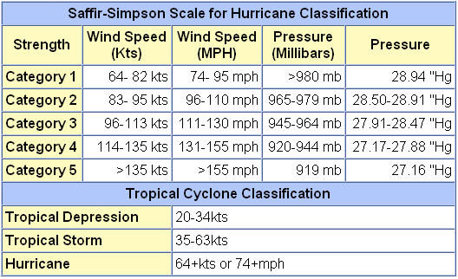
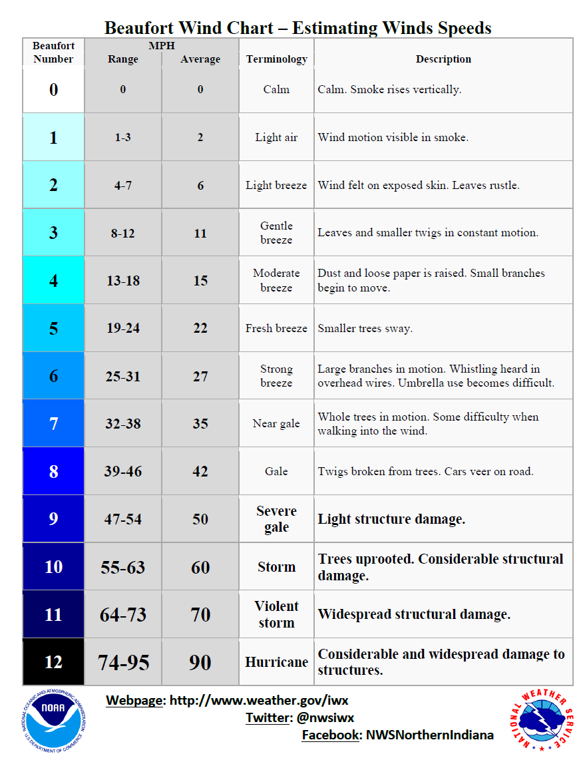

Combined NOAA/TORRO Hailstorm Intensity Scales
Size Code | Intensity Category | Typical Hail Diameter (inches) | Approximate Size | Typical Damage Impacts
H0 | Hard Hail | up to 0.33 | Pea | No damage
H1 | Potentially Damaging | 0.33-0.60 | Marble or Mothball | Slight damage to plants, crops
H2 | Potentially Damaging | 0.60-0.80 | Dime or grape | Significant damage to fruit, crops, vegetation
H3 | Severe | 0.80-1.20 | Nickel to Quarter | Severe damage to fruit and crops, damage to glass and plastic structures, paint and wood scored
H4 | Severe | 1.2-1.6 | Half Dollar to Ping Pong Ball | Widespread glass damage, vehicle bodywork damage
H5 | Destructive | 1.6-2.0 | Silver dollar to Golf Ball | Wholesale destruction of glass, damage to tiled roofs, significant risk of injuries
H6 | Destructive | 2.0-2.4 | Lime or Egg | Aircraft bodywork dented, brick walls pitted
H7 | Very destructive | 2.4-3.0 | Tennis ball | Severe roof damage, risk of serious injuries
H8 | Very destructive | 3.0-3.5 | Baseball to Orange | Severe damage to aircraft bodywork
H9 | Super Hailstorms | 3.5-4.0 | Grapefruit | Extensive structural damage. Risk of severe or even fatal injuries to persons caught in the open
H10 | Super Hailstorms | 4+ | Softball and up | Extensive structural damage. Risk of severe or even fatal injuries to persons caught in the open

5.4 Winter Storms: Ice and Snow

History of Occurrence (from the National Oceanic and Atmospheric Administration (NOAA), National Center for Environmental Information (NCEI), formally the National Climate Data Center (NCDC) website and FEMA DR List.) Due to the area-wide nature of winter storms, snowfall depths vary in and around the Town of Moretown. Snow and/or ice events occur on a regular basis during the winter months. Recent significant events have included:

Date | Event | Location | Extent
11/26/2018 | Winter Storm | Washington County | In Washington county, snow accumulated 6-14”
11/15/2018 | Winter Storm | Washington County | A widespread 3-8” of snow fell in Washington county
3/13/2018 | Winter Storm | Washington County | Long duration snowfall event eventually delivered 12-30” across Washington county
3/7/2018 | Winter Storm | Washington County | A long duration snow event deposited 7-13” across Washington county,
2/7/2018 | Winter Storm | Washington County | A widespread 5-8” of snow fell across Washington county.
12/22/2017 | Winter Storm | Washington County | Snowfall amounts of 6-12”were reported
12/12/2017 | Winter Storm | Washington County | A widespread 6-12” of snow fell across Washington county
3/31/2017 | Winter Storm | Washington County | Widespread 6-12” of a heavy, wet snow fell across the region
3/14/2017 | Winter Storm | Moretown, Washington County | Snowfall totals across Washington county generally ranged from 14-24”
2/12/2017 | Winter Storm | Moretown, Washington County | Widespread 8-14” of snowfall reported
12/29/2016 | Winter Storm | Washington County | A widespread 5-10” of snow was observed.
11/20/2016 | Winter Storm | Washington County | Snowfall of 6-12”was observed in higher elevations
2/2/2015 | Winter Storm | Washington County | Snowfall across Washington county was 6-12”
1/18/2015 | Winter Storm | Washington County | A heavy wet snow of 2-6” fell across Washington county, accounting for isolated to scattered power outages.
12/9/2014 | Winter Storm | Moretown, Washington County | Heavy, wet snowfall totals across Washington county ranged 6-24”
11/26/2014 | Winter Storm | Washington County | Snowfall totals of 8-14” were found across Washington county
3/12/2014 | Winter Storm | Washington County | Snowfall totals across Washington county were generally 12-20”+
12/14/2013 | Winter Storm | Washington County | 8-12” of snow fell across Washington county
3/19/2013 | Winter Storm | Washington County | 6-14” of snow fell across Washington county
2/8/2013 | Winter Storm | Washington County | 6-12” of snow fell across Washington county
12/26/2012 | Winter Storm | Moretown, Washington County | Snowfall totals of 9-18” were common in Washington county
2/29/2012 | Winter Storm | Washington County | Storm total snowfall accumulations ranged from 9-15”
2/24/2012 | Winter Storm | Washington County | Storm total snowfall accumulations ranged from 4-18”
11/23/2011 | Winter Storm | Moretown, Washington County | 5-12” of a heavy, wet snow mixed with rain and sleet at times fell across Washington county.
3/6/2011 | Winter storm | Washington County | 15-25” of snow, 10,000 customers lost power statewide
2/23/2010 | Winter Storm | Washington County | 20” of snow and 50,000 customers lost power statewide
2/22/2009 | Winter Storm | Washington County | 16” of snow, 30 mph wind gusts
2/1/2008 | Winter storm | Washington County | 3-7” of snow and ice ¼-1/2”thick, 50 mph wind gusts
2/14/2007 | Winter storm | Washington County | 22” of snow
2/14/2006 | Winter storm | Moretown, County Wide | 30” of snow
1/4/2003 | Winter storm | Washington County | 19” of snow
3/5/2001 | Winter storm | Washington County | 15-30” of snow
12/31/2000 | Winter storm | Washington County | 10” of snow
1/15/1998 | Winter storm | Washington County | 10-12” snow (not a DR in Washington County)
12/29/1997 | Winter storm | Washington County | 21” of snow
12/7/1996 | Winter Storm | Washington County | 12” of snow
3/21/1994 | Winter storm | Washington County | 5-11” of snow
11/1/1993 | Winter storm | Washington County | 15” of snow
1/3/1993 | Freezing Rain | Statewide | ¼-1/2” of ice formed

A winter storm is defined as a storm that generates sufficient quantities of snow, ice or sleet to result in hazardous conditions and/or property damage. Ice storms are sometimes incorrectly referred to as sleet storms. Sleet is similar to hail only smaller and can be easily identified as frozen rain drops (ice pellets) that bounce when hitting the ground or other objects. Sleet does not stick to wires or trees, but in sufficient depth, can cause hazardous driving conditions. Ice storms are the result of cold rain that freezes on contact with the surfaces coating the ground, tress, buildings, overhead wires and other exposed objects with ice, sometimes causing extensive damage. Periods of extreme cold tend to occur with these events.

Although winter storms and periods of cold temperatures are a frequent occurrence, the extent of winter storms within Moretown is difficult to estimate as it is dependent on the size and path of the storm. In general, Moretown does not consider a storm of up to 12 inches of snowfall significant because they are equipped to handle it. The chart of historical occurrences in this Plan identifies some of the more significant events from 2017 - 1993. Specific data for Moretown does not exist.

In terms of ice events, the Town has elected to include ice due to the hazard it presents on travel, road infrastructure, and the loss of electrical power. A major ice storm event has not been logged in Washington County between 1950 and 2018, however, the Town recognizes the ice present in winter storms and will mitigate against the hazards it presents.

For the next plan update, Moretown will more closely monitor winter storms and collect data to determine the worst extent possible on the Town. Extent data can be based on volumes of snow; winter weather alerts issued, or wind chill factor. See tables below for descriptions and scales.

Based on past occurrences, the worst anticipated winter weather Moretown could experience would be 2-3’ of snow with more at higher elevations and several days of power outages. Past worst storms were in March 2011 and after that the Blizzard of 1888. More recently in the past five years, the worst winter storm occurred December 9 to December 13, 2014 with Vermont receiving a federal declaration (DR4207-VT) for the storm damages. Heavy wet snow with a snow to water ratio of 8:1 caused over 175,000 power outages, the second most power outages due to weather in the state of Vermont at that time. FEMAs total Public assistance grant funds obligated to the state was $3,949,028.57. An extended period of extreme cold occurred in January and February of 2015. Dangerously cold wind chills of 30 degrees below zero and colder occurred. Overall, in the past five years the extreme cold, winter storms, ice storms, and heavy snows have spared the state of Vermont compared to the historical records of the past when heavy snowstorms and winter storms were more frequent and common. Power outages caused by broken tree limbs or downed trees from wet heavy snow loads or ice storms continue to create a challenge to the town.

Extent Scale - Winter Weather Alerts
Winter Weather advisory  Winter storm watch | This alert may be issued for a variety of severe conditions. Weather advisories  may be announced for snow, blowing or drifting snow, freezing drizzle,  freezing rain, or a combination of weather events.  Severe winter weather conditions may affect your area (freezing rain, sleet or  Heavy snow may occur separately or in combination).
Winter Storm Warning | Severe winter weather conditions are imminent.
Freezing rain or freezing drizzle  Sleet | Rain or drizzle is likely to freeze upon impact, resulting in a coating of ice  Glaze on roads and all other exposed objects.  Small particles of ice usually mixed with rain. If enough sleet accumulates on  the ground, it makes travel hazardous.
Blizzard Warning  Frost/freeze warning | Sustained wind speeds of at least 35 mph are accompanied by considerable  falling or blowing snow. This alert is the most perilous winter storm with  visibility dangerously restricted.  Below freezing temperatures are expected and may cause significant damage  to plants, crops and fruit trees.
Wind Chill | A strong wind combined with a temperature slightly below freezing can have  the same chilling effect as a temperature nearly 50 degrees lower in a calm  atmosphere. The combined cooling power of the wind and temperature on  exposed flesh is called the wind‐chill factor.

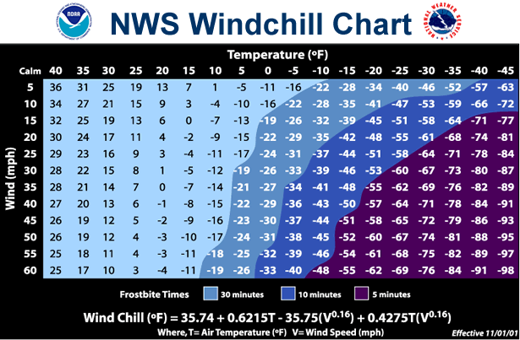
Wind Chill Extent Scale

One of the major problems associated with ice storms is the loss of electrical power. Major electric utility companies have active, ongoing programs to improve system reliability and protect facilities from damage by ice, severe winds and other hazards. Typically, these programs focus on trimming trees to prevent encroachment of overhead lines, strengthening vulnerable system components, protecting equipment from lightning strikes and placing new distribution lines underground.

Electric service in Moretown is provided by Green Mountain Power (GMP), Washington Electric Cooperative Inc. (WEC), and small portion from the Town of Northfield. Each utility has a specific area they are allowed to serve under the State of Vermont rules governing a utilities service territory. WEC serves those homes and businesses located in the more remote areas of Moretown served by dirt roads and located in the higher elevations of the Town. WEC serves the Moretown area from a substation several miles away located on the Moretown Common Road. Because the lines serve much of the remote and higher elevation areas in Moretown they are more prone to damage from falling trees especially during heavy wet snows, ice storms and violent electrical storms. As a result, homes located in these areas may experience a higher frequency and duration of outages than homes located in the low lying areas and valleys such as those along the Route 100B corridor. GMP serves homes and businesses located generally along the Route 100, Route 100B and Route 2 corridors along the Winooski River and Mad River. These areas are not as prone to significant weather events and therefore experience a reduced frequency of outages. When outages do occur, access to make repairs is via a paved road and therefore can be done more quickly than in the more remote areas. Northfield’s municipal utility serves the southeastern corner of Moretown.

Both GMP and WEC have online real time outage tracking tools. In addition, WEC and the Moretown Emergency Team have redundant means of communication in place in the event of a sever outage in WEC territory.

Vulnerable populations, such as the elderly and handicapped are of greatest risk to this hazard. If this type of multiple hazard event takes place for an extended period of time, back-up power would be necessary for critical facilities such as the Moretown Elementary School, Harwood Union High School, Town Offices, and Town Highway Garage. The Town Offices and Harwood Union High School building both have generators giving them back up capacity and the ability to be used as shelters if needed.

The E911 CARE form is posted on the Town Web page which allows residents that have special requirements in the event of power outages or other emergencies to provide information on their needs that is made available to first responders during an emergency. The Emergency Team will maintain and keep the list up to date.

During the many winter storms, ice storms, and extreme cold, Moretown has experienced school closings, increased road maintenance, pressure on the town highway budget, power outages (from downed lines and extreme cold), downed trees and tree limbs, vehicular accidents, collapsed structures from heavy snow and ice loads, frozen culverts and more. In addition, the potential for increased medical needs due to over exertion with clean up and snow removal and falls, often with broken bones, due to icy surfaces exists.

By observing winter storm watches and warnings, adequate preparations can usually be made to lessen the impact of snow, ice and sleet, and below freezing temperature conditions on the Town of Moretown. Providing for the mass care and sheltering of residents left without heat or electricity for an extended time and mobilizing sufficient resources to clear broken tree limbs from roads, are the primary challenges facing community officials. Shelter locations include: Town Offices and Harwood Union High School (Duxbury). The Town encourages residents who are in remote locations to be equipped with generators and backup fuel supplies, water, food, and medical supplies in the event of prolonged power outages and travel restrictions. In the event of an extended power outage, the Town is in the position to open its emergency shelter. Often, residents without power will seek family and friends to stay with during the duration of an outage.

Other major problems include closed roads and restricted transportation.

Many of the impacts from these hazards can be reduced by using common sense and practicing preparedness measures such as staying off the snow and ice covered roads until they are cleared, having vehicles equipped with proper winter gear and snow tires, using moderation and resting when removing snow and cleaning up from a storm, keeping heating pipes cleared and well ventilated, keeping roofs clean of heavy snow/ice loads, checking on and helping the elderly and disabled residents of the community, and listening to the local weather forecast for storm updates. Participating in the free VTAlert system is highly encouraged and an important resource in emergency preparedness.
Hazard | Location | Vulnerability | Extent | Impact | Probability
Ice | Town Wide. All roads, utility poles and lines, Town Forest, Private woodlots/ timber stands, private residences and businesses, public infrastructure | Elderly & handicapped populations, remote structures, old/under insulated structures, public infrastructure and utilities, trees, telecommuni-cations, school system | Jan/Feb 2015 15-20 days below zero with wind chills of negative -30 degrees below zero. | Depends on severity – additional sheltering/ plowing/ emergency services costs for town. School closing and vehicular accidents.  Downed trees and power lines. Prolonged power outages for 175,000 customers statewide.  12/2014 FEMA Total PA obligated statewide $3,949,028  A gap in the data exists for Moretown. | Medium
Snow | Town Wide. All roads, utility poles and lines, Town Forest, Private woodlots/ timber stands, private residences and businesses, public infrastructure | Elderly & handicapped populations, remote structures, old/under insulated structures, public infrastructure and utilities, trees, telecommuni-cations, school system | Minimal to Moderate depending on severity; 18+” snowfall in March 2011 event  12/9/2014 – 12/13/2014  6 to 24 inches wet heavy snow in county. No specific extent data for Moretown is available. | Depends on severity – additional sheltering/ plowing/ emergency services costs for town. School closing and vehicular accidents.  Downed trees and power lines. Prolonged power outages for 175,000 customers statewide.  12/2014 FEMA Total PA obligated statewide $3,949,028  A gap in the data exists for Moretown. | High

6. Mitigation

The goal of this Plan is to update the local mitigation strategy that makes Moretown more disaster resistant and reduces its risk from natural hazards. Further, it is the goal of this Plan to take actions to reduce or eliminate the long-term risk to human life and property from:
- The natural hazard of fluvial erosion.
- The natural hazard of inundation flooding.
- The natural hazard of ice.
- The natural hazard of wind.
- The natural hazard of snow.

6.1 Town Plan Goals and Objectives that Support Local Hazard Mitigation

  - Pursue land use planning and regulatory approaches that will protect water quality and prevent the degradation of water resources (Resource protection)
    - Support the goals and objectives identified in the Mad River Valley Corridor Management Plan (Resource Protection).
    - Action: Complete the Phase 2 Geomorphic Assessment for the Mad River and its tributaries.
    - Action: Initiate a public process to assess whether to revise our flood hazard regulations to include erosion hazard areas once the state releases river corridor maps for the rivers and tributary streams in town.
    - Action: Revise our zoning regulations to increase the minimum setback and buffer requirement from rivers and streams to at least 50 feet, and incorporate more specific standards with regard to the removal of natural vegetation from riparian buffers.
  - Encourage compact development residential patterns and building types that facilitate efficient use of land and preserve open space. (Land Use and Development)
    - Action: Review the state’s river corridor mapping when it becomes available and consider expanding our flood hazard regulations to include any additional mapped areas.
  - Support efforts to complete geomorphic assessments, assessments of all stream crossings (bridges and culverts) and river corridor (erosion hazard) delineations for all our river and major tributary streams. (Resiliency, Sustainability, and Adaptation).
    - Avoid locating new buildings, particularly residences, within flood and other known hazard areas.
    - Identify properties located in the flood hazard and fluvial erosion areas of Moretown.
    - Explore participation in the FEMA Community Rating System (CRS) in order to reduce the cost of flood insurance for property owners in Moretown and to expand the town’s ability to access state and federal funding for flood mitigation and recovery.
  - Continue to maintain town roads and transportation infrastructure in a manner that is cost-effective over the klong-term, improves safety for all roadways users, incorporates complete streets principles, and protects rural and scenic character (Infrastructure and Transportation).
    - Advocate for the timely replacement of the state’s bridge on Route 100B south of Moretown Village, and for the new bridge to be designed and constructed to minimize flooding hazards, to serve as an attractive gateway to our community, to slow and calm traffic entering the village, and to safely accommodate all roadway users.
    - Action: Establish a flood resource section on the town website to assist property owners with finding information about flood mapping, insurance, regulations, mitigation, and recovery.
    - Action: Request that the Selectboard periodically hold a meeting of first responders, emergency management chairperson, highway department, town health officer, planning commission and the zoning administrator to discuss the current status and trends such as demand for emergency services and availability of volunteers, disaster response and hazard mitigation planning, and development activity to aid the town with planning to meet emergency response needs. Incorporate recommendations into the town’s Hazard Mitigation Plan as appropriate.
  - Continue to participate in the National Flood Insurance Program (Administration and Governance).
    - Action: Regularly review our Emergency Operations Plan, Hazard Mitigation Plan, and Rapid Response Plan and update them as needed.

6.2 Proposed Hazard Mitigation Programs, Projects & Activities
Hazard mitigation programs, projects and activities that were identified for implementation at the Moretown Local Hazard Mitigation meeting:

Hazards Mitigated | Mitigation Action | Local Leadership | Prioritization | Funding Resources | Time Frame
Flooding, Fluvial Erosion | Widening of bridge south of village on S-curves | SB, Road Foreman, VTRANS |  | AOT Funds, town funds
Fluvial Erosion, Inundation Flooding | Evaluate Technological Feasibility and overall viability of blasting in the gorge | SB, PC, VT DEC |  | Town Funds
All hazards | Install generator at Moretown School | SB, PC |  | PDM, Town funds
All hazards | Generator Education and Training for Residents | PC, VEM |  | PDM, Town Funds
Fluvial Erosion, Inundation Flooding | Moretown School Parking Lot Improvements as defined in the Top 5 BMP. | SB, Road Foreman, VTRANS |  | HMGP, AOT Funds, PDM
Fluvial Erosion, Inundation Flooding | Evaluate public perception of adoption of River Corridor bylaws within 5 years. | SB, PC |  | Town Funds, HMGP, MPG
Wind, Ice, Snow | Maintain ROW for electric utilities. | Green Mountain Power and Washington Electric Coop |  | Electric Utility Budgets
Wind, Ice, Snow | Inventory and remove ash trees in Town ROW | SB, PC, Town Tree Warden |  | Town Funds, AOT Funds

VEM also emphasizes a collaborative approach to achieving mitigation on the local level, by partnering with ANR, VTrans, ACCD, Regional Planning Commissions, FEMA Region 1 and other agencies, all working together to provide assistance and resources to towns interested in pursuing mitigation projects and planning initiatives.

The mitigation activities are listed in regards to local leadership, possible resources, implementation tools, and prioritization. The method used for prioritization of the actions was qualitative and based upon: 1) the Community’s need to address the issue, 2) the action’s cost, 3) the action’s benefit, and 4) the availability of potential funding. Emphasis was placed on a review of the benefits (pros) and costs (cons) when prioritizing the mitigation actions with the expectation that the benefits would outweigh the costs.

In performing the benefit cost review, the team reviewed a wide range of questions concerning the mitigation actions. How immediate and critical is the need to the community? How costly is the action? Is it a low-cost strategy? Is the action cost effective and seem reasonable for the nature of the project? Are funds already secured or readily available? Does the action use outside funding sources? Is there a time restriction on expending funds? Can the action be budgeted in the current or upcoming budget cycle or does it require long term debt? What is the level of risk to community assets (people, economy, structures, critical facilities & infrastructure, and the natural environment)? Does the action provide for the protection of life and property and reduce the risk for loss, injury, or damage? How critical are the community assets that benefit from the action? How fast will the action take to implement? How many people and or area will benefit from the action; whole community, neighborhood, individual? What benefits will the action provide? Does the action support the community goals, polices and plans?

The following categories are used to define the priority of each mitigation action/strategy:
HIGH - A High prioritization denotes that the action is either critical or potential funding is readily available or in hand, and should have a timeframe of implementation of less than two years. These projects also use grants and other outside funding sources; provide the greatest protection from loss of life and property damage; are cost effective; have a larger benefit; and provide a higher degree of risk reduction for community assets. Generally, the community assets that benefit from these actions are critical and of high priority.

MEDIUM - A Medium prioritization is warranted where the action is less critical or the potential funding is not readily available and has a timeframe for implementation of more than two years but less than four. These projects are somewhat cost effective at reducing damage to property and people, have some benefit, and provide some degree of risk reduction for community assets.

LOW - A Low prioritization indicates that the timeframe for implementation of the action, given the action’s cost, availability of funding, and the community’s need to address the issue, is more than four years. These actions may have limited benefit or the cost effectiveness is low. The community assets that benefit from the action are not in immediate need or are a low priority.

Moretown understands that in order to apply for FEMA funding for mitigation projects that a project must meet FEMA benefit cost criteria. The Town must also have a FEMA approved Hazard Mitigation Plan as well.

Attachments

- Moretown Areas of Local Concern Map
- Moretown Areas of Local Concern Map – Village Inset
- 5 year plan maintenance and review process
- Survey
- Certificate of Adoption

7.1 Moretown Areas of Local Concern Map
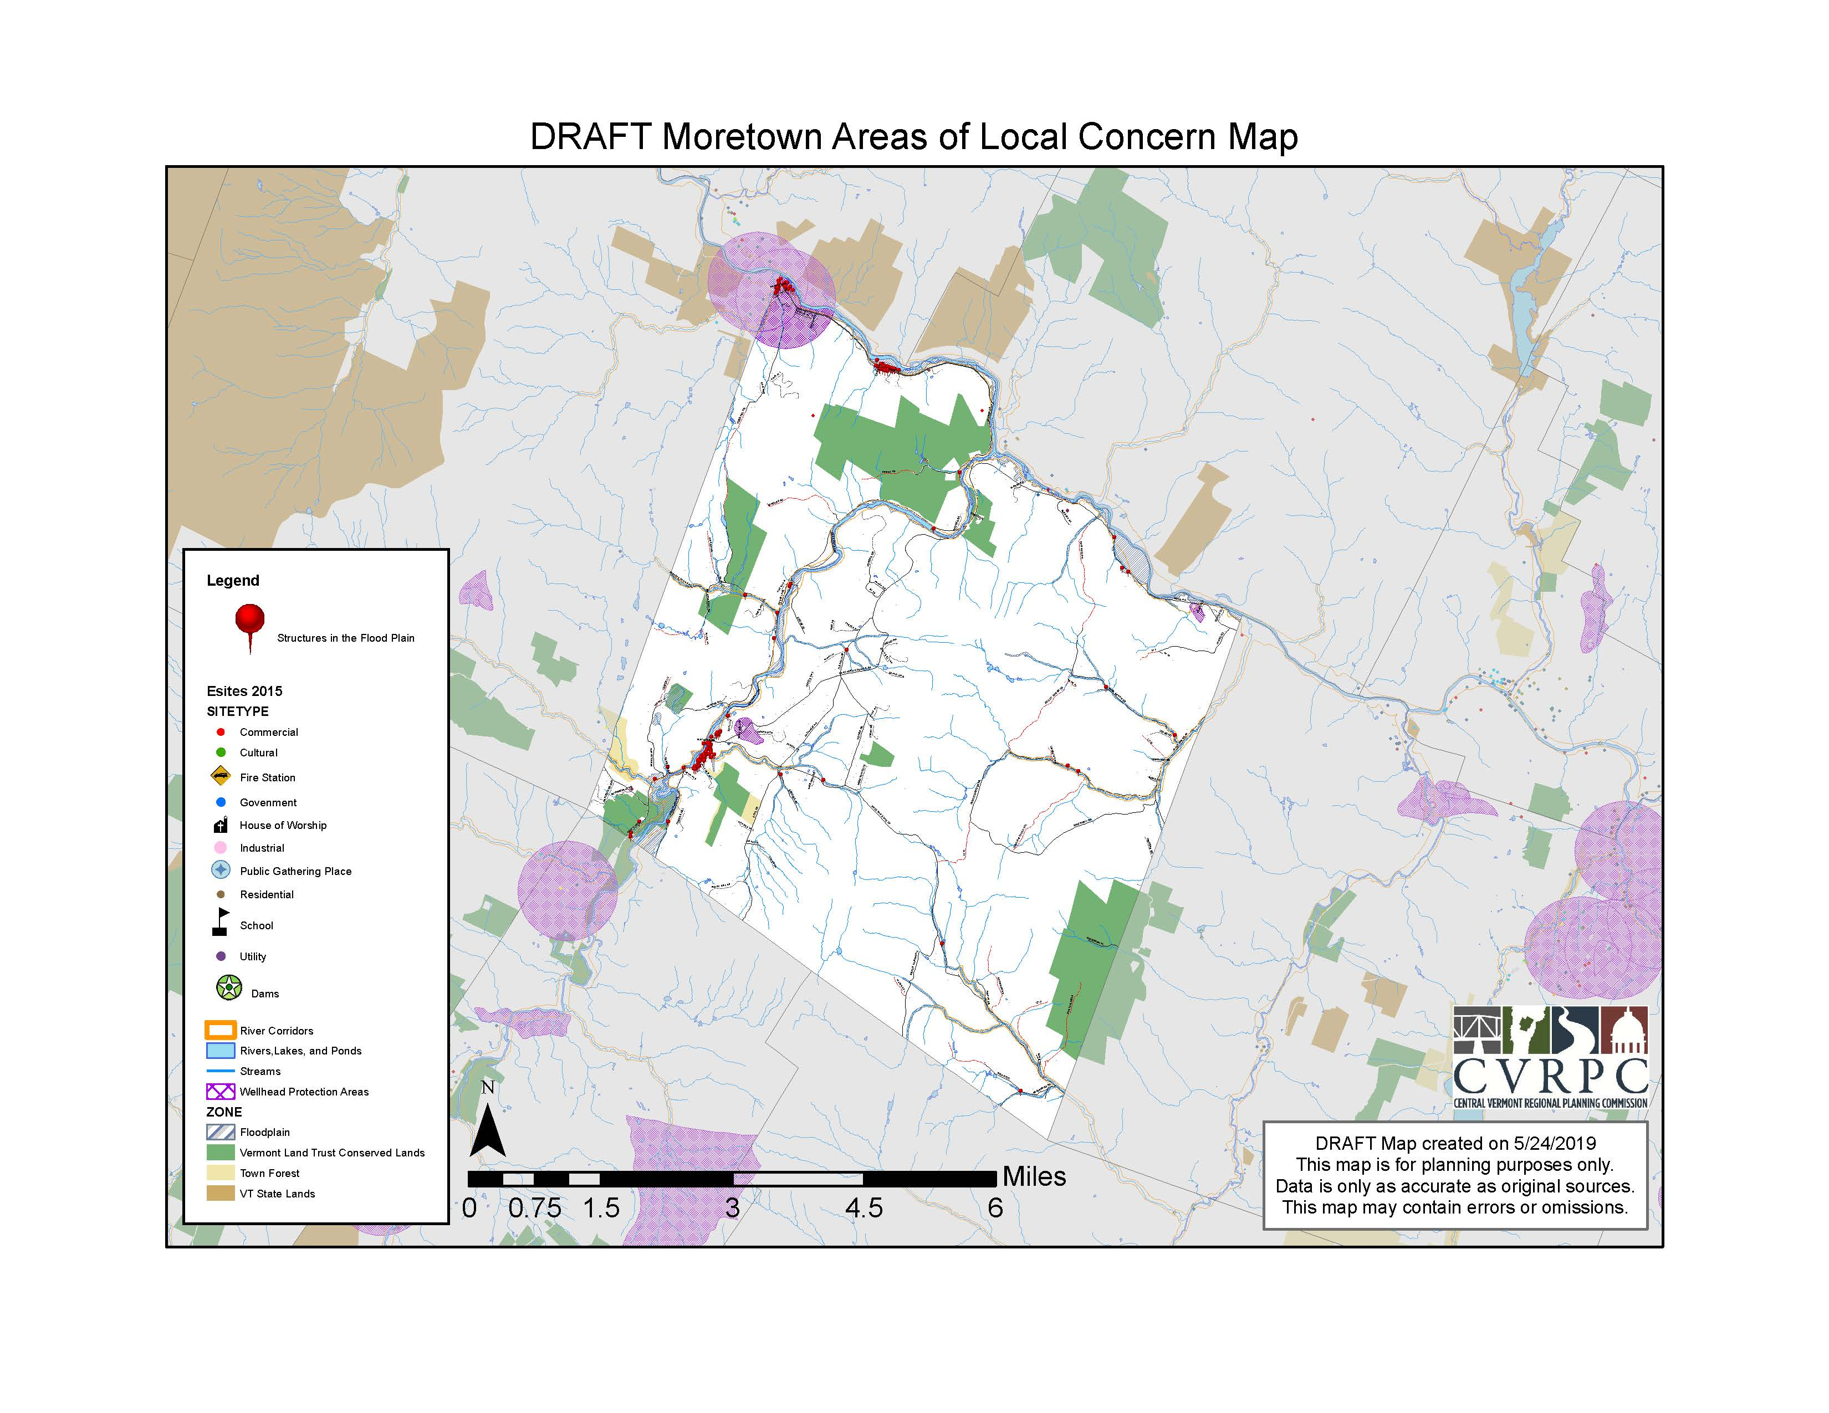

7.2 Moretown Areas of Local Concern Map – Village Inset
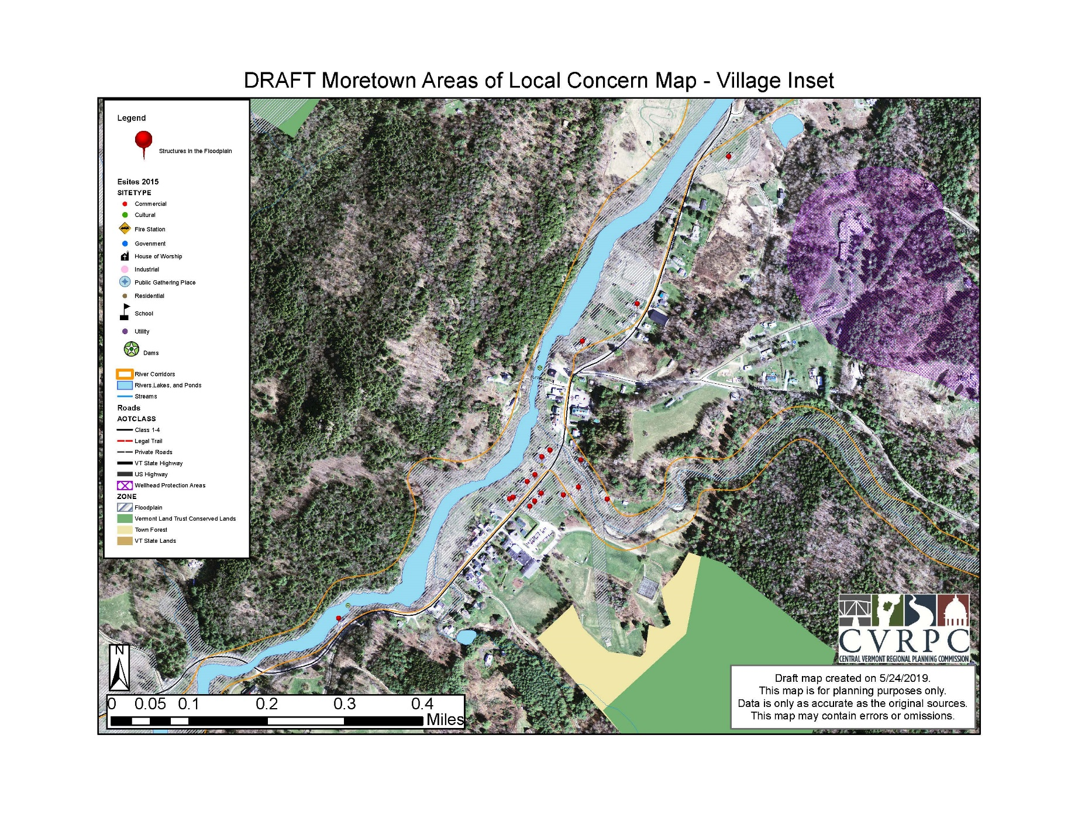

7.3 5-Year Plan Maintenance and Review Process
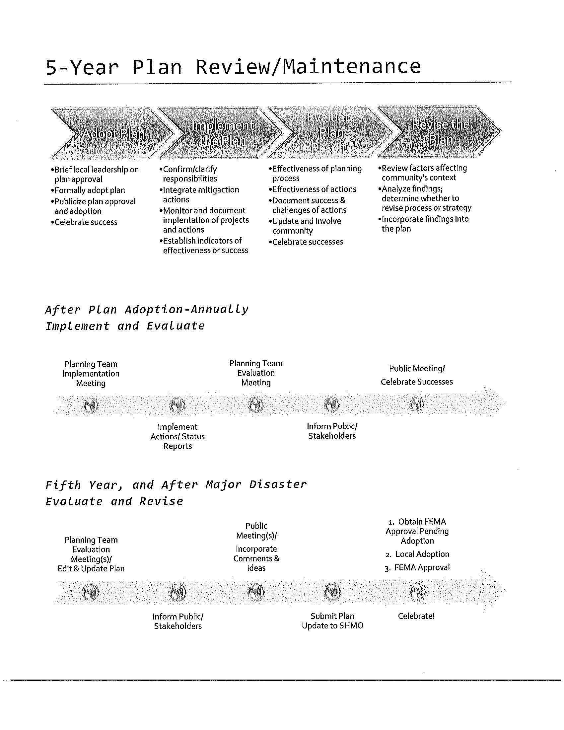

7.4 Public Engagement Survey
Moretown planning commission
Survey
To inform hazard mitigation planning process

Thank you for taking the time to answer the moretown planning commission’s survey regarding hazards and where the town should focus its efforts in updating the hazard mitigation plan, which is required by the federal emergency management administration. Your answers will help us develop a plan that addresses the biggest risks to the population and infrastructure in moretown.

1) have you ever been affected physically or financially by a natural disaster in moretown?

2) which kind of hazard was the cause of the disaster you experienced in moretown? (please check all that apply)

____________ avalanche
____________bird flu
____________drought
____________dust storm
____________earthquake
____________extreme cold
____________extreme heat
____________flood/stream bank erosion
____________hazardous materials spill
____________hurricane/tropical storm
____________ice jam
____________infectious disease
____________infrastructure failure
____________invasive species
____________landslide
____________lightening
____________long term power outage
____________severe thunderstorm
____________severe wind
____________severe winter weather
____________structural fire
____________tornado
____________transportation spills
____________wastewater system failure
____________contaminated water supply
____________wildfire
____________other

3) how concerned are you about the following hazards? Please indicate vc, mc or nc.
very concerned (vc) moderately concerned (mc) not concerned (nc)

____________ avalanche
____________bird flu
____________drought
____________dust storm
____________earthquake
____________extreme cold
____________extreme heat
____________flood/stream bank erosion
____________hazardous materials spill
____________hurricane/tropical storm
____________ice jam
____________infectious disease
____________infrastructure failure
____________invasive species
____________landslide
____________lightening
____________long term power outage
____________severe thunderstorm
____________severe wind
____________severe winter weather
____________structural fire
____________tornado
____________transportation spills
____________wastewater system failure
____________contaminated water supply
____________wildfire
____________other

4) in terms of vulnerability to hazards, how concerned are you about impacts on the following? Please indicate vc, mc or nc.
Very concerned (vc) moderately concerned (mc) not concerned (nc)

____________ people (loss of life/injury)
____________ economic loss (business interruption, crop damage, equipment damage)
____________infrastructure damage (roads, bridges, utilities, public buildings, internet, cell service)
____________ cultural and historic resources
____________ environmental damage (damage to trees, waters of the state, shoreland erosion, damage due to invasive species)
____________ governance (ability to provide municipal services)

5)what community assets are most important to you? (churches, schools historic buildings, recreational resources, municipal buildings)
__________________________________________________________________________________________________________________________________________________________________________________________________________________________________________

6) in your opinion, how effective would the following actions be to reduce or eliminate the risk of future damage from hazards?

____________improve infrastructure resiliency (upgrade, roads, bridges, culverts)
____________avoid new construction in areas subject to flooding and erosion
____________work with dam owners to understand and mitigate hazards
____________maintain trees along utility and road rights of way
____________conduct education and awareness programs
____________access to back up power for emergency shelters, town infrastructure.

Additional comments:
__________________________________________________________________________________________________________________________________________________________________________________________________________________________________________________________________________________________________________________________________________________________________________________________________________________________________________________________________________________________________________________________________________________________________

Thank you for taking time to complete this survey. If you would like to receive future updates or be involved in the local hazard mitigation process in moretown , please provide your name, phone number and email below.

Name: ______________________________________________________________________________
Phone #: ______________________________________________________________________________
Email: ______________________________________________________________________________

Please return this survey no later than april 26th, 2019 to:
Moretown planning commission
Moretown town office
79 school st.
Moretown, vt 05660

