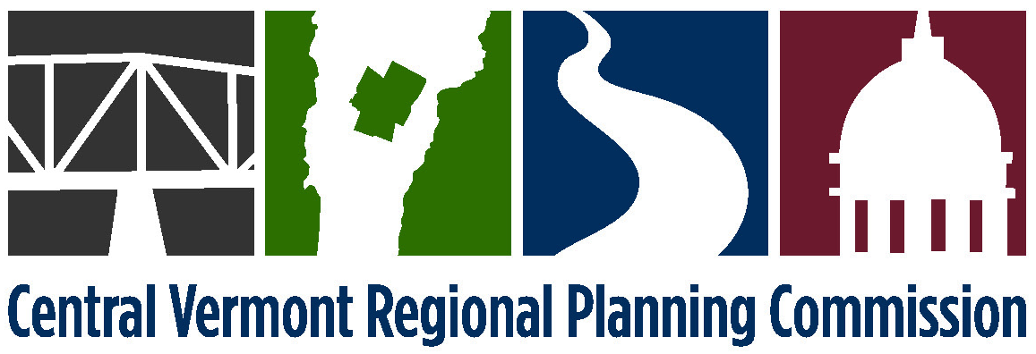

Board of Commissioners
Tuesday, March 8, 2016
Note Change
of Location
7:00 p.m.
Steakhouse Restaurant
1239 US Route 302, Berlin, VT
(Directions Attached)

5:00-7:00 pm – Open House for Laurie Emery’s Retirement, includes hors d'oeuvre
7:00 pm – Board of Commissioners Meeting

AMENDED AGENDA

- 7:00 Public Comments
- 7:05 Presentation to Laurie Emery
- 7:10 Adjustments to the Agenda
- 7:12 February 9, 2016 meeting minutes (attached)*
- 7:15 Staff Reports (attached) and any updates
- 7:20 Executive Director’s report (attached) and any updates
- 7:30 Central VT Economic Development Corporation report
- 7:35 Nominating Committee Appointment*
- 7:40 Municipal Shared Services
Workshop on Legislative Alternatives and H. 249, Regional Council of Governments
- 8:20 Amicus Brief Participation*
- 9:00 Adjournment

* denotes anticipated action item

Directions to the Steakhouse Restaurant
- Take exit 7 off I-89.
- Go thru 3 sets of traffic lights. Always staying in the right lane.
- After going under the 3rd set of traffic lights bear to the right at the fork in the highway. (Sign reads "Montpelier exit only")
- Follow the road to the bottom of the hill.
- At the bottom of the hill turn right at the traffic light onto US Route 302 east.
- Go to 2 more sets of traffic lights.
- Turn right into the Burger King/Vermont Lottery entrance at that 2nd traffic light.
- Upon leaving the highway take a quick left and proceed along the front of the Lottery building.
- We are the next building beyond the Lottery complex

This map shows the route to travel from the Commission’s usual meeting location at the Central Vermont Chamber of Commerce to the March meeting location at the Steakhouse Restaurant.

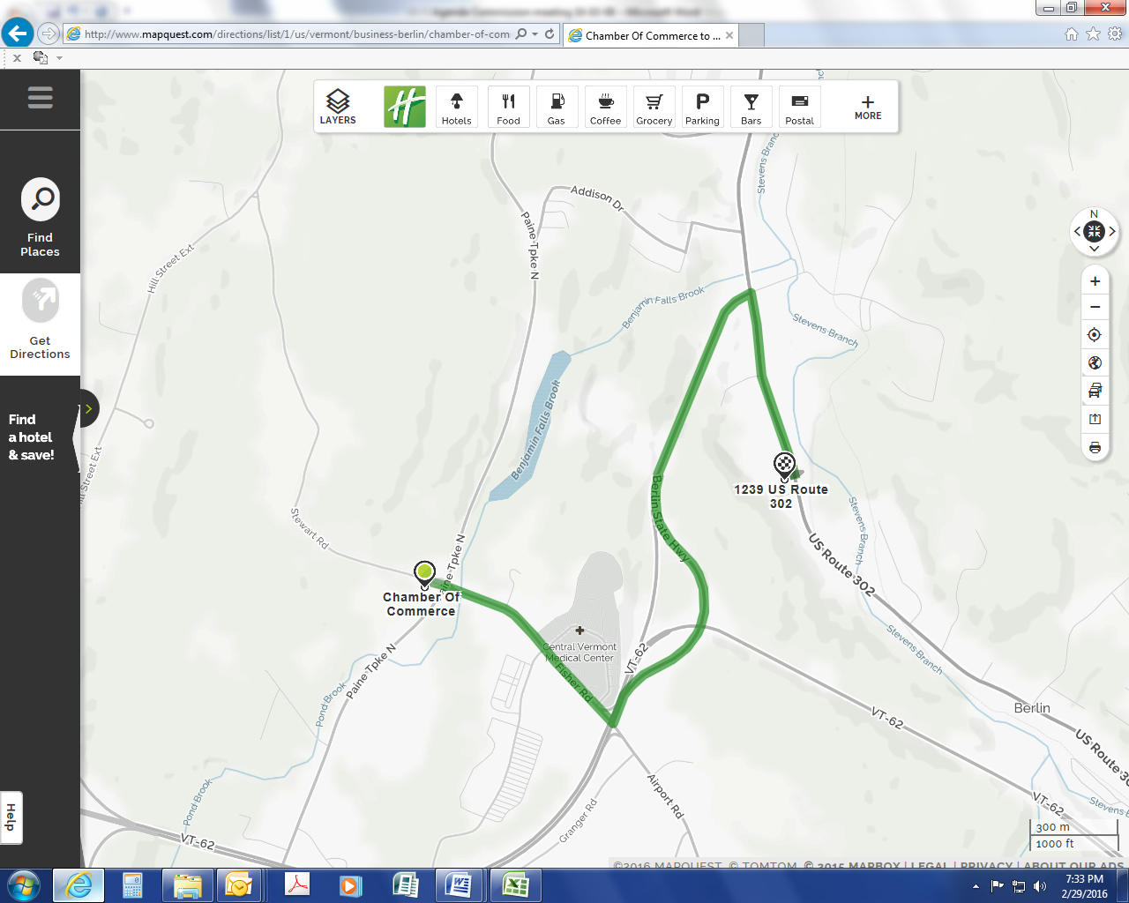
Steakhouse
Restaurant

