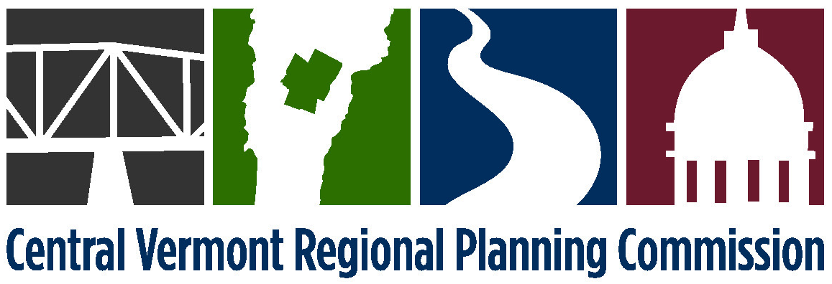

EXECUTIVE COMMITTEE MEETING
Monday, November 30, 2015
4:00 p.m. at CVRPC’s Office

AGENDA
- 4:00 Public Comment
- 4:05 Adjustments to the Agenda
- 4:10 November 2, 2015 meeting minutes* (attached)
- 4:15 Financial Report (attached)
- 4:20 Executive Director Report (attached)
- 4:30 Personnel Policy Interim Revision – Compensatory Time* (attached)
- 4:45 Regional Plan Housing Element* (attached)
- 5:00 Executive Director’s Probationary Evaluation (discussion)
- 5:15 December 8, 2015 CVRPC Meeting Agenda
- 7:00 Public Comments
- 7:05 Adjustments to the Agenda
- 7:08 November 10, 2015 meeting minutes (attached)
- 7:10 Staff Reports (attached) and any updates
- 7:15 Executive Director’s report
- 7:20 Central VT Economic Development Corporation report
- 7:25 Review and acceptance of the Housing Element for the 2016 Regional Plan
- 8:50 Regional Plan Amendment Schedule
- 9:00 Adjournment
9. 5:30 Adjourn

Future Executive Committee agenda items: CVRPC Committee structure and ex-officio members, budget restructure and project/program descriptions

*Denotes anticipated action item

NEXT MEETING: Monday, January 4, 2016 at 4:00 p.m.

