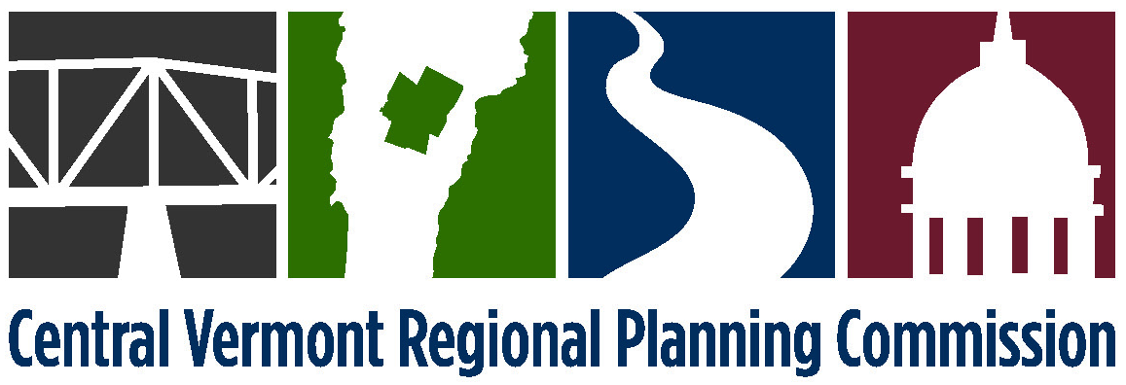

EXECUTIVE COMMITTEE MEETING
Monday, February 1, 2016
4:00 p.m. at CVRPC’s Office

AGENDA
- 4:00 Public Comment
- 4:05 Adjustments to the Agenda
- 4:10 January 4, 2016 meeting minutes* (attached)
- 4:15 Financial Report (attached)
- 4:20 Executive Director Report (attached)
- 4:30 Authorize Chair to sign contracts (attached):
  - Dept of Emergency Management & Homeland Security – Emergency Management Planning Grant (EMPG) FY16 for annual planning, training & exercise, technical assistance and response & recovery support.
- 4:35 Commission Meeting Schedule and Proposed Agendas (attached)
- 4:45 Draft FY16 Strategic Goals (attached)
- 5:00 Executive Session - Personnel [1 V.S.A Chapter 5, §313(a)(3)]* (attached)
- 5:25 December 8, 2015 CVRPC Meeting Agenda
- 7:00 Public Comments
- 7:05 Adjustments to the Agenda
- 7:08 January 12, 2016 meeting minutes (attached)
- 7:10 Staff Reports (attached) and any updates
- 7:15 Executive Director’s report
- 7:20 Central VT Economic Development Corporation report
- 7:25 Panel Discussion: An Overview of Energy for Central Vermont
- 8:25 Regional Plan Housing Element (attached)
- Proposal for Alternatives to a Housing Distribution Plan
- Acceptance of Housing Element*
- 8:50 H.249, An act relating to intermunicipal services and the authority to create a regional council of governments
- 9:00 Adjournment
9. 5:30 Adjourn

Future Executive Committee agenda items: CVRPC Committee structure and ex-officio members

*Denotes anticipated action item

NEXT MEETING: Monday, February 29, 2016 at 4:00 p.m.

