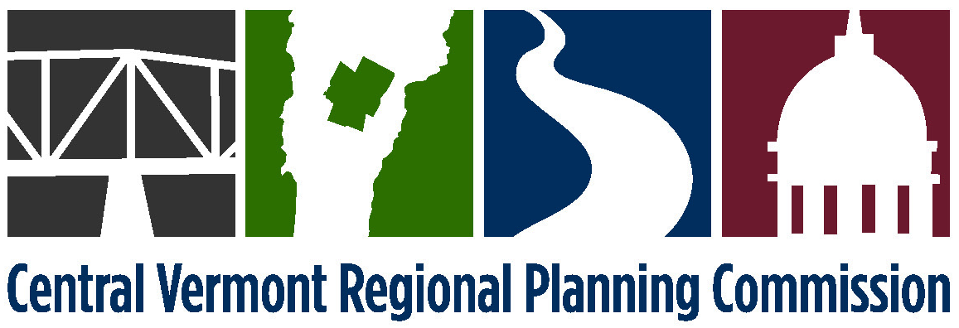

EXECUTIVE COMMITTEE MEETING
Tuesday, March 8, 2016
6:30 p.m.at the Steakhouse Restaurant,
1239 US Route 302, Berlin, VT
(Directions Attached)

AGENDA
- 6:30 Public Comment
- 6:35 Adjustments to the Agenda
- 6:37 Amicus Brief Participation* (attached)
- 6:52 Approval of Non-Competitive Procurement of Bookkeeping/Finance Manager Services
due to Exigent Circumstances * (attached)
- 6:57 Possible Executive Session - Personnel [1 V.S.A Chapter 5, §313(a)(3)]
- 7:00 Adjourn

*Denotes anticipated action item

NEXT MEETING: Monday, April 4, 2016 at 4:00 p.m.

Directions to the Steakhouse Restaurant
- Take exit 7 off I-89.
- Go thru 3 sets of traffic lights. Always staying in the right lane.
- After going under the 3rd set of traffic lights bear to the right at the fork in the highway. (Sign reads "Montpelier exit only")
- Follow the road to the bottom of the hill.
- At the bottom of the hill turn right at the traffic light onto US Route 302 east.
- Go to 2 more sets of traffic lights.
- Turn right into the Burger King/Vermont Lottery entrance at that 2nd traffic light.
- Upon leaving the highway take a quick left and proceed along the front of the Lottery building.
- The Steakhouse is the next building beyond the Lottery complex.

This map shows the route to travel from the Commission’s usual meeting location at the Central Vermont Chamber of Commerce to the March meeting location at the Steakhouse Restaurant.

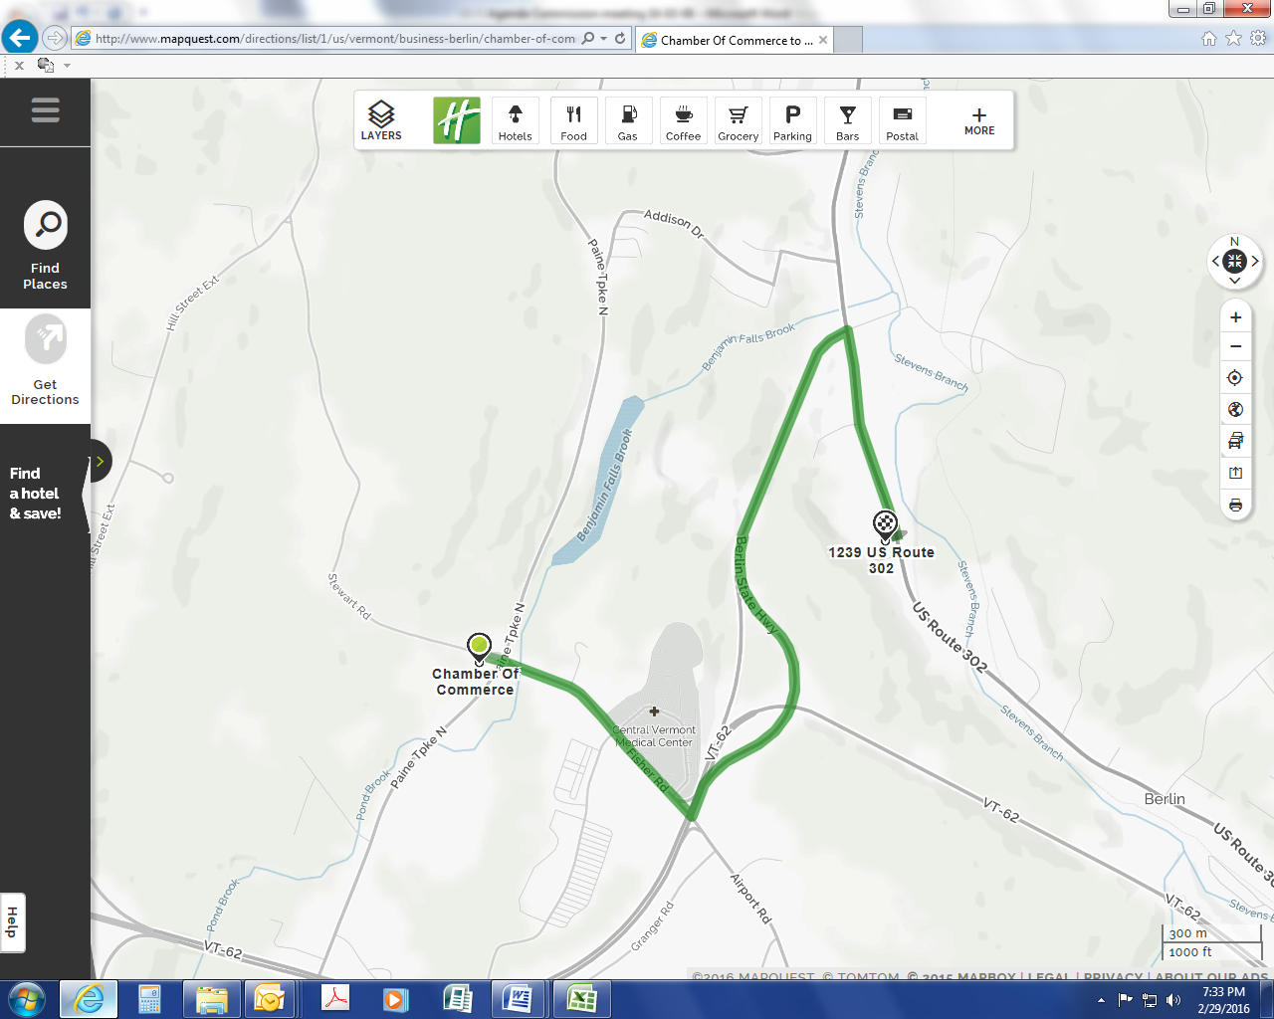
Steakhouse
Restaurant

