
Central Vermont Regional Southern Windsor County Windham Regional
Planning Commission Regional Planning Commission Commission

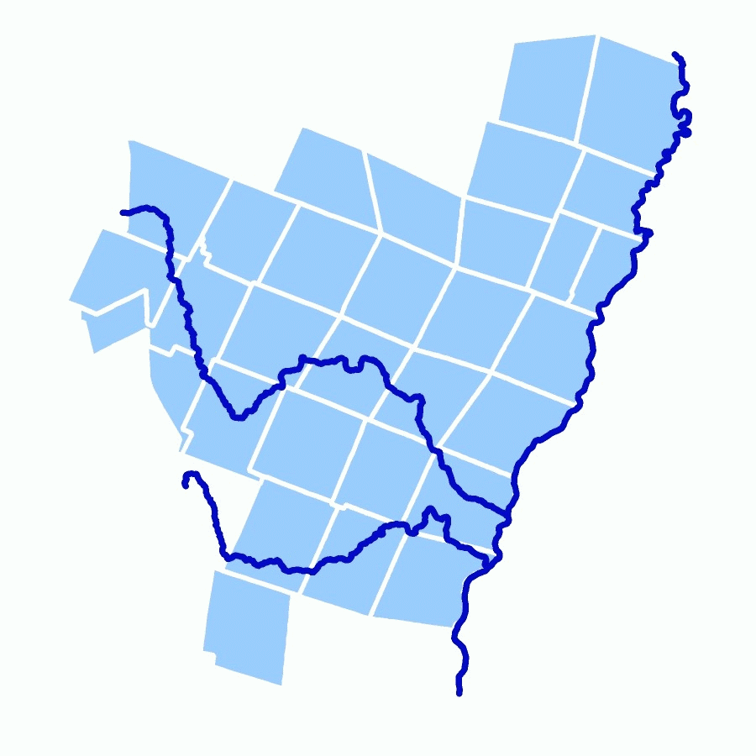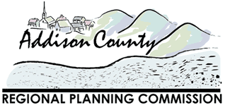
Two Rivers-Ottauquechee Rutland Regional Planning Commission Addison County Regional
Regional Commission Planning Commission


Bennington County Northeastern Vermont Chittenden County
Regional Commission Development Association Regional Planning Commission

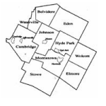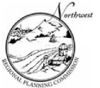
Lamoille County Northwest Regional
Planning Commission Planning Commission

