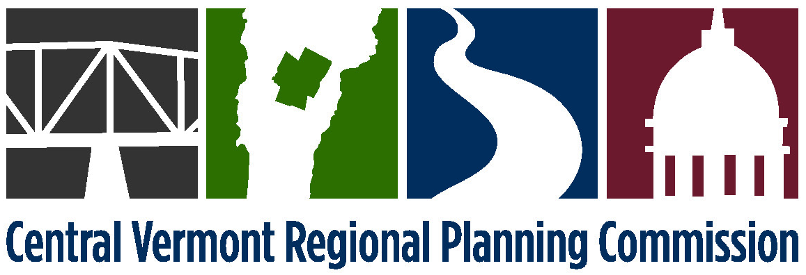

PROJECT REVIEW COMMITTEE
PROCEDURES
Adopted October 9, 1990,
Amended May 12, 1992, March 12, 1996, July 9, 1996, July 8, 1997,
June 11, 2002, June 1, 2010

Draft August 1, 2014

Purpose: To guide staff and Commissioners on when and how the Regional Planning Commission participates in the Act 250 and Section 248 regulatory proceedings.

Background: Regional planning commissions (RPCs) are statutory parties (Title 10) and are required by statute to participate in Act 250 proceedings (Title 24). Contracts from the Agency of Commerce and Community Development also require that CVRPC submit of testimony on all major Act 250 permit applications. Vermont Statutes require RPCs to develop and adopt Regional Plans that contain a definition of Substantial Regional Impact.

How we get involved? The CVRPC Project Review Committee will make a determination on behalf of the full Commission regarding conformance or non-conformance with the Regional Plan based on information provided. The conclusions reached will so state that they are made on available information. CVRPC’s “position” must state that the project is either “in conformance” with the Regional Plan or “not in conformance” with the Regional Plan. Position statements such as “generally in conformance” or “not in conflict” will not be given. CVRPC staff shall represent the Commission at review proceedings.

When do we participate? CVRPC will actively participate in the Act 250/Section 248 hearing process and other relevant review processes:

- If a project has substantial regional impact, might contribute to cumulative impacts, and/or is precedent setting, for the purpose of advancing the goals and objectives of the Regional Plan. CVRPC reserves its statutory right to participate in the Act 250/Section 248 hearing process if it must appear to ensure proposed projects are in conformance with the Regional Plan, regardless of whether the proposal has substantial regional impact.
- If a request is made by the legislative body on behalf of a member municipality for CVRPC's involvement in the review of a project and the local position is compatible with the adopted Regional Plan, staff will provide technical assistance.

Review Process: CVRPC staff reviews every application that is filed and makes the initial determination of substantial regional impacts. When a project appears to have substantial regional impacts, staff will then circulate an initial review pertaining relevant Regional Plan goals and policies to the Project Review Committee via mail or electronic mail. Staff will schedule a Project Review Committee meeting and invite the applicant or the applicant’s representative.

The stated policies within the adopted Regional Plan shall serve as guidance for participation by CVRPC as a statutory party in Act 250/Section 248, or other relevant review processes. The Project Review Committee will identify information needs, issues and areas of non-conformance with the Regional Plan as necessary.

The Committee will also consider the cumulative impacts that may occur. CVRPC may initiate cumulative impact review by requesting, coordinating and reviewing cumulative impact studies. The scope of each cumulative impact study should address impacts to both the natural and human environment and offer measures to avoid and/or mitigate adverse impacts. The costs of such studies should be borne by the applicant.

Who serves on the Committee? The Project Review Committee will consist of a standing body of five municipal commissioners and one alternate, appointed by the Commission annually for three year, staggered terms, and to include at least one member of the Executive Committee.

The alternate will only vote when filling in for one of the five standing members or if otherwise designated. If none of the standing members are from the municipality hosting the project under review, the host municipality's commissioner will be asked to participate on the Project Review Committee as a non-voting member for the duration of the review of the project in his or her municipality. . A majority vote of the members appointed is required to decide an issue.

The officers of the Project Review Committee shall consist of a Chair and a Vice-Chair, each of whom shall be duly appointed annually the Committee.
Logistical Considerations: In the event that the number of projects to be reviewed at any one time outstrips the Commission's ability to staff, coordinate, and undertake project review through the review committee process described herein, the Executive Committee may perform the duties of the Project Review Committee, as needed.

CVRPC appeals of a hearing board’s decision on a project shall be approved by the Executive Committee or the full Commission.

CVRPC will offer to mediate disputes regarding a project if the effects of a project advance the purposes of the Regional Plan, or a local plan where there is no substantial regional impact, and staff resources are available.

If, in its review, the Project Review Committee determines that a conflict exists between the provisions of town plans and the Regional Plan, CVRPC will work with town officials to alleviate or minimize the conflict. If a conflict between a town plan and the Regional Plan cannot be resolved, the town plan will prevail except as provided in # below.

If the Project Review Committee believes that a conflict exists between the provisions of the Regional Plan and any applicable town plan with respect to the development proposal under consideration, then the Project Review Committee, with the assistance of CVRPC staff, shall prepare a report that assesses Substantial Regional Impact and gives consideration to the following:

Operating Guidelines for the Review of Projects
Adopted October 9, 1990 and amended March 12, 1996, June 12, 2007, June 1, 2010

DRAFT July 31, 2014

Projects that meet any one, or combination of, the below criteria may characterize a development proposal as having substantial regional impact.

- A development will have substantial and ongoing impact on two or more municipalities, including the host municipality.

2. A development exceeding the following thresholds:
- increases the total number of year round housing units (according to the most recent U.S. Census) in its host municipality by more than 2%;
- creates more than 30 housing units of any type; or
- creates more than 5 “affordable” housing units, as defined by VSA 24 Chapter 117 Section 4303. _{(added June 12, 2007)}
- commercial, industrial or institutional new construction or expansion involving 20,000 square feet or more of gross floor area.

3. A development which may affect settlement patterns to the extent that it:
- requires the alteration, degradation or destruction of designated regionally significant historic, cultural, natural, aesthetic or scenic features;
- is locating in geographic areas that have not supported the type, scale or intensity of proposed development in the past, and is not supported by local or regional Future Land Use Maps; or
- is disregarding the scale, architectural or design features of nearby existing structures.

4. A development that may affect infrastructure capacity by:
- substantially affecting the safety of the traveling public on highways and other transportation facilities within other towns;
- adding an additional 75 vehicles per hour to any intersection or road segment on the regional highway system in one or more municipalities;
- adding an additional 75 vehicles per hour to any intersection or road segment in two or more municipalities, even if the highway or streets affected are not included on the regional highway system;

- contributing to a reduction in the peak hour Level of Service (LOS) from D to E or from E to F at a signalized intersection;
- substantially changing the service area or capacity of utility services, including but not limited to, public water and sewer systems, and/or solid waste services; or
- creating capital improvements such as the extension, upgrading or enlargement of electrical transmission lines.

5. A development which may place substantial demands on the region’s economy, or on a major sector of the economy by:
- increasing the cost or availability of affordable housing in municipalities immediate to the project site;
- increasing the cost or availability of energy for users in the Region immediate to the project site;
- having an impact on the tax rates of major employment centers or growth centers in the region;
- generating new employment equal to or greater than 1% of the region’s existing employment level.

6. A development which endangers the perpetuation or appreciation of regionally significant natural or cultural features, including, but not limited to: wildlife habitats, gravel resources, hydrogeological resources, fragile and natural areas, public water supply watersheds, aquifer protection areas, agricultural and forest resources, and historic and scenic resources.

7. A development which impairs the continued function of significant regional facilities, including, but not limited to, Interstate highway systems, waterways, educational institutions, hospitals, recreational facilities, bridges, dams, airports and trails.

8. A development or series of developments:
- located within a limited geographic area;
- under the control of a single applicant; and
- developed and planned incrementally over a relatively short period of time, the impacts of which may result in environmental, economic or social conditions substantially adverse to Regional Plan goals and policies.

LOS D: A small increase in traffic may cause substantial increases in delay at intersections and decreases of travel speeds on road segments. LOS E: Significant delays at intersections with road segment travel speeds at approximately 1/3 of the posted speed. LOS F: Extremely slow travel speeds, high delays, and extensive vehicle back-ups at intersections. (VTrans)

