Electric Vehicle Charging Station
FY16 Grant Application
Please submit one electronic copy of the complete application to gary.holloway@vermont.gov. While electronic submissions are preferred, paper applications may be submitted to:
Division for Community Planning and Revitalization
Department of Housing and Community Development (DHCD)
One National Life Drive, 6th Floor
Montpelier, VT 05620
Applications are due by 4:30 PM, October 31, 2015
The application must contain the following information:
Project Overview
Municipality name:
Project name:
Project location:
☐ Yes ☐ No – Does the municipality have an existing or planned EVCS? ?
☐ Yes ☐ No -- Is the project part of a larger capital improvement project?

Primary Contact
Name: Title:
Mailing address: Zip code:
Email address: Phone number:
Accounting Procedures
Please note that responses to the following questions will not impact the competitiveness of your application and will be used for grant administration purposes only.
What type of accounting system does you municipality use?
☐ Automated ☐ Manual ☐ Combination of both
Does your organization have an accounting system that will allow you to completely and accurately track the receipt and disbursements of funds related to the award?
☐ Yes ☐ No

FY16 Electric Vehicle Charging Station Grant
Program Description

Program Overview
The Vermont Agency of Commerce and Community Development (ACCD) and the Vermont Agency of Natural Resources (ANR) have partnered to help create a state-wide network of Electric Vehicle Charging Stations (EVCS) in state Designated Downtowns and Village Centers. There is approximately $44,000 in available funding in this third round of the EVCS grant program. Grantees must provide a 25% match in either cash or in-kind services. Grant funds will be provided as a reimbursement once the installation has been completed and final closeout report submitted.

FY 2016 Timeline
- Application Deadline: October 31, 2015
- Award Decisions: November 23, 2015 (or scheduled board meeting)
- Project Completed: November 23, 2016
- Final Closeout Report Due: December 23, 2016

Eligibility and Funding
- Any municipality with a State Designated Downtown District or a State Designated Village Center may apply for funding.
- The maximum grant award for a municipality is $25,000.
- Eligible project costs may include design and engineering, electrical, electric vehicle charging station equipment, installation, project management, permitting, signage and parking space striping.
- Grant funds may not exceed 75% of the overall project cost and a 25% match is required.
- Grant funds will be paid out as a reimbursement after submission and approval of a final report.
- In-kind costs are an eligible source of matching funds.

Priority Consideration
Priority consideration will be given to high priority areas that do not currently have an existing or planned EVCS in the designated downtown or village center and/or geographic location is close to major highways/roads (see criteria on page 6 for details). You can find locations for the existing electric vehicle charging stations in Vermont by following this link.
http://www.driveelectricvt.com/charging-stations/public-charging-map

Standard Provisions
- Proposed projects must be on municipally-owned land within the downtown or village center designated boundary.
- The EVCS must be open to the general public 24 hours a day/ 7 days per week and accessible to all plug-in electric vehicles.
- The use of the parking spaces will be for the sole purpose of EVCS and must be marked accordingly.
- The EVCS must be a Level 2 (208-240 VAC) or DC Fast Charging (208 to 480 VAC).
- Once installed, the EVCS must be registered with the National Renewable Energy Lab’s Alternative Fuels Data Center database.
- The EVCS must remain in operation for 5 years, unless otherwise approved by DHCD.
- Projects must be completed within 12 months of the date of award.
- No grant extensions are allowed.
- State statute requires the Vermont Division for Historic Preservation to review potential impacts to archaeological sites and/or historic buildings for all state-funded projects.
- For awarded grants the final report must include a copy of the municipal resolution or minutes showing a local ordinance approving the use of parking space(s) for the sole purpose of EVCS.
- All awards are contingent upon an eligibility check to confirm that potential grantees are not (a) suspended or debarred by the Federal Government; (b) delinquent in submitting their sub-recipient annual reports; and (c) delinquent in submitting their Single Audit Reports (if required).

Competitive Criteria
Grants are competitively allocated and the Vermont Downtown Development Board scores and ranks projects prior to the board meeting using the competitive criteria on pages 5 & 6.

Please direct questions to Gary Holloway at gary.holloway@vermont.gov or 802-828-3220.

Electric Vehicle Charging Station
FY16 Grant Application
Attachments

Project Description
- On a separate piece of paper, attach a brief description of the project including location and rationale for the location.

Municipal Authorization
- Attach a copy of the municipal resolution showing the project and application are authorized by the municipality. (See Appendix C for resolution template.)

Site Map and Photographs
- Attach a project site map that includes the boundary of the designated downtown or village center, buildings, streets and the location of the project clearly marked. (See Appendix A for sample site map and create your map by using ANR Atlas http://anrmaps.vermont.gov/websites/anra/.)
- Attach labeled, color photographs of the project site and surroundings, especially adjacent or nearby buildings impacted by the project. If the project involves or impacts historic buildings, include photos of elements or materials that will be removed, altered or repaired. Photographs should be labeled with the project name or description, location/address, and the view (e.g., EV Charging Station at Welcome Center, 50 Main Street). (See Appendix B for sample pictures.)

Project Schedule
- Attach a project schedule that demonstrates that the project will be completed within 12 months of the date of award. If part of a larger capital improvement project, please show how this project fits into the overall timeline.

Budget Worksheet
Complete the budget form itemizing the scope of work and the sources and amounts of all project funds. Please indicate the status of each fund and attach this sheet to the application.
- Note: The amount requested may not exceed 75% of the total project cost. There is a required 25% match and in kind costs may be used as part of the 25% match. The funding must be for an Electric Vehicle Charging Station and may include design and engineering, electrical, electric vehicle charging station (EVCS) equipment, installation, project management, permitting, EVCS signs.

Itemized Project Budget
Item Description | Quantity | Unit Cost | Total Cost
Total

Funding Sources
Funding Source | Status of Funding | Amount
Total

Competitive Criteria
The Board uses the responses to the criteria to score and rank applications. The Board scores the applications prior to the board meeting and may award less funding than requested.
Please respond to items 2-5 and attach your response to the application. Please limit the response to 1 page or less.

The Downtown Board uses the following criteria when the total requests for funds exceeds available funding:

(3 points) 1. Quality of Application
The application is complete, well-written and internally consistent. The budget for construction is realistic.
2. Priority Consideration
(1 point) Is the proposed project located in a designated downtown?

(2 points) Are there any EVCS within or planned for the designated downtown or village center?

(2 points) Is the downtown or village center in a high priority location for an EVCS due to geographic location in close proximity to major highways/roads?

(4 points) 3. Community Impact
Explain how the project addresses and supports local revitalization efforts, as articulated in the town plan, capital budget, downtown strategic plan, or other adopted documents. Describe the plan to market and promote the EVCS in the community.

(4 points) 4. Visibility and Convenience
Is EVCS located in a parking space that is clearly visible and in close proximity to amenities or key buildings in the downtown or village center and will there be appropriate signage directing vehicles to the EVCS?

(4 points) 5. Ease of Implementation
Explain how the improvements can be made with minimal disruption to existing utilities or other public infrastructure and describe how the project will be completed within 1 year.

Required Attachments
The complete application must contain the application cover sheet with following attachments:
Attachment Checklist

☐ Project Description
☐ Municipal Authorization
☐ Project Site Map
☐ Color Photographs
☐ Project Schedule
☐ Budget Worksheet
☐ Competitive Criteria Response

Appendix A
Sample Site Map
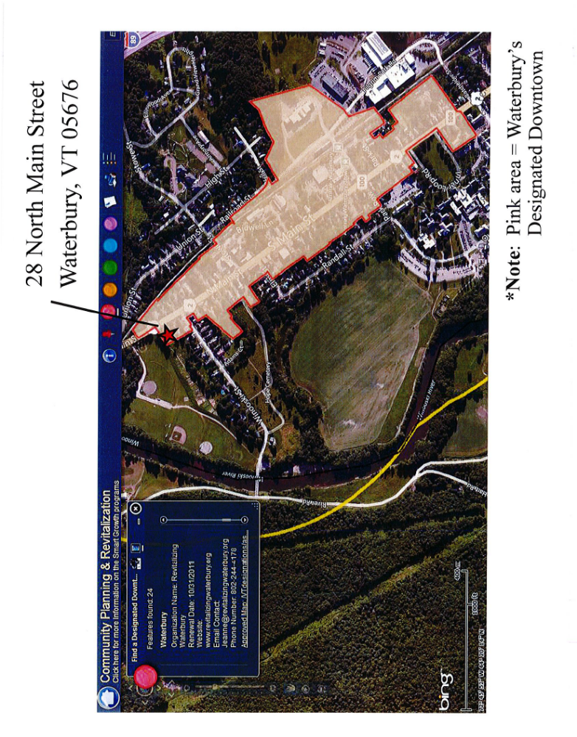
Appendix B
Sample Pictures
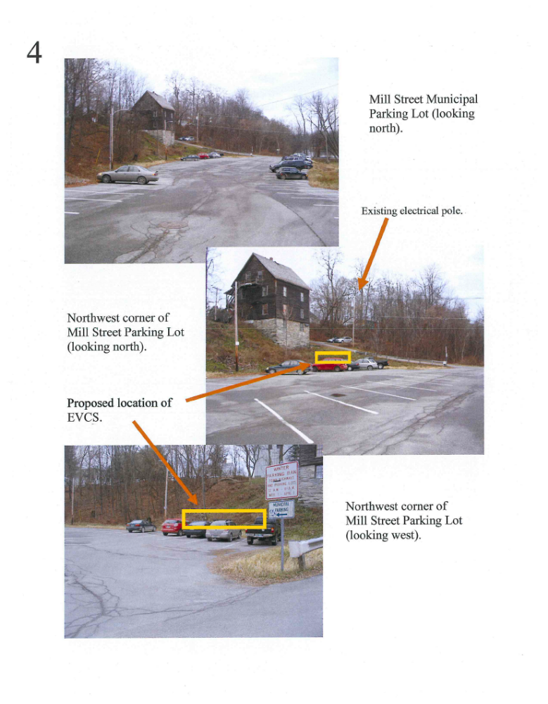
Appendix C
Resolution

Application or Grant #________________________________

RESOLUTION FOR ELECTRICAL VEHICLE CHARGING STATION

WHEREAS, the Municipality of ____________________________ is applying for funding as provided for in the FY 2016 Budget Act and may receive an award of funds under said provisions; and

WHEREAS, the Department of Housing and Community Development may offer a Grant Agreement to this Municipality for said funding; and

WHEREAS, the municipality has voted at an annual or special meeting to provide local funds for an electric vehicle charging station,

Now, THEREFORE, BE IT RESOLVED

1. That the Legislative Body of this Municipality enters into and agrees to the requirements and obligations of this grant program including a commitment to match funds of 25% of total project cost;

2. That the Municipal Planning Commission recommends applying for said Grant;

___________________________________ ________________________________
(Name of Planning Commission Chair) (Signature)

3a. That (Name)_____________________________Title________________________________
who is either the Chief Executive Officer (CEO), as defined by 10 VSA §683(8), or is a Select Board Member, the Town Manager, the City Manager, or the Town Administrator, is hereby designated to serve as the Municipal/Authorizing Official (M/AO) and to execute the Grant Agreement and other such Documents as may be necessary to secure these funds.
3b. (Alternate Authorizing Official for redundancy)
That (Name)_____________________________Title________________________________
who is either the Chief Executive Officer (CEO), as defined by 10 VSA §683(8), or a Select Board Member, is the Town Manager, the City Manager, or the Town Administrator, is hereby designated to serve as the Municipal/ Authorizing Official (M/AO) and to execute the Grant Agreement and other such Documents as may be necessary to secure these funds.
3c. That (Name) ______________________________Title________________________________
is hereby designated as the Grant Administrator, the person with the overall Administrative responsibility for the Electric Vehicle Charging Station grant activities related to the application, and any subsequent Grant Agreement provisions.
Passed this ___________ day of ____________, ______.

LEGISLATIVE BODY*
(name) |  | (signature)
 |  | (CEO)
INSTRUCTIONS FOR RESOLUTION FORM
- A. The Legislative Body of the Municipality must adopt this resolution or one that will have the same effect. This Form may be filled in or the adopted Resolution may be typed on municipal letterhead, filling in the name of the municipality, the Legislative Body (e.g., Board of Selectmen), and the name and title of the Municipal/ Authorizing Official(s)(M/AO(s); and the Grant Administrator.

- B. Following formal adoption, the Resolution must be signed by a majority of the legislative body. The Chair of the Planning Commission must also sign upon endorsement by vote of the Planning Commission.

- C. This form must be included in the grant application e-mailed to gary.holloway@vermont.gov , or mailed to:

Electric Vehicle Charging Station Grant
Department of Housing and Community Development
One National Life Drive, Sixth Floor
Montpelier, VT 05620-0501

Appendix D
Electric Vehicle Charging Station Map
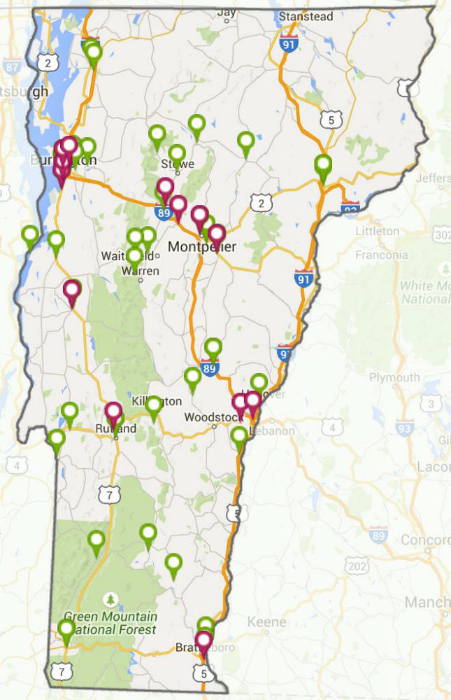
– DC Fast Charge Stations
– Level 2 Charge Stations

