Central Vermont Regional Planning Commission invites you to:
Green Stormwater Infrastructure Workshop
Alternative Techniques for Managing Stormwater

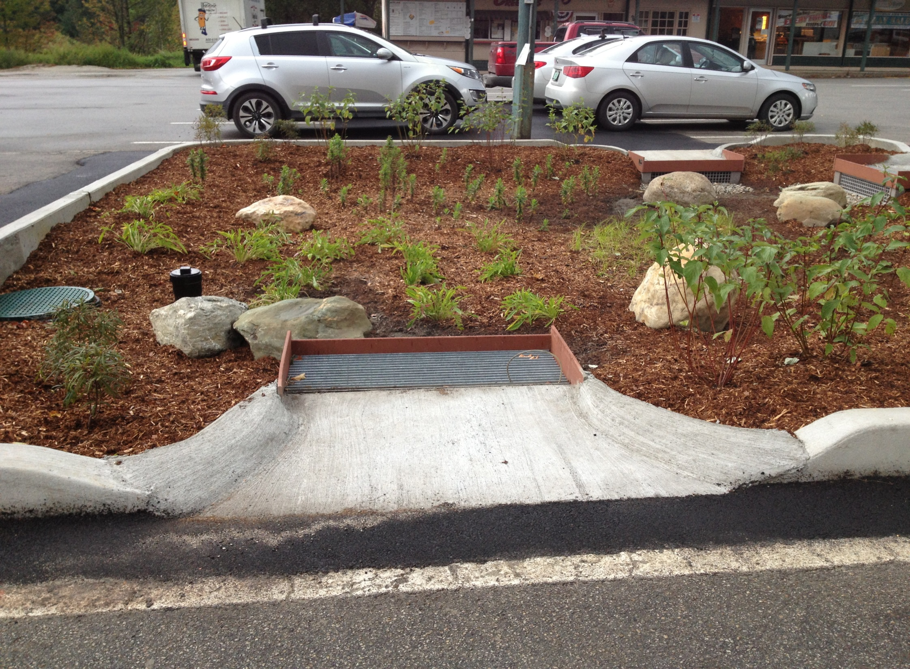

Two Dates:
October 28th, 6 pm – 8:30 pm &
October 29th, 10 am – 12:30 pm
Northfield Public Library

Managing stormwater runoff and water quality is a growing issue for municipalities in the Winooski River watershed of Central Vermont. Join fellow selectboard members, planning commissioners, public works officials, and highway officials to learn about Green Infrastructure(GI). Stormwater runoff is a major cause of water pollution in urban areas. When rain falls in undeveloped areas, the water is absorbed and filtered by soil and plants. When rain falls on our roofs, streets, and parking lots, however, the water cannot soak into the ground. In most urban areas, stormwater is drained through engineered collection systems and discharged into nearby waterbodies. The stormwater carries trash, bacteria, heavy metals, and other pollutants from the urban landscape, degrading the quality of the receiving waters. Higher flows can also cause erosion and flooding in urban streams, damaging habitat, property, and infrastructure.
Green infrastructure uses vegetation, soils, and natural processes to manage water and create healthier urban environments. At the scale of a city or county, green infrastructure refers to the patchwork of natural areas that provides habitat, flood protection, cleaner air, and cleaner water. At the scale of a neighborhood or site, green infrastructure refers to stormwater management systems that mimic nature by soaking up and storing water. The workshop will cover basic concepts, tools for implementation, and a site visit and exercises to get you thinking about how to use GI in your municipality.

- Care for more information? Check out http://www.anr.state.vt.us/dec/waterq/stormwater/htm/sw_green_infrastructure.htm
Or
http://vpic.info/GreenInfrastructureToolkit.html

There is NO COST for this workshop, and light refreshments will be served.
Please contact Gail Aloisio, aloisio@cvregion.com or 802-229-0389 with questions

