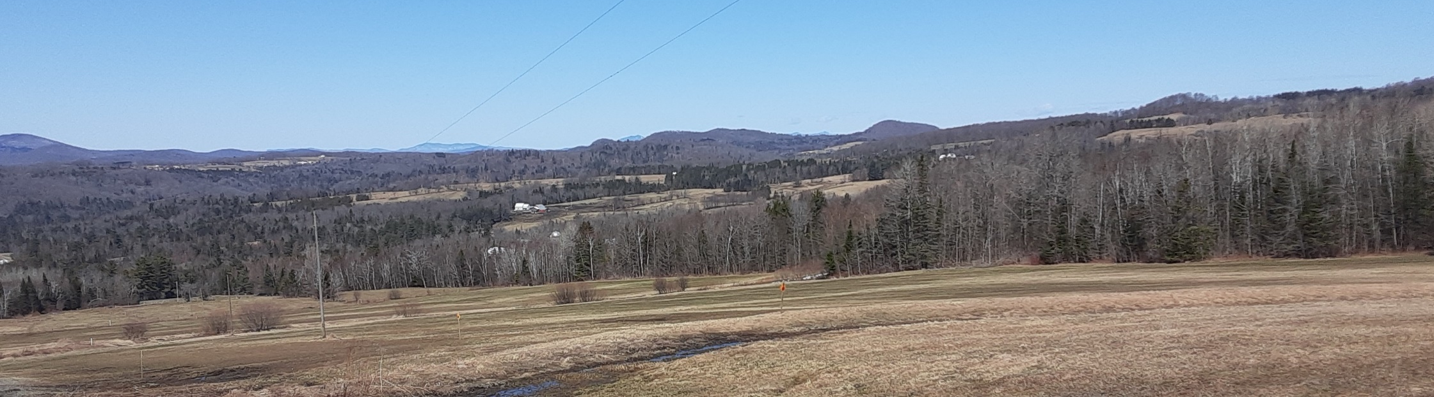
Cabot’s Hub + Spoke
Trail Network Master Plan and Implementation Program
August 17, 2020
Final Draft

Prepared for:

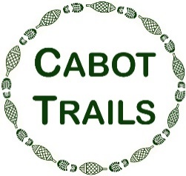

Town of Cabot, Vermont

Prepared by:


29 Main St, Suite 4
Montpelier, VT 05602

August 2020

Project funded with a Municipal Planning Grant
Agency of Commerce and Community Development
Department of Housing and Community Development

Contents
INTRODUCTION 1
Overview 1
Benefits of Trails 3
Purpose + Need of Developing a Trails Plan 4
The Planning Process + Engaging the Public 5
TRAIL PLANNING PRINCIPLES + GUIDELINE 8
Principles of Trail Planning + Design 8
General Trail Classifications 9
Regulatory + Permitting Considerations 11
CABOT’S HUB + SPOKE TRAIL NETWORK 12
Observations + Opportunities 12
Hub + Spoke Conceptual Trail Plan 15
Implementation Program 17
Resources 24
Funding Opportunities 24
Trail-related Organizations, Handbooks, + Manuals 26
Existing ConditionS 27
APPENDICES 45
Trail Design Standards 45
Public Recreation on Private Land Guide 45
Public Engagement Materials 45

Page left intentionally blank
INTRODUCTION
This Trail Plan is organized as follows:
Introduction: Background on benefits, purpose and need of developing a trail plan and the process of public engagement in plan development.
Trail Planning Principles and Guidelines: Considerations in trail planning (Principles and Guidelines) and background on general trail classifications.
Cabot’s Hub + Spoke Network: Description of the Hub + Spoke conceptual trail plan that connects a variety of recreation, historic, and scenic areas of town (the Spokes) to Cabot Village (the hub.) This section includes the 5-year Implementation Program for carrying out the Hub + Spoke trail plan - with objectives, implementation actions, partners, timing, and level of priority.
Resources: A description of funding opportunities and various guides, manuals, and trail handbooks that can be utilized to support trail development efforts.
Existing Conditions: A community profile that includes facts and figures about the town that are relevant to trail planning.
Appendices: Public engagement background and materials

Overview
The Town of Cabot has historically maintained recreation trails for the enjoyment of visitors and members of the community. Over time the existence of the trails became unknown to many. Through past planning surveys, Cabot residents have indicated that trails were the recreational feature they valued most. While past efforts have waned recent interest and resources have rekindled a renewed effort.
Following the planning and public engagement activities surrounding the development of 2019 Cabot Village Revitalization Strategy a new Cabot Trails Committee was formed. One of their initial tasks has been to outline a course of action toward the creation of a town wide trail network in Cabot.
In early 2019 the Cabot Trails Committee, in partnership with the Town of Cabot and the Cabot Community Association Cabot was awarded a Municipal Planning Grant to evaluate the constraints and opportunities of developing a non-motorized trail network to link the village center to regional networks and local recreation amenities.
Cabot’s Hub + Spoke Trail Network Master Plan serves as a conceptual guide or “blue print” for the development of an interconnected system of trails. The accompanying Implementation Program serves as the pathway for achieving the vision outlined in the master plan. Subsequent plans or preliminary designs will likely be needed for the full realization of new trail construction.

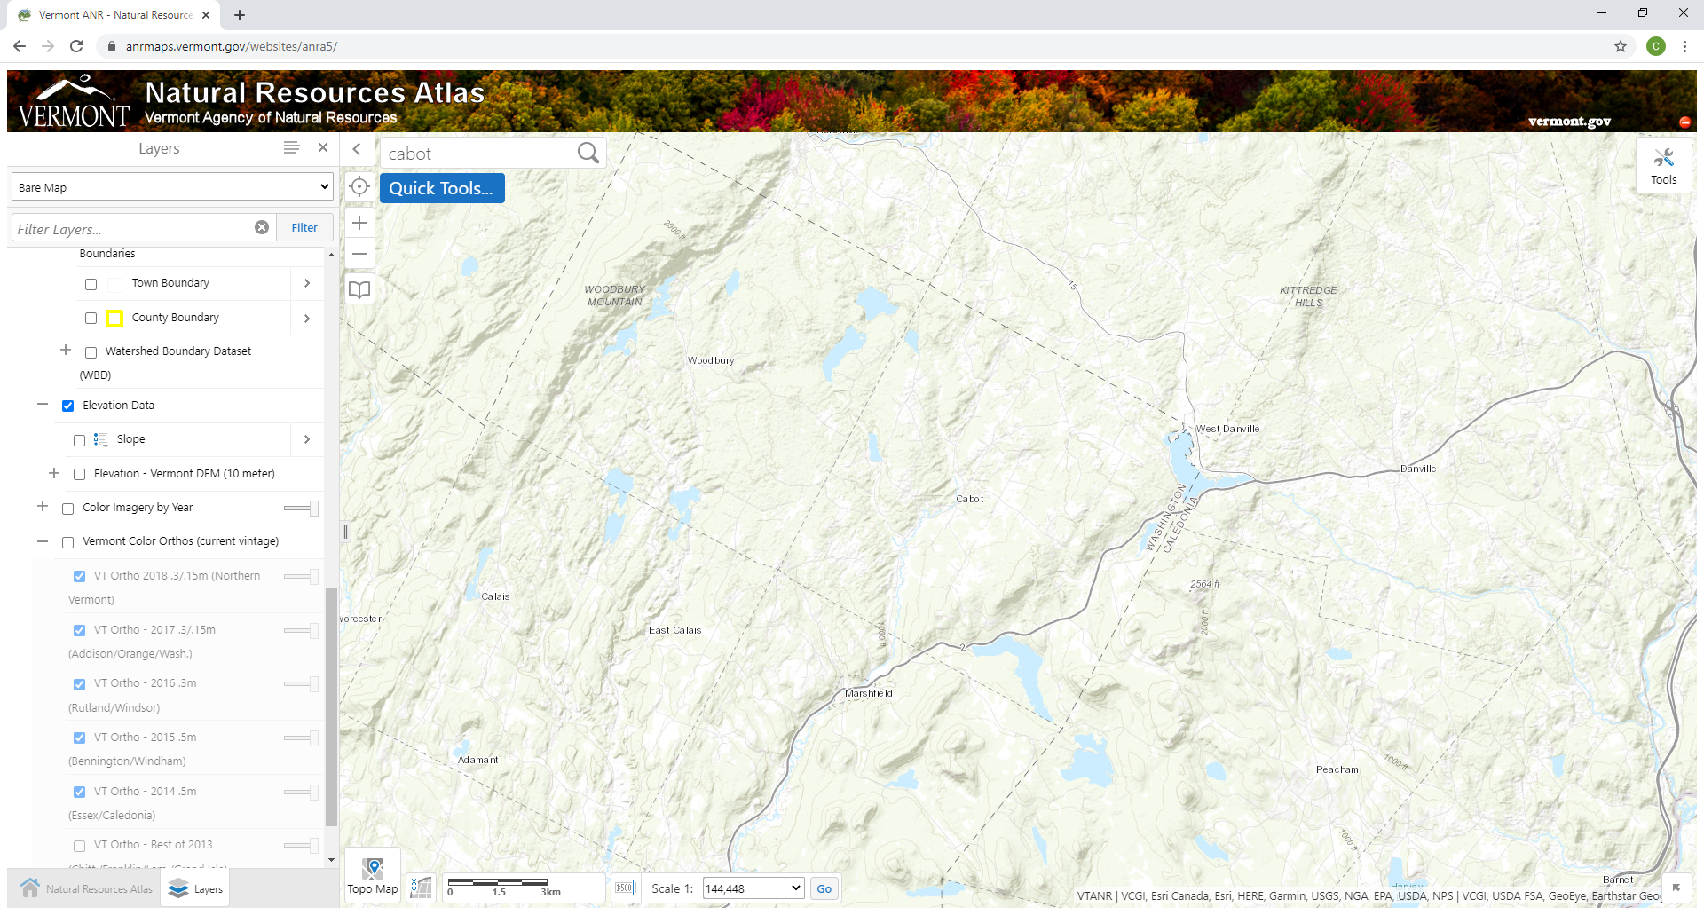

About Cabot

Located in the northeastern corner of Washington County, the Town of Cabot sits midway between St Johnsbury to the east and Montpelier to the west. The Town is about 36 square miles and encompasses the headwaters of the Upper Winooski Watershed.

Cabot has a handful of recreation areas and parks but few legal and legitimate public trails. It is located between two regional trail networks: the Lamoille Valley Rail Trail cuts across the northeast corner of town and the Cross Vermont Trail passes through Marshfield village located just to the south. Just across the town boundary to the northwest, trails in Woodbury provide public access to Nichols Ledge.
Cabot
to Montpelier
Cross VT Trail
Lamoille Valley Rail Trail
to St Johnsbury
Nichols Ledge

Benefits of Trails
Trails provide benefits to the individual trail user, the local economy, and the surrounding ecosystem. On an individual scale, trail development has been shown to improve health outcomes for rural residents, especially those at higher risk of inactivity as identified by the American Journal of Preventative Medicine. The Central Vermont Medical Center’s 2019 Community Health Needs Assessment stated the importance of physical activity for health outcomes of Washington County youth.
In Vermont the Department of Forest, Parks and Recreation has identified that trail usage contributes $15 million annually to the State economy through spending on Food & Drinks, Lodging, and Transportation, and attracts over 400,000 trail users to the State every year.

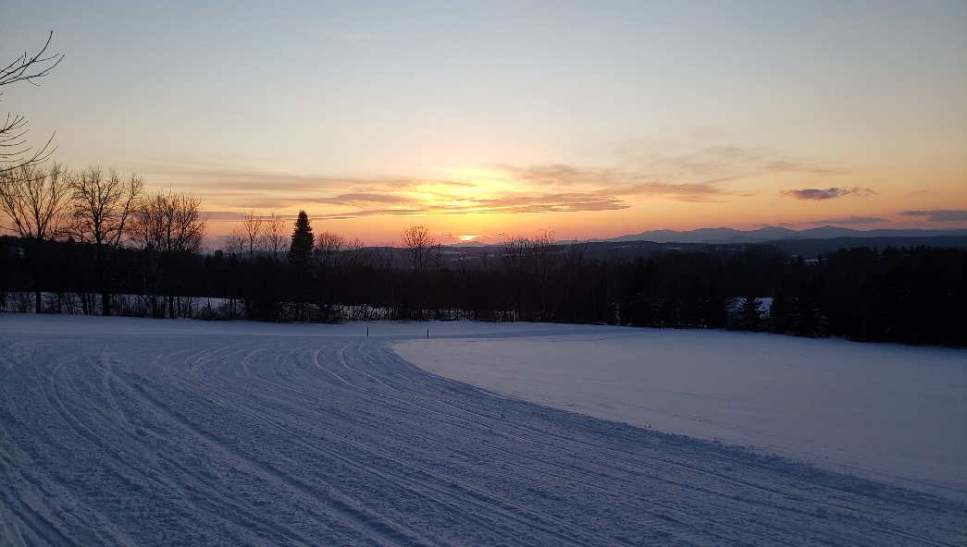
On a community scale, trail development is a key part of bolstering the recreational economy, which can be split into the outdoor recreation equipment and trip and travel expenses. A nationwide study by Rails-To-Trails Conservancy estimated that public investment in trails could result in a $138.5 billion economic benefit annually.
From Top: Bikes in Cabot Plains; Cabot VAST Trails

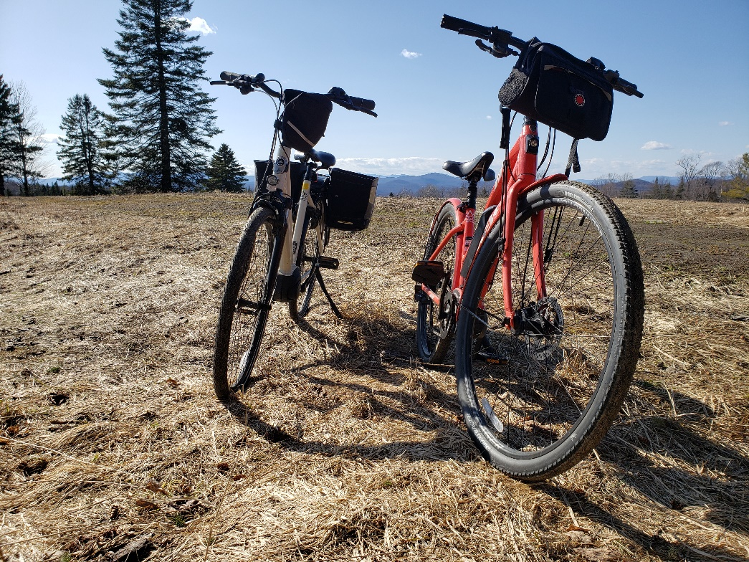
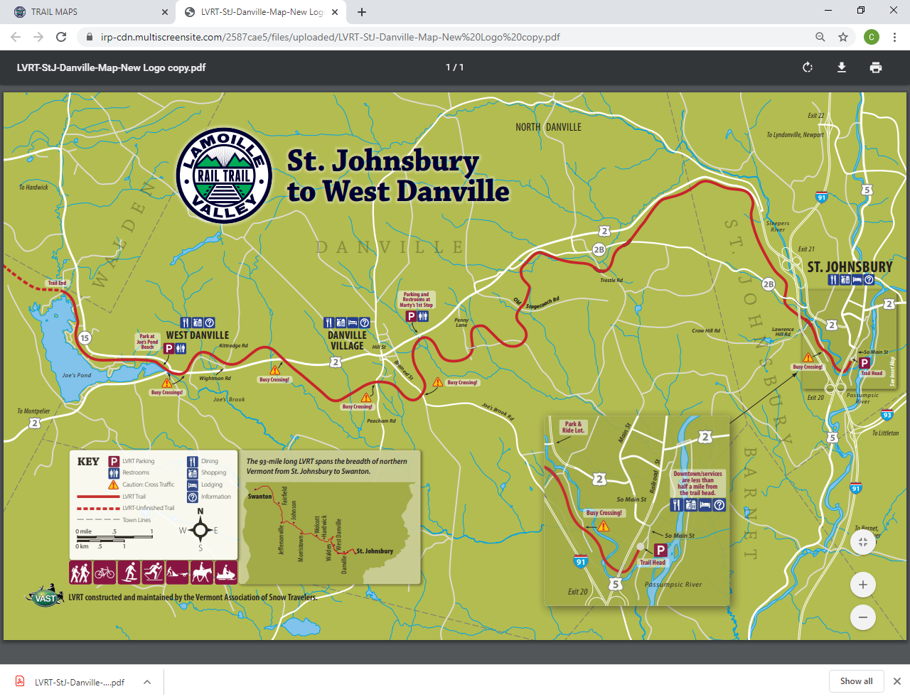
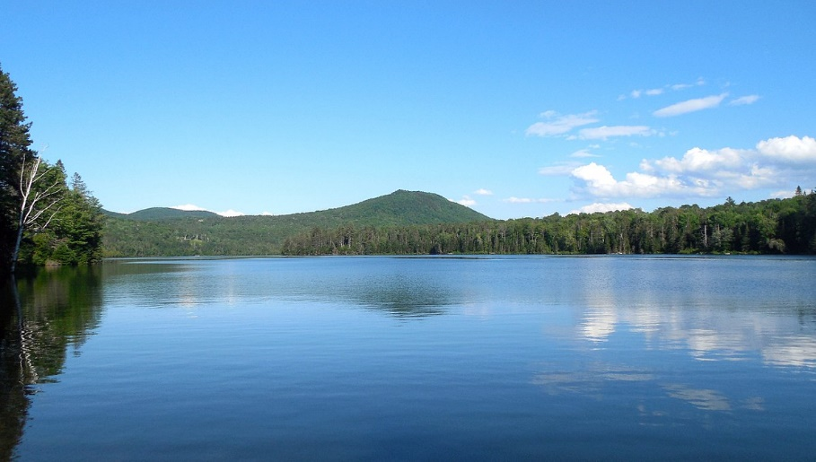
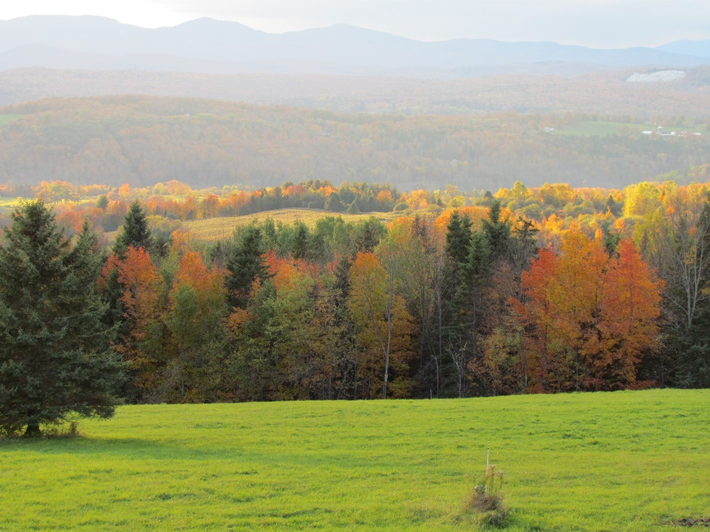

Purpose + Need of Developing a Trails Plan
The purpose of the Cabot Trail Plan is to evaluate the constraints and opportunities of developing a non-motorized trail network that will link the designated village center to regional networks and/or local recreation amenities. The Trail Plan will serve as a master guide or pathway for the Cabot Trails Committee to develop, manage, and maintain a public trail network.
The need of the Cabot Trails Plan is due to:
- The lack of an interconnected, accessible, trail system that is designed for multiple uses or user types.
- The lack of a trail system that has the potential to promote village vitality, the local agricultural economy and other local businesses.
- The lack of extensive public lands for the development of trails.
- The lack of trail linkages between existing trails, informal trails, and the village.
- The lack of trail linkages between recreational assets in the area (such as the Cross Vermont Trail, the Lamoille Valley Rail Trail and Molly’s Falls Pond State Park.)
- Speeding vehicles and narrow shoulders on town roads pose safety concerns for cyclists and pedestrians.
From Top: View of Cabot; Lamoille Valley Rail Trail official map; Molly’s Falls Pond State Park

The Planning Process + Engaging the Public
Over the course of the project, the public was kept informed of the development of the trails plan via various outlets and engagement opportunities. Public forums were held to coincide with key milestones throughout the process and serve to ensure public input had been solicited.

Public Meetings + Events
Date | Public Meetings + Events | Summery Description
May 18, 2019 | Talking Trails Breakfast | Presentation of the project to the community and breakout sessions to gather feedback on favorable trail locations and destinations.
July 4, 2019 | Fourth of July Parade | Participation in community celebration to raise awareness about the project. Committee members marched in the parade holding a trails banner and staffed an informational table about the project.
October 26, 2019 | Landowner Breakfast | Presentation of the project to landowners and breakout sessions to build partnership and gather feedback on landowner concerns.
May 2019 – August 2020 | Trail Committee public meetings | Monthly meetings to discuss progress of the project and provide updates on landowner partnerships.
September XX, 2020 |  | Insert info

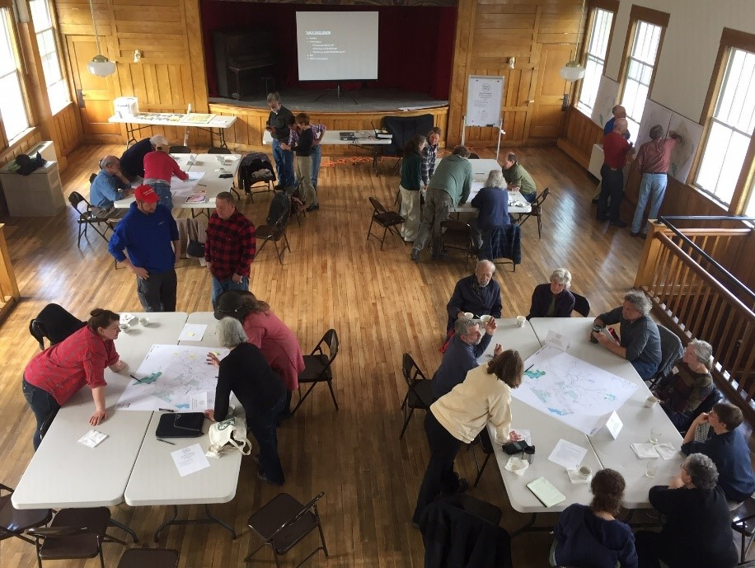
Numerous articles were published in the Cabot Chronicle a bi-monthly newspaper delivered, free of charge, to every household within and around the Town of Cabot. Articles advertised upcoming public events and also informed the public of how the project was progressing.
Talking Trails Breakfast, May 18, 2019

Talking Trails Breakfast - Around thirty residents attended, representing a number of interests, viewpoints and areas in town. Participants discussed priorities, concerns, trails they would like to see, informal trails they know about, and more. After some breakout discussions at each table marking maps and talking through ideas and concerns, a brief presentation of each map was made to the group.

A number of common areas were identified as either favorable to trails or already having informal networks that could potentially be developed. These included the Coits pond area, areas close to the village center, connecting to the Lamoille Valley Rail Trail, access to Molly’s Falls and more. A number of others expressed interest in opening their land for public trail development. Discussion followed about trail usage, types, etiquette, and resources to develop and maintain trails.

Landowner Breakfast - In total, eighteen residents from Cabot were present, including seven members from the Cabot Trails Committee. The meeting used a world café style format with a total of four tables. Each table was set up with a map showing the destinations and potential trail corridors that were identified at the first community meeting. Each table was facilitated by a member of the Cabot Trails Committee.

The meeting started with a joint presentation on the project, the Purpose and Needs statements, and the importance of landowner partnerships in Cabot to develop trails. Greg Weston, from the Cross Vermont Trail Association spoke about experiences working with landowners to develop trails. After the presentation the meeting moved into an open discussion on issues and concerns for the landowners. Some of the topics included: utilization of web resources to find trails in area; other community examples; landowner permission forms, relationships, and needed protocol; trail signage, etiquette, communication, publication, and seasonal usage; and also trail maintenance.

Cabot Trail Committee meetings - During the course of the development of this plan the Cabot Trails Committee met on a monthly, sometime bi-monthly basis to plan outreach to private landowners, coordinate field work and provide input on the trails plan. The Committee has started the process of securing agreements with a few landowners and has identified potential new short trail segments. Input from public meetings informed the determination of trail destinations and points of interest. Working with private landowners and consideration of existing and historic trails informed the identification of Possible Connections and Future Linkages as depicted on the conceptual trail map.

Place holder for descriptions of:
Last public outreach

Outreach Materials
To supplement the public meetings and events a collection of resource documents were compiled to aid the Cabot Trails Committee in building landowner partnerships. The “Meeting in a Box” contains among other items project background information, a list of frequently asked questions, and a sample trail permission form and maintenance agreement. The Trails Committee has started to use these materials to engage willing landowners who are eager to host public access on their land. The contents for the Box are contained within the appendix.

TRAIL PLANNING PRINCIPLES + GUIDELINE

Principles of Trail Planning + Design
- Understand trail use first – before laying out a trail alignment, define the specific user of the trail to ensure appropriate trail widths and grades.
- Recognize existing trails may not be designed for users of today or tomorrow – alignment and layout of Class 4 Roads and Legal Trails may traverse steep stopes and may have been historically constructed without recognition of ecologically sensitive areas.
- Highlight natural features and points of interest – identify unique destinations (such as scenic views of geologic formations) or places of interest along the trail to create a site specific trail experience.
- Plan with wildlife in mind – consider sensitive wildlife habitat or agricultural operations along the trail. Strive to make the trail wildlife friendly by thinking of the trail in terms of a corridor. Consider the swath of impact approximately 100 ft on either side of the trail alignment. Be aware of conflicts which often arise between animals and trail users such as equestrians and mountain bikers. (Horses can be startled by cyclists, causing injury.)
- Avoid impacts to ecologically sensitive areas – locations such as wetlands, rare species breeding areas, and significant natural communities are integral to the health of the environment and contribute to biodiversity. Ensure trail development doesn’t interfere with these important natural functions.

- Balance distance and elevation change – long distance trails with steep uphills can exclude many potential trail users, except the few committed outdoor enthusiasts. Within a trail network include a range of trail segment distances for various abilities.
- Plan for multi-objectives trails - consider how trails may serve not only multi-users but also multi objectives: alternatives to traditional modes of transportation (why go by car if you can walk?), opportunities for increasing physical activity for health and wellness, preservation of undeveloped river and stream buffers and floodplains for natural hazard protection.
- Integrate trail plans into existing documents – a variety of funding sources may be accessed to develop trails and related infrastructure, be sure to integrate trail-related development and improvements into transportation, recreation, and open space policies (such as those contained within the town plan) to demonstrate the multi-purpose benefits and eligibility for additional funding.
- Ensure timely, effective and regular communications with private property owners - Due to the relatively limited amount of public land in Cabot, the development of an extensive trail network will rely upon the willing participation of private property owners. In return, landowners should expect timely, effective and regular communications to monitor trail use and maintenance issues and concerns that may arise.

General Trail Classifications
 | 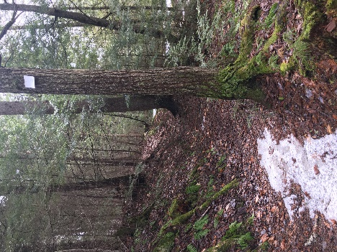  Minimally Developed Fully Developed | 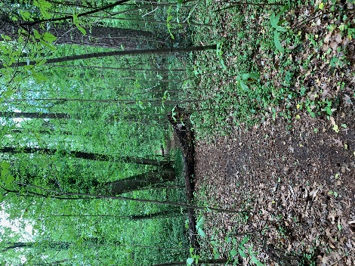 | 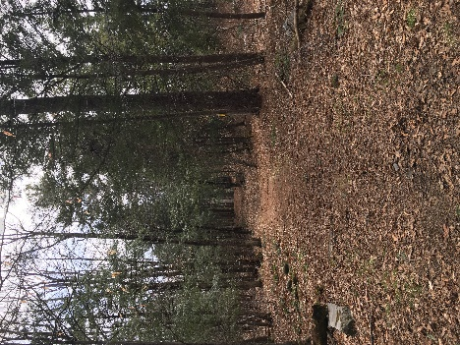 | 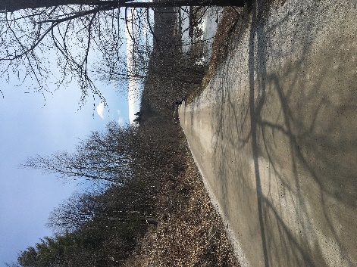 | 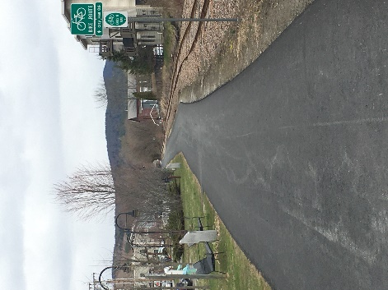
Uses | Hiking | Hiking  Mountain Biking  Snowshoeing | Hiking  Mountain Biking  Snowshoeing  Cross Country Skiing | Hiking  Mountain Biking  Snowshoeing  Cross Country Skiing  Bicycle  Accessible | Multi-Purpose  Accessible
Level of Use | Low level use.  Trail challenging and typically for mid- to highly skilled users. | Low level use.  Trail challenging and typically for mid- to highly skilled users. | Moderate use.  Moderately easy travel with short intervals of challenges. | High Use.  Users with minimal skill and experience.  Easy travel with none, or very limited challenges.  Fully accessible. | Moderate to High Use.  Users with minimal skill and experience.  Easy travel with some challenges to accommodate connections.  Fully accessible.
Features + Elements | Only structures are those where protection of trail infrastructure is necessary. | Structures are minimal, and when needed are limited in size, scale and number.  Structures where protection of trail infrastructure is necessary.  Natural drainage and infiltration practices applied.  Primitive foot crossing where needed. | Structures may be common.  Limited drainage structures and infiltration practices applied.  Generally native materials used.  Trail bridges as needed for resource protection and appropriate access. | Structures present and substantial.  Trail infrastructure meets ADA requirements.  Substantial trail bridges are used at water crossings.  Drainage structures are present. | Structures are present and may be continuous.  Trail infrastructure meets ADA requirements.  Drainage structures are present and frequent.
Amenities | None, limited, infrequent for safety or resource protection purposes.  Trailheads and/or visitor services limited or none. | None, limited, infrequent for safety or resource protection purposes.  Trailheads and/or visitor services limited. | Limited for safety or resource protection purposes.  Trailheads and/or visitor services present with limited amenities. | Amenities exist for safety or resources protections.  Trailheads and/or visitor services are present with full amenities. | Amenities exist for safety or resources protections.  Trailheads and visitor services are present with full amenities. Also supported by amenities of adjacent trails
Signage | Minimum for basic direction. | Minimum for basic direction.  Limited for resource protection.  Limited interpretive signs. | Present for regulations and resource protection.  Directional signs at junctions or when confusion is likely.  Limited interpretive signs. | Present for regulations and resource protection.  Directional and park informational signs.  Interpretive signs. | Directional, safety and informational signs are present.  Table adapted from U.S. Forest Service trail classifications

Regulatory + Permitting Considerations
Improvements to existing trails and new trail construction may require permit approvals at the State and/or local level and consideration given to the following regulatory concepts:
- Avoid or limit impacts on historic and ecologically sensitive areas (such as wetlands, vernal pools, areas with Rare, Threatened, and Endangered Species and archeological importance.)
- Ensure riparian buffers are maintained or installed along trail segments which parallel surface waters or other ecological sensitive drainage areas.
- Limit surface water crossings and plan crossings at the narrowest points.

4’ to 8’
soft surface trail

- Provide adequate erosion control and drainage techniques are employed during construction and maintained regularly.
Prior to construction, grading, or placement of fill check with the local zoning administrator and the state permit specialist. All regulatory requirements should be identified when in the planning and design phase of specific trail construction.
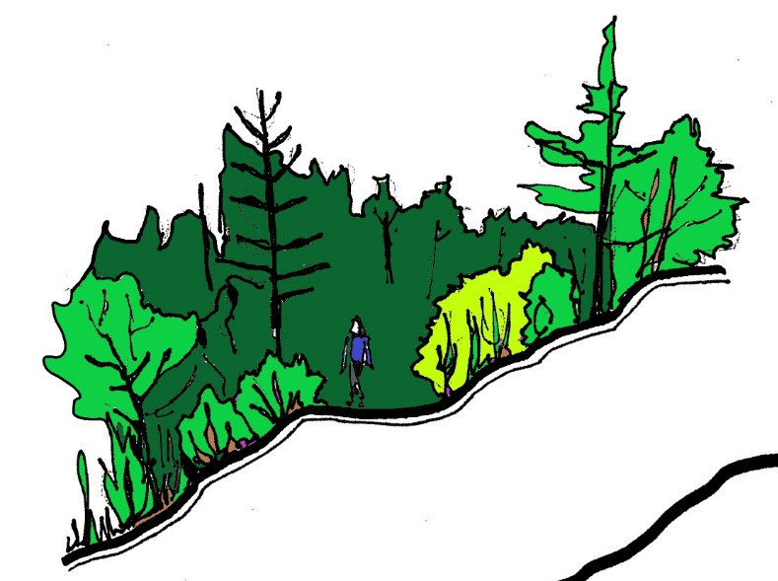

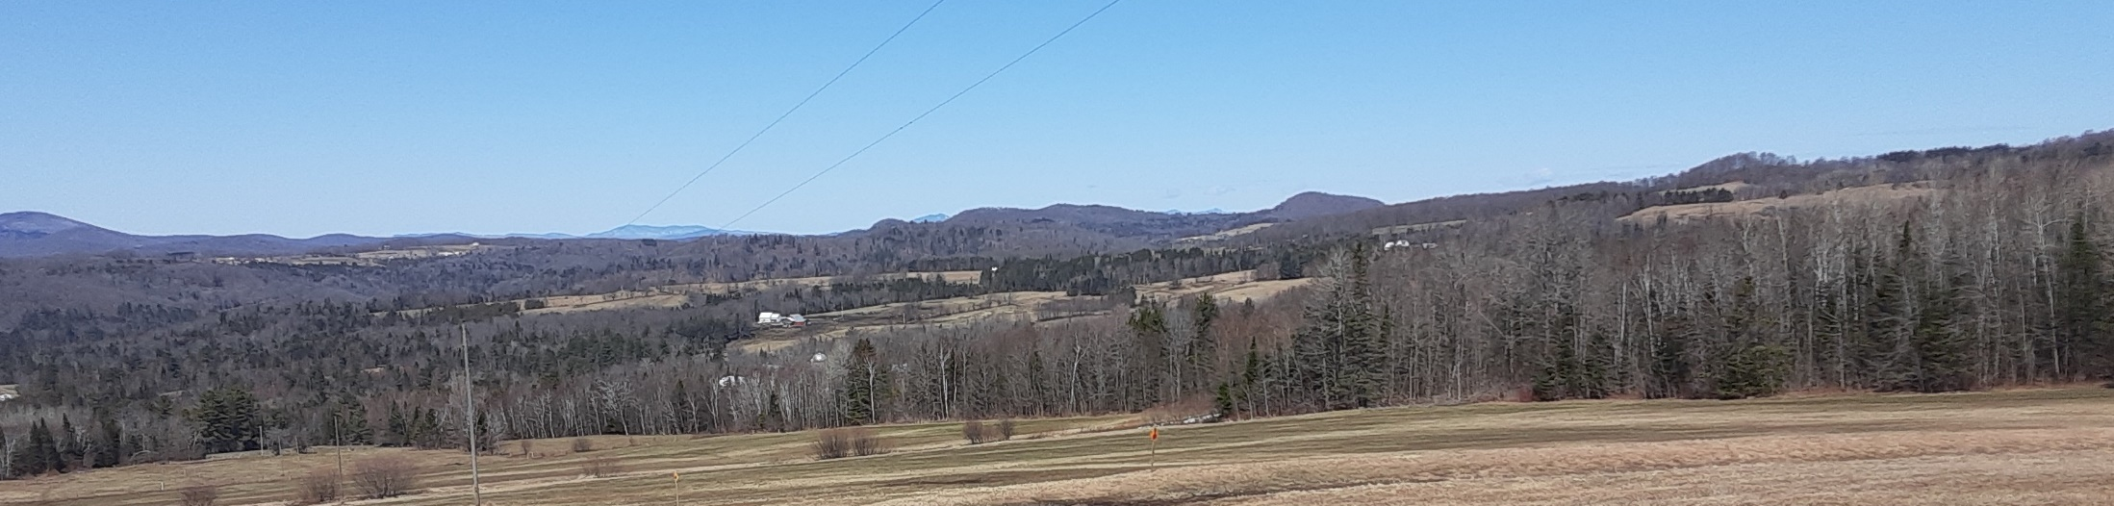
Views from the Cabot Winter Trail

CABOT’S HUB + SPOKE TRAIL NETWORK

Observations + Opportunities
Located in the northeastern corner of Washington County, the Town of Cabot is approximately midway between St Johnsbury to the east and Montpelier to the west, and encompasses the headwaters of the Upper Winooski Watershed. The Cabot Creamery draws many visitors to town, and local efforts are underway to attract those visitors to other local businesses in the area. The town has a handful of recreation areas and parks but few legal and legitimate public trails. The town sits between two regional trail networks: the Lamoille Valley Rail Trail to the northeast and the Cross Vermont Trail to the southeast. Additional trails are located to the northwest in the Town of Woodbury.
Based upon an analysis of Existing Conditions and incorporation of the input from the Public Engagement Process the following observations and opportunities exist for development of trails system in Cabot:
Due to the relatively limited amount of public and municipal land across the town, the development of an extensive trail system in Cabot will rely on willing participation by private property owners. The existing trail system is for the most part comprised of Class 4 Roads, Legal Trails and informal or unsanctioned access on private property.
Class 4 Highways and especially Legal Trails (as identified on the VTrans Highway Map) present the greatest opportunity to be used and integrated into a formal four-season trail system. With voluntary land owner permissions, use of private roads, discontinued roads and informal trails may provide opportunities for the establishment of new public trails. Overhead utility right-of-ways (ROWs) throughout Cabot could also potentially be used as trail corridors.
Linking a local trail system to the Lamoille Valley Rail Trail in the northeast quadrant of town offers the possibility to increase non-motorized access to neighboring points of interest, including Danville and St Johnsbury to the east and Hardwick to the northwest. Similarly, partnering with the VAST organization and the Rails to Trails Conservancy may provide another opportunity to expand the local trail system.
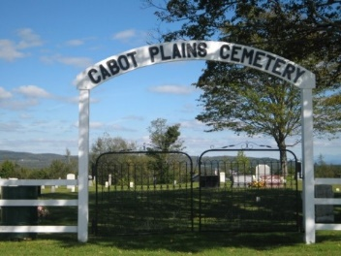
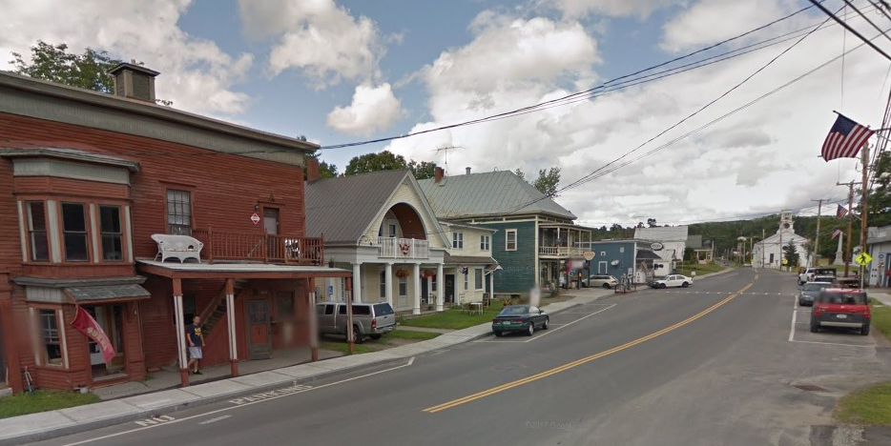
Due to its historical existence, reestablishment and formalization of the Winter Trail (particularly the Old Town Loop and the extension to Dubray Road) is likely a welcome first step in the development of a trail system in Cabot.
Cabot Plains Cemetery
Cabot Village
The existing sidewalk network is limited to the village core. There are no bike lanes or bike paths. Speeding vehicles and narrow shoulders on many roads has been identified as a safety hazard to bicyclists and pedestrians alike. The town has identified the lack of a walking and bike path between the village and the recreation fields; and along Route 215 to the Lower Village.
Integration of Complete Street policies into State and municipal transportation projects will help ensure consideration of all modes of users including pedestrians and bicyclists on paved highways. Development of a trail or path separate from the main highways would greatly increase safety.
Limiting crossings of State Highways is a significant factor to ensure trail user safety. Crossing Route 2 will be necessary in the establishment of a trail connection from the village to Molly’s Falls Pond State Park. Working in partnership with the Agency of Transportation will be integral to overcome this obstacle.
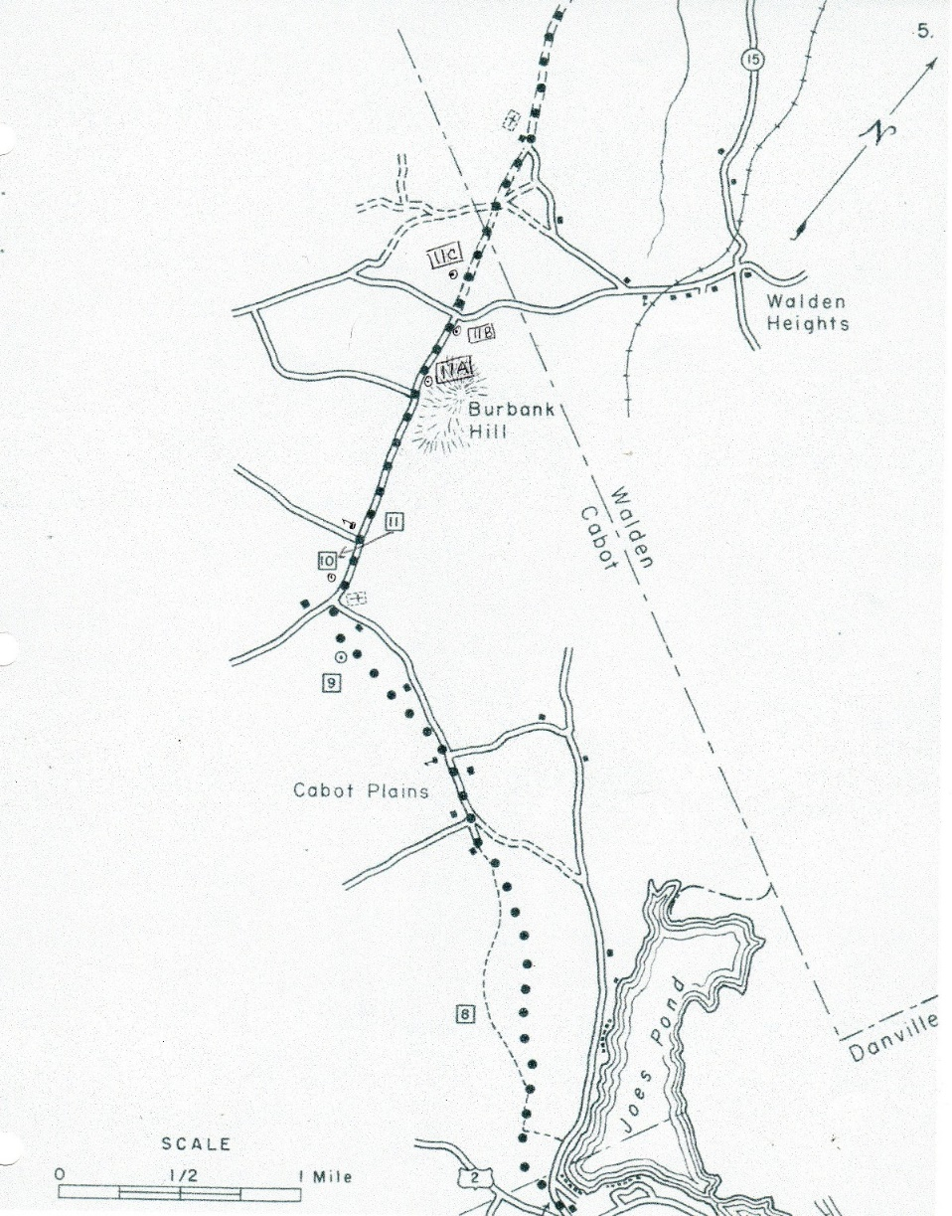
Both the 2017 Town Plan and the 2018 Cabot Economic Revitalization Strategy identify the local economic value of developing a trail system for its recreational opportunities to residents and visitors alike. Cabot’s significant historic areas and agricultural history have already been identified as places of interests and a trail system linking together historic settlement areas of the village, Cabot Plains and the Old Town Center with agricultural lands and land-based businesses presents opportunities for a unique and scenic recreational experience.
Historic Bayley-Hazen Road route
Cabot values its natural resources. The development of trails and related infrastructure should be sensitive to areas of ecological value while providing the opportunity for the public to appreciate its scenic qualities. This includes avoiding the destruction of significant habitat; not contributing to habitat fragmentation; limiting the disruption of wildlife movement, migration, and behavior; and not degrading water quality and aquatic habitat. It has already identified that the alignment of the Legal Trail connecting Urban Road to Bolton Road currently passes through a mapped wetland. This conflict is an obstacle which can be overcome by either re-routing the trail or possibly constructing a boardwalk or similar structure.
Opportunities exist to co-locate parking for trail users at municipal- and state-owned properties and additional locations may also need to be identified in order to distribute trail users across the system. In the village it will be necessary to work closely with the Town to identify trail-related parking doesn’t negatively impact existing businesses.
A sustained community commitment to trail-related efforts will be necessary to ensure the continued maintenance and development of local trail network. Partnerships with the municipality, the Planning Commission and the Cabot Community Association are integral to attainment of the overlapping goals of the town plan and the revitalization strategy. Development of a “friends of the trails”/ trail steward network can help foster the careful construction and maintenance of the trail system.

Hub + Spoke Conceptual Trail Plan
Goal: Establish, maintain and expand an inter connected, four-season, non-motorized trail system throughout Town that links the village center with existing recreational, scenic, and historic resources for the enjoyment of Cabot residents and visitors.
Objectives:
- Utilize Class 3 and 4 roads and legal trails where ever possible.
- Recruit willing private landowners to allow public trails on private property.
- Prioritize trail linkages from the village to the town forest, to the Lamoille Valley Rail Trail, and to Molly’s Falls Pond State Park.
- Create trail linkages to historic points of interest, including Cabot Plains, the Bayley Hazen Road and Cabot Center.
- Plan for additional linkages to agricultural and land based businesses as additional points of interest or destinations.
- Ensure trails are well marked, well maintained and user protocols are clearly communicated.
- Develop trails which are accessible to all non-motorized user types.
- Respect ecologically sensitive areas in the development and management of the trail system.
- Work closely with the municipality, State, and private landowners to evaluate appropriate locations for trail user parking.
- Sustain capacity and support for trail-related efforts.

Hub + Spoke network of trails connects a variety of recreation, historic and scenic area to the village hub.

Historic area

Village

Scenic area

Recreation area

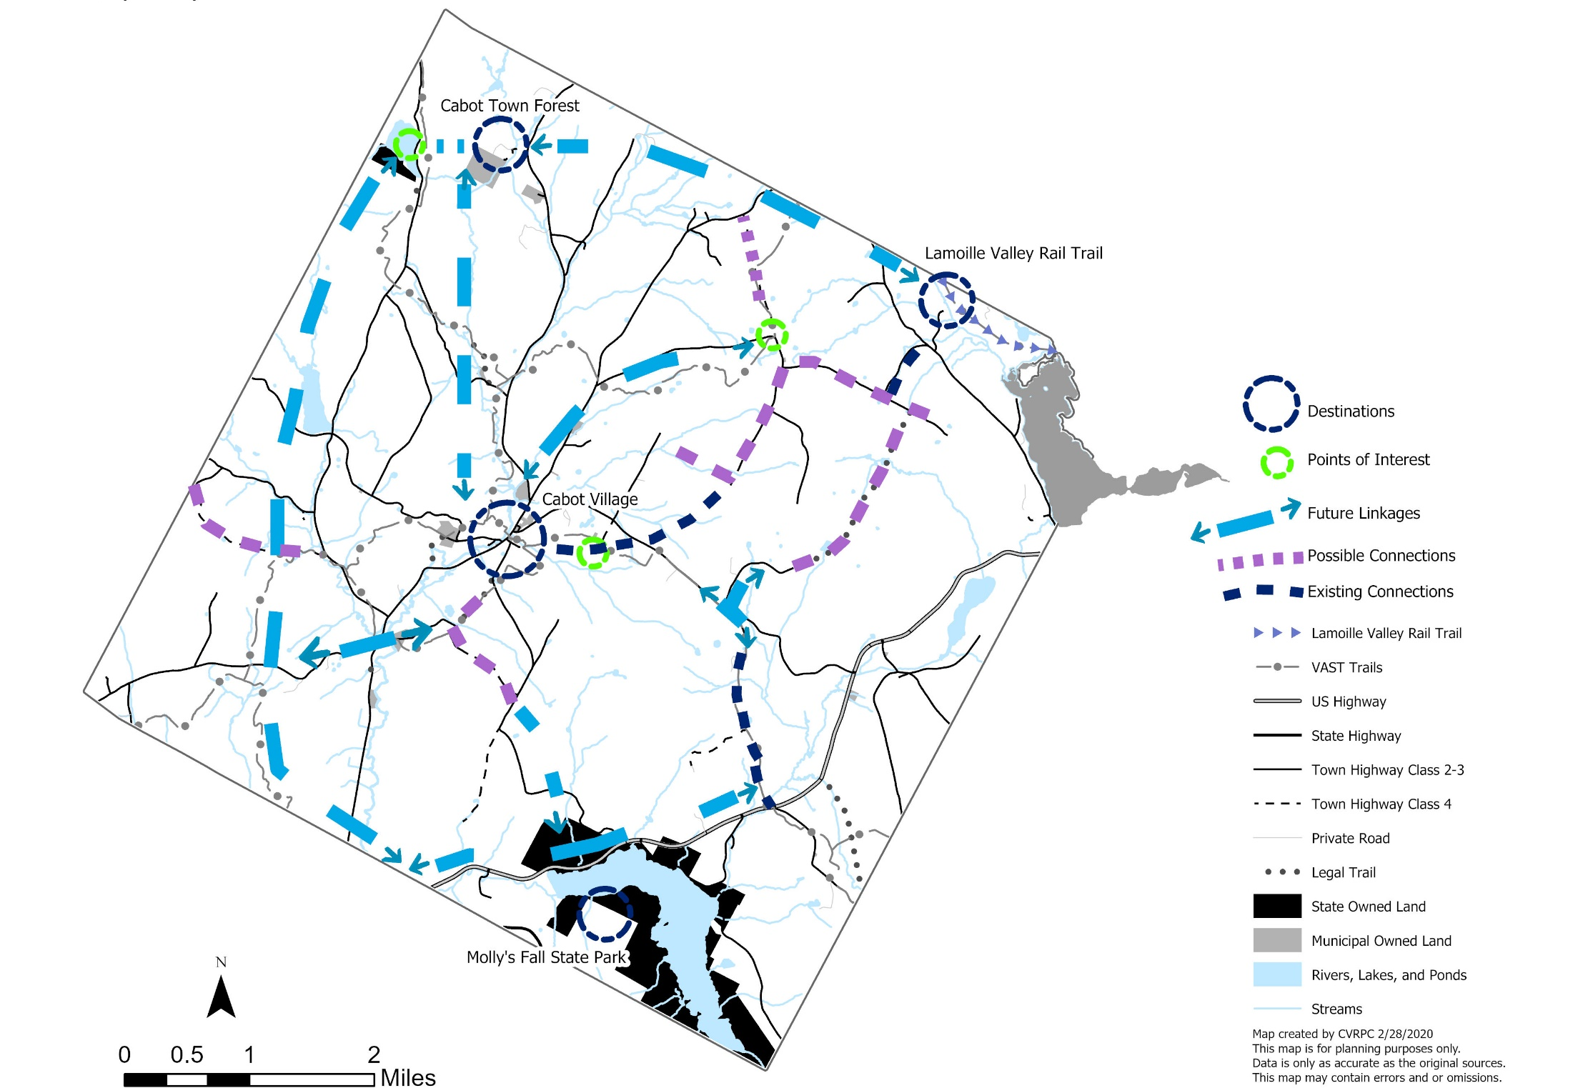

Implementation Program
Estimated Cost: $=low cost, $$=medium cost, $$$ = high cost, $$$$ = very high cost
Timing: Short Term = 1-2 years, Medium Term = 3-5 years, Long Term = 5-10 years
Objective | Implementation Action | Recommended Partner | Estimated Cost | Timing | Priority
1. Utilize Class 3 and 4 roads and Legal Trails where ever possible. | a. Evaluate all Legal Trails in wet and dry conditions and inventory any areas of significant erosion or obstacles which would infringe of trail usage. | Road Commissioner, Conservation Commission | $ | Short Term | High
 | b. Evaluate all Class 4 Roads and Legal Trails and determine appropriate user groups based upon widths and grades (See "Guidelines for trail use.") | Road Commissioner | $ | Short Term | High
 | c. Evaluate Class 3 roads for safe shoulder widths for viable trail connectors. | Road Commissioner | $ | Med. Term | High
2. Recruit willing private landowners to allow public trails on private property. | a. Match landowners with potential trail opportunities. | Lister | $ | On-going | High
 | b. Utilize Meeting-in-Box to recruit participation by willing landowners. | Friends of the Trails | n/a | Short Term | High
 | c. Maintain landowner agreements and maintain regular landowner communication. | Town Clerk | $ | On- going | High
 | d. Create, maintain and update trail maps to share with interested landowners. | CVRPC | $-$$ | On-going | High
 | e. Plan annual landowner recognition and annual public meeting events. | Select Board, CCA, local businesses | $$ | On-going | High
3. Prioritize trail linkages from the village to the town forest, to the Lamoille Valley Rail Trail, and to Molly’s Falls Pond State Park. | a. Establish a local trail linkage to the Lamoille Valley Rail Trail. | LVRT, private landowners | $ | Med. Term | Medium
 | b. Partner with regional groups to coordinate trail linkage between the Lamoille Valley Rail Trail and the Cross VT Trail (in Marshfield) | CVRPC, Northeast Rails to Trails Conservancy (Northeast Office), Cross VT Trail Association | $ | Med. Term | Medium
 | c. Investigate potential usage of seasonal trails for year round use. | VT Association of Snow Travelers (and local VAST chapter), Private Landowners | $ | Short Term / on-going | Medium
 | d. Identify a RT2 pedestrian crossing to Molly's Falls Pond State Park. | VT Agency of Transportation, Road Commissioner, CVRPC | $$-$$$$ | Med./ Long Term | Medium
 | e. Advocate for the development of trails on State Lands. | VT Department of Forest, Parks and Recreation | $ | Med. Term | Low
 | f. Complete trail system on town forest property. | friends of the trails | $-$$ | Short Term | High
 | g. Plan connector trail between town forest and Coits Pond. | Select Board, VT Department of Forest, Parks and Recreation, Private Landowners | $-$$ | Med. Term | Low
 | h. Advocate and support municipal efforts to establish trail linkages between recreation fields and the village. | Planning Commission, Select Board, school | $ | On-going | Medium / High
 | i. Investigate legal alignment and conduct outreach to adjoining property owners for establishing trail use of the Urban Road Legal Trail. | Private Landowners | $ | Med. Term | Low
4. Create trail linkages to historic points of interest, including Cabot Plains, the Bayley Hazen Road and Cabot Center. | a. Re-establish the green and yellow Winter Trails ("Old Town Center Loop" and the connector to Dubray Road) for year round use. | Historical Society, Private Landowners | $-$$ | Short Term | High
 | b. Inventory and collect information about historic points of interest for future interpretive signs and/or trail map information. | Historical Society | $ | Med. Term | Low
5. Plan for additional linkages to agricultural and land based businesses as additional points of interest or destinations. | a. Identify and map agricultural and land-based businesses. | Working Lands Committee, CCA, CVRPC | $-$$ | Med. Term | Low
 | b. Prioritize outreach to identified agricultural and land-based businesses based upon proximity to conceptual trail alignments for willingness to host public trail access. | CCA, Private Landowners | $ | Long Term | Low
6. Ensure trails are well marked and well maintained and user protocols are clearly communicated. | a. Develop a management and maintenance plan and program for the trail system. | Other Trail Organizations | $$ | Med. Term | Medium
 | b. Develop a Friends of the Trails program to involve community members and assist with trail maintenance. | Private Landowners | $ | Short Term | High
 | c. Coordinate the design and development of trail signs and trail markers with other municipal and community branding efforts. | CCA | $$ | Med. Term | Low
 | d. Develop a web presence to share information about the trail system. | CCA, municipality, friends of the trails | $$ | Med. Term | Medium
 | e. Develop a trail map for trail users. | CVRPC, TrailFinder, CCA | $-$$ | Short Term | High
 | f. Host a trail maintenance workshop for trail stewards. | Other Trail Organizations | $$ | Med. Term | Low
7. Develop trails which are accessible to all non-motorized user types. | a. Plan trail segment which is accessible for the residents living at the Cabot Commons Senior Housing. | Cabot Commons Property Manager | $$-$$$$ | Long Term | Low
 | b. Advocate for trails built between the village and the recreation fields to meet federal accessibility standards. | Planning Commission, Select Board | $$$-$$$$ | Long Term | Low
 | c. Identify and plan routes for bicyclists and mountain bikers. | Road Commissioner, Private Landowners | $-$$$ | Med. Term | Medium
8. Respect ecologically sensitive areas in the development and management of the trail system. | a. Investigate extent of wetland on Urban Road Legal Trail and identify appropriate trail alignment. | Conservation Commission, Adjoining Private Landowners | $-$$$ | Long Term | Low
 | b. Incorporate findings of local natural resource inventory into trail planning efforts. | Conservation Commission | $ | Long Term | Medium /Low
9. Work closely with the municipality, State and private landowners to evaluate appropriate locations for trail user parking. | a. Meet with the Selectboard to identify possible parking location to access the town forest. | Select Board, Road Commissioner, Private Landowners | $ | Med. Term | High
 | b. Upon establishment of trail heads on Class 3 or Class 4 Roads ensure a parking plan is also identified. | Select Board, Road Commissioner, Private Landowners | $-$$$ | Med. Term | Medium
10. Sustain capacity and support for trail related efforts. | a. Actively work to continue funding on-going projects through grants and fund raising efforts. | Select Board, CCA | $ | On-going | Medium
10. Sustain capacity and support for trail related efforts. | b. Consider an annual request for trails funding be added to the municipal budget | Select Board | $ | On-going | Medium
10. Sustain capacity and support for trail related efforts. | c. Conduct nature walks (bird walks, tracking walks) on trails for all ages. | Conservation Commission, School | $-$$ | Long Term | Low
10. Sustain capacity and support for trail related efforts. | d. Continue to help coordinate and co-host the Ride the Ridges bicycle community event. | CCA | $ | On-going | Medium
10. Sustain capacity and support for trail related efforts. | e. Develop a nature interpretive trail to draw attention to trail efforts. | Conservation Commission, School | $$ | Long Term | Low

Resources

Funding Opportunities

Better Connections Program (BCP) - The program supports implementation-focused, municipal planning initiatives that: provide safe, multi-modal and resilient transportation systems that supports the Vermont economy; support downtown and village economic development and revitalization efforts; and lead directly to project implementation. The program has been used for trails and active transportation master plans, village connection planning and other multi-modal planning efforts. http://vtrans.vermont.gov/planning/projects-programs/better-connections

Cabot Community Fund (CCF) - Funding to support community based projects and events. The CCF is funded by the generous support of the Cabot Creamery. https://www.cabotvermont.org/cabot-community-fund-ccf/

Land and Water Conservation Fund (LWCF) - Matching grants to help local communities enhance the outdoor recreation resources on public land. Eligible projects are acquisition of land for parks and public outdoor recreation or development and/or renovation of existing facilities for outdoor recreation. https://fpr.vermont.gov/land-and-water-conservation-fund

Municipal Planning Grant Program (MPG) - Grants available for a range of municipal planning projects including trail networks, walking and biking improvements, and village and neighborhood planning. Local match required. http://accd.vermont.gov/community-development/funding-incentives/municipal-planning-grant

Northern Border Regional Commission Grants (NBRCG) - Projects must focus on the following program areas: transportation infrastructure, basic public infrastructure, telecommunications infrastructure, workforce develop, entrepreneurship and business and technology development, resources and open space conservation, recreation and tourism, and renewable and alternative energy. http://accd.vermont.gov/economic-development/funding-incentives/Northern-Boarder-Regional-Commission

Recreational Facilities Grants Program (RFG) - Matching state grants for capital costs associated with the development and creation of community recreational opportunities. This program provides last gap funding for shovel ready projects. The program requires a match. https://bgs.vermont.gov/commissioner/building-communities-grants

Recreational Trails Program (RTP) - Funds to development and maintaining recreational trail projects. Grants funds support a wide range of trail activities and can be used for the following types of projects: construction of new trails or trail connections; construction of new trailhead areas/parking facilities; construction of trailside facilities; maintenance, renovation, or restoration of trails; improvements to signage or trail structures along the trail; assessments of existing trail conditions for accessibility and improvements; equipment; and trail-related educational projects. https://fpr.vermont.gov/recreational-trails-program

Transportation Alternatives Program (TAP) - Grant funding for programs and projects defined as transportation alternatives, including on- and off-road pedestrian and bicycle facilities, sidewalks, and bicycle infrastructure. Local match required. http://vtrans.vermont.gov/highway/local-projects/transport-alt

Vermont Arts Council Animating Infrastructure Grant (AIG) - Funds projects that integrate public art into existing or proposed infrastructure improvements, which could include buildings, recreational paths, parks, bridges, small-scale renewable energy projects, and water treatment facilities. http://www.vermontartscouncil.org/grants-and-services/organizations/animating-infrastructure

Vermont Community Foundation – General Grants (VCF) - A variety of grants are available to support projects to improve environmental sustainability, cultural heritage, social justice, historic preservation, and vitality of Vermont communities. http://www.vermontcf.org/Nonprofits/AvailableGrants.aspx

VHCB Local Conservation Projects (VHCP) - Funding to conserve natural areas, recreation lands, and historic properties. For public outdoor recreation projects, VHCB provides loans to enable the project to leverage other funds or grants in cases where local efforts to obtain sources of funding have been exhausted. VHCB also provides funding for feasibility analysis, project-specific capacity (i.e, engineering work, historic preservation analysis, and hazardous materials analysis). https://vhcb.org/our-programs/conservation/apply-for-funding

VTrans Bicycle and Pedestrian Program (BPP) - Funds for scoping, design, and construction of bike and pedestrian facilities, sidewalks, shared-use paths, and bike lanes. A local match is required and amount may vary. https://vtrans.vermont.gov/highway/local-projects/bike-ped

Trail-related Organizations, Handbooks, + Manuals

Cross Vermont Trail Association - a member based and volunteer driven non-profit organization dedicated to the competition of a 90-mile path connecting towns across the state from Lake Champlain to the Connecticut River. A portion of the trail crossed through neighboring Marshfield and can serve as a possible resource in local trail building efforts. https://www.crossvermont.org/index.php

Town Forest Recreation Planning Toolkit – Hosted by the VT Urban & Community Forestry Program the planning toolkit contains a wealth of information to assist communities in providing public access to municipal forests. Information contained within the Implementation Pod includes Parking Considerations, Trail Sign Guidance, an Index of Standard Recreational Improvement Costs, and Construction Plans and Designs for Trailhead Kiosks and Benches. https://vtcommunityforestry.org/node/4332

East Montpelier Trails, Inc (EMTI) – A volunteer non-profit organization working to build and maintain a network of trails in East Montpelier. The organization may serve as a potential resource to the Cabot Trails Committee and the formation of a Friends of the Trails program. https://emtrails.org/

Town of Underhill, VT Trail Handbook – Developed by a local Vermont trails committee, the handbook serves as a helpful template to help guide the development of a Cabot trail management and maintenance plan. https://www.underhillvt.gov/vertical/sites/%7B4E962BB9-B4BB-4504-A3EE-ED54521A1BCE%7D/uploads/Underhill_Trails_Handbook_Rev___2_July_2011.pdf

TrailFinder – a free interactive mapping site designed to help residents and visitors find trails across the State. With trail manger approvals, local trails may be uploaded onto the site along with trail-related information to provide accurate and essential information about local trails available for public use. https://www.trailfinder.info/

Rails to Trails Conservancy – A national organization dedicated to the creation of a nationwide network of trail from former rail lines. Website hosts a variety to trail related information and the Northeast Regional Office may serve as a resource in connecting the Lamoille Valley Rail Trail to the Cross Vermont Trail. https://www.railstotrails.org/

Vermont Trails and Greenways Manual - Published by the Vermont Trails and Greenways Council the manual is intended, in part to help trail groups in the preservation, maintenance and establishment of local trails. It covers a variety of topics including landowner and public outreach, the permit process and trail management, maintenance and stewardship. https://www.cccofvt.org/wp-content/uploads/2009/02/manual_final_0905.pdf

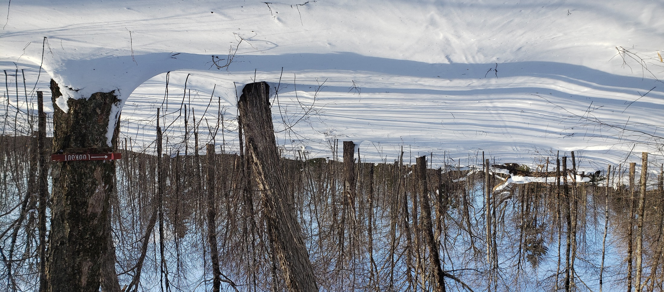
Existing ConditionS
Joe’s Hill, Cabot

Regional Context & Community Profile
Located in the northeastern corner of Washington County, the Town of Cabot is approximately midway between St Johnsbury to the east and Montpelier to the west, and encompasses the headwaters of the Upper Winooski Watershed which drains westward into Lake Champlain. Except for the irregular boundary at Joe's Pond, Cabot is square in shape, six miles on each side, a total of 22,325 acres. The Cabot Creamery attracts many visitors to town but many of those visitors do not venture beyond the flagship facility to patronize other local businesses. The town has a handful of recreation areas and parks but few legal and legitimate public trails. The town sits between two regional trail networks: the Lamoille Valley Rail Trail passes through the northeast corner of town and the Cross Vermont Trail passes through Marshfield village located just to the south of town. To the northwest just across the municipal boundary, trails in Woodbury provide public access to Nichols Ledge.
According to the 2010 census the population of Cabot is 1,433, representing an 18% increase in total population compared to the proceeding decade. However population estimates derived from the American Community Survey now indicate a declining population (2018 estimate 1,328) similar to statewide population trends. Census data illustrates an aging population with a shrinking population of school age children. The median household income in slightly lower than the State median and a majority of residents travel outside of town to work.

Community Snapshot
Size of Municipality (acres) | 22,325
Population | 1,433
Median Age | 43
School Age Children as % of population | 24.7%
% male / % Female | 50.1% / 49.9%
Median Household Income | $47,167
% of workforce that live in a different town | 63%
% Dwelling Units in Season /Recreational Use | 23%
Number of parks and recreation fields | 3
% of acres enrolled in Current Use | 53%
% of Acres owned by municipality | 0.5%
% of properties conservation easements | 9%
Miles of Trail | 4.5

Local Planning Efforts
2017 Town Plan
Updated in 2017, the Cabot Town Plan lays out a vision for Cabot which includes “a vibrant, compact village center surrounded by acres of open farmland and forest that contain ample recreational resources, majestic scenery, clean and bountiful waters, and historic features.” The plan further identifies specific goals which further support a trails network in Cabot:
- Improve non-motorized access from rural areas of Town to the village areas.
- Identify and ensure access to resources for various recreational activities.
- Capitalize on Town’s scenic, recreational, and historic resources to draw new customers to local businesses.

2018 Village Revitalization Strategy
In 2018 the Town worked with the Cabot Community Association (CCA) to complete the Cabot Village Revitalization Strategy. The focus of this effort is to help ensure the Village maintains and strengthens its role as a rural center for entrepreneurs, artisans and artists. Towards that end the revitalization strategy identified the link between providing a recreational trails network as a mechanism to attract visitors to town. The Village economic plan outlined the following trails and recreation related strategies for the Town of Cabot:
- Create “experience trails” with Northeast Kingdom communities.
- Continue to create a system of recreational trails in and around Cabot.

Local Trail Efforts
The Town of Cabot has historically maintained several mixed use recreation trails for the enjoyment of visitors and members of the community but over time some parts of the trail system fell into disrepair and the existence of the trails became unknown to many Cabot residents and visitors.
In June 2010, a community-wide survey solicited opinions from Cabot residents about the state of affairs in the community. Out of 85 respondents, nearly 25% specifically noted that trails were the recreational feature in Cabot they valued most, indicating that trails for hiking or cross-country skiing, biking and walking. Trails planning was under the auspices of the Cabot Recreation Department. But as the Recreation Department focuses primarily on youth athletics there was limited capacity to fully address the development of trails.
A subcommittee of the Recreation Department was formed in 2013 to rehabilitate the existing trails. This committee established goals of reviewing the current state of the existing trails, improving the physical condition of the trails, and raising awareness of the trail resources. The committee saw the excellent potential for the trails to become the centerpiece of the Cabot trail network providing access to the center of town, and connections to multiple points of interested across Cabot. Over the preceding years the capacity if the trails group lessened and trails conditions deteriorated.
In May 2018 trail-related efforts were rekindled during the development of the Cabot Village Revitalization Strategy. During this economic planning process the community reinforced the importance and needs of creating a system of recreational trails in and around Cabot. In 2019 the new Cabot Trails Committee was formalized; one of their initial tasks is to outline a course of action toward the creation of a town wide trail network in Cabot.

Land Use + Property Ownership
Historically land use in Cabot has been predominantly agrarian. Although the number of acres actively farmed has decreased, along with the population, Cabot's landscape is still characterized by working farms and forested hillsides. Its village settlements are still distinct and marked by nineteenth-century residential and civic architecture.
Although a majority of all housing developed in Cabot since the early 2000’s has been outside the historic village areas, this has not yet significantly altered Cabot's rural character. Cabot has, for the most part, retained its pattern of compact village settlements surrounded by large tracts of forested and open land. Development along the corridor of Route 215 in the areas of Cabot Village and Lower Cabot Village still defines the center of civic and commercial activity in Town.

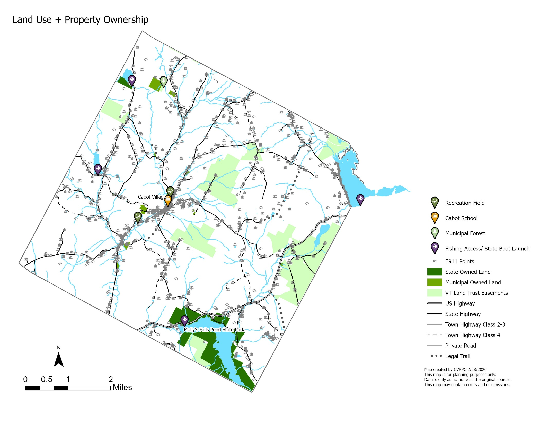

Dense residential development exists along the shores of Joe's Pond, in the northeastern part of Cabot. Although this lakefront area was originally a community of summer camps, in recent years the houses have become year-round residences, and many have been substantially renovated and enlarged. State Route 2 passes through the southeast portion of Town. The land along this corridor has remained largely undeveloped, and lies adjacent to significant environmental features including Molly's Pond, the Marshfield Reservoir (Molly's Falls Pond), wetlands and watercourses, and forested and agricultural land.
Today, agriculture and forestry figure significantly in the Town's land use. In 2016, approximately 13,140 acres in Cabot were enrolled in the "Current Use" program, representing about 53% of the total area of the Town. Land now enrolled in the Current Use program does not ensure that this land will not be developed with other uses in the future.
Several private landowners in Cabot have chosen to permanently conserve their land by partnering with the Vermont Land Trust (VLT). VLT conservation easements do not provide or guarantee public access rather it is an indication that future commercial or residential development will be curtained on the property and that the landowner is committed to preserving productive and undeveloped land for future generations. To date, 2,033 acres of land in Cabot are permanently preserved through easements held by the Vermont Land Trust.
The Town owns relatively little land as a percentage of the total land area, they include:
- Town Garage, South Walden Road
- Town Forest, South Walden Road
- Town Recreation Building, located on the recreation fields on the west side of South Walden Road at its intersection with Main Street
- Masonic Hall, Main Street
- Cabot School Property, Main Street
- Willey Building, Main Street
- Firehouse, Main Street
- Wastewater Treatment Building and storage facility, Saw Mill Road
- Old Mill House (currently not in use), Saw Mill Road

Public Land + Recreation Areas
Public lands in Cabot are available for hiking, swimming and boating access for fishing and hunting, and other low-impact recreation. These include:
- Town Common: Located in the heart of the village the traditional New England-style town green hosts a civil war memorial and serves as community gathering place for a variety of activities and uses including school athletic field, farmers markets, Fourth of July celebrations and winter ice skating rink.

- Cabot School: Located on the southwest side of Main Street just north of the Town Common the school campus is comprised of 7 buildings and outdoor play space. There is strong link between the Cabot Community and the Cabot School.
- Recreation Fields: Cabot owns the recreation fields at the north end of village, with its two ball fields, basketball court, storage buildings, and picnic area. A privately owned facility, Larry and Son Field, located at the south end of the Village is leased by the town and is used for soccer, baseball & softball. Limited parking is available at both locations.

- Town Forest: located in the northwest corner of town the 40-acre property double check acreage is municipally owned. To date there are no formal trails on the property or designated public access areas.

- Public Boating and Fishing Access: Access is available at West Hill Pond, Joe's Pond, Coits Pond and the Molly's Falls Reservoir. All access points are on State land and have small parking areas. Recreational activities at Joe's Pond include boating, fishing, and swimming and there is a State boating access and municipal swimming and picnic areas in Danville.

- Molly's Falls Pond State Park: The Vermont Department of Forests, Parks and Recreation purchased the 1,064 acres, including the 411-acre reservoir in 2015 guaranteeing continued recreational access to the reservoir and surrounding lands for Cabot residents, Vermonters and visitors to Vermont. Currently, recreational activities include boating, paddling, fishing, and picnicking, swimming, and limited camping.
- Coits Pond Wildlife Management Area: The State of Vermont owns a 27+ acre tract on the southwest shore of Coits Pond, there are no trails on the property.
Town rights-of- way and Class 4 roads, are available for walking, biking, jogging, skiing, and horseback riding. For additional info about these see: Transportation Network section.

Rural Economy
Cabot’s historic rural, agrarian land use has defined its economy. The village served as the hub of economic activity where farmers dropped off their products and picked up supplies; where local goods were manufactured and services traded. Over the course of the last century that traditional agricultural economy slowed and people found jobs, services and products farther afield. In 2018 the Town invested in the development of village revitalization strategy to help local businesses thrive in today’s economy and to encourage new economic investment by attracting new businesses to locate in Cabot. The economic plan also aims to welcome visitors to spend more time and money in the village.

Historical and Cultural Landscape
Cabot’s history is evident in it buildings and settlement areas. The Cabot Historical Society has identified a list of historically significant sites and structures in Cabot. The following geographic areas highlight aspects of Cabot’s cultural heritage.
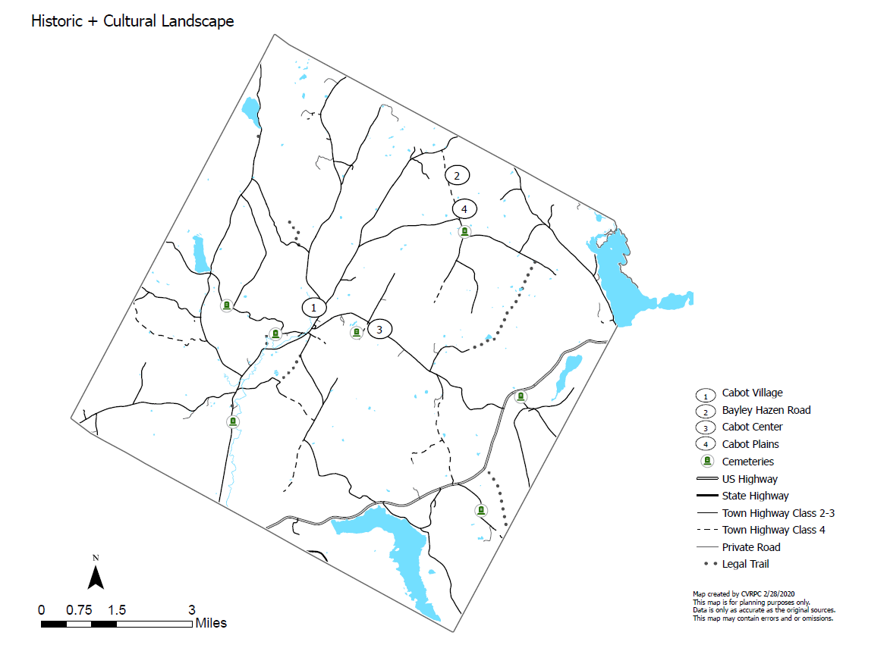
Cabot Village
The historic village center provides a classic example of a small 19th century manufacturing and agricultural settlement. It was chosen for its strategic location on the Winooski River which provided a source of power to local mills. By the 1880's the village held several stores, potash and pearl ash manufactory and distillery, cloth-dressing and wool carding mill, two blacksmith shops with a trip-hammer and foundry. The village's location midway between Montpelier and St. Johnsbury made inn-keeping a lucrative business.
Today the village continues to serve as the community hub and civic center of town. The Common is the focal point around which is clustered the buildings of the Cabot School, the Cabot Historical Society, the United Church of Cabot, and residential and commercial structures, all of which comprise the State-Register listed Cabot Village Historic District. A collection of locally owned businesses continue to provide goods and services and the village is also home to Cabot Creamery which was founded in 1919.
The Town gained Village Center Designation status from the Vermont Agency of Commerce and Community Development in 2014. The Designation Program supports local revitalization and historic preservation efforts by providing technical assistance and state funding to enhance and retain historic village centers.

Cabot Plains
Along the Cabot Plains Road in the vicinity of Dubray Road and Bayley-Hazen Road is the site of one of Cabot’s first settlement areas and is the location of the first Cabot School. Today the area is characterized by sweeping expansive views to both the east and west. The historic Cabot Plains Cemetery is located on the west side of the road and nearby is the Walbridge School House, which has been extensively renovated while retaining its original appearance and is a fine example of adaptive reuse of an historic building. While this was not the original school house, it was moved from its original location on the Walden Heights Road.
The picturesque A.M. Foster Bridge is perhaps the most notable site in Cabot Plains. Located on private property the wooden covered bridge spans a small pond and is a replica of a farm bridge which is located on the Winooski River in neighboring Marshfield.

The Bayley-Hazen Road
The Bayley-Hazen Road was built in two phases, the first in 1776, financed by Colonel Jacob Bayley, from the present village of Wells River in Newbury to Cabot Plains, the second in 1779 by General Moses Hazen from Cabot Plains to Hazen's Notch in Lowell. It was intended as a supply route for American Revolutionary forces in Quebec, but later proved useful as a route for settlers. The Bayley-Hazen Road cuts through the northeastern section of Town. Seven small granite markers were placed beside the road identifying a collection of historic buildings and points of interest from the late 1700’s/ early 1800’s.

Cabot Center
Located in the geographic center of Town on the plateau, Cabot Center was the main settlement in Town prior to the mid-1820s, when the area which is the present village center gained prominence. In the 1820's some buildings were actually moved to the valley location. The first Congregational Church in Cabot was original constructed in the Center and was moved to the village in 1826. Its location is now marked by a large boulder bearing an inscription. The Center Cemetery, located on Old Center Road, contains the oldest gravestones in Cabot, including many of the first settlers. About one acre of land encompassing the church site was given to the town in 1803.

Cemeteries
Additional historic buildings and sites are present throughout Cabot, including 8 cemeteries in Town that are historically significant. They are:
- Center Cemetery- Established 1799; the Town's first cemetery;
- Durant Cemetery - Established 1813 in Lower Cabot;
- Cabot Village Cemetery (Elm Street) - established in 1820;
- Kimball Cemetery- Established 1814 (not maintained as a town cemetery);
- West Hill Cemetery- Established 1817;
- Cabot Plains Cemetery - Established 1825;
- South Cabot Cemetery - Established 1834;
- East Cabot Cemetery - Established around 1847

Natural Features
Cabot lies in the geographic region known as the Piedmont, in the foothills of the Green Mountains. The highest point in Cabot is Danville Hill (2,246 feet), followed by Joe's Hill (2,198 feet), Burbank Hill (1,980 feet) and Thistle Hill (1,909 feet). The lowest part of town is 880 feet at the point where the Winooski River exits the town at the Marshfield border. Most of Cabot lies within the Winooski River drainage basin, and Coits Pond is considered to be the headwaters of the Winooski. A small portion of the town drains eastward into the Connecticut River Watershed.
Lakes and Ponds
Five significant lakes and ponds lie at least partially within Cabot's borders:
Molly's Pond: A 40-acre scenic, natural pond with a large diversity of aquatic plants (including rare species) and outstanding wildlife value. There are no public lands adjacent to the pond, although the Vermont Land Trust holds easements on large tracts of land bordering the pond.
West Hill Pond: A 48-acre artificial, privately-owned lake covering about forty-eight acres, with a maximum depth of thirteen feet. The state maintains a public boating access. Fishing is allowed, motorized boating is not.
Molly's Falls Reservoir (Marshfield Reservoir): A 411- acre artificial, lake rich in wildlife (including loons and migratory birds). Ninety-eight percent of the land within its watershed is undeveloped. The reservoir is a power supply source operated by Green Mountain Power, which owns around the dam and a small camp lot along the shoreline of the reservoir. The rest of the shoreline, the reservoir and 643 acres surrounding the reservoir is now owned by the Vermont Department of Forests, Parks and Recreation and is operated as Molly's Falls Pond State Park. There is a state fishing access and gas motors and jet skis are allowed on the reservoir. Other activities include swimming, paddling, picnicking and limited camping.
Joe's Pond: A natural lake that covers about 396- acres, has a watershed area of 18,445 acres. Tremendous diversity of plant life exists on the lake and adjoining wetland, which is large and significant. The pond has a heavy concentration of development along its shorelines in both Cabot and Danville. Joe's Pond is noted for fishing and other popular recreational activities include boating and swimming. There is a State boating access and municipal swimming and picnic areas in Danville.
Coits Pond: A 17-acre shallow, public lake in the northwestern corner of Cabot is considered by many of the actual headwaters of the Winooski. The State of Vermont owns a 27+ acre tract on the southwest shore of this pond. Current uses include fishing and carry-in boating; motorized watercraft are not allowed. Public access has recently been improved with a small parking area.
Wetlands
Wetlands are now known to perform important functions such as reducing flooding, filtering sediment and pollutants before reaching surface waters, supporting numerous wildlife species, and providing open space and scenic beauty. Cabot contains numerous small wetlands, totaling approximately 670 acres or 2.7 percent of the land area. Many of these wetlands were initially designated by the Vermont Water Resources Board as Class Two wetlands. Class Two wetlands have an initial buffer of 50 feet. There are no Class One wetlands in Cabot. Class Three wetlands are those that are either not significant or have not yet been evaluated and are not protected under the Vermont Wetland Rules.
There is one large wetland complex in East Cabot, to the west of Route 2 that is greater than forty acres in size. This Northern White Cedar Swamp contains an assemblage of plants and animals indicative of a unique natural community and is deserving of particular attention. It consists mainly of forested wetland, with smaller areas of scrub-shrub and emergent zones.
The remainder is small wetlands from one to ten acres in size, scattered along the Winooski River and to the west. The richest, most diverse wetlands occur in association with several ponds, including Coits, Joe's, Molly's and West Hill.
Although poorly designed and sited development in or near wetlands can impair their functions, in most cases, development can be accommodated in the vicinity of wetlands when properly planned. Allowed uses include most farming and forestry activities; recreational activities, and repair and maintenance of utility lines and poles.
A natural resource inventory is currently underway in Cabot and this will provide further characterization of significant wetlands.

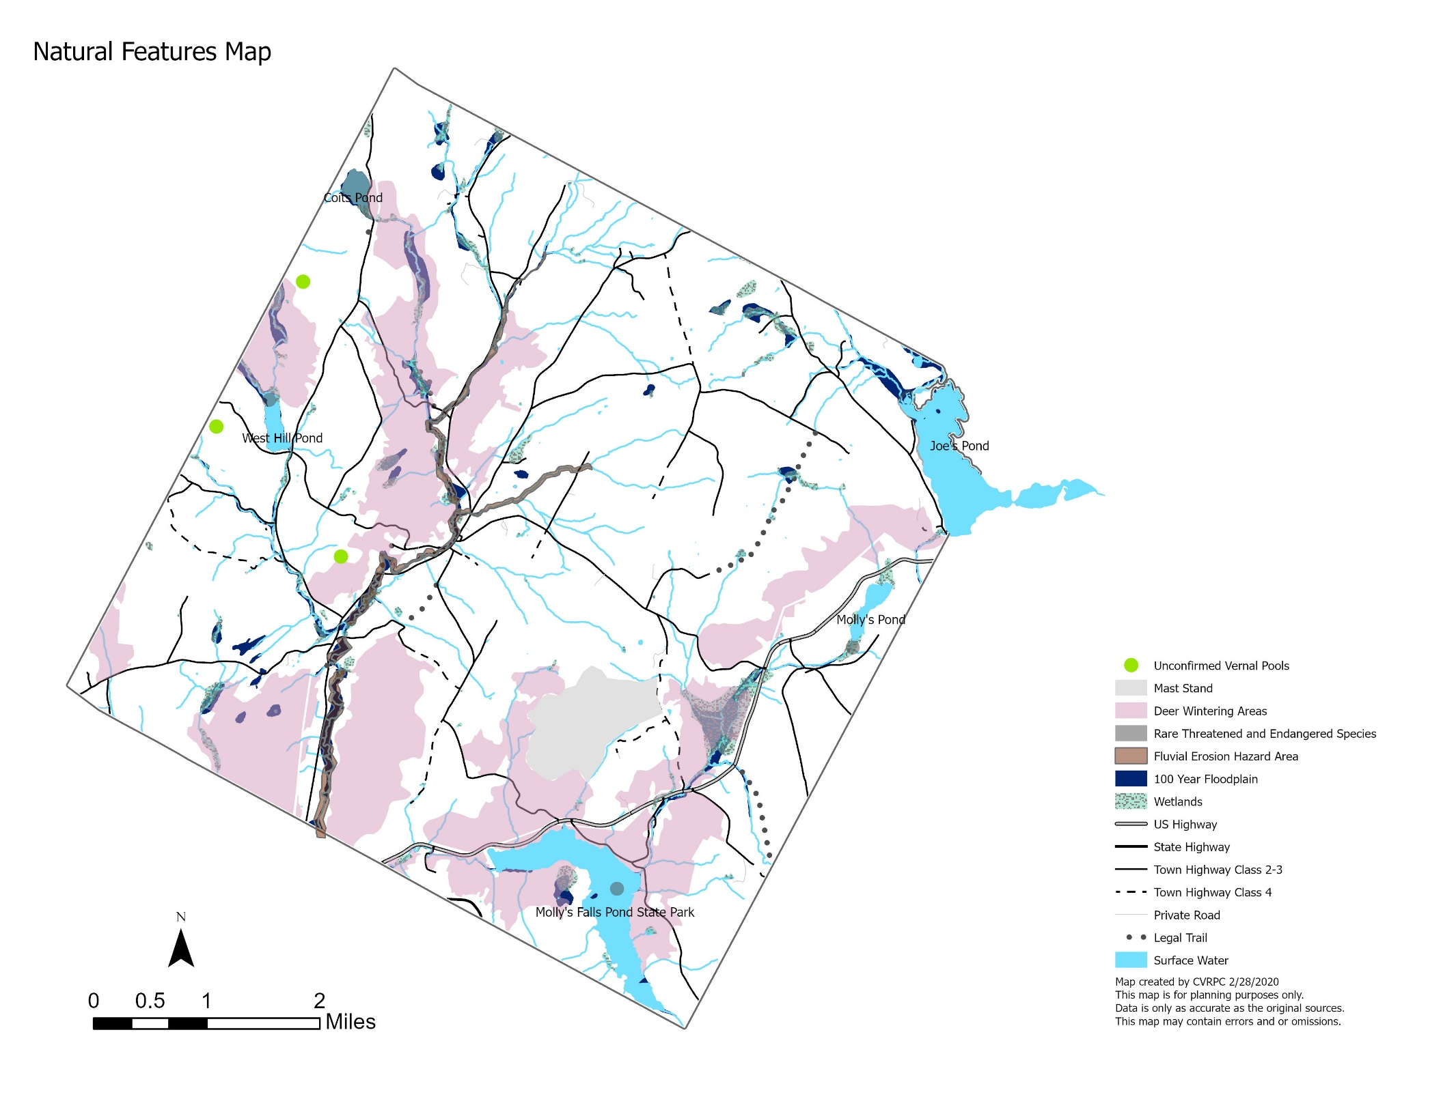

Floodplains, Flood Hazards and Fluvial Erosion
These places serve important ecological functions, including floodwater storage, sediment trapping, nutrient filtering and aquifer recharge, they can be hazardous locations for people and property. High water causes damage in two distinct, but related, ways. Inundation can fill structures with water and cause property damage and drowning. Whereas erosion from flash flooding (i.e. fluvial erosion) actually causes greater damage. Within the area of a stream or river's active channel movement, known as the Fluvial Erosion Hazard Zone (or FEH), bank failures and changes in river channel courses during floods can undermine buildings, roads, farm fields, and utility infrastructure. Cabot is not immune to either of these hazards.
It is important to consider how land use within a watershed impacts flooding. Impervious surfaces, such as roads, driveways, parking areas and buildings prevent water from soaking into the ground, increasing runoff and erosion potential. Any disturbance of the soil or any change in topography may increase erosion potential.
Contiguous Forests and Connecting Land
Contiguous forest habitat is an area of forested land with either no roads or low densities of Class 3 or 4 roads and little or no human development. Contiguous forest areas may have various age classes or forest cover and may be composed of other habitat types such as wetlands or old meadows that are part of the overall contiguous habitat complex.
Connecting lands or habitat is land that links larger patches of habitat within a landscape. These connections are essential to keep habitat patches (genetic reservoirs) from becoming isolated; if cut off from the local and regional movement of wildlife, populations can die out. Many of the smaller wetland or wooded areas in Town retain their wildlife populations only because they are connected to larger, less disturbed areas. These connection or linkages are disappearing, mostly due to housing development. There are few large and unbroken tracts of wetland or forest left in Town.
Deer Winter Habitat
Deer yards can vary in size from a few acres to hundreds of acres, consisting of mature or maturing softwood cover that provides protection from deep snow, cold temperatures, and wind. A variety of other wildlife species also benefit from dense softwood stands, including snowshoe hare, coyote, fox, fisher, bobcats, crows, ravens, and many others. Logging can be either beneficial or detrimental to the habitat depending on harvest method, and education on management practices is important. About 24% of Cabot's land area is considered deer winter habitat.
Mast Stands
The seeds of shrubs and trees serve as important wildlife food for numerous species including mammals, birds, amphibians and reptiles. Beech and oak stands are absolutely essential for the survival of black bears in Vermont. Mapping significant mast stands and encouraging their protection through education will protect wildlife diversity.

Rare, Threatened and Endangered species
Rare, threatened or endangered species have been identified on all of Cabot’s lakes and ponds. Most notably, loons are present on Molly's Falls Reservoir and Joe's Pond.
Vernal Pools
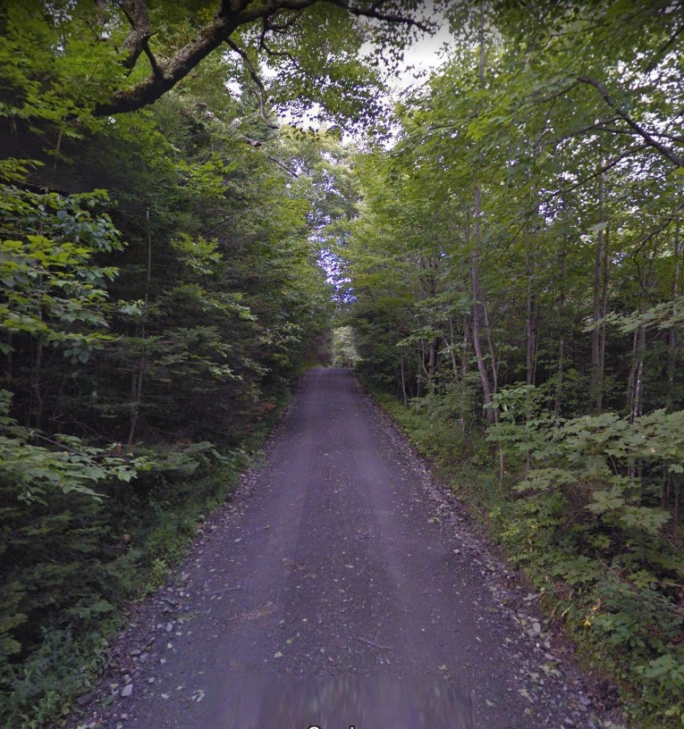
Small (generally less than one acre) ephemeral pools typically found in upland forests over a relatively impermeable substrate layer serve as critical breeding habitat for a variety of salamanders and other small amphibians. Cabot has five mapped vernal pools.

Transportation + Trails Network
Cabot’s existing road system was initially designed to carry horse-drawn wagons and sleighs. Some roads once served now-abandoned hill farms and settlements and have since been abandoned and in other cases the town has retained these public right-of-way.
Public Roadways and Trails
Today that system has approximately 64.78 linear miles of public roadways, 18 miles paved and approximately 46.19 gravel surfaced roadway. Class 1, 2, 3 highways are defined for the purpose of receiving state aid and are passable with a pleasure vehicle on a year-round basis. Class 4 roads and legal trails do not. The Town has developed a Class 4 roads and Trails Ordinance which outlines the municipality’s policy for management: https://cabotvt.us/publications/.
Dubray Road, Cabot
In 2012, the State of Vermont authorized "Complete Streets" legislation to ensure that the needs of all users of Vermont's transportation system (including motorists, bicyclists, public transportation users, and pedestrians of all ages and abilities) are considered in all state and municipally managed transportation projects and project phases, including planning, development, construction, and maintenance, except in the case of projects or project components involving unpaved highways.

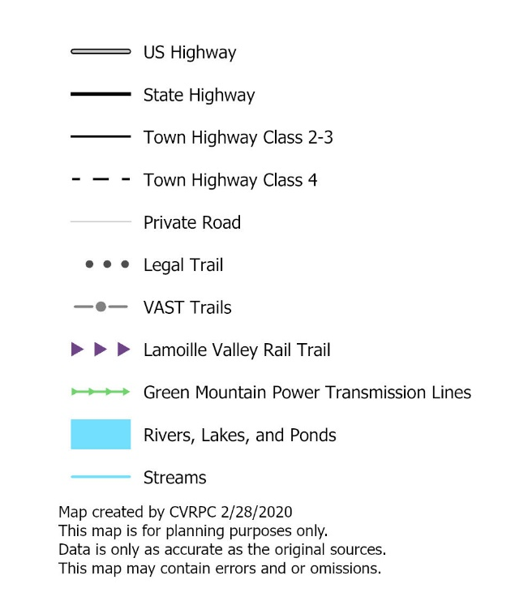
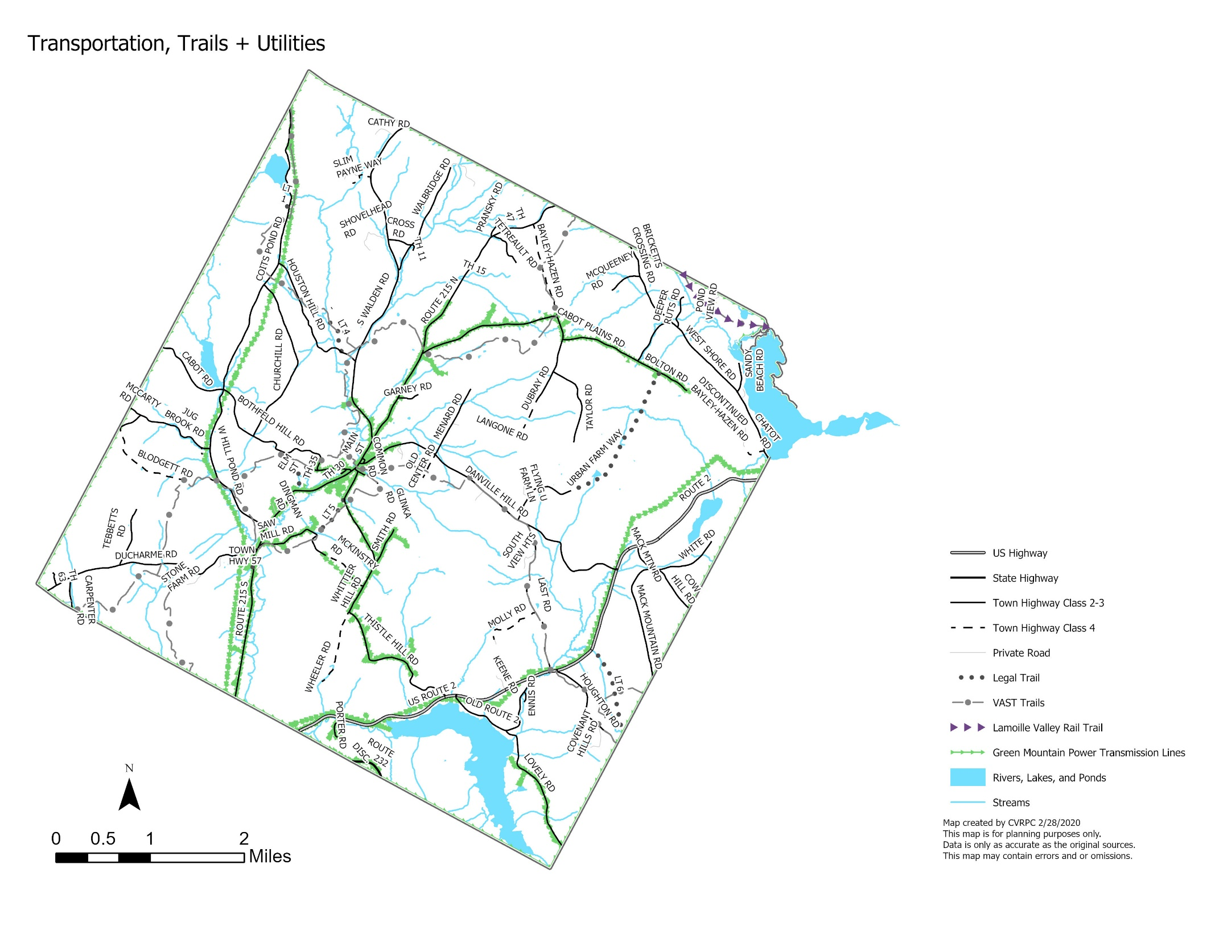

Road Class |  | Condition | Miles
Class 1 State/Federal Highways (U.S. Route 2, Route 232) | State-designated town highways that serve as extensions of state highway routes and carry a state highway number. | paved | 6.6
Class 2 Highways (Route 215, South Walden Rd, West Hill Pond Rd/Cabot Rd, Danville Hill Rd) | Locally designated town highways that carry more than normal amounts of traffic and connect neighboring towns and are primarily the responsibility of the Town. | paved / gravel | 13.6 / 3.5
Class 3 Highways | Other town highways that are maintained for year-round use by pleasure cars. | gravel | 41.2
Class 4 Highways | All other town highways; minimal maintenance requirements. Class 4 Town highways include pent roads (public roads that may be gated by permission of the governing body). The Town's responsibility for these roads is limited to maintenance of drainage structures (bridges and culverts). Roads are maintained in the summer season, no winter maintenance is provided by the town. | varied | 7.4
Legal Trails | Public right-of-ways which is not a highway and are designated through legal proceedings. Legal trails include previously designated highways and new public-rights-of-ways laid out as a trail by the Selectboard for the purpose of providing access to abutting properties for the recreational use. Public right-of-way are not highways; and there are no statutory maintenance requirements. | varied | 4.5

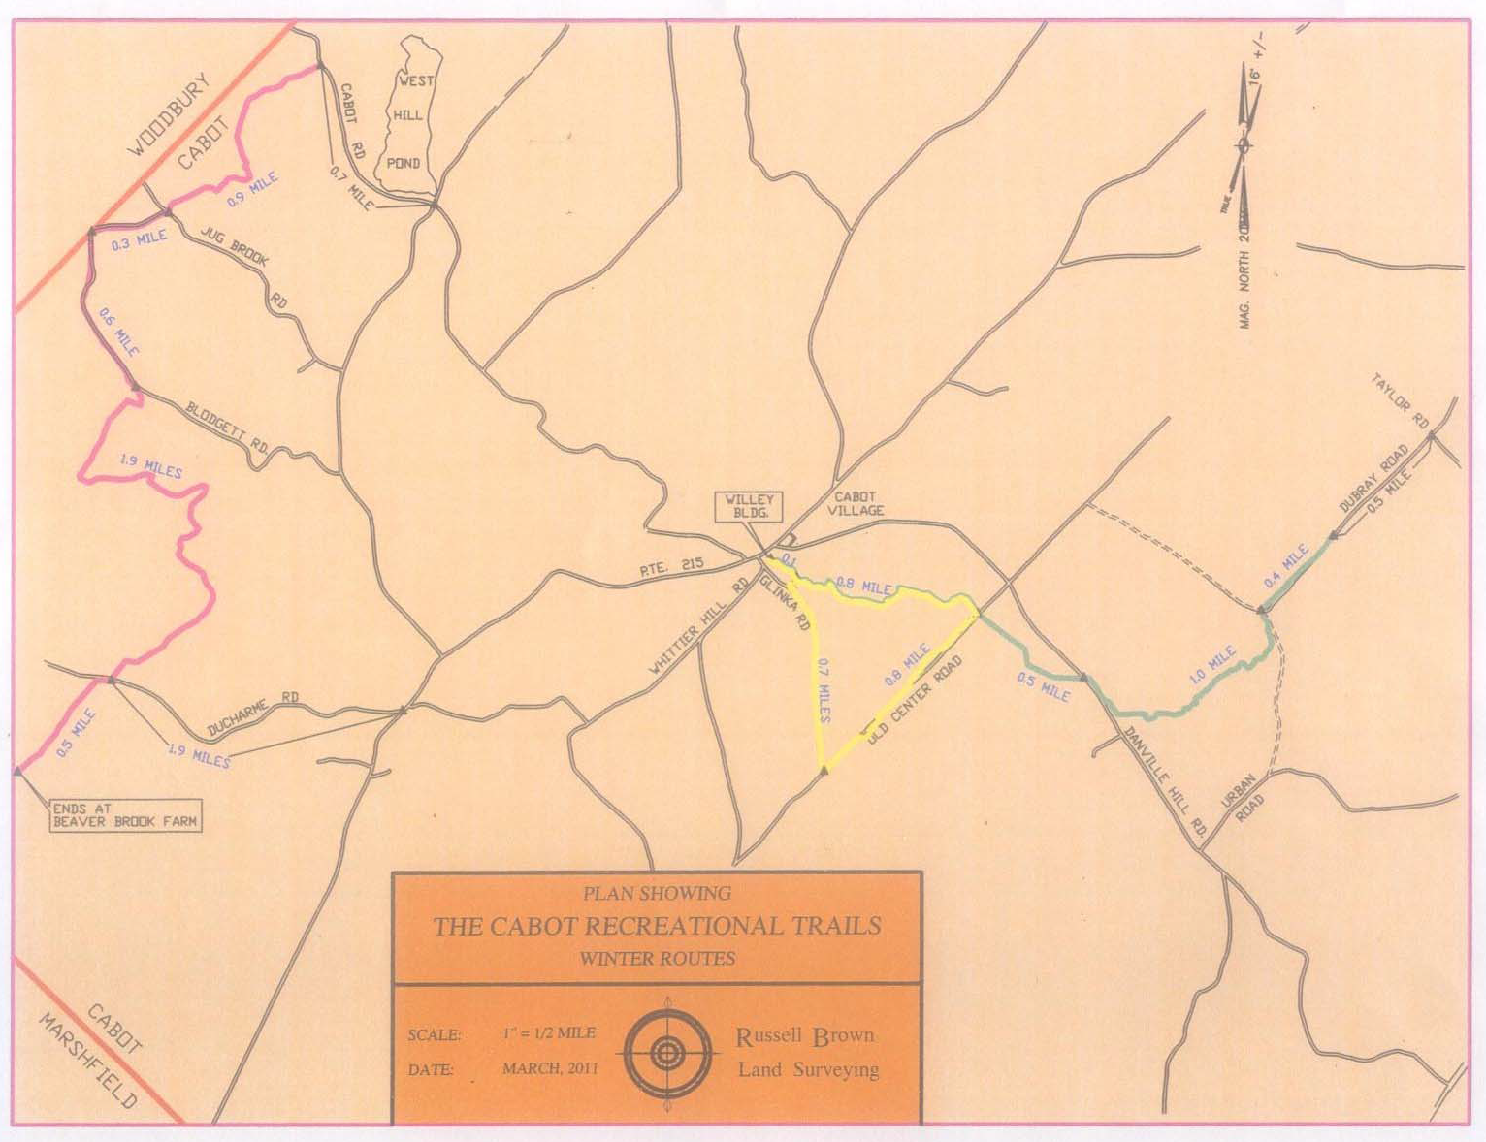
Winter Trails – Legacy trails from previous efforts provided seasonal access by non-motorized travel from the village eastward to Old Center Road and beyond to Dubray Road. The "Old Center Loop" started and ended behind the Willey building, and extended up to Old Center Road and returning via Glinka Road. Maps created in 2011 also indicate another winter trail located in the western section of town extending from Beaver Brook Farm northward to Cabot Road.

Lamoille Valley Rail Trail - The Lamoille Valley Rail Trail system is envisioned to be a 93-mile four-season, multi-purpose trail which will eventually extend 93 miles long from Swanton in northwestern Vermont to St Johnsbury. A portion of this trail network passes through the northeastern portion of Cabot near Joes Pond and into the neighboring Village of West Danville, where parking is provided for trail users at the local Park & Ride lot. The Rails-to-Trails Conservancy (Northeast Region) has expressed an interest in working to establish a link from the Lamoille Rail Trail southward to the Cross Vermont Trail in Marshfield.
Other Roads and Trails
Private Roads – Most of the private roads in Cabot basically function as shared driveways to small clusters of private homes. Vehicle accesses serving 3 or more residential dwellings are classified as private roads by enhanced 911 Board, they are not for public right-of-way and are maintained privately.
Discontinued Roads –while appearing on some maps, previously designated town highways no longer provide public right-of-way and land ownership has reverted or been reconvened to adjoining property owners.
Informal Trails – a collection of informal trails have been identified in Cabot. These trails have evolved over time and are not permanently managed nor are they officially open to the public. Some property owners have expressed concern about making the location of these trails available to the public. A map with these trails is filed with the Town Clerk.
VAST Trails - The Vermont Association of Snowmobile Travelers (V.A.S.T.) is a statewide non- profit organization which works with private landowners to provide seasonal trails for snowmobiles. The local club (Skylighter's Snowmobile Club) maintains approximately 50-miles of trails in Cabot. Permission to use snowmobile trails does not extend to use of these trails by ATVs, four-wheelers, motor or mountain bikes, hiking or other uses, unless specifically authorized with written landowner permission. A VAST trail is a trail only during the snow season; any other use will be considered trespassing.
Closed Roads – Closed roads are not necessarily discontinued, they are merely taken off the map for ongoing maintenance and traffic is not allowed or supported anymore. Sometimes closed roads appear as Class 4 Roads, but others may not as they were closed before Class 4 roads were considered a category by the State.
Bike & Pedestrian Facilities
In Cabot Village, a sidewalk extends on the northwest side of Main Street (Rt. 215 North) from the Masonic Hall to just before the intersection of Main Street with Elm Street. On the southeast side of Main Street a second sidewalk with crosswalk exists in front of the Willey Building extending to the rear accessible entryway.
Bike and pedestrian access by children to the recreation fields in both upper and lower Cabot Village is not adequate, and poses a safety concern. In particular, the bridge near the intersection of Route 215 and South Walden Road that must be traversed to reach the recreational fields from the Cabot School is too narrow to provide for safe pedestrian or bicycle access. Extension of the walking trails through a shared bicycle and walking trail to the lower recreation field south of Main Street has been identified within a Bike and Pedestrian Safety Scoping Study, as is replacement of the sidewalk from the Masonic Hall to the upper recreation field at the North end of the Village.

While there is significant interest in bicycling in town, there are currently no bike lanes or designated bike paths in the Village, and in the outlying areas safety is a concern particularly on narrow roads with no shoulders.
Public Parking
Village parking for businesses and community functions was limited before the parking lot at the Willey Building was upgraded and expanded. The construction of a Park and Ride lot at the Masonic Building has also alleviated some public parking pressure and provides for longer term off street parking.

Utility corridors
Cabot is served by two electric utilities: Green Mountain Power (GMP), and Washington Electric Cooperative (WEC). GMP serves those areas around VT-215 corridor and along the Marshfield border, while WEC serves the rest of the Town. Green Mountain Power is amicable to non-motorized trail development in their overhead utility right-of-ways (ROWs), but development requires landowner permission if GMP does not own the land outright. Most recently, GMP has worked with Cross Vermont Trail to develop a trail system along the Winooski River in Montpelier.
The Rails-to-Trails Conservancy offers guidance on the development of trails in non-rail ROWs that usually are home to electrical utilities. By receiving an easement from the Utility and landowner permission (if the Utility does not own the land), a trail may be constructed in a Utility ROW. Utilities and trail developers can both reap benefits including trail construction and improved access, depending on landowner permissions.

APPENDICES

Trail Design Standards
Public Recreation on Private Land Guide
Public Engagement Materials
- Talking Trails Presentation + meeting notes
- Landowner Partners Presentation + meeting notes
- Insert minutes from last public engagement event
- Meeting in a Box

