# 1 INTRODUCTION

Mitigation planning provides an opportunity for local government to lessen the impact of the next natural disaster. The goal of this plan is to advance and prioritize mitigation investment to reduce risks posed by natural hazards and to increase the Town of Waitsfield’s resilience to damages from natural hazard impacts.

Hazard Mitigation is any sustained policy or action that reduces or eliminates long-term risk to people and property from the effects of natural hazards. FEMA and state agencies have come to recognize that it is less expensive to prevent disasters than to repeatedly repair damage after a disaster has struck. This plan recognizes that opportunities exist for communities to identify mitigation strategies and measures during all the other phases of Emergency Management – Preparedness, Response and Recovery. While the hazards can never be completely eliminated, it is possible to identify what the hazards are, where their impacts are most severe, and identify local actions and policies that can be implemented to reduce or eliminate the severity of the impacts.

**2** PURPOSE

The purpose of this plan is to assist the town in identifying all-natural hazards facing the community, ranking them according to local vulnerabilities, and developing strategies to reduce risks from those hazards. Once adopted, this plan is not legally binding; instead, it outlines goals and actions to prevent future loss of life and property. The intention is to create a multi-year pathway to mitigating hazards within the community.

The benefits of mitigation planning include:

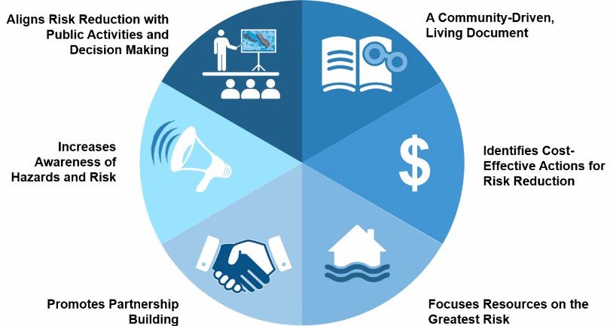

*Source: FEMA LHMP Skill Share Workshop 2021*

***Furthermore, the Town seeks to be in accordance with the strategies, goals, and objectives of the 2023 State Hazard Mitigation Plan.***

**3 3** COMMUNITY PROFILE

### Land Use and Development Patterns

The Town of Waitsfield is a small, rural, residential, and tourism-based community located in the southwestern portion of Washington County. It is bordered by Moretown and Duxbury to the north, by Fayston to the west, by Warren to the south, and Northfield to the east.

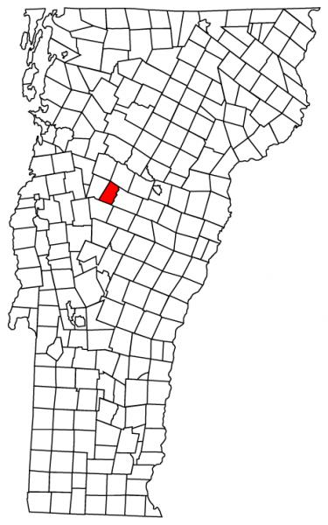

According to the 2023 Waitsfield Town Plan, the town charter was granted in 1782. It was first surveyed in 1788 with settlers following a year later. Many water powered mills fed by the Mad River and its tributaries fueled the early development of the town.

Waitsfield nestled between the main range of the Green Mountains and the Northfield range is drained by the Mad River. Waitsfield Village, is the only state designated village with in the town. Irasville and Waitsfield Village are the main economic areas within the town with multiple stores and restaurants.

Outside of the villages, residential development in Waitsfield has a rural character. Much of the town still has active agricultural lands. Residential structures throughout the town are a mix of year-round residences and seasonal homes largely due to the close access to Sugarbush and Mad River ski destinations.

**Land Features**

Waitsfield’s landscape is defined by forested mountains, the Mad River and many of its tributaries. This varies from river bottom farm fields to steep slopes of the Northfield Range to the East. The town lies at the base of the eastern slopes of the Green Mountain Range. Elevation ranges from 620 feet at its lowest elevation to 2867 at Scragg Mountain on the town’s eastern edge.

Several extensive land areas are owned by the State and the town including Camel’s Hump State Forest, Wu Ledges, Lareau Park, Mad River Park and Scragg Mountain Town Forest.

### Demographics and Growth Potential

The 2020 Decennial Census prepared by the U.S. Census Bureau shows an estimated population of 1,844 and 1,049 housing units. Over 50 years of steady growth the trend within Waitsfield is expected to continue.

*Source: Census data with excel projection of expected growth*

Between 2010 and 2020, the median age of Waitsfield has increased by 2.3 years; 48.2 is the median age, higher than the Vermont median age of 43.2. The portion of the population over 65 is 44.8%, compared to 21.6% in Vermont and 16% in the country. The population density of the town is 68.6 people per square mile compared to an overall state density of 68.

## Waitsfield’s growth potential is limited by a lack of developable land and access to sewer utilities to allow greater density. Revitalizing existing infrastructure and properties, encouraging mixed-use development, and repurposing underutilized spaces offer the greatest opportunities for growth in Waitsfield.

Of Waitsfield’s two designated growth areas, Irasville and Waitsfield Village makes up one area and has the most potential for new residential development. The other area is between Airport Road and North Fayston Road. There is currently little opportunity for new development. The rural countryside also lacks access to public utilities and much of the property is either owned, rented, or leased. The town is trying to address this by undertaking a Wastewater planning project focusing on the Irasville and Waitsfield Village area. This would allow for a great density of development within the areas served by this system. This directly aligns with the State’s guidance of increased development. Also addressing climate change by attempting to limit vehicle miles travelled by increasing density and walkability.

### Precipitation and Water Features

Average annual precipitation is 45 inches of rain; with July being the wettest month. Average annual snowfall is 102 inches; with February being the snowiest month.

The Mad River and its many tributaries (High Bridge Brook, Mill Brook, Pine Brook, and Shepard Brook) are the major water features in Waitsfield.

### Drinking Water and Sanitary Sewer

Public drinking water is supplied by Waitsfield Municipal Water System which is managed by the Waitsfield Water Commission. This system provides water to 130 connections, serving 250 businesses, dwellings, and municipal organizations with 28 hydrants for fire protection. All other structures and residences are served either by private wells or springs.

Municipal sanitary sewer service is being studied for the Waitsfield Village and Irasville area. This is still in the planning phase as the town is trying to acquire funds for construction. The town has discussed that if implemented that the Wastewater plant should have a robust Emergency Action Plan to prevent accidental discharges during extreme weather events.

### Transportation

Waitsfield is ±40 square miles in size with primary access via Vermont Route 100, a north-south minor arterial route, and VT Route 17, running East-West connecting Route 100 with Route 4 south of Vergennes.

The 2023 VTrans Town Highway data indicates that Waitsfield has 29.67 municipal road miles: No miles of Class 1; 9.45 miles of Class 2; 20.22 miles of Class 3; 5.94 miles of Class 4 (or functionally Class 4). Of the total municipal road miles, ±26% are paved and 74% are gravel. In addition, there are 7.83 miles of State highway in Waitsfield, for a total of ±43 traveled highways, including Class 4 roads.

According to the Town’s 2023 road erosion inventory, 47% of Waitsfield’s Road mileage is hydrologically connected - meaning it is within 100-feet of a water resource (i.e., stream, wetland, lake, or pond). Proximity to water resources can make these sections of road more vulnerable to flooding and fluvial erosion. These sections must be up to the standards created for the Municipal Roads General Permit program with a requirement of 7.5% of non-compliant segments being upgraded per year.

According to the Town’s 2023 bridge inventory, Waitsfield has a total of 8 municipal bridges – 2 short structures (6’-20’ length) and 6 long structures (>20’ length). The town’s 6 long structures are inspected every two years by VTrans through the Town Highway Bridge Program.

Waitsfield has a total of 277 culverts in the municipal road right-of-way; all were inventoried in 2020 by the Central Vermont Regional Planning Commission. Several culverts were listed in critical or poor condition and ideally been considered for replacement and/or upgrade in accordance with Town Road and Bridge Standards. The local road network is maintained by the municipal highway department, whose garage is located on Trembly Road.

### Electric Utility Distribution System

Electric service to approximately 1034 accounts is provided by the State of Vermont Department of Public Safety. Average annual outage statistics between 2017 and 2019 are summarized in Table 1.

### Table 1: Power Outage Summary

|  |  |
| --- | --- |
| **Average Annual (2017-2019)** | |
| % of customers who lost power was in a year | 8.02 |
| Avg number of outages greater than 24 hours | 8 |

This data has limitations to its accuracy due to the State of Vermont and many of the utilities not tracking outage data at the town level.

### Public Safety

Fire protection is provided by the Waitsfield Fayston Volunteer Fire Department, an all-volunteer organization. The Fire Department is a member of the Capital Fire Mutual Aid Association. Law enforcement is provided by the Washington County Sheriff’s department and the town constable, with support from Vermont State Police. The nearest hospital is the Central Vermont Medical Center which is a half hour drive from the center of town. There are limited routes available for travelling out of the valley to the hospital, each of these routes can become compromised during a flooding event cutting off the valley from these services except by air transport. Ambulance services are provided by Mad River Ambulance service a volunteer ambulance service. Whether or not we can continue this model as the town grows and experiences demographic changes may present issues as far as long-term sustainability. Especially based on overall trends nationwide of securing volunteers.

### Emergency Management

Per the Town’s Local Emergency Management Plan, currently the EMD is a member of the Selectboard and is assisted by the town Emergency Management Coordinator an appointed position. They work with others in town to keep the LEMP up to date and coordinate with nearby towns and regional emergency planning efforts.

### Vulnerable Populations

Waitsfield has multiple vulnerable communities within the town’s boundaries. Residents who have medical needs and are residing in their homes can choose to be listed in the CARES (citizen assistance registration for emergencies) program. The town Emergency Management director can access this list from the Vermont Emergency Management Watch officer. Also, there are two facilities that deal with Senior Housing: Evergreen Place and Mad River Meadows. The town also has the Waitsfield School, Spring Hill School, Waitsfield Children’s Center, and the Neck of the Woods day care. Finally, the Verdmont Park Mobile home park. These communities are all called out and addressed in the town Local Emergency Management Plan.

# 4 PLANNING PROCESS

### Plan Developers

The Town assembled a Hazard Mitigation Planning Team to participate in updating the Plan. Team members included: Selectboard member (local EMD), Emergency Management Coordinator, representative of the Planning Commission, and Friends of the Mad River staff.

The Central Vermont Regional Planning Commission (CVRPC) assisted the Town with this Plan update. FEMA Building Resilient Infrastructure and Communities (BRIC) funds supported this process.

### Plan Development Process

The 2023 Local Hazard Mitigation Plan is an update to the 2017 single jurisdiction mitigation plan. A summary of the process taken to develop the 2023 update is provided in **Table 2.**

**Table 2: Plan Development Process**

Nov 1, 2023: Kick-off meeting. Discussed what an LHMP is; benefits of hazard mitigation planning; current plan status; planning process; outreach strategy; and plan sections. Planning Team working meetings were not open to the public.

Nov 29, 2023: Planning team working meeting. Discussed outreach plan and plan for holding public forums. Reviewed possible locations for public forum and next steps.

Feb 2024: To notify the Whole Community* of the plan update, the Town posted physical and online notices. Physical notices were posted at the Town Office, Waitsfield Post Office, Mehuron’s Market, Joslin memorial library, and Shaw’s Grocery. Online notices were posted on the Town website [(waitsfieldvt.us)](https://waitsfieldvt.us/), and Front Porch Forum.

*Whole Community stakeholders include: 1) local and regional agencies involved in hazard mitigation; 2) entities with authority to regulate development; 3) neighboring towns; 4) representatives of business, schools/academia, and other private organizations that sustain community lifelines; and 5) representatives of nonprofit organizations that work directly with or provide support to vulnerable populations.

CVRPC posted online notices on the CVRPC website [(centralvtplanning.org)](https://centralvtplanning.org/). CVRPC also direct emailed notice to 1) officials (Selectboard and Planning Commission chairs, Town Managers and Clerks, Emergency Management Directors) in neighboring towns of Fayston, Moretown, Warren, and Northfield.

2) Key Partners Mad River Planning District, Winooski Natural Resources Conservation District, Hardwood Unified School District, Central Vermont CWSP, VDH Regional Emergency Preparedness Specialist, VTrans District 6 Projects Manager, Central VT Floodplain Manager). Notice included CVRPC contact for information on planning process and opportunities for public input – see **Appendix C**.

Feb 2024: To solicit input from the Whole Community, the Town utilized a survey (see **Appendix D**) and hosted an in- person Community Workshop on Feb. 29th. The Town provided notice of the survey and workshop by posting physical notices at the Physical notices were posted at the Town Office, Waitsfield Post Office, Mehuron’s Market, and the Joslin memorial library. Online notices were posted on the Town website [(waitsfieldvt.us)](https://waitsfieldvt.us/), and Front Porch Forum

CVRPC posted online notices on the CVRPC website of the opportunity to provide input on where each hazard might impact the Town; assets most likely to be affected; and preferred types of mitigation actions (Sections 5 and 6). CVRPC also direct emailed notice of the survey and February Workshop to local officials in neighboring towns and Key Partners – see **Appendix C**.

March 25, 2024: Planning Team working meeting discussing mitigation actions and drafting team will submit additions and will meet again to review (Section 6). Also discussed sections 1-3, and 5 drafts.

April 25, 2024 Planning Team working meeting discussing mitigation actions and to review at public meeting (Section 6). Discussion of process moving forward.

In addition to the local knowledge of Planning Team members and other relevant parties, several existing plans, studies, reports, and technical information were utilized in the preparation of this Plan. A summary of these is provided in Table 3

**Table 3: Existing Plans, Studies, Reports & Technical Information**

2017-2019 VT DPS Power Outage Data Used to develop Table 1 in Section 3.

2024 Zoning Ordinance Referenced to develop Community Capabilities, Integrating into Existing Plans and Procedures, Mitigation Strategy Updates – Changes Since 2017 Plan in Section 6.

2020 US Census Data Used to develop the Demographics and Growth Potential information in Section 3.

2023 State of Vermont Hazard Mitigation Plan Primarily referenced to develop the risk assessment and profiles in Section 5.

2017 FEMA Region 1 Mitigation Ideas for Natural Hazards Used to develop mitigation actions to address impacts from severe winter storms, high wind, and floods.

2023 Road Erosion Inventory Referenced to develop the risk profile in Section 5 and mitigation actions to address floods in Section 6.

2019 Central Vermont Stormwater Master Plan Duxbury, Fayston, Moretown, Waitsfield, and Warren Referenced to develop the risk profile in Section 5 and mitigation actions to address floods in Section 6.

2013 FEMA Mitigation Ideas Resource for Reducing Risk to Natural Hazards Used to develop mitigation actions to address impacts from severe winter storms, high wind, and floods.

VTrans Town Highway Bridge Inspection Reports Referenced to develop the risk profile in Section 5 and mitigation actions to address floods in Section 6.

VTrans Transportation Resilience Planning Tool Referenced to develop the risk profile in Section 5 and mitigation actions to address floods in Section 6.

Vermont Dam Inventory (VDI) Referenced to develop the risk profile in Section 5 and mitigation actions to address floods in Section 6.

2023 FEMA Local Mitigation Planning Handbook Used to ensure plan meets the Federal mitigation planning requirements, including those for addressing climate change.

2023 FEMA Hazard Mitigation Assistance Program Policy Guide Used to ensure plan meets the Federal mitigation planning requirements, including those for addressing climate change.

2020 US Census Data Used to develop the Demographics and Growth Potential information in Section 3.

National Oceanic and Atmospheric (NOAA) National Climatic Data Center’s Storm Events Database Referenced to develop the risk profile and hazard history in Section 5.

FEMA Disaster Declarations for Vermont Referenced to develop the risk profile and hazard history in Section 5.

Vermont Department of Health Referenced to develop the risk profile in Section 5.

Vermont Department of Conservation Stream Geomorphic Assessments-Structures Used to identify bridges and culverts that are undersized and prone to failure mitigation actions to address floods in Section 6.

Vermont Agency of Natural Resources Natural Resources Atlas Referenced to develop the risk profile in Section 5.

2021 Vermont Climate Assessment Referenced to develop the flood risk profile in Section 5.

2023 Local Emergency Management Plan Primarily used to identify local organizations that support vulnerable populations to ensure these organizations are invited to participate in the plan update.

2020 Structures Inventory (culverts and short structures) Referenced to develop the risk profile in Section 5 and mitigation actions to address floods in Section 6.

2023 FEMA NFIP Insurance Reports Used to determine how many structures are insured, number of repetitive loss properties, and describe NFIP compliance in Section 6.

2023 Waitsfield Town Plan Referenced to develop Community Capabilities, Integrating into Existing Plans and Procedures, Mitigation Strategy Updates – Changes Since 2017 Plan in Section 6.

Mitigation Strategy Update - Changes Since 2017 The 2017 local hazard mitigation planning effort analyzed natural hazards and the risk they posed to the Town of Waitsfield. The risk assessment resulted in the categorization of High, Medium and Low risk level hazards. Floods and fluvial erosion; dam failures and ice jams; hurricanes and severe storms; and winter storm, ice storms, extreme cold with power outages; were ranked as the community’s High-risk natural hazards. Actions proposed in 2017 focused on mitigating risks from flooding due to their frequency and severe nature.

As the Town has sought to implement the 2017 mitigation strategy, they have looked for opportunities to incorporate information and recommendations from the 2017 Plan into other plans, programs, and procedures. They were successful in doing so in recent Town Plan and Zoning Ordinance updates.

The Waitsfield Town Plan, adopted in 2023, serves as the Town’s framework and guide for reaching community goals, including those for how future growth and development should proceed.

It includes flood resilience and land use policies and actions to support the goal of mitigating risks to public safety, critical infrastructure, historic structures, and municipal investments posed by flooding and fluvial erosion.

The Town Plan is the basis for local land use controls such as those in the Waitsfield Zoning Bylaws, amended in 2020 and currently undergoing another amendment update. Waitsfield Zoning Bylaws includes Flood Hazard Area and Fluvial Erosion Hazard Overlay Districts to ensure the selection, design, creation, and use of development in these hazard areas is reasonably safe and accomplished in a manner that is consistent with public wellbeing, does not impair stream equilibrium, flood plain services, or the stream corridor.

In addition, Waitsfield made significant progress in completing other mitigation actions identified in the 2017 Plan – see Appendix B.

They have much to be proud of and noteworthy mitigation accomplishments are highlighted below.

Improvements to the town roads especially in culvert upsizing and the Mad River Valley Stormwater Master Plan has helped to make town roads and infrastructure more resilient to flash flooding and fluvial erosion have achieved the intended results and performed well during the July and December 2023 storms. These mitigation investments have 1) strengthened the community’s Transportation lifeline; 2) reduced risk to infrastructure; and 3) supported Town efforts to comply with the Municipal Roads General Stormwater Discharge Permit and protect water quality by controlling erosion and stormwater runoff from municipal roads.

Generators have been installed at the Town Office building; local shelter at the elementary school, Waitsfield-Fayston Fire station, and at Mad River Valley Ambulance. These mitigation investments have 1) strengthened the community’s Energy; Communications; and Food, Water, Shelter lifelines; 2) reduced risk to people during power outages and 3) provide continuity of emergency and vital town services during power outages.

Actions taken by Waitsfield since 2017 have made the community more prepared and less vulnerable to future natural hazard impacts.

As described in the Community Profile above, Waitsfield’s population has been in a steady growth cycle and growth potential is believed to be limited by a lack of public sewer utilities that would allow a greater density.

So, changes in population and development since 2017 have not made Waitsfield more vulnerable to natural hazards and therefore are not the primary drivers for a shift in the Town’s mitigation priorities in 2024. Rather changing weather conditions most influenced the Town’s current mitigation strategy.

Changes in population and development since 2018 have not made Waitsfield more vulnerable to natural hazards. Rather changing weather conditions most influenced the Town’s current mitigation strategy.

Climate change is increasing the frequency, duration, and intensity of storms, floods, fires, and extreme temperatures across the nation. Local communities are feeling the impacts of climate change now, and these multi-hazard trends are expected to continue to increase in severity over the next century2.

As a result, Waitsfield considered the effects of future conditions, like climate change, on the type, location, and range of intensities of identified hazards when they conducted the risk assessment in 2024. The highest risk hazard impacts that the Town believes they are most vulnerable to remained essentially the same as those from 2017:

Floods associated with thunder and/or winter storms and ice jams.

Extreme cold, snow, and ice associated with severe winter storms;

Landslides, slope failure, severe erosion

Invasive Species, plant and animal

In addition to the traditional natural hazards assessed in 2024, the Town also considered infectious disease and invasive species to align with the hazards identified in the 2023 State Hazard Mitigation Plan.

The primary mitigation goal in the 2024 Plan is to increase the Town’s resilience to natural hazards by advancing mitigation investment to reduce or avoid long-term risk to people, homes, neighborhoods, the local economy, cultural and historic resources, ecosystems, and Community Lifelines.

When evaluating mitigation actions, the Town selected actions that support the mitigation goal and are acceptable and practical for the community to implement. Actions that directly benefit a vulnerable population were assigned a high prioritization score – see Table 6.

2 FEMA Hazard Mitigation Assistance Program and Policy Guide, March 23, 2023.

1. **HAZARD IDENTIFICATION AND RISK ASSESSMENT**

Local Vulnerabilities and Risk Assessment

One of the most significant changes from the 2017 Plan is the way hazards are assessed. To be consistent with the approach to hazard assessment in the 2018 State Hazard Mitigation Plan, the Hazard Mitigation Planning Team conducted an initial analysis of known natural hazard events* to determine their probability of occurring in the future (high probability events are **orange** in **Table 4**).

The Team then ranked the impacts associated with the natural hazard events based on 1) probability of occurrence and 2) potential impact to people, infrastructure, the environment, and local economy.

This assessment considered the effects of future conditions, like climate change, on the type, location, and range of intensities of identified hazards.

**Table 4: Community Hazard Risk Assessment**

The ranking results are presented in **Table 4** and reflect the following **highest risk hazard impacts** that the Town believes they are most vulnerable to:

**\*This plan defines a natural hazard as a source of harm or difficulty created by a meteorological, environmental, or geological event.**

***FEMA Local Mitigation Planning Handbook, May 2023***



***Floods*** *associated with thunder and/or winter storms and ice jams.*



***Extreme cold, snow, and ice*** *associated with severe winter storms.*

Each of the **highest risk hazard impacts** are profiled in this section. Lower risk hazard impacts do not justify mitigation due to a low probability of occurrence and/or low impact and are not profiled in this Plan. See the State Hazard Mitigation Plan for information on the lower risk hazards.

|  |  |  |  |  |  |  |  |
| --- | --- | --- | --- | --- | --- | --- | --- |
| **2024 Hazard Mitigation Plan - Hazard Assessment** | | | | | | | |
| **Hazard Impacts** | **Probability** | **Potential Impact** | | | | | **Score*:** |
| Infrastructure | Life | Economy | Environment | **Average:** |
| **Fluvial Erosion** | **4** | **4** | **3** | **4** | **4** | **3.75** | **15** |
| **Inundation Flooding** | **4** | **4** | **3** | **4** | **4** | **3.75** | **15** |
| **Ice** | **3** | **3** | **3** | **3** | **2** | **2.75** | **8.25** |
| **Snow** | **4** | **2** | **3** | **3** | **1** | **3.00** | **12.00** |
| **Wind** | **3** | **2.5** | **2** | **2** | **2** | **2.125** | **6.38** |
| **Heat** | **3** | **1** | **2** | **1** | **1** | **1.25** | **3.75** |
| **Cold** | **3** | **1** | **2** | **1** | **1** | **1.25** | **3.75** |
| **Drought** | **3** | **1** | **1** | **3** | **3** | **2** | **6.00** |
| **Landslides** | **3** | **3** | **1** | **3** | **2** | **3.00** | **9.00** |
| **Wildfire** | **2** | **2** | **2** | **2** | **2** | **2.00** | **4.00** |
| **Dam Failure** | **2** | **3** | **2** | **3** | **3** | **2..75** | **5.5** |
| **Invasive Species** | **4** | **2** | **1** | **2** | **4** | **2.25** | **9.00** |
| **Infectious Disease Outbreak** | **2** | **1** | **3** | **2** | **1** | **2.25** | **4.50** |
| **Ice Jam Flooding** | **3** | **3** | **2** | **3** | **2** | **2.75** | **8.25** |
| *Score = Probability x Average Potential Impact  Other hazards removed from list   * Earthquakes-minimal risk in region * Hail- most damages in region come from associated strong wind (severe storm) | | | | | | | |

*Score = Probability x Average Potential Impact

|  |  |  |
| --- | --- | --- |
|  | **Frequency of Occurrence:**  Probability of a plausibly significant event | **Potential Impact:**  Severity and extent of damage and disruption to population, property, environment, and the economy |
| **1** | **Unlikely:** <1% probability of occurrence per year | **Negligible:** isolated occurrences of minor property and environmental damage, potential for minor injuries, no to minimal economic disruption |
| **2** | **Occasionally:** 1–10% probability of occurrence per year, or at least one chance in next 100 years | **Minor:** isolated occurrences of moderate to severe property and environmental damage, potential for injuries, minor economic disruption |
| **3** | **Likely:** >10% but <75% probability per year, at least 1 chance in next 10 years | **Moderate:** severe property and environmental damage on a community scale, injuries or fatalities, short-term economic impact |
| **4** | **Highly Likely:** >75% probability in a year | **Major:** severe property and environmental damage on a community or regional scale, - multiple injuries or fatalities, significant economic impact |

IMPACT DEFINITIONS

INFRASTRUCTURE IMPACTS: (Effects on Roads, Bridges, Structures, Homes)

* 1—Minor: Localized/Isolated impacts to Infrastructure (Temporary loss of use)
* 2—Moderate: Neighborhood level impacts (1-2-day loss of use)
* 3—Severe: Community-wide impacts (2-5-day Loss of use)
* 4—Disastrous: Regional losses of roads, bridges, homes (Extensive replacement/rebuild)

LIFE SAFETY ISSUES: (Health and Welfare of Population)

* 1—Minor scrapes/injuries
* 2—Occasional Hospitalization required due to injuries
* 3—Multiple hospitalizations required and/or fatality
* 4—Community-wide hospitalizations and/or fatalities

ECONOMIC IMPACTS: (Direct recovery costs to municipality and residents)

* 1— < $10,000 in damages (Can generally be handled within budget or via insurance)
* 2—$10,000-$100,000 (May require assistance for the uninsured or large impact on local budget)
* 3—$100,000-$1,000,000 (Requests of assistance/FEMA eligible)
* 4— > $1,000,000- (All resources used, Possible National Guard use)

ENVIRONMENTAL IMPACTS: (Effects to municipal operations and environment)

* 1 – Negligible: Short term impacts, low clean-up costs for spills
* 2 – Minor: Moderate clean-up costs, temporary redirection of municipal resources
* 3 – Moderate: Extended redirection of local resources/ impacts to normal operations, high clean-up costs
* 4 – Major: Long-term recovery efforts (could take years for full recovery or permanent loss of use)

Highest Risk Hazard Profiles

Floods can damage or destroy property; disable utilities; destroy or make impassable roads and

bridges; destroy crops and agricultural lands; cause disruption to emergency services; and result in fatalities.

People may be stranded in their homes for a time without power, heat, or communication or they may be unable to reach their homes. Long-term collateral dangers include the outbreak of disease, loss of livestock, broken sewer lines or wash out of septic and wastewater systems causing water supply pollution, downed power lines, loss of fuel storage tanks, fires, and release of hazardous materials.

As noted in the 2023 State Hazard Mitigation Plan and 2021 Vermont Climate Assessment, the most common recurring hazard event impacting Vermont communities is flooding. There are two types of flooding: inundation and flash flooding. Inundation is when water rises onto low lying land. Flash flooding is a sudden, violent flood which often entails stream bank erosion (fluvial erosion).

Inundation flooding of land adjoining the normal course of a stream or river is a natural occurrence. If these floodplain areas are in their natural state, floods likely would not cause significant damage. However, most business districts within Vermont are built within this floodplain due to the historical significance of water power.

While inundation-related flood loss can be a significant component of flood disasters, the more common mode of damage in Vermont is fluvial erosion, often associated with physical adjustment of stream channel dimensions and location during flood events. These dynamic and often catastrophic adjustments are due to bed and bank erosion of naturally occurring unstable stream banks, debris and ice jams, or structural failure of or flow diversion by human-made structures.

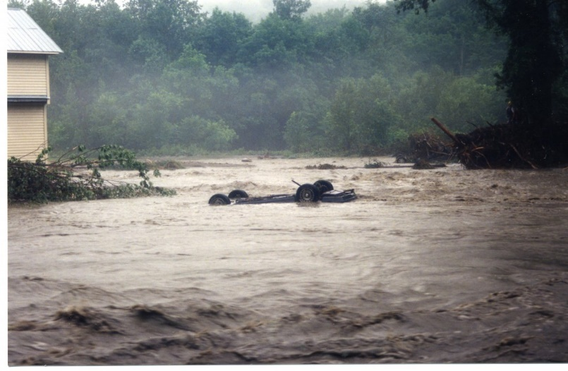

*Flood of 1998*

***Damage from high flows is the single most costly type of disaster in Vermont, primarily due to the erosive power of water. Many roads and culverts conflict with the room needed by streams and rivers.”***

***2021 Vermont Climate Assessment***

Several major flooding events have affected the state in recent years, resulting in multiple Presidential Disaster Declarations. From 2003 to 2019, Washington County experienced roughly $88.82 million in municipal property damage due to flood events. The totals from the most recent July 2023 flood event are still being totaled at the time of this writing.

The worst flooding event in recent years to strike the town of Waitsfield came in August of 2011 from Tropical Storm Irene (DR4022), which dropped up to 5-7+ inches of rain in some areas of Washington County. Irene caused 2 deaths and $60 million in reported property damages and $2.5 million in crop damage in Washington County alone. Luckily the July 2023 flooding event that is the worst to affect the State and region since the Flood of 1927 primarily missed the Mad River valley, where the town only received ~5” of rain during this event and had minimal flooding within the town.

The December 2023 rain on snow flooding caused localized flooding in the town but the mitigations actions that were implemented post Irene helped to prevent any large damages, limiting the effects to minor flooding of low-lying areas and road closures due to inundation. For a short period of the event the town was almost cut off and had to adjust medical transport to the local hospital to avoid inundation areas. The effects of these storms are profiled in this flooding section.

The town is concerned with the increased temperatures in winter seasons brought on by climate change. The increase in temperature fluctuations and associated precipitation is worrisome of rain on snow events impacting the region and specifically the town of Waitsfield due to its location and associated mountains. The snowpack can become hazardous due to the rapid melting from rain on snow and sudden warming, fueling extreme and rapid runoff.

Waitsfield is vulnerable to inundation flooding primarily along the Mad River. A wide range of assets are at risk from inundation flooding in these areas. There are 14 buildings in the FEMA floodway; as well as roads, culverts, bridges well as roads, culverts, bridges, and two water wells listed for public establishments on the Vermont ANR map viewer.

With inundation flooding, there are cascading impacts involving infectious disease as floodwater can contain numerous types of infectious agents and host insects that transmit disease. Mosquitos, for example, breed in standing water and when their population increases, so does the risk of diseases they transmit – such as West Nile Virus.

Flash flooding can occur any time the area has heavy rain. It can impact areas that are located outside of designated floodplains, including along streams confined by narrow valleys (also known as River Corridors). Again, a wide range of assets are at risk from flash flooding. There are 50 buildings in the State-mapped River Corridors (outside of designated floodplains); as well as roads, culverts, bridges, and dams.

The most common type of flash flood damage is road washouts. When runoff volumes exceed the capacity of the stormwater collection system (ditching and culverts), washouts can occur.

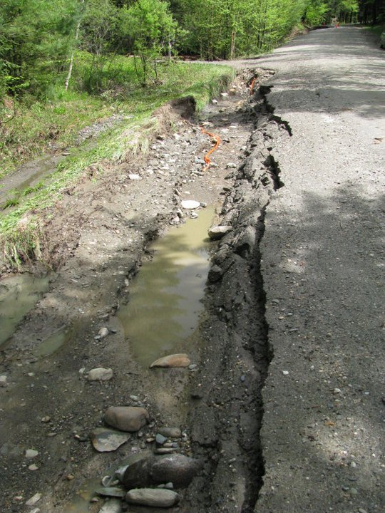

*Brook Road Storm Damage – May 2011*

The town’s structures and road erosion inventories as well as VTrans highway flood vulnerability and risk tools were used to help identify locations and assets at risk from flash flooding.

Sections of several roads have a history of flash flooding – Route 100 in 2 locations Folsom Brook and Mill Brook, Meadow Road, and Tremblay Road. The locations all show as at risk of inundation or fluvial erosion in the Vermont Transportation Resiliency Planning Tool.

Culvert failures and road washouts can have a significant negative impact on the Town. Especially if they occur on roads considered locally important routes for through-traffic, short-cuts, detours, and/or access to critical facilities – such as VT Route 17, VT Route 100, East Warren Road, North Road, and Common Road.

When roads are impacted by flooding, the Town coordinates with the fire department, town road crew and State dispatch to close roads and set up detours. Road closures can create longer commute times and longer emergency service response times.

In addition to stormwater runoff from roads, ice jams and dam failures can result in flash flooding in Waitsfield. Ice jams on the Mad River and Mill Brook in the vicinity of VT Route 17/100 intersection and in the Waitsfield Village just upstream of the covered bridge are possible, with impacts to the roads and the Waitsfield Village.

There are two dams in Waitsfield listed in the Vermont Dam Inventory (a database managed by the VT Dam Safety Program containing spatial, structural, historic, and regulatory information on dams in the state). One is classified as low hazard potential and one is a breached dam. None of the dams are owned by the town and there are no high hazard potential dams in Waitsfield. The low hazard potential dam is the Sugarbush Snowmaking pond dam which is owned and maintained by the Sugarbush resort.

There is one high hazard potential dam upstream of Waitsfield in the town of Warren. It is the Warren Lake Dam, an earthen dam on the Mills Brook a tributary of the Mad River. This dam was built in 1983 and is 530 ft long and 35 ft high and has a normal storage of 350-acre feet and a maximum storage of 1567 acre feet. The drainage for the lake is 595 acres. The last reported inspection of the dam on the ANR dams inventory site was 11/13/2020 and lists the dam as in fair condition.

Community survey respondents ranked damages to roads and bridges as particularly important (7 out of 7) to protect against future severe weather impacts.

Flash flooding often entails stream bank or fluvial erosion. Several existing studies were used to help identify locations and assets at risk from fluvial erosion, specifically, a 2008 Phase 2 Stream Geomorphic Assessment for the Mad River watershed and the Central Vermont Stormwater Master Plan completed in 2019.

Stream Geomorphic Assessments (SGAs) provide information about the physical condition of streams and factors that influence their stability. The 2008 Mad River watershed SGA identifies priority locations for river corridor protection, planting stream buffers, stabilizing stream banks, removing berms, and removing/replacing human- placed structures (i.e., dams, bridges, culverts).

Stormwater Master Planning (SWMP) involves identifying stormwater, sediment, nutrient, and septic inputs to waterways and designing projects to mitigate those inputs; either eliminating them at the source through green stormwater infrastructure, septic system improvements, back road projects or improving floodplain access within the stream network to increase sediment attenuation.

The 2019 Central Vermont SWMP (Waitsfield) recommended 20 projects to reduce environmental impacts of nutrient and sediment loading to the Mad River, as well as mitigate flood vulnerability to municipal or state road and drainage infrastructure.

As demonstrated in the above referenced studies, environmental impacts from flooding can be significant, especially to the water quality in the Mad River and the Winooski River. This can in turn have an adverse impact on local tourism and recreation. Flood events with associated road closures can also have a short-term impact on the local economy due to fewer shopping trips and commuter delays.

Floods Hazard History

These are the most up to date significant events impacting Waitsfield. Federal declarations are depicted in **bold**.

12/18-19/23: 2” of rain on snow event

**7/11/2023: DR4720** 5-9”” rain: $Still to be determined

7/20/2021: Heavy rain: $50,000 county damages

7/14/2020: 3-4” rain: $5,000 town damages

11/1/2019: 2-4” rain: $250,000 county damages

6/20/2019: Heavy rain: $25,000 county damages

5/20/2019: Heavy rain: $25,000 county damages

**4/15/2019: DR4445** 1” rain with significant snow melt:

**7/1/2017: DR4330** 3-4” rain the previous 3-4 days with flash flooding on 7/1/17: $240,000 county damages

7/19/2015: Heavy rain: $1,000,000 county damages

**4/15-18/2014: DR 4178** heavy rain on snow event

$250,000 county damages

**6/25-7/10/2013: DR4140** 1-3” of heavy rain over a half hour: $625,000 county damages

**8/28/2011: DR4022** Tropical Storm Irene with 3-7+” rain:

$75,000,000 Public county damages

**5/26-27/2011: DR4001** 3-5+”rain on snow event: $5,500,000 county damages

**5/20/2011: DR4043:** Heavy rain: $400,000 county damages

**4/23-5/9/2011: DR4043** rain on snow event: $1,000,000 county damages

**19 buildings are in the Special Flood Hazard Area (2% of community structures); mostly single family dwellings and businesses.**

**According to FEMA, 74% of these properties have flood insurance. In total, these 14 policies cover $350,000 in value.**

***There are 4 repetitive loss properties with 2 of them being insured.***

**19 buildings are in the Special Flood Hazard Area (2% of community structures); mostly single family dwellings and businesses.**

**Acco**

**rding to FEMA, 74% of these properties have flood insurance. In total, these 14 policies cover $350,000 in value.**

***There are 4 repetitive loss properties with 2 of them being insured.***

## As weather patterns shift and we see larger storms and more frequent freeze-thaw cycles, the town will monitor for signs that rivers that have historically been stable becoming less stable, with increased erosion, widening, trees falling in from its banks, etc.



Landslides: A landslide is the sliding of a large mass of rock, earth, or debris, down a sloped section of land. Landslides can be caused by rainstorms,

fires, alternate freezing or thawing and/or by the steepening of slopes by erosion or human modification. In Waitsfield, landslides tend to occur or are exacerbated by fluvial erosion as most of the landslides occur on or near a stream bank, or during extreme wet conditions in areas of clay substrate.

Landslides have three major causes: geology, morphology, and human activity. Geology refers to characteristics of the material itself. The earth or rock might be weak or fractured, or different layers may have different strengths and stiffness.

Morphology refers to the structure of the land. For example, slopes that lose their vegetation to fire or drought are more vulnerable to landslides. Vegetation holds soil in place, and without the root systems of trees, bushes, and other plants, the land is more likely to slide away.

Human activity, such as agriculture and construction, can increase the risk of a landslide. Irrigation, deforestation, excavation, and water leakage are some of the common activities that can help destabilize, or weaken, a slope.

The Town of Waitsfield has 37 landslide locations with in the town as listed on the Vermont Agency of Natural Resources Landslide map that was last updated in 2020.

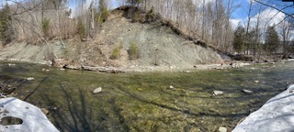

Landslide on Mill Brook at town boundary

Total damages for landslides are not tracked well within the State of Vermont since often landslides are in association with Fluvial Erosion the damages are often lumped together there. With the increase in precipitation trends due to climate change the risk from landslides is increasing. This can be addressed through land use regulations and mitigation of surface runoff from human actions and development.



Extreme Cold, Snow, and Ice Hazard History

These are the most up to date significant events impacting Waitsfield. Federal declarations are depicted in **bold**.

1/11-14/2022: 10-40 below zero with winds: no reported damages

12/18/2021: 5-7” snow $10,000 county damages

1/16/2021: 3-6” wet snow: $50,000 county damages 3/23/2020: 7-10” snow: $5,000 county damages

2/7/2020: 10-16”; ¼” ice: $20,000 county damages

**1/16/2020: DR 4474** 6-10” snow: $10,000 county damages

3/22/2019: 9” snow: $25,000 county damages

2/12/2019: 7-15” snow: $10,000 county damages

1/29/2019: 6-10” snow: $10,000 county damages

1/19/2019: 10-18” snow: $25,000 county damages

1/8/2019: 8-20+” snow: $25,000 county damages

11/26/2018: 6-14” heavy snow: $125,000 county damages

3/13/2018: 12-30” snow: $20,000 county damages 3/7/2018: 7-13” snow: $10,000 county damages

1/7/2015: 0-10 degrees with wind of 15-30 mph creating wind chills colder than 20-30 below zero: no reported local damage

**12/9/2014: DR4207** 10-20” snow: $250,000 county damages

Severe Storms with Snow, Wind and Ice events typically occur between the months of December and March in the Central Vermont Region. They

can include snow, sleet, freezing rain, or a mix of these wintry forms of precipitation. Events can also be associated with strong wind or floods, increasing the potential hazard.

The costs of these storms come in the form of power outages due to heavy snow or ice, damaged trees, school closings, and traffic accidents. From

2014 to 2022, Washington County experienced $585,000 in property and crop damage from winter storms.

There have been two winter storm-related federally declared disasters in the county (the ice storm of January 2020 – DR 4474; and December 2014 DR 4207, respectively (see table at right).

Extreme cold can have impacts on public health and safety, especially if extreme temperatures coincide with power outages, which can cut off heat and communication services. Severe winter storm impacts can put vulnerable populations (e.g., older adults, children, sick individuals, pets) at even greater risk.

See the strong wind profile below for more information about the town’s vulnerability to power outages.

Snow accumulation typically does not result in loss of road accessibility. The town’s fleet of snowplows ensures all roads are accessible, even in major accumulation events. Roads adjacent to critical facilities are well maintained and along with connector routes, are prioritized in winter storm events.

Environmental impacts are predominantly tree damage. Extreme snow and ice events typically have a short-term impact on the local economy – fewer shopping trips and commuter delays.

Strong wind can occur alone, such as during straight-line wind events, or it can accompany other natural hazards,

including severe thunder and/or winter storms.

FEMA’s National Risk Index defines strong wind as damaging winds that exceed 58 mph. Strong wind poses a threat to lives, property, and vital utilities primarily because of flying debris or downed trees and power lines.

From 1996 to 2022, wind events caused more than $1.270 million in property damage in Washington County, with $450,000 due to one event in December 2022.

***Strong wind is possible here; Waitsfield is susceptible to high directional winds town wide. Many storms with high winds result in downed trees as well as damaged phone and power lines, buildings, and other property.***

Downed trees within the road right-of-way are the root cause of many power outages. Roads that pass through dense wooded areas are prone to downed trees, which often can lead to fallen power lines.

Power outages are the main reason for disrupting communications, which are crucial in times of crisis. For example, the loss of phone service is of particular concern for Waitsfield’s vulnerable populations and residents. Landline phones that have been converted from copper wire to fiber rely on an in- home battery back-up. The battery life is typically less than eight hours, whether the phone is used or not. Though many residents use cell phones, longer power outages and damage from high winds further complicating the problem of contacting emergency services during power outages.

Telecommunications are also needed for warning systems before a disaster, as well as for response during and recovery after. During a disaster, municipal response is managed by the local Emergency Operations Center (EOC), this would include all communications – from phone calls to internet browsing and 2-way radio.

To mitigate the impacts of power outages, the following public buildings/critical facilities have been equipped with backup power or generator hookup: Water supply pump house, fire station, Mad River ambulance, and Waitsfield elementary school (as emergency shelter).

The public buildings lacking backup power are the town garage.

In addition to power outages, downed trees during strong wind (and heavy snow/ice) events can damage buildings and other property and in rare cases result in fatality. One hundred percent (100%) of community survey respondents reported having seen areas in the community damaged during a past severe weather event. The most common type of damage that survey respondents reported seeing was downed trees. Seventy-one percent (71.4%) of community survey respondents reported having experienced damage during a past severe weather event.

Environmental impacts are predominantly tree and roof damages. Strong wind events with associated power outages can have a short-term impact on the local economy due to business closures.

Vermont’s Emerald Ash Borer infestation was first detected in 2018 in northern Orange County. The potential risk to public and private structures and impacts on the local economy have not been quantified. But the impact of invasive pests has a real economic effect on landowners and utilities in dealing with dead trees and their potential to cause damages.

***As weather patterns shift and we see larger storms and more frequent freeze-thaw cycles, the Town will monitor for signs that rivers and streams that have historically been stable are becoming less stable, with increased erosion, widening and trees falling in from its banks, etc.***

Strong Wind Hazard History

These are the most up to date significant events impacting Waitsfield. Federal declarations are depicted in **bold**. Damages are to Washington County.

**12/23/2022**: 50-60+ wind gusts: $450,000

10/30/2017: 40 mph wind: $250,000

2/26/2010: 55 mph wind: $15,000

2/17/2006: 37 mph wind: $10,000

9/29/2005: 35 mph wind: $50,000

11/13/2003: 35 mph wind: $10,000

10/15/2003: 50 mph wind: $10,000

3/10/2002: strong wind: $5,000

12/12/2000: strong wind: $5,000

3/28/2000: strong wind: $5,000

9/17/1999: strong wind: $75,000

11/23/1998: strong wind: $10,000

2/22/1997: 50 mph wind: $15,000

Droughts in the Northeast. We frequently experience what are referred to as “flash” droughts, defined as rapid onset of intense dry

periods that can follow periods of normal or above normal precipitation. These may last from 2-6 months, and can have profound impacts within the region, on agricultural losses, shortages of water supply and very low stream flows. This pendulum often swings from a dry year to a wet year.

The Town’s risk of droughts is mainly addressed through the Ordinances for the Town water supply. Most residents of the Town are on private wells and bear the costs and risks of mitigation themselves. The Town’s Water Ordinance has the appropriate language for conserving water and limiting non-essential usage during a drought emergency.

Wildfires are not often much of a concern within our region, although the spring and fall can be times

when dry hazardous conditions exist. Opportunity for wildfires occurs due to the lack of foliage in these seasons, before spring green up or in the fall after foliage has died back when combined with dry conditions. Historically, Vermont has seen the most wildland fires between March and June. These are generally times when dry conditions exist for an extended period causing drought conditions. Ignition of wildfires is predominantly caused by human activity and mainly from debris fires that are not contained or not supervised. Thus, messaging when conditions exist is very important to convince individuals not to make mistakes in relation to ignition sources. This messaging is handled by the town fire warden in association with the fire department.

Infectious Disease and Invasive Species

This Plan must assess the risk of all hazards identified in the 2018 Vermont State Hazard Mitigation Plan, including infectious disease and invasive species. Due to the different nature of these hazards, the Planning Team assessed them separately from the natural hazards in **Table 4**.

Infectious diseases and invasive species are diverse categories of hazards. So, while their probability of occurrence in Waitsfield may be likely, potential impacts will be highly dependent on the specific infectious agent or invasive.

The Planning Team acknowledges that impacts to Waitsfield’s people, environment, and local economy from infectious disease and/or invasive species could be significant. However, given the diverse nature of these hazards, they cannot be fully explored in this plan. This plan does include information about the potential hazards and risks associated with a specific infectious agent (West Nile Virus) and invasive species (Emerald Ash Borer) due to cascading impacts associated with flooding and storm-related tree damage.

Readers should look to the Vermont Department of Health for more information on significant infectious disease outbreaks, such as epidemics and pandemics and the Vermont Agency of Natural Resources for more information on invasive species, including terrestrial invasives, forest pests, and aquatic invasives.

Extreme heat and cold warnings are becoming increasingly more prevalent due to our shifting climate. Vermont has been seeing an

Increase in 90+ degree temperature days. This trend is expected to continue. Most of our housing stock and individuals are well adapted to dealing with cold temperature, but the quick swings to higher temperatures do not allow for acclimation, and many of our structures are designed to retain, rather than shed, heat. Due to the climate of our region the high temperatures and high humidity often create situations that negatively affect older individuals and those with preexisting conditions.

Due to the instability of the jet stream from climate changes, extreme cold can still be an issue. If it is a long-lasting cold without snow cover, frost can migrate deep into the ground freezing pipes and heaving roadways. Most of this would be dealt with by the town either through their utility contracts or by the town road crew in keeping the transportation infrastructure in usable condition. Loss of power during one of these cold snaps may require use of the town shelter and is planned for in the town Local Emergency Management Plan.

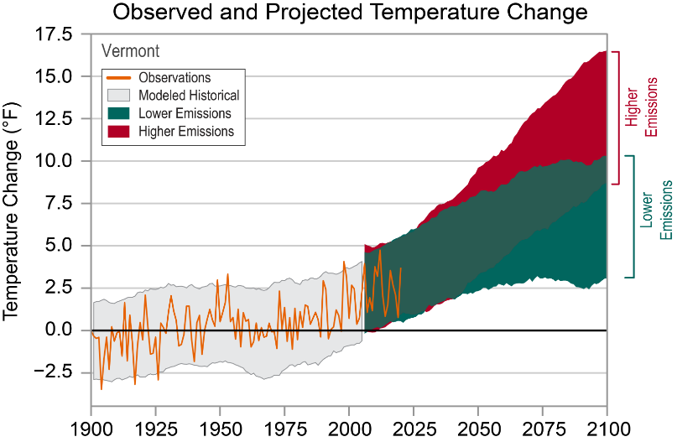

*-NOAA 2022 Vermont Climate summary*

**Hazards**

* Location
  + Extent

-Past Occurrence

* + Future Probability

**RISK**

**Community Assets**

- People

* Infrastructure
* Environment

- Economy

***The Hazard Identification and Risk Assessment is the foundation for the Mitigation Strategy to***

***reduce future risk.***

With the increasing risks of events from our changing climate, all weather-related natural events are expected to have an increase in both frequency and in intensity. Vermont is predicted to experience increases in heat waves, downpours and flooding.

The Northeastern United States has already seen an increase of seventy one percent precipitation totals increase since 1950 and an increase in extreme weather events. It is imperative that we have solid plans of mitigating future disasters proactively to minimize risk.

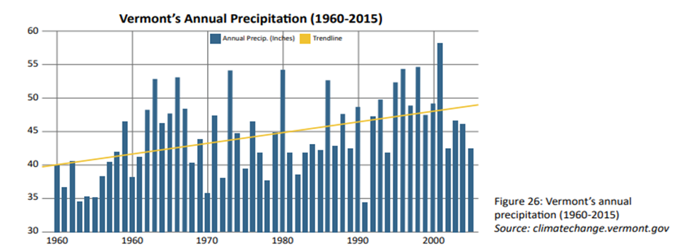  
 -*precipitation data showing increased precipitation trends from VT state climate action plan*

# 6 HAZARD MITIGATION STRATEGY

The highest risk natural hazards and vulnerabilities identified in the previous section of this Plan directly inform the hazard mitigation strategy outlined below, which the community will strive to accomplish over the coming years. The mitigation strategy chosen by the Town includes the most appropriate activities to reduce future risk from potential hazards.

Mitigation Goals

The Hazard Mitigation Planning Team identified the following as the community’s primary mitigation goal:

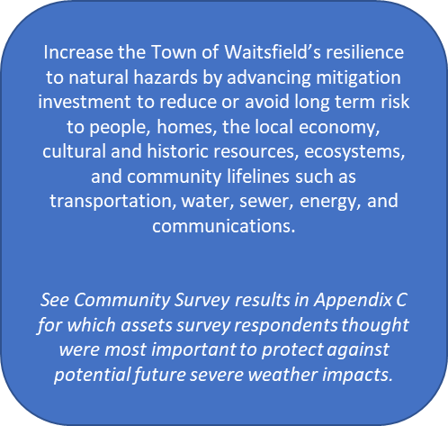

Community Capabilities Each community has a unique set of capabilities, including authorities, programs, staff, funding, and other resources available to accomplish mitigation and reduce long-term vulnerability. Waitsfield’s mitigation capabilities that reduce hazard impacts or that could be used to implement hazard mitigation activities are listed below:

**Administrative & Technical** This capability refers to the Town’s staff and their skills and tools that can be used for mitigation planning and to implement actions. In addition to the Emergency Management staff described in Section 3, municipal staff that can be used for mitigation planning and to implement specific mitigation actions include: Town Administrator, Town Treasurer, Town Clerk, Assistant Town Clerk, and Planning and Zoning Administrator.

In addition to paid staff, there is a 5-member Selectboard, 5-member Planning Commission, Fire Warden, Town Health Officer, Conservation Commission and Constable.

To augment local resources, the Town has formal mutual aid agreements for emergency response – fire and EMS. Technical support is available through the CVRPC in the areas of land use planning, emergency management, transportation, GIS mapping, and grant writing. Technical support is also available through the State ANR for floodplain bylaw administration and VTrans Districts for hydraulic analyses.

**Planning & Regulatory** These capabilities are the plans, policies, codes, and ordinances that prevent and reduce the impacts of hazards. Examples of planning capabilities that can either enable or inhibit mitigation include: land use plans, capital improvement programs, transportation plans, stormwater management plans, disaster recovery and reconstruction plans, and emergency preparedness and response plans. Examples of regulatory capabilities include the enforcement of zoning ordinances, subdivision regulations, and building codes3 that regulate how and where land is developed, and structures are built.

**Town Plan:** December 2023

Description: A framework and guide for how future growth and development should proceed.

Relationship to Natural Hazard Mitigation Planning: Includes goals and policies related to flood resilience and land use.

**Zoning Ordinance with Flood Hazard Area and Fluvial Erosion Overlay District Requirements:** September 2016 Description: Provides for orderly community growth promoting the health, safety, and general welfare of the community.

Relationship to Natural Hazard Mitigation Planning: Site plan review requirements and zoning districts, including Flood Hazard and River Corridor Overlay Districts, with specific standards for proposed development. Requirements are designed to prevent overdevelopment; to mitigate negative impacts to the natural and human environment; minimize effects to the historical and aesthetic character of the community; and ensure design and construction of development in flood and other hazard areas are accomplished in a manner that minimizes or eliminates the potential for flood loss or damage to life and property.

**Road and Bridge Standards:** July 2019

Description: Provide minimum codes and standards for construction, repair, maintenance of town roads and bridges. Relationship to Natural Hazard Mitigation Planning: Standards include management practices and are designed to ensure travel safety, minimize damage to road infrastructure during flood events, and enhance water quality protections.

**Road Erosion Inventory Report***:* **2020**

Description: Prioritizes those infrastructure projects necessary to improve transportation network resiliency and water quality. Relationship to Natural Hazard Mitigation Planning: Improvements are designed to minimize or eliminate flood impacts on hydrologically connected road segments.

**Local Emergency Management Plan:** April 2023 Description: Establishes lines of responsibility and procedures to be implemented during a disaster and identifies high risk populations, hazard sites, and available resources.

Relationship to Natural Hazard Mitigation Planning: Includes actions for tracking events and response actions including damage reports to facilitate funding requests during recovery. The following information can be essential to preparing hazard mitigation project applications for FEMA funding.

**Fire Department ISO Rating:** Issued in 2015 Description: Where municipal water is available, the rating is 7.7. This rating is a score from 1 to 10 that indicates how well- protected the community is by the local fire department. Will be coming up for renewal in ~2 years and may be able to improve.

Relationship to Natural Hazard Mitigation Planning: Everyone wants to keep family, home, and business safe from fires. The ISO rating is a measure of the effectiveness of a community’s fire services.

**Water Ordinance:** November 2018

Description: Establish minimum standards for design, construction, installation, control, operation of public drinking water system.

Relationship to Natural Hazard Mitigation Planning: Adopted standards that reduce risk, make the system more resilient, and conserve water.

Waitsfield Ash Tree Management Plan-2021

Description: Inventoried and prioritizes ash tree management due to Emerald Ash Borer infestations within the town ROW.

Relationship to Natural Hazard Mitigation Planning: Identifies locations for work to remove affected trees from ROW to prevent debris from accumulating or impacting town roads.

**Upper Mad River Corridor Plan:** 2008

Description: Identify river best management practices and develop prioritized projects to mitigate stormwater water quality problems.

Relationship to Natural Hazard Mitigation Planning: Many proposed projects accomplish multiple goals: -water quality and mitigation.

3 Waitsfield does not have any local building codes. Vermont has adopted statewide codes for commercial building fire safety and energy standards. The energy code also applies to residential buildings. Codes enforced by Vermont’s Division of Fire Safety are the 2015 National Fire Protection Association (NFPA) 1 Fire Code; 2015 NFPA 101 Life Safety Code; the 2015 International Building Code (IBC); 2017 NFPA 70 National Electrical Code; 2021 International Code Council (ICC) International Plumbing Code; and the 2015 National Board Inspection Code from the National Board of Boiler and Pressure Vessel Inspectors.

**Financial** These capabilities are the resources that a community has access to or is eligible to use to fund mitigation actions.

Waitsfield’s 2024 town budget is $2,673,901, with $590,356 to fund the Road Department. In addition to property tax revenues, the Town collects separate fees for water services.

**Outreach & Education** Waitsfield has several outreach and education opportunities that could be used to implement mitigation activities and communicate hazard-related information:

* Waitsfield-Fayston Fire Department Mad River Ambulance, Waitsfield Elementary School, Waitsfield Conservation Committee, Friends of the Mad River
* Town website, Front Porch Forum, Valley Reporter

**National Flood Insurance Program Compliance**

The Town joined the National Flood Insurance

Program (NFIP) in 1978. The effective date of the

current Flood Insurance Rate Map (FIRM) is March 18, 2013. The Zoning Administrator enforces NFIP compliance through permit review requirements in its Flood Hazard Area regulations. Waitsfield’s regulations outline detailed minimum standards for development in flood hazard areas defined as FEMA Special Flood Hazard Areas and Floodway Areas. The regulations also require administering Substantial Improvement and Substantial Damage (SI/SD) requirements in accordance with FEMA P-758 SI/SD Desk Reference, May 2010.

The town is currently awaiting the new flood insurance maps that are being compiled by FEMA and will be reviewed and accepted to maintain the town’s NFIP status once the process has been completed.

The Town discussed the following as possible

actions to continue NFIP compliance:

1) Prepare, distribute, or make available NFIP

insurance explanatory pamphlets or booklets.

2) Participate in NFIP training offered by the State and/or FEMA.

3) Establish mutual aid agreements with neighboring communities to address administering the NFIP following a major storm.

Community Lifelines

Community Lifelines enable the continuous operation of critical government and business functions and are essential to human health and safety or economic security. The goal of the lifeline concept is to focus response efforts on stabilizing or re-establishing these most fundamental services during and after a disaster. Mitigating lifelines should reduce cascading impacts across government and business functions and lessen system-wide damage.

Community Lifelines are organized into seven categories:





**State Incentives for Flood Mitigation** Vermont’s Emergency Relief Assistance Funding (ERAF) provides state funding to match FEMA Public Assistance after federally declared disasters. Eligible public costs are generally reimbursed by FEMA at 75% with a 7.5% State match. The State will increase its match to 12.5% or 17.5% if communities take steps to reduce flood risk as described below.

12.5% funding for communities that have adopted four (4) mitigation measures:

1. NFIP participation;
2. Town Road and Bridge Standards;
3. Local Emergency Plan; and
4. Local Hazard Mitigation Plan.

17.5% funding for communities that also participate in FEMA’s Community Rating System OR adopt Fluvial Erosion Hazard or other river corridor protection bylaw that meets or exceeds the Vermont ANR model regulations.

***Waitsfield’s current ERAF rate is 7.5%. Upon adoption of the 2024 Local Hazard Mitigation Plan, their ERAF rate will increase to 17.5% because the Town has adopted Flood Hazard regulations that are strong enough to receive interim status as River Corridor Bylaws.***

Mitigation Action Identification

The Hazard Mitigation Planning Team discussed the mitigation strategy, reviewed projects from the 2018 Plan, and identified possible new actions from the following categories for each of the highest risk natural hazards identified in Section 5.

**Local Plans & Regulations** These actions include government authorities, policies, or codes that influence the way land and buildings are developed and built.



**Structure & Infrastructure Projects** These actions involve modifying existing structures and infrastructure to protect them from a hazard or remove them from a hazard area. This applies to public or private structures as well as critical facilities.

**Natural Systems Protection** These actions minimize damage and losses and preserve or restore the functions of natural systems.

**Outreach & Education Programs** These actions inform and educate the public about hazards and potential ways to mitigate them. Although this type of action reduces risk less directly than structure projects or regulation, it is an important foundation. Greater awareness is more likely to lead to community support for direct actions.



*Local Plans & Regulations Examples*

**Integrate Mitigation into Capital Improvement Programs:** Incorporate risk assessment and hazard mitigation principles into capital planning.

**Reduce Impacts to Roadways:** The leading cause of death and injury during winter storms is automobile accidents, so it is important to plan for and maintain adequate road and debris clearing capabilities.

**Develop a Road Right-of-Way Vegetation Management Plan**: Identify community priorities and plan of action for site-specific tree and roadside forest management to increase roadside resilience.

**Improve Flood Resilience with a Flood Study:** The aim of a flood study is to define existing flood behavior for a particular catchment, river, or creek. The study helps inform building, land use planning, community awareness and disaster management.

**Improve Stormwater Management Planning**: Rain and snowmelt can cause flooding and erosion in developed areas. A community-wide stormwater management plan can address stormwater runoff- related flooding.

**Manage Development in Erosion Hazard Areas:** The intent of River Corridor Bylaws is to allow for wise use of property within river corridors that minimizes potential damage to existing structures and development from flood-related erosion.

**Structure & Infrastructure Project Examples Protect Power Lines:** Protect power lines by 1) inspecting and maintaining hazardous trees in the road right-of-way and 2) burying power lines.

**Protect Critical Roadways:** Use snow fences or living snow fences (e.g., rows of trees) to limit blowing and drifting of snow.

**Retrofit Critical Facilities:** Critical facilities can be protected from the impacts of high winds and winter storms by 1) retrofitting them to strengthen structural frames to withstand wind and snow loads; 2) anchoring roof-mounted mechanical equipment; and 3) installing back-up generators or quick connect wiring for a portable generator.

**Remove Existing Structures from Flood Hazard Areas:** FEMA policy encourages the removal of structures from flood-prone areas to minimize future flood losses and preserve lands subject to repetitive flooding.

**Improve Stormwater Drainage Capacity:** Minimize flooding and fluvial erosion by 1) increasing drainage/absorption capacities with green stormwater management practices; 2) increasing dimensions of undersized drainage culverts in flood- prone areas; 3) stabilizing outfalls with riprap and other slope stabilization techniques; and 4) re- establishing roadside ditches.

**Conduct Regular Maintenance for Drainage Systems**: Help drainage systems and flood control structures function properly with 1) routine cleaning and repair; 2) cleaning debris from support bracing underneath low-lying bridges; and 3) inspecting bridges and identifying if any repairs are needed to maintain integrity or prevent scour.

**Protect Infrastructure and Critical Facilities:** Minimize infrastructure losses and protect critical facilities from flooding by 1) elevating roads above base flood elevation to maintain dry access; 2) armoring streambanks near roadways to prevent washouts; 3) rerouting a stream away from a vulnerable roadway; and 4) floodproofing facilities.

*Natural Systems Protection Examples*

**Protect and Restore Natural Flood Mitigation Features:** Natural conditions can provide floodplain protection, riparian buffers, groundwater infiltration, and other ecosystem services that mitigate flooding. Preserving such functionality is important. Examples include 1) adding riparian buffers; 2) stabilizing stream banks; 3) removing berms; 4) minimizing impervious area development; 5) restore floodplain; and 6) restore incision areas.

*Outreach & Education Program Examples*

**Educate Residents about Extreme Winter Weather:** Winter storms create a higher risk of car accidents, hypothermia, frostbite, carbon monoxide poisoning, and heart attacks from overexertion. Educational outreach can help minimize these risks.

**Assist Vulnerable Populations:** Measures can be taken to protect vulnerable populations from natural hazards, such as

* 1. organizing outreach and
  2. establishing and promoting accessible heating or cooling centers in the community.

Mitigation Action Evaluation

For each mitigation action identified, the Planning Team evaluated its potential benefits and/or likelihood of successful implementation. Actions were evaluated against a range of criteria, including a planning level assessment of whether the costs are reasonable compared to the probable benefits. Results of this evaluation are presented in **Table 5**.

See Community Survey results in **Appendix D** for which category of mitigation actions survey respondents wanted the Town to prioritize.

Mitigation Action Plan for Implementation

After careful evaluation, the Planning Team agreed

on a list of actions that support the Mitigation Goals of this Plan and are acceptable and practical for the community to implement.

***Actions without overall public support/political will were not selected for implementation. Actions whose costs were not reasonable compared to probable***

***benefits were also not selected.***

For the selected actions, the Planning Team then 1) assigned a responsible party to lead the completion of each action; 2) identified potential grant funding;

defined a timeframe for implementation; and ranked each action’s priority (high, medium, low).

Natural hazards pose a unique threat to the Town’s vulnerable populations. Data has shown that underserved and marginalized populations tend to live in at-risk hazard-prone areas or in homes with substandard construction. The data also suggests that this segment of the community is less likely to fully recover after a disaster. 4 When ranking an action’s priority, those that directly benefit a vulnerable population were ranked high.

The action plan is presented in **Table 6**

**Table 5: Mitigation Action Evaluation and Prioritization**

|  |  |  |  |  |  |  |  |  |  |
| --- | --- | --- | --- | --- | --- | --- | --- | --- | --- |
| **Mitigation Action** | **Life**  **Safety** | **Prop**  **Protect** | **Tech** | **Political** | **Admin** | **Other**  **Obj** | **Benefit**  **Score** | **Est**  **Cost** | **C/B** |
| **Local Plans & Regulations** | | | | | | | | | |

|  |  |  |  |  |  |  |  |  |  |  |  |
| --- | --- | --- | --- | --- | --- | --- | --- | --- | --- | --- | --- |
| Integrate Mitigation into Capital Improvement  Programs and Planning |  | |  |  |  |  |  |  |  | |  |
| Plan for and Maintain Adequate Road and  Debris Clearing Capabilities |  | |  |  |  |  |  |  |  | |  |
| Update Road Erosion and Culvert Inventories |  | |  |  |  |  |  |  |  | |  |
| Identify and prioritize roads for base/drainage upgrades to stabilize mud season conditions |  | |  |  |  |  |  |  |  | |  |
| Inspect Town Short-Structures and Review VTrans Bridge Inspection Reports 5 for Town Long-Structures and Plan for Repairs to  Prevent Flood-related Impacts like Scour |  | |  |  |  |  |  |  |  | |  |
| Plan for Road Right-of-Way Vegetation  Management |  | |  |  |  |  |  |  |  | |  |
| Hot and Cold Weather Planning |  | |  |  |  |  |  |  |  | |  |
| Update Zoning Ordinance to Require New  Subdivision Development to Bury Power Lines |  | |  |  |  |  |  |  |  | |  |
| Burn Bans and outreach for fire danger |  | |  |  |  |  |  |  |  | |  |
| Adopt Local Building Codes for Roof Wind and Snow Loads |  | |  |  |  |  |  |  |  | |  |
| Adopt Flood Hazard Area and/or River Corridor  Bylaws | Planning Team did not evaluate this action because the Town has already  adopted both FHA and received interim status for river corridor bylaws. | | | | | | | | | | |
| Emergency Action Plan for Waste Water system as part of the development process |  |  | |  |  |  |  |  | |  |  |
| Study areas of concern for flood mitigation |  |  | |  |  |  |  |  | |  |  |
| Incident Command System training for municipal officials ICS-402 |  | |  |  |  |  |  |  |  | |  |
| **Structure & Infrastructure Projects** | | | | | | | | | | | |

|  |  |  |  |  |  |  |  |  |  |  |
| --- | --- | --- | --- | --- | --- | --- | --- | --- | --- | --- |
| Protect Power Lines and Roads by Inspecting  and Removing Hazardous Trees in Road ROW |  |  | |  |  |  |  |  |  |  |
| Install Back-up Generators at the town garage |  |  | |  |  |  |  |  |  |  |
| Increase Drainage/Absorption Capacities with  Green Stormwater Management Practices |  |  | |  |  |  |  |  |  |  |
| Stabilize Outfalls |  |  | |  |  |  |  |  |  |  |
| Install/Re-establish Roadside Ditches |  |  | |  |  |  |  |  |  |  |
| Routinely Clean and Repair Stormwater  Infrastructure |  |  | |  |  |  |  |  |  |  |
| Routine Clear Debris from Support Bracing Underneath Low-Lying Bridges |  |  | |  |  |  |  |  |  |  |
| Increase Dimension of Drainage Culverts to  Bank full width standard |  |  | |  |  |  |  |  |  |  |
| Remove Existing Structures from Flood-Prone  Areas |  |  | |  |  |  |  |  |  |  |
| Center Fayston Road Stream culvert 36” needs upgraded to bank full width # 21416-6 |  |  | |  |  |  |  |  |  |  |
| Create process for rebuilding prioritized roads to alleviate mud season conditions |  |  | |  |  |  |  |  |  |  |
| Common Road High Bridge Brook culvert 5’ upgraded to bank full width # 21480-3 |  |  | |  |  |  |  |  |  |  |
| Elevate Route 100 to maintain access along Mill Brook |  |  |  | |  |  |  |  |  |  |
| Bury Power Lines |  |  |  | |  |  |  |  |  |  |
| Stabilize slide at slope near town line on Mill Brook along Bragg Hill Road |  |  |  | |  |  |  |  |  |  |
| East Warren Road Folsom Brook Tributary culvert 6’ upsize to bank full width #21481-35 |  |  |  | |  |  |  |  |  |  |
| North Road-South of North Ridge Road culvert 2’ upsize to bank full width # 21479-1 |  |  |  | |  |  |  |  |  |  |
| North Road-South of Tremblay Road culvert 6’ upsize to bank full width # 21479-7 |  |  |  | |  |  |  |  |  |  |
| River View Road-1st stream culvert 4’ upsize to bank full width standard # 21415-2 |  |  |  | |  |  |  |  |  |  |
| Sherman Road tributary of Folsom Brook culvert 4.5’ upsize to bank full width #21477-8 |  |  |  | |  |  |  |  |  |  |
| Tremblay Road- by town garage culvert 7.5’ upsize to bank full width #21419-6 |  |  |  | |  |  |  |  |  |  |
| Old Center Fayston Road-1st stream culvert 6’ upsize to bank full width # 21418-3 |  |  |  | |  |  |  |  |  |  |
| North Road-South of Tannery Road culvert 6’ upsize to bank full width #21479-11 |  |  |  | |  |  |  |  |  |  |
| Retrofit Critical Facilities to Strengthen  Structural Frames to Withstand Wind and Snow Loads |  |  |  | |  |  |  |  |  |  |
| Anchor Roof-Mounted Mechanical Equipment on Critical Facilities |  |  |  | |  |  |  |  |  |  |
| Floodproof Critical Facilities, town buildings |  |  |  | |  |  |  |  |  |  |
|  | | | | | | | | | | |

|  |
| --- |
| **Natural Systems Protection** |

|  |  |  |  |  |  |  |  |  |  |
| --- | --- | --- | --- | --- | --- | --- | --- | --- | --- |
| Stabilize Stream Banks |  |  |  |  |  |  |  |  |  |
| Remove Berms and/or Accumulated Debris from Stream to Restore Flood Capacity |  |  |  |  |  |  |  |  |  |
| Streambank buffer plantings |  |  |  |  |  |  |  |  |  |
| Identify and restore wetlands in appropriate locations |  |  |  |  |  |  |  |  |  |

|  |  |  |  |  |  |  |  |  |  |
| --- | --- | --- | --- | --- | --- | --- | --- | --- | --- |
| Remove Significant Hazard Potential Dams |  |  |  |  |  |  |  |  |  |
| Reconnect Floodplain on Town owned Austen Parcel |  |  |  |  |  |  |  |  |  |
| Reconnect Floodplain on the Town owned Tardy Parcel |  |  |  |  |  |  |  |  |  |
| Reconnect Floodplain on the Town owned Lower Fairground Parcel |  |  |  |  |  |  |  |  |  |
| Study and possibly reconnect Flood chute just south of Tremblay road on private property |  |  |  |  |  |  |  |  |  |
| Establish Vegetative Buffers in Riparian Areas |  |  |  |  |  |  |  |  |  |
| Floodplain Restoration |  |  |  |  |  |  |  |  |  |
| Restore Incision Areas |  |  |  |  |  |  |  |  |  |
| **Outreach & Education Programs** | | | | | | | | | |

|  |  |  |  |  |  |  |  |  |  |
| --- | --- | --- | --- | --- | --- | --- | --- | --- | --- |
| Educate the Public About the Risks of Infectious  Disease and/or Invasive Species and How to Protect Against Them |  |  |  |  |  |  |  |  |  |
| Educate DPW Staff to Recognize the Presence of Large Mosquito Populations Around Standing Water and How to Report this Information to the  VDH District Office to Improve Vector Control |  |  |  |  |  |  |  |  |  |
| Education campaign to landowners of benefits of wetlands and wetland restoration for flood mitigation |  |  |  |  |  |  |  |  |  |

**Not Recommended for Implementation**

|  |  |
| --- | --- |
| Educate the Public About How to Prepare for  Extreme Winter Weather | Planning Team did not evaluate this action because the Town already does  outreach/education on how to prepare for extreme winter weather. |
| Assist Vulnerable Populations | Planning Team did not evaluate this action because the Town already has a procedure for assisting vulnerable populations in its Local Emergency  Management Plan. |
| Keep the Ditches Clean Campaign | Planning Team did not evaluate this action because the filling of ditches by  adjacent property owners is not a problem in the community. |

**Table 5 Evaluation Criteria:**

**Life Safety** –Will the action be effective at protecting lives and preventing injuries?

**Property Protection** –Will the action be effective at eliminating or reducing damage to structures and infrastructure?

**Technical** – Is the action a long-term, technically feasible solution?

**Political** – Is there overall public support/political will for the action?

**Administrative** – Does the community have the administrative capacity to implement the action?

**Other Community Objectives** – Does the action advance other community objectives, such as capital improvements, economic development, benefit a vulnerable population, environmental quality, or open space preservation?

**Rank each of the above criteria in Table 5 with a -1, 0, or 1 using the following table:**

1 = Highly effective or feasible 0 = Neutral

-1 = Ineffective or not feasible

**Estimated Cost** – 1 = less than $50,000; 2 = $50,000 to $100,000; 3 = more than $100,000

**C/B** – Are the costs reasonable compared to the probable benefits? Yes or No

Table 6: Mitigation Action Plan

This area will be filled by mitigation actions once presented and reviewed by the town planning commission.

Integrating into Existing Plans and Procedures

For Waitsfield to succeed in reducing long-term risk, information from this Plan should be integrated throughout government operations. When activities are connected, they can not only reduce risk and increase resilience, but also accomplish other objectives such as environmental protection, economic development, financial stability, and land use planning.

There are several ways the Town can achieve integration into existing plans and procedures to support risk-informed community planning. They can include the community’s primary mitigation goal as stated on page 18, information from the risk assessment, and mitigation actions as follows:

* + The mitigation goal and risk assessment information can be considered when prioritizing capital improvements. Mitigation actions listed in this Plan can be included in the annual budgeting process.
  + Funding for mitigation actions can be prioritized in the annual budget process.
  + The mitigation goal and risk assessment information can be incorporated into the next Town Plan update (Land Use and Flood Resilience chapters in particular) to help steer growth and redevelopment away from high-risk locations.
  + The mitigation goal and risk assessment information can be incorporated into future zoning ordinance updates. Ideally incorporating this while doing zoning updates for the acceptance of new flood maps.
  + The mitigation goal and risk assessment information can be incorporated into any plans to expand public water and sewer utilities to ensure they are not expanded into high-hazard areas.
  + Several flood-related mitigation actions for increasing road resiliency can be implemented under the existing Municipal Road General Permit (8054-9040) for controlling stormwater discharges from town roads.
  + Several flood-related mitigation actions for increasing road resiliency can be implemented under the existing Municipal Road General Permit (8054-9040) for controlling stormwater discharges from town roads.

**7 PLAN MAINTENANCE**

This Plan is dynamic. To ensure it remains current and relevant, it should be annually evaluated and monitored and updated every five years, in accordance with FEMA guidelines in effect at the time.

Annual Evaluation and Monitoring

Within 12 months of FEMA Final Approval, the Plan will be annually evaluated and monitored as follows:

Make Annual

Evaluate Plan Effectiveness



**1**

**2**

Monitor Mitigation Action Progress

Invite Public Comment/Input

**3**

Progress Report Available to Public

**4 5**

Adjust Mitigation Strategy/Actions as Necessary

The Selectboard will evaluate the effectiveness of the Plan in meeting the stated goals. Things to consider during this evaluation:



**1**

* What disasters has the town (or region) experienced?
* Should the list of highest risk natural hazard impacts be modified?
* Are new data sources, maps, plans, or reports available? If so, what have they revealed, and should the information be incorporated into this plan?
* Has development in the region occurred and could it create or reduce risk?
* Has the town adopted new policies or regulations that could be incorporated into this plan?
* Have elements of this plan been incorporated into new plans, reports, policies, or regulations?
* Are there different or additional community capabilities available for mitigation implementation?

Next, the Selectboard will monitor mitigation action progress. Things to consider:



**2**

* Is the mitigation strategy being implemented as anticipated?
* Were the cost and timeline estimates accurate?
* Should new mitigation actions be added?
* Should proposed actions be revised or removed?
* Are there new funding sources to consider?

The status (e.g., in progress, complete) of each action should be recorded in **Table 7**. If the status is “in progress” note whether the action is on schedule. If not, describe any problems, delays, or adverse conditions that will impair the ability to complete the action.

The Selectboard will seek public comment from the Whole Community on plan implementation. Things to consider:



**3**

* Are there any new stakeholders to include?
* What public outreach activities have occurred?
* How can public involvement be improved?

Based on input received, the mitigation strategy and/or actions will be modified, if needed.



**4**

A report (or record in the form of meeting minutes) of the annual evaluation and monitoring will be made available to the public.



**5**

**Table 7: Mitigation Action Status**

|  |  |  |  |  |  |
| --- | --- | --- | --- | --- | --- |
| **Mitigation Action** | **2024** | **2025** | **2026** | **2027** | **2028** |
| **Local Plans & Regulations** | | | | | |
| Plan for and Maintain Adequate Road and Debris Clearing Capabilities |  |  |  |  |  |
| Update Road Erosion and Culvert Inventories |  |  |  |  |  |
| Road Right-of-Way Vegetation Management Plan |  |  |  |  |  |
| Plan for Bridge Repairs |  |  |  |  |  |
| Stormwater Master Plan |  |  |  |  |  |
| Flood Study |  |  |  |  |  |
| **Structure & Infrastructure Projects** | | | | | |
| Remove Hazard Trees in Road Right-of-Way |  |  |  |  |  |
| Install Back-up Power at Critical Facilities |  |  |  |  |  |
| Install Green Stormwater Management Practices |  |  |  |  |  |
| Stabilize Culvert Outfalls |  |  |  |  |  |
| Install/Re-work Roadside Ditches |  |  |  |  |  |
| Routinely Clean and Repair Stormwater Infrastructure |  |  |  |  |  |
| Routinely Clear Debris from Low-Lying Bridge Support  Bracing |  |  |  |  |  |
| Adequately Size Culverts in Flood-Prone Areas |  |  |  |  |  |
| Remove Structures from Flood-Prone Areas |  |  |  |  |  |
| Install Live Snow Fence or Equivalent Technique on  Critical Roadways |  |  |  |  |  |
| **Natural Systems Protection** | | | | | |
| Stabilize Stream Banks |  |  |  |  |  |
| Remove Accumulated Debris to Restore Flood Capacity |  |  |  |  |  |
| **Outreach & Education Programs** | | | | | |
| Infectious Disease and/or Invasive Species Awareness |  |  |  |  |  |
| Disease Vector Control Training |  |  |  |  |  |

5-Year Updates

This Plan will be updated at a minimum every five (5) years as follows:



Initiate Plan Update

Approval Pending Adoption

FEMA Final Approval

**1 2 3 4 5**

Opportunities for Whole Community Involvement

Local Adoption

Currently, funding to assist municipalities in paying for planning services to update the Local Hazard Mitigation Plan is available through FEMA’s Building Resilient Infrastructure and Communities grant program. If using this grant, Waitsfield should contact Vermont Emergency Management (VEM) to apply for funding in 2027 – approximately 2 years before the Plan expires.



**1**

Once funding is secured and the grant agreement between the Town and State is in place, the Town Manager can issue a request for proposals (RFP) to procure planning services in accordance with the grant agreement. The RFP should be issued approximately 14 months before the Plan expires.

Once a consultant is procured, the Plan update can begin with a kick-off meeting including the consultant and local hazard mitigation planning team. The kick-off meeting should be scheduled approximately 12 months before the Plan expires. The Town should allot approximately 8 months for the Plan update process.

Opportunities for Whole Community involvement throughout the Plan update process need to be factored into the schedule. These opportunities may include a community survey, planning workshop, and public meetings at critical milestones agreed to at the project kick-off meeting.



**2**

Once the local hazard mitigation planning team has prepared a final draft, they can seek authorization from the Selectboard to submit the Plan for VEM/FEMA approval. Plan approval is accomplished in two steps – the first is Approval Pending Adoption. The Town should submit for Approval Pending Adoption approximately 4 months before the Plan expires to allow for time to respond to any review comments received from VEM/FEMA.



**3**

Once the Town receives Approval Pending Adoption, the Selectboard should adopt the Plan as soon as their next regular meeting.



**4**

Once adopted, the Town can submit the Plan for VEM/FEMA Final Approval. The Town should submit for Final Approval approximately 1 month before the Plan expires to ensure there is no gap in coverage between updates. The FEMA Final Approval date starts the clock on the effective dates of the 5-year Plan.



**5**

**CERTIFICATE OF ADOPTION**

**Town of Waitsfield, Vermont Selectboard**

**A Resolution Adopting the Waitsfield, Vermont 2024 Local Hazard Mitigation Plan**

WHEREAS the Waitsfield Selectboard recognizes the threat that natural hazards pose to people and property within the Town of Waitsfield; and

WHEREAS the Waitsfield Selectboard has prepared a natural hazard mitigation plan, hereby known as the Waitsfield, Vermont 2024 Local Hazard Mitigation Plan in accordance with federal laws, including the Robert T. Stafford Disaster Relief and Emergency Assistance Act, as amended; the National Flood Insurance Act of 1968, as amended; and the National Dam Safety Program Act, as amended; and

WHEREAS the Waitsfield, Vermont 2024 Local Hazard Mitigation Plan identifies mitigation goals and actions to reduce or eliminate long-term risk to people and property in the Town of Waitsfield from the impacts of future hazards and disasters; and

WHEREAS adoption by the Waitsfield Selectboard demonstrates its commitment to hazard mitigation and achieving the goals outlined in the Waitsfield, Vermont 2024 Local Hazard Mitigation Plan.

NOW THEREFORE, BE IT RESOLVED BY THE TOWN OF WAITSFIELD, VERMONT, THAT:

Section 1. In accordance with 24 VSA §872, the Waitsfield Selectboard adopts the Waitsfield, Vermont 2024 Local Hazard Mitigation Plan. While content related to the Town of Waitsfield may require revisions to meet the plan approval requirements, changes occurring after adoption will not require the Town of Waitsfield to re-adopt any further iterations of the plan. Subsequent plan updates following the approval period for this plan will require separate adoption resolutions.

ADOPTED by a vote of in favor and against, and abstaining, this day of , 2024.

By: (print name) Selectboard Chair

ATTEST: By: (print name)

**MITIGATION ACTIONS FROM 2017 PLAN**

**Stormwater Management Planning:**

Participate with the 5 Mad River Valley towns in stormwater management planning for the Mad River Valley watershed

Who: Zoning Administrator, Floodplain Manger Partners: MRVPD, Friends of the Mad River When: Summer 2015-Winter 2017 Priority: High

How: Municipal Planning Grant, High Meadows fund, HMGP

**2024 Update:** This master plan project was completed in 2019

**Communications:**

Complete enrollment in VT Alert program

Who: Emergency Management director Partners: Fire Department

When: Complete Summer 2016 Priority: High

How: Vermont Emergency Management

**2024 Update:** The town is enrolled and currently has both the EMD and EMC trained.

**Flood mapping:**

Create a flood model meeting FEMA specification to update existing floodplain boundaries along the Mad River, including Waitsfield.

Who: Zoning Administrator, Floodplain Manger Partners: CVRPC, MRVPD, Planning Commission, Selectboard, FMR, ANR

When: June 2017 Priority: High

How: CDBG-18 Disaster recovery

**2024 Update:** The town chose not to pursue this work at this time due to staff/volunteer limitations.

**Upgrade Culverts:**

Continue to evaluate and upgrade high priority culverts. Seek funding for culvert and bridge upgrades.

Who: Select Board Partners: Road Commissioner, CVRPC, Town administrator

When: 2016-2020 Priority: High

How: Municipal Budget, AOT Town Highway Structures Program, Better Roads

**2024 Update:** The town has continued to upgrade culverts as necessary to state standards.

**Roads:**

Identify vulnerable road segments and necessary improvements to prevent failure during flood episodes.

Who: Road Commissioner Partners: CVRPC

When: summer 2017-Fall 2020 Priority: High

How: Municipal Budget, Municipal Planning Grant

**2024 Update:** The town has identified vulnerable segments and areas and been acquiring necessary funding for improvements as necessary and available.

Flood-proof the Waitsfield Village Meeting House and the library

Who: Town Administrator Partners: MRVPD, CVRPC

When: Fall 2017 Priority: High

How: HMGP, CDBG-DR

**2024 Update:** The library is already a flood proofed structure and the town may still pursue the floodproofing of the village meeting house.

**Shepard Brook**

Conduct restoration on lower Shepard Brook to repair damaged river banks and remove bar of debris and sediment.

Who: Private landowners, Z.A., Floodplain manager Partners: ANR, CVRPC

When: Fall 2017 Priority: Medium

How: Vermont Community Foundation, Vermont Disaster Relief Fund

**2024 Update:** The town has chosen not to pursue this action.

Evaluate fluvial erosion hazard regulations and maps and discuss with key stakeholders to determine maintenance of eligibility for highest state share of post-disaster FEMA Public Assistance.

Who: Z.A., Floodplain Manager Partners: ANR, Planning commission, Town Administrator, Selectboard

When: Summer 2016-summer 2017 Priority: Medium

How: Municipal Budget

**2024 Update:** The town has received the highest ranking from the Vermont Emergency Relief and

Assistance Funding program due to achieving interim status of River Corridor bylaws.

**Ronk Road**

Upgrade one culvert and one bridge on Ronk Road.

Who: Selectboard Partners: Road Commissioner, Town administrator

When: Summer 2017-2019 Priority: Medium

How: Municipal Budget, AOT Town Highway Structures Program, Better Backroads

**2024 Update:** The town has replaced one of the Ronk Road culverts but has chosen not to replace the bridge at this time.

**Dams:**

Develop a dam failure notification system, including increased communication regarding the Warren timber crib dam and Sugarbush snowmaking pond.

Who: Emergency Management Director Partners: Fire Department

When: Summer 2017-winter 2019 Priority: Medium

How: Municipal Budget, Fundraising

**2024 Update:**  The town chose not to pursue this and will rely upon VTalert as the message system used by Emergency Management Director to communicate dam failures to residents.

**Obtain generator for town garage for resiliency planning.**

Who: Emergency Management Director Partners: Selectboard, Road Commissioner When: Winter 2017-2019 Priority: Medium

How: DEMHS Generator Grant program, Municipal Budget

**2024 Update:** The town has not obtained a generator.

**Shepard Brook**

Evaluate feasibility of alternative mitigation options to protect properties along lower Shepard Brook, such as flood chutes or property acquisitions.

Who: Z.A., Floodplain Admin., Town Admin. Partners: CVRPC, DEMHS, ANR, landowners When: Fall 2018 Priority: Medium-Low

How: HMGP

**2024 Update:** The town has chosen not to pursue this action.

**NFIP**

Investigate cost-effectiveness of enrollment in NFIP community rating system.

Who: Town Administrator Partners: Selectboard, Z.A., ANR, CVRPC

When: Summer 2016-Summer 2019 Priority: Low

How: Municipal Budget

**2024 Update:** The town is enrolled in the NFIP but has chosen to not pursue the Community Rating System due to the administrative costs to enroll being higher than the financial benefits currently.

**CARE outreach**

Conduct outreach to vulnerable residents about CARE: Citizens Assistance Registration for Emergencies.

Who: Town Clerk & Administrative Staff Partners: United Way, 211, VT E911

When: 2017 Priority: Low

How: Municipal Budget

**2024 Update:** The town is registered and promotes the use of the CARE registry for individuals who may be in need of assistance.

Develop a plan for ice monitoring and coordination with local contractors, ANR & AOT for removal.

Who: Emergency Management Director Partners: Local contractors, ANR, AOT

When: 2108-2020 Priority: Low

How: Municipal Budget

**2024 Update:** The Emergency Management Director monitors Ice levels and coordinates with necessary individuals and entities.

Coordinate with partners to seek out opportunities to purchase river channel management rights through river conservation easements.

Who: Town Administrator Partners: Conservation Commission, Mad River Conservation Partnership (MRVPD, VLT, FMR)

When:2016-2020 Priority: Low

How: High Meadows Fund/VCF, ANR Ecosystem Restoration Program, CDGB, ANR Rivers Management Program

**2024 Update:** The town has chosen not to pursue this action.

**SUMMARY OF PUBLIC COMMENTS ON DRAFT PLAN**

Public comments received throughout the plan development process are summarized here. For detailed information about how the Whole Community was invited to participate reference **Table 2**.

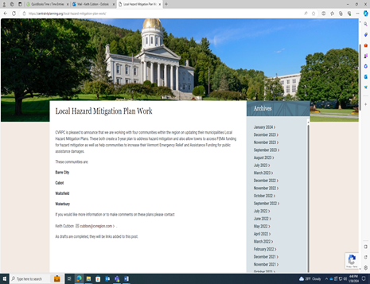

Example Plan update kick-off public notice from Central Vermont Regional Planning Commission website.

No inquiries received in response to the kick-off notice.

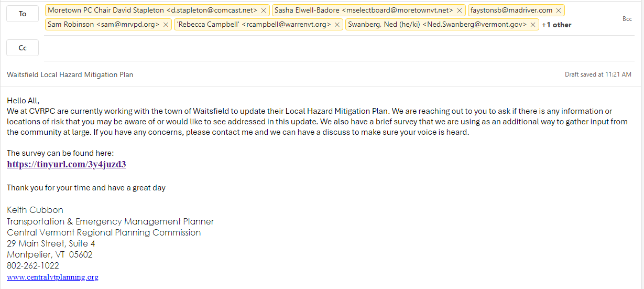

Example email to Key Partners announcing Plan update dated January 31, 2023.

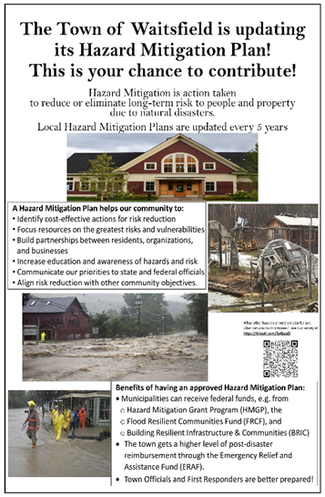

Example Local Hazard Mitigation Planning Community Survey poster used in town, on town Facebook and Front Porch Forum, posted on March 1, 2024.

See **Appendix D** for copy of survey and results.

Waitsfield Hazard Mitigation Planning Workshop advertisement posted at locations throughout town.

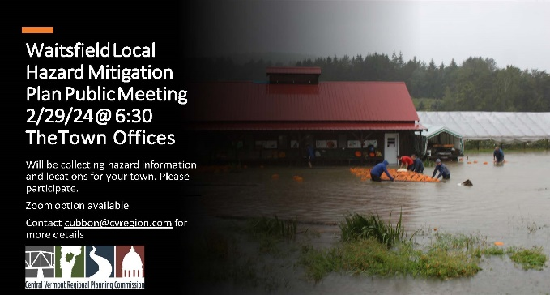

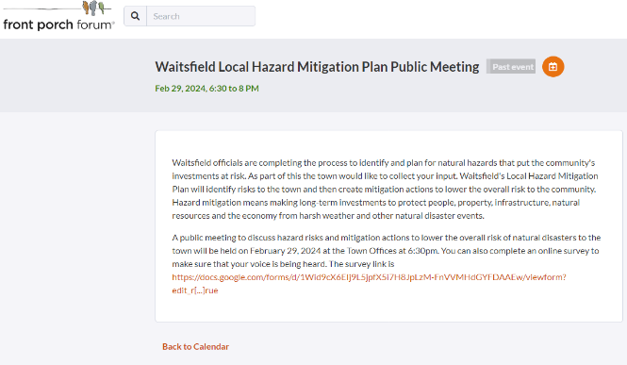 Example: Waitsfield Hazard Mitigation Planning Workshop advertisement on Front Porch Forum, posted on February 22, 2024 and repeated multiple times in days leading up to meeting



Example: Waitsfield Mitigation Public Meeting to discuss Mitigation

available for public comment at during plan development process from Central Vermont Regional Planning Commission website, including link to draft plan, posted on February 5, 2024.

Minor editorial comments received from the Waitsfield Planning Commission were incorporated into the Plan.

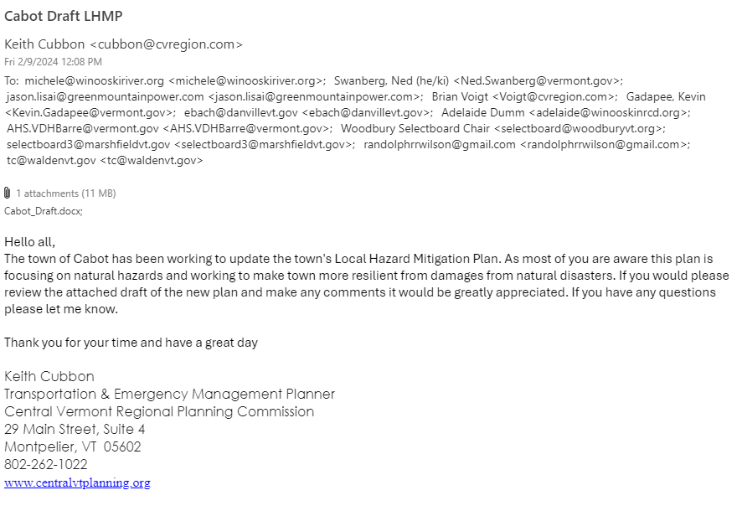

Example email to Key Partners and local officials in neighboring towns seeking comments on draft plan as draft was completed in plan development process – dated February 9, 2024.

Final Draft of the Waitsfield LHMP was posted to the town website on May ????, 2024. ? comments were received.

[placeholder for any VEM/ FEMA comments to plan and how they were addressed. ]

**COMMUNITY SURVEY RESULTS**

The Town of Waitsfield utilized a survey to solicit public input on 1) potential natural hazard impacts and 2) mitigation strategies to reduce these impacts in the future. The survey was made available online as well as hard copy over the course of 8 weeks between February and April 2024. The Town received 7 responses and a summary of the input received is provided below, followed by a copy of the actual survey.

